Supplemental Data

Figure S1 Phylogenetic of species referred in this study
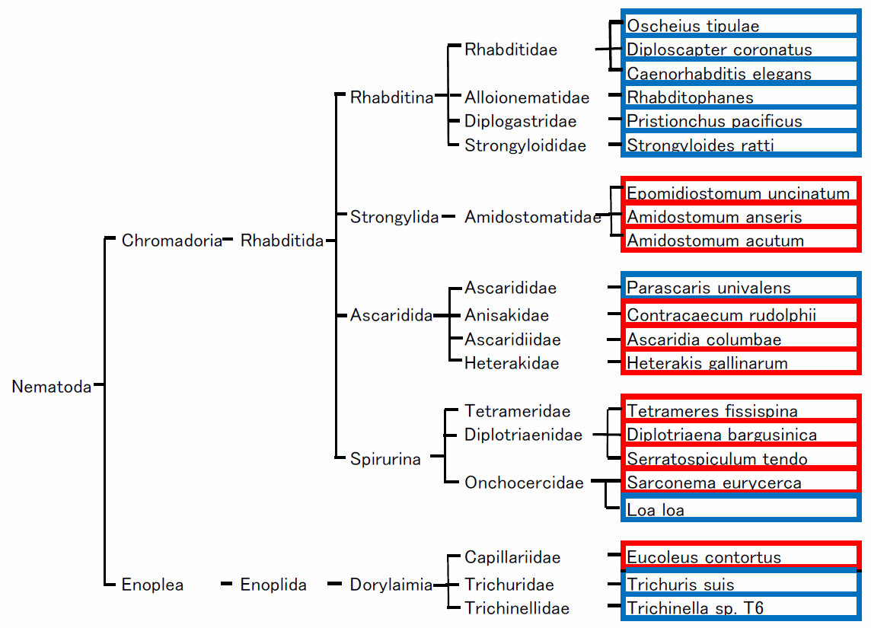

Phylogenetic tree were constructed according to Blaxter and Koutsovoulos (2015) (rno). The species surrounded by a red frame is the target species of DOP-PCR, and the species surrounded by a blue frame indicates the species referred to at the time of primer design.

Table S1 Predicted numbers of nonamers-inverted repeats within the 1,500 bases in the species referred to at the time of primer design.
nonamer | Diplosscapter_coronatus | Loa_loa | Pristionchus_pacificus | Caenorhabditis_elegans | Strongyloides_ratti | Oscheius_tipulae | Rhabditophanes | Trichuris_suis | Parascaris_univalens | Trichinella_sp_T6
P1 | 3 | 4 | 20 | 59 | 0 | 9 | 0 | 16 | 22 | 2
P2 | 3 | 1 | 19 | 50 | 0 | 5 | 1 | 3 | 26 | 5
P3 | 6 | 11 | 16 | 60 | 0 | 22 | 1 | 5 | 14 | 5
P4 | 32 | 9 | 32 | 34 | 5 | 21 | 2 | 6 | 15 | 1
P5 | 9 | 3 | 7 | 44 | 1 | 20 | 2 | 8 | 21 | 4
P6 | 27 | 8 | 10 | 53 | 4 | 28 | 4 | 13 | 37 | 1
P7 | 8 | 13 | 5 | 27 | 0 | 17 | 1 | 7 | 24 | 9
P8 | 37 | 7 | 24 | 80 | 0 | 22 | 0 | 8 | 50 | 5
P9 | 11 | 8 | 21 | 32 | 1 | 10 | 1 | 8 | 15 | 8
P10 | 3 | 3 | 18 | 29 | 3 | 6 | 3 | 3 | 9 | 5
P11 | 10 | 3 | 111 | 2 | 0 | 1 | 0 | 2 | 4 | 2
P12 | 17 | 0 | 13 | 23 | 0 | 13 | 0 | 6 | 9 | 1
P13 | 39 | 11 | 20 | 68 | 1 | 14 | 3 | 7 | 20 | 6
P14 | 32 | 10 | 14 | 30 | 3 | 19 | 4 | 8 | 18 | 4
P15 | 8 | 6 | 18 | 23 | 2 | 20 | 1 | 4 | 12 | 6
P16 | 14 | 5 | 4 | 12 | 0 | 5 | 0 | 11 | 9 | 2
P17 | 25 | 6 | 93 | 15 | 4 | 12 | 7 | 11 | 23 | 6
P18 | 35 | 2 | 1 | 18 | 0 | 12 | 4 | 5 | 11 | 2
P19 | 13 | 9 | 14 | 26 | 0 | 7 | 1 | 7 | 12 | 3
P20 | 19 | 7 | 80 | 42 | 0 | 8 | 6 | 27 | 12 | 1
P21 | 40 | 3 | 248 | 10 | 0 | 24 | 0 | 1 | 33 | 0
P22 | 18 | 5 | 17 | 2 | 5 | 3 | 1 | 8 | 25 | 2
P23 | 53 | 10 | 47 | 15 | 0 | 11 | 4 | 7 | 75 | 0
P24 | 26 | 7 | 17 | 13 | 0 | 16 | 0 | 9 | 12 | 4
P25 | 13 | 16 | 17 | 16 | 0 | 16 | 1 | 9 | 20 | 2
P26 | 13 | 4 | 10 | 14 | 0 | 4 | 4 | 2 | 12 | 1
P27 | 65 | 1 | 77 | 16 | 0 | 13 | 2 | 4 | 17 | 4
P28 | 11 | 2 | 4 | 9 | 1 | 7 | 1 | 6 | 11 | 2
P29 | 10 | 12 | 15 | 20 | 0 | 9 | 2 | 10 | 16 | 4
P30 | 15 | 7 | 12 | 18 | 8 | 9 | 3 | 11 | 11 | 1
P31 | 9 | 2 | 17 | 8 | 1 | 9 | 1 | 19 | 27 | 12
P32 | 13 | 6 | 30 | 34 | 1 | 10 | 1 | 12 | 29 | 4
P33 | 18 | 19 | 13 | 15 | 2 | 4 | 6 | 7 | 9 | 6
P34 | 36 | 7 | 24 | 27 | 0 | 3 | 0 | 3 | 22 | 2
P35 | 61 | 8 | 60 | 21 | 0 | 8 | 3 | 3 | 15 | 5
P36 | 10 | 2 | 8 | 46 | 1 | 7 | 1 | 4 | 7 | 1
P37 | 17 | 6 | 8 | 3 | 0 | 8 | 1 | 17 | 13 | 4
P38 | 2 | 3 | 20 | 19 | 1 | 9 | 1 | 10 | 16 | 11
P39 | 18 | 10 | 10 | 8 | 1 | 6 | 3 | 17 | 34 | 5
P40 | 18 | 4 | 5 | 10 | 1 | 1 | 3 | 4 | 18 | 3
P41 | 36 | 7 | 33 | 7 | 0 | 21 | 0 | 13 | 28 | 2
P42 | 13 | 8 | 5 | 21 | 1 | 19 | 7 | 13 | 20 | 6
P43 | 5 | 6 | 14 | 32 | 0 | 6 | 0 | 9 | 51 | 15
P44 | 20 | 0 | 43 | 14 | 0 | 12 | 0 | 2 | 7 | 3
P45 | 17 | 6 | 11 | 19 | 0 | 0 | 0 | 15 | 16 | 1
P46 | 33 | 10 | 124 | 8 | 1 | 7 | 4 | 3 | 40 | 2
P47 | 21 | 1 | 21 | 20 | 0 | 2 | 1 | 4 | 43 | 2
P48 | 17 | 5 | 10 | 12 | 5 | 13 | 1 | 12 | 21 | 12
P49 | 2 | 7 | 26 | 8 | 2 | 10 | 1 | 20 | 45 | 8
P50 | 7 | 6 | 21 | 12 | 0 | 11 | 3 | 8 | 18 | 2
Positions and frequencies were searched nonamers-inverted repeats which flanking a 100-1,500 base-sequence, such as ATGGGCTAC (100 to 1,500 bases) GTAGCCCAT, throughout the genomic sequences (Genbank Genome IDs 41, 55525, 2686, 55370, 33949, 246, 36407, 3496, 41654 and 13427).

Table S2 Assembled genomic data registered in NCBI genome.
Genus/Species | Genome assemblies | NCBI Genome ID | Date
Trichinella | 3 | 41654 | 2015/11/24
Oscheius | 3 | 36317 | 2015/02/26
Heligmosomoides polygyrus | 2 | 36519 | 2016/09/18
Rhabditophanes | 1 | 36407 | 1/01/01
Plectus sambesii | 1 | 65345 | 2017/11/28
Diploscapter pachys | 1 | 56859 | 2017/09/07
Caenorhabditis latens | 1 | 56214 | 2017/08/18
Diploscapter coronatus | 1 | 55525 | 2017/06/07
Oscheius tipulae | 1 | 55370 | 2017/05/22
Globodera ellingtonae | 1 | 46034 | 2016/09/12
Caenorhabditis nigoni | 2 | 44874 | 2016/05/13
Globodera rostochiensis | 1 | 44826 | 2016/04/22
Ditylenchus destructor | 1 | 43946 | 2016/03/03
Trichinella patagoniensis | 1 | 41656 | 2015/11/24
Subanguina moxae | 1 | 37144 | 2015/04/02
Soboliphyme baturini | 1 | 36532 | 1/01/01
Parascaris equorum | 1 | 36531 | 2017/11/27
Haemonchus placei | 1 | 36529 | 2016/03/12
Gongylonema pulchrum | 1 | 36527 | 2015/03/15
Cylicostephanus goldi | 1 | 36526 | 1/01/01
Brugia timori | 1 | 36524 | 1/01/01
Parastrongyloides trichosuri | 1 | 36401 | 1/01/01
Syphacia muris | 1 | 36393 | 1/01/01
Strongyloides papillosus | 1 | 36387 | 1/01/01
Trichinella murrelli | 2 | 35264 | 2015/11/24
Caenorhabditis tropicalis | 1 | 35261 | 2011/01/19
Trichinella papuae | 1 | 35252 | 2015/11/24
Trichinella zimbabwensis | 1 | 35251 | 2015/11/24
Trichinella britovi | 1 | 35242 | 2015/11/24
Trichinella nativa | 2 | 35238 | 2015/11/24
Trichinella nelsoni | 1 | 35237 | 2015/11/24
Parascaris univalens | 2 | 33949 | 2017/08/18
Meloidogyne floridensis | 1 | 33826 | 2014/06/11
Globodera pallida | 1 | 32442 | 2014/05/25
Trichuris muris | 1 | 31518 | 2014/03/25
Angiostrongylus cantonensis | 3 | 30176 | 2013/01/09
Elaeophora elaphi | 2 | 24454 | 2013/11/05
Romanomermis culicivorax | 1 | 23995 | 2014/01/06
Onchocerca ochengi | 2 | 18268 | 2013/08/20
Steinernema monticolum | 1 | 17810 | 2013/12/10
Steinernema glaseri | 1 | 17808 | 2014/09/24
Steinernema scapterisci | 1 | 17807 | 2014/09/24
Steinernema feltiae | 1 | 17805 | 2014/09/24
Haemonchus contortus | 2 | 16936 | 2013/05/10
Panagrellus redivivus | 1 | 16242 | 2013/02/19
Thelazia callipaeda | 1 | 14733 | 2012/08/01
Meloidogyne graminicola | 1 | 14464 | 2017/11/16
Trichuris suis | 3 | 13427 | 2014/06/11
Trichuris trichiura | 1 | 13417 | 2014/03/25
Strongyloides stercoralis | 1 | 13317 | 1/01/01
Brugia pahangi | 2 | 13249 | 2015/09/10
Strongyloides venezuelensis | 1 | 12700 | 2015/10/16
Ascaris lumbricoides | 1 | 11969 | 2011/10/31
Onchocerca flexuosa | 2 | 11948 | 2017/08/09
Trichinella pseudospiralis | 5 | 11844 | 2015/11/24
Table S2 continued
Bursaphelenchus xylophilus | 1 | 11822 | 2011/09/28
Rotylenchulus reniformis | 1 | 11277 | 2015/06/10
Nippostrongylus brasiliensis | 2 | 11002 | 2017/08/05
Ancylostoma ceylanicum | 2 | 10936 | 2013/05/24
Meloidogyne javanica | 1 | 10912 | 2017/04/29
Meloidogyne arenaria | 1 | 10908 | 2017/04/29
Dracunculus medinensis | 1 | 10838 | 2011/09/18
Teladorsagia circumcincta | 1 | 10767 | 2017/09/20
Dirofilaria immitis | 1 | 10757 | 2013/08/20
Setaria digitata | 1 | 9486 | 2017/12/06
Strongylus vulgaris | 1 | 9335 | 2010/02/12
Angiostrongylus costaricensis | 1 | 9101 | 2009/08/05
Enterobius vermicularis | 1 | 8694 | 2008/09/30
Toxocara canis | 3 | 8517 | 2014/12/18
Anisakis simplex | 1 | 7896 | 2006/03/28
Strongyloides ratti | 1 | 3496 | 2014/09/18
Caenorhabditis angaria | 1 | 3127 | 2010/10/18
Steinernema carpocapsae | 1 | 2699 | 2014/09/24
Onchocerca volvulus | 2 | 2687 | 2010/02/02
Loa loa | 2 | 2686 | 2010/02/03
Wuchereria bancrofti | 3 | 2616 | 2010/02/03
Heterodera glycines | 1 | 852 | 2008/03/20
Oesophagostomum dentatum | 1 | 782 | 2014/12/05
Dictyocaulus viviparus | 1 | 779 | 2015/01/07
Necator americanus | 1 | 770 | 2013/12/13
Heterorhabditis bacteriophora | 1 | 481 | 2011/08/16
Ascaris suum | 3 | 350 | 2011/01/28
Ancylostoma duodenale | 1 | 348 | 2015/01/08
Meloidogyne incognita | 2 | 281 | 2008/09/09
Meloidogyne hapla | 1 | 260 | 2008/09/29
Caenorhabditis brenneri | 1 | 254 | 2007/07/17
Caenorhabditis remanei | 3 | 253 | 2005/02/09
Caenorhabditis japonica | 1 | 252 | 2008/04/03
Pristionchus pacificus | 1 | 246 | 2009/01/07
Trichinella spiralis | 2 | 238 | 2007/12/14
Brugia malayi | 1 | 42 | 2002/09/25
Caenorhabditis elegans | 5 | 41 | 2001/12/03
Caenorhabditis briggsae | 1 | 40 | 2002/08/22
Species, registered number of assemblies, GenBank Genome ID, and registration date are confirmed at Feb 1st 2018.

