Supporting Information
Thermopower Modulation Analyses of High-Mobility Transparent Amorphous Oxide Semiconductor Thin-Film Transistors

Hui Yang^{1,2,}*, Yuqiao Zhang^{3,4}, Yasutaka Matsuo¹, Yusaku Magari^{1,5},
and Hiromichi Ohta^{1,}*

¹Research Institute for Electronic Science, Hokkaido University, N20W10, Kita, Sapporo 001-0020, Japan

²Institute of Optoelectronic Technology, Beijing Jiaotong University, Beijing 100044, China

³Institute of Quantum and Sustainable Technology, Jiangsu University, Zhenjiang 212013, China

⁴Foshan (Southern China) Institute for New Materials, Foshan 528200, China

⁵Graduate School of Natural Science and Technology, Shimane University, Matsue, Shimane, 690-8504, Japan

*Email: 19118044@bjtu.edu.cn, hiromichi.ohta@es.hokudai.ac.jp
Table S1. The transistor characteristics of the ITZO-TFTs with various ITZO thickness.

ITZO thickness (nm) | I_{ON}/I_{OFF} | μ_{FE}  (cm² V⁻¹ s⁻¹) | S.S.  (mV decade⁻¹) | V_{th}  (V)
5 | 1.74 × 10⁹ | 34 | 100 | −2.9
10 | 4.97 × 10⁹ | 58 | 70 | −5.5
20 | 3.23 × 10⁹ | 43 | 90 | −5.9
30 | 2.38 × 10⁸ | 49 | 180 | −12
40 | 3.51 × 10⁸ | 35 | 120 | −12.9
50 | 1.65 × 10⁹ | 33 | 150 | −14.5
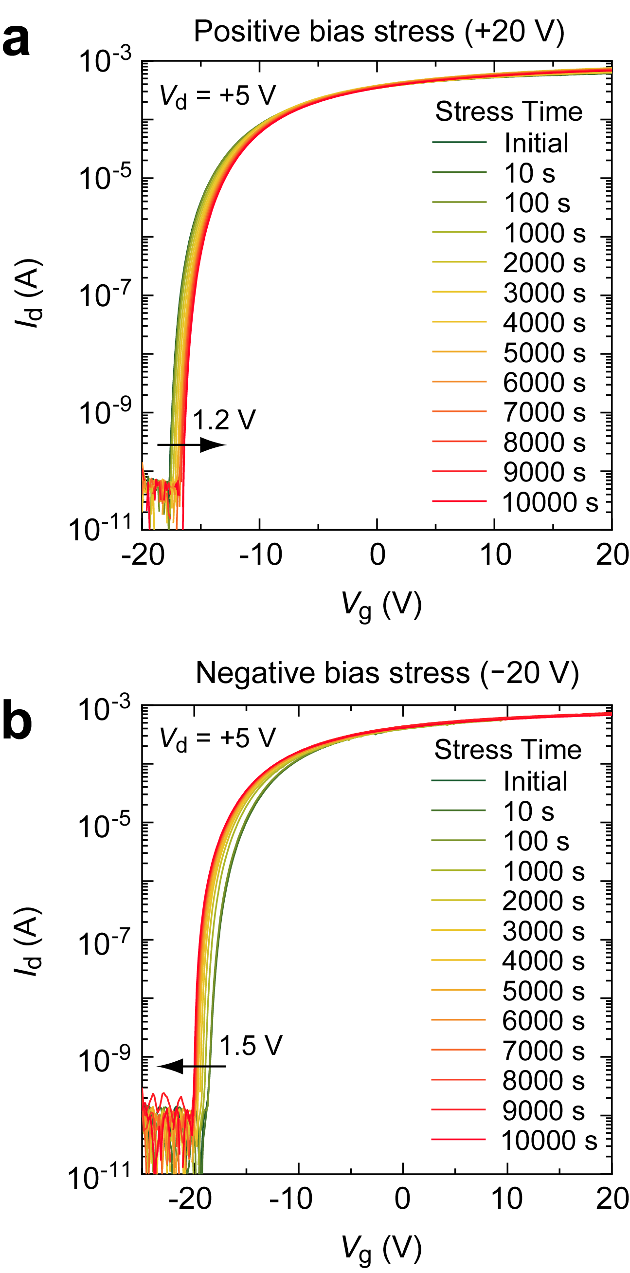

Figure S1 | Transfer characteristics of the 10-nm-thick a-ITZO TFTs under (a) positive bias stress (PBS) (b) negative bias stress (NBS). The bias stability test was conducted at room temperature, the V_{g} was setting as $±$20 V with the stress time up to 10000 s. The transfer characteristics curve shifted to the positive/negative direction, the V_{th} shift (ΔV_{th}) under PBS is + 1.2 V while under NBS is −1.5 V without any passivation.

