Supporting Information 1
Substrate-Assisted Reductive Elimination Determining the Catalytic Cycle: Theoretical Study on the Ni-Catalyzed 2,3-Disubstituted Benzofurans Synthesis via C–O Bond Activation

Ray Miyazaki,ª Kenji Iida,^{b} Shohei Ohno,^{c,‡} Tsuyoshi Matsuzaki,^{d} Takeyuki Suzuki,^{d} Mitsuhiro Arisawa,^{c} and Jun-ya Hasegawa^{b,*}

ªFritz-Haber-Institut der Max-Planck-Gesellschaft, Faradayweg 4-6, D-14195 Berlin, Germany
^{b}Institute for Catalysis, Hokkaido University, N21 W10 Kita-ku, Sapporo, Hokkaido 001-0021, Japan
^{c}Graduate School of Pharmaceutical Sciences, Osaka University, Suita, Osaka 565-0871, Japan
^{d}Comprehensive Analysis Centre, SANKEN (The Institute of Scientific and Industrial Research), Osaka University, Mihogaoka 8-1, Ibaraki, Osaka 567-0047, Japan
‡Present Address: Department of Chemistry, Yale University, New Haven, Connecticut 06520, United States

Corresponding Author: Jun-ya Hasegawa
hasegawa@cat.hokudai.ac.jp

S1. Comparison of Computational Settings
S2. Reductive Elimination without Another Substrate
S3. Reductive Elimination with DMF molecules or Another Ligand
S4. Experimental Results of Mass Spectrometry
S5. Optimized Structures along Paths-A and B
S6. Energy Levels of the Ni Complex before Entering Paths-A and B
S7. Comparison between Singlet and Triplet State
S8. Investigation of Electronic Structure of Ni Complexes

S1. Comparison of Computational Settings
Because the computational setting of the present study is different from that of our previous work¹, the relative stabilities of the intermediates were investigated with each computational settings (Scheme S1). Although the ligand of the Ni catalyst and substituents at the 2- and 3-positions of benzofurans are different, the same trend was obtained for the relative stability of the intermediates. An experimental result also showed that the same products were produced (see subsection S4).

Scheme S1. The difference of the computational settings between our previous work¹ and the present study.

As shown in Table S1, relative stabilities of Int A, B, and C were same with both computational settings (i.e., Path-A is thermodynamically favorable than Path-B). Additionally, Int D was ruled out in both previous and present studies because Int D was rather unstable than Int C.

Table S1. Relative stability of each intermediateª.
(kcal/mol) | Int A | Int B | Int C | Int D
Previous¹ | 0.0 | 8.5 | −3.9 | 5.9
Present | 0.0 | 16.3 | −8.3 | 18.0
ªThe relative potential energies of each intermediate. The reference point was set to the potential energy of Int A with each setting.

1. Ohno, S.; Qiu, J.; Miyazaki, R.; Aoyama, H.; Murai, K.; Hasegawa, J.; Arisawa, M., Ni-Catalyzed Cycloisomerization between 3-Phenoxy Acrylic Acid Derivatives and Alkynes via Intramolecular Cleavage and Formation of the C−O Bond To Give 2,3-Disubstituted Benzofurans. Org. Lett. 2019, 21, 8400-8403.

S2. Reductive Elimination without Another Substrate
Reductive elimination from the six-membered metallacycle intermediate without another substrate was investigated (the direct elimination: Figure S1). The activation energy was calculated to be 28.8 kcal/mol, and it is larger than that of the substrate-assisted mechanism (Figure 1: TSA7) by 0.9 kcal/mol. Additionally, the reaction energy was calculated to be +7.1 kcal/mol (i.e., endergonic reaction) although TSA7 was calculated to be exergonic reaction ($∆G_{r}=$ −5.2 kcal/mol). Thus, the substrate-assisted reductive elimination is more favorable than the direct reductive elimination to PCM.
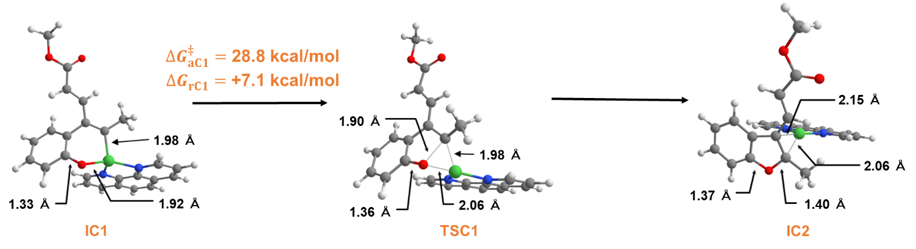
Figure S1. The reductive elimination without another substrate. White: hydrogen, gray: carbon, red: oxygen, green: nickel, and blue: nitrogen.

S3. Reductive Elimination with DMF molecules or Another Ligand
Because the intermediate is surrounded by not only substrates but also solvent molecules (i.e., DMF) and (uncoordinated) ligands, the reductive elimination with explicit DMF molecules or another ligand were investigated.
The activation energy of the reductive elimination with one (explicit) DMF molecule was calculated to be 25.3 kcal/mol (Figure S2a), and it is smaller than that of the substrate-assisted mechanism (Figure 1: TSA7) by 2.6 kcal/mol. However, the reaction was calculated to be endergonic ($∆G_{rC2}^{}=$ +6.3 kcal/mol) although TSA7 was calculated to be exergonic reaction ($∆G_{r}=$ −5.2 kcal/mol). The activation energy of the reductive elimination with two DMF molecules ($∆G_{aC3}^{‡}=$ 23.6 kcal/mol in Figure S2b) is smaller than that with one DMF molecule by 1.7 kcal/mol. However, the reaction energy was calculated to be +14.1 kcal/mol, and thus, the elimination assisted by two DFM molecules is thermodynamically unfavorable than the direct mechanism.
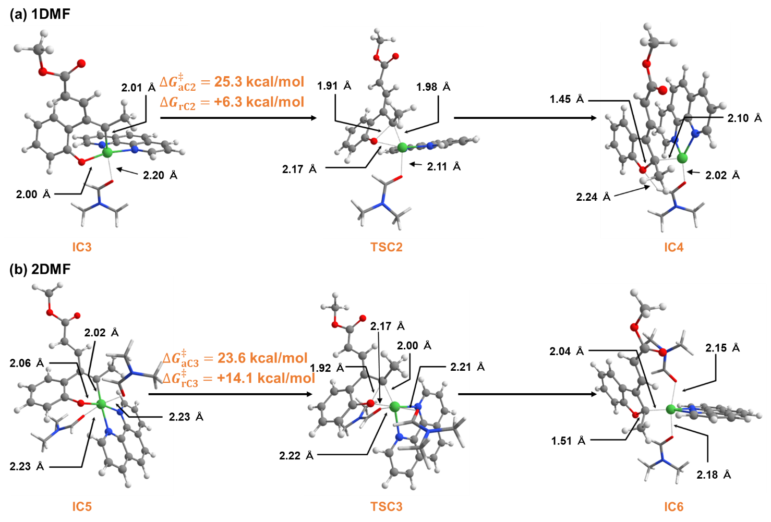
Figure S2. The reductive elimination with (a) one DMF molecule and (b) two DMF molecules. White: hydrogen, gray: carbon, red: oxygen, green: nickel, and blue: nitrogen. In this figure, the explicit DMF molecules are visualized in the tube-style model for simplicity (the same computational setting was adopted for both DMF molecules and the intermediates).

The activation energy of the reductive elimination with another ligand was calculated to be 27.7 kcal/mol (Figure S3), and it is almost same as that of the substrate-assisted mechanism ($∆G_{rA7}^{‡}=$ 27.9 kcal/mol). However, the reaction energy was calculated to be +6.0 kcal/mol (i.e., endergonic reaction).

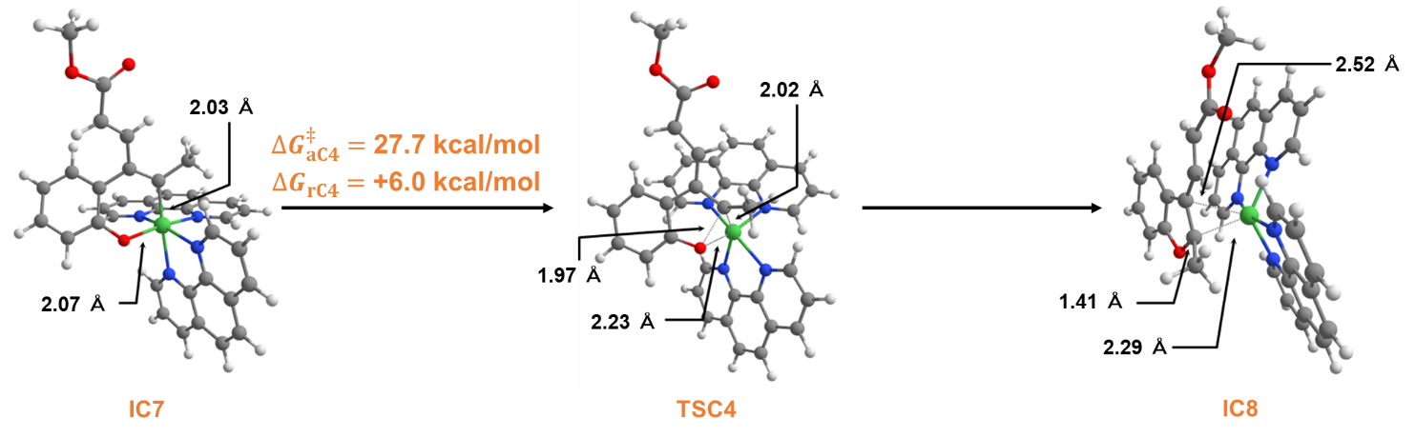
Figure S3. The reductive elimination with another ligand. White: hydrogen, gray: carbon, red: oxygen, green: nickel, and blue: nitrogen.

From these results, it was suggested that the reductive elimination assisted by DMF molecules or free ligand proceeds as an endergonic reaction. Additionally, further reaction steps and activation energies for the elimination of DMF or ligand are required to proceed to the next catalytic cycle. Therefore, the substrate-assisted reductive elimination with the smooth (exergonic) connection to Path-A is more reasonable mechanism.

S4. Experimental Results of Mass Spectrometry
We used electrospray ionization (ESI) mass spectroscopy to obtain some information about the nickel species in this reaction. The reaction with stoichiometric amount (1 eq.) of nickel species was performed within 5 min and then was analyzed (Figure S4). Although the m/z of the intermediate deviated from the theoretical value by 0.0144, we detected a peak of C₂₅H₂₀N₂NaNiO₃⁺ at 477.0864) (Figures S5), which possibly correspond to the intermediates (Calcd [M+Na]⁺ for C₂₅H₂₀N₂NaNiO₃ 477.0720), whose structures were shown in Figure S4. The peak of the isotope was also found at 479.0819 (Figure S6). Other peaks of isotopes other than 479.0819 were found around 480. The m/z of the other isotopes also deviated slightly from the theoretical values, but their isotope patterns were consistent with the theoretical values. Also, tandem mass spectrometry (MS/MS) was performed on the peak at 477.0864 and the results are shown in Figure S7. Here we observed a strong peak of C₁₃H₁₂NaNiO₃⁺ at 297.0171 that seemed to be a fragment of phenanthroline-desorbed intermediates (Calcd [M+Na]⁺ for C₁₃H₁₂NiO₃Na 297.0038), whose structures were shown in Figure S4.
Figure S4. Sample preparation and Int A, Int B, Int C, Reactant, and Product which possibly correspond to a peak at 477.0864.

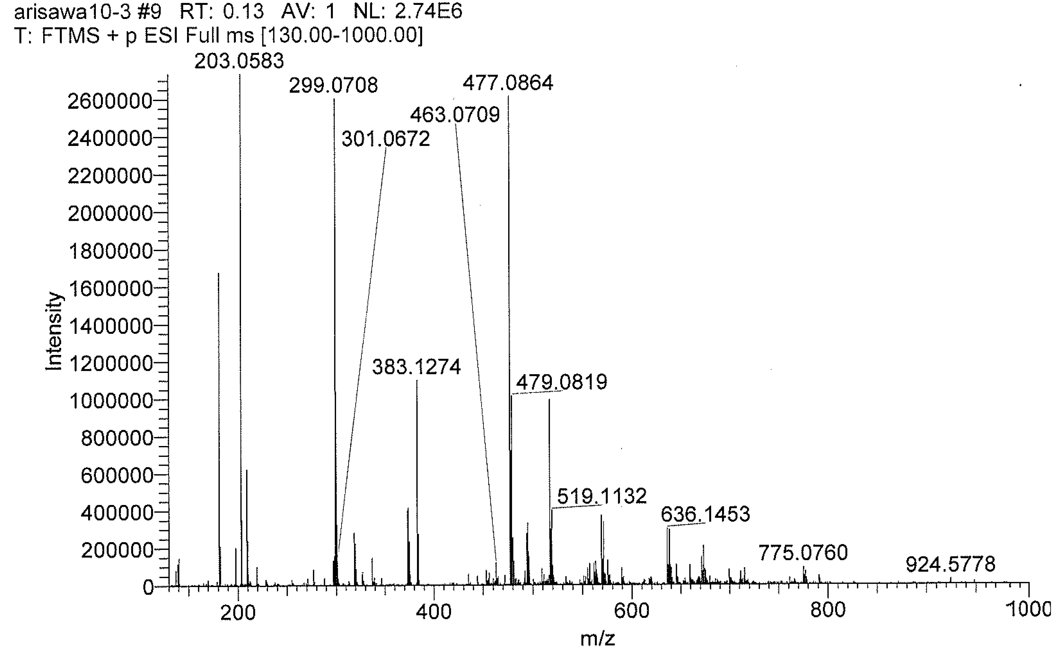
Figure S5. Results of Mass analysis.

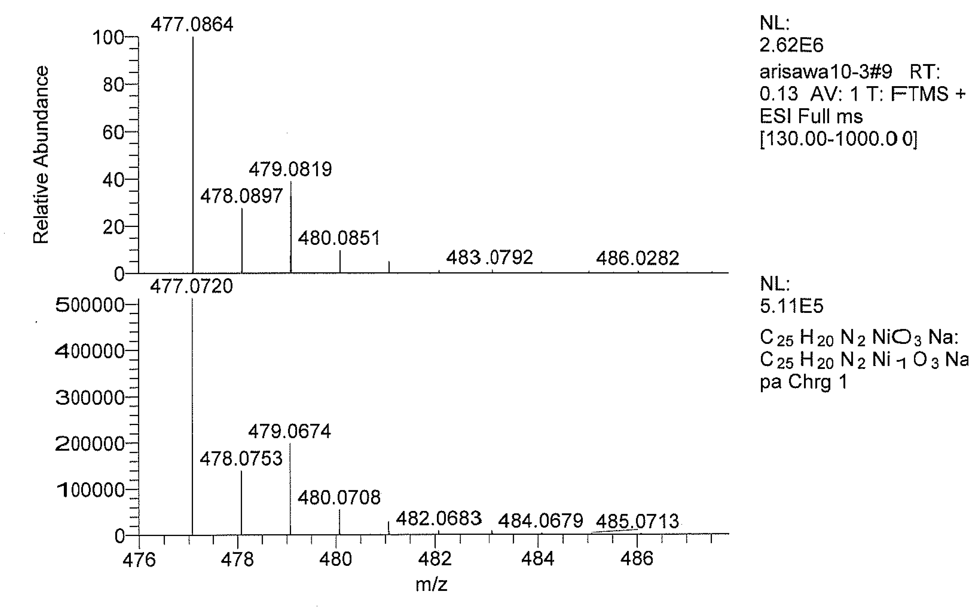
Theoretical
Observed
Figure S6. m/z: spectrum around 480 (enlarged version of Fig. S5).

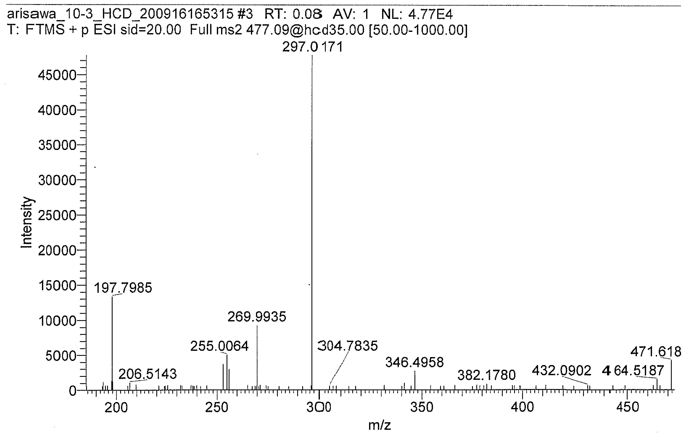
Figure S7. Results of MS/MS measurement.

S5. Optimized Structures along Paths-A and B 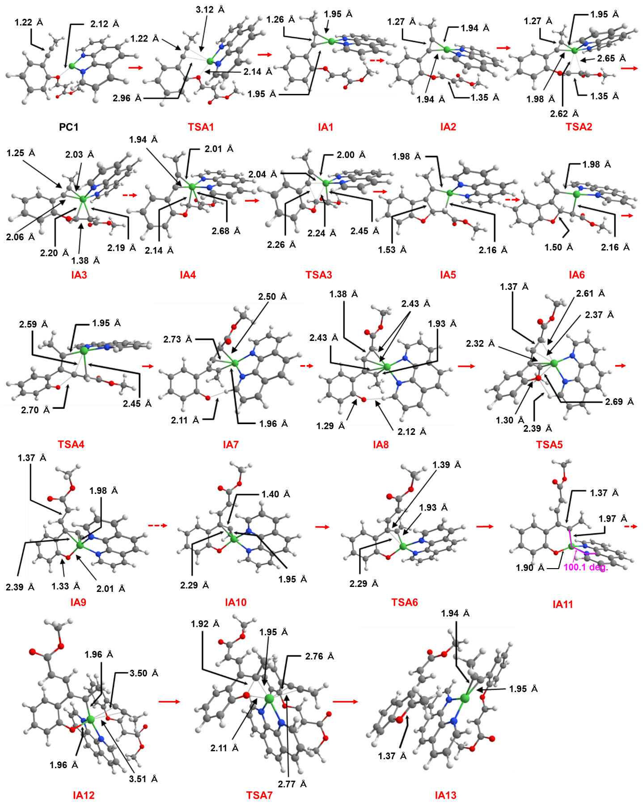
Figure S8. Equilibrium and transition state structures along Path-A. White: hydrogen, gray: carbon, red: oxygen, green: nickel, and blue: nitrogen.

Figure S9. Equilibrium and transition state structures along Path-B. White: hydrogen, gray: carbon, red: oxygen, green: nickel, and blue: nitrogen.

S6. Energy Levels of the Ni Complex before Entering Paths-A and B
We investigated the relative stability of the Ni complexes with possible ligands including phen, cod, DMF (solvent), and substrate. As shown in Figure S10, Ni(phen)₂ is the most stable Ni complex and has been set to the reference point for the relative energy. When one of the phen ligands is substituted to the substrate, the precursor complex IA2 for Path-A and IB1 for Path-B are formed. IA2 is connected to a transition state for the C-C bond formation (TSA3) via coordination to the vinyl group (TSA2). As seen in Figure S8, the substrate is coordinated at the alkynyl group in IA2. IB1 is a precursor for oxidative addition to C(vinyl)-O bond (TSB2). A Ni complex involving the cod ligands are relatively high in energy. Ni(cod)₂ and Ni(cod)(phen) are by 17.8 kcal/mol and 13.6 kcal/mol higher than Ni(phen)₂, indicating the ligand exchange from Ni(cod)₂ to Ni(phen)₂ is energetically reasonable.

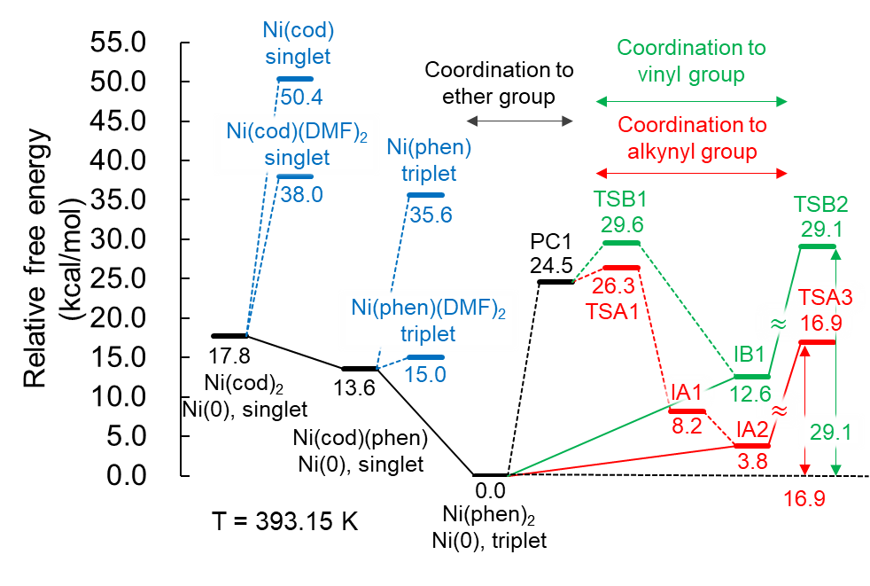
Figure S10. Relative energy of the Ni complexes before the reaction. For the structure, see Figure S11 for Ni(cod)₂, Ni(phen)₂, Ni(cod)(phen), Ni(cod)(DMF)₂, Ni(phen)(DMF)₂. See Figure S8 for PC1, TSA1, IA1, and IA2. See Figure S9 for TSB1 and IB1. The detail of the electronic structure of Ni complexes is discussed in S7 and S8 in SI.

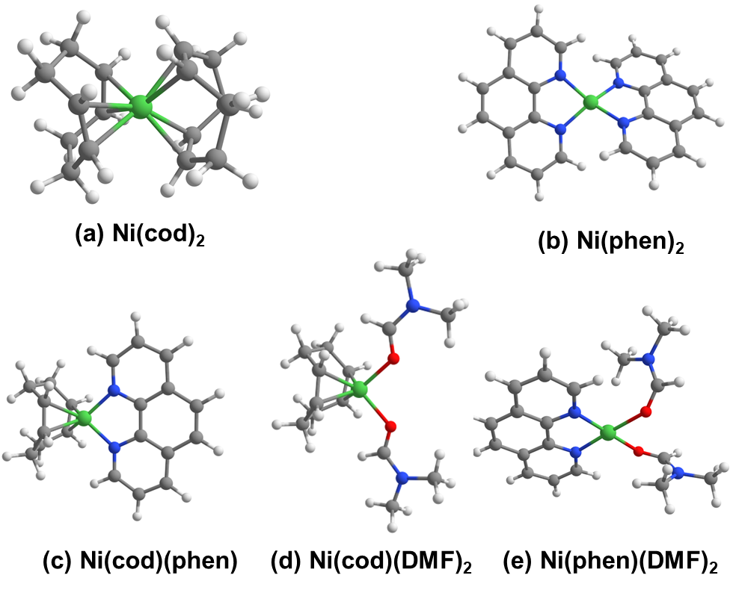
Figure S11. Optimized structures of Ni complexes. (a) Ni(cod)₂ , (b) Ni(phen)_{2,} (c) Ni(cod)(phen),
(d) Ni(cod)(DMF)₂, and (e) Ni(phen)(DMF)₂.

S7. Comparison between Singlet and Triplet State
We calculated free energy difference between singlet and triplet states ($∆{\text{G}}_{T-S}$) of the key intermediates,
$$∆{\text{G}}_{T-S}=G_{T}-G_{S}$$
where $G_{T}$ and $G_{S}$ are Gibbs free energies of triplet and singlet states, respectively. As shown in Table S2, Ni complexes with the cyclooctadiene ligand, Ni(cod)₂ and Ni(cod)(phen), are stable in singlet state. To form an Ni(phen)₂, there should be at least one intersystem crossing point. Thermodynamical stability of the triplet state of Ni(phen)₂ against the singlet state of Ni(cod)₂ and Ni(cod)(phen) are clear, and therefore, MECP was not calculated. Key intermediates given in Scheme1, Int A and Int B, are more stable in their triplet state. Singlet states of Int C are slightly by 0.4 kcal/mol more stable than triplet state. As these two spin states are closely lying, we expect the MECP point is also close to those energy minimums. Thus, the effect of the intersystem crossing could be minor. In this way, the energy profile for the catalytic cycles were calculated as triplet state.

Table S2. Free energy difference between singlet and triplet states of the key intermediates.
(T = 393.15 K) | Ni(cod)₂ | Ni(cod)(phen) | Ni(phen)₂ | Int A (IA5) | Int B (IB4) | Int C (IA11)
ΔG_{T-S} (kcal/mol) | 34.5 | 1.4 | -14.0 | -6.8 | -18.5 | 0.4

S8. Investigation of Electronic Structure of Ni Complexes
We investigated number of excess spin-up electrons on Ni ($∆N_{Ni}$ in Table S3). In Ni(phen)₂, $∆N_{Ni}$ was calculated to be 0.91 while that in IA5 and IB4 was calculated to be 1.61 and 1.62, respectively. Additionally, as summarized in Table S3, NPA charge of Ni in IA5 and IB4 (q_{Ni} = 0.88 and 0.92, respectively) shows more positive value than that in Ni(phen)₂ (q_{Ni} = 0.50). On the other hand, NPA charge of Ni in Ni(cod)₂ and Ni(cod)(phen), which are in singlet state, is almost neutral (q_{Ni} = 0.13 and 0.18, respectively). Electron population of Ni 3d orbitals (3d_{occ} in Table S3) also decreases from Ni(cod)₂ and Ni(cod)(phen) to IA4 and IA5 via Ni(phen)₂. From those results and also from a conventional formal assignment, the oxidation state of Ni(cod)₂ and Ni(cod)(phen) is Ni(0), while that of IA5 and IB4 intermediates is Ni(II). To figure out the intermediate properties of Ni(phen)₂, the Ni-phen orbital interaction was analyzed. As shown in Figure S12a, Ni 3d_{x2-y2} orbital and N 2p orbitals have σ-antibonding interaction in the SOMO(α)-1. Additionally, the SOMO(α) is composed of Ni 3d_{x2-y2} orbital and π* orbitals of the phenanthroline ligands (Figure S12b) with bonding interactions. These π* (phen) orbitals correspond to the LUMO of phenanthroline (Figure S12c). These orbital interactions generate a low-lying SOMO(α) which allows to be occupied by one electron. In this way, the Ni(phen)₂ complex is in triplet multiplicity. Regarding the oxidation state, although the orbital interaction induces the charge transfer from Ni to the phenanthroline ligands, we followed the community’s convention and defined as Ni(0).

Table S3. Number of excess spin-up electrons on Ni ($∆N_{Ni}$)ª, NPA charge (q_{Ni}) of Ni, and electron population of Ni 3d orbitals (3d_{occ}).
 | Ni(cod)₂ | Ni(cod)(phen) | Ni(phen)₂ | IA5 | IB4
spin | singlet | singlet | triplet | triplet | triplet
$$∆N_{Ni}$$ | - | - | 0.91 | 1.61 | 1.62
q_{Ni} | 0.13 | 0.18 | 0.50 | 0.88 | 0.92
3d_{occ} | 9.04 | 8.94 | 8.84 | 8.38 | 8.33
ª $∆N_{Ni}=N_{Ni}^{α}-N_{Ni}^{β}$ calculated by natural population analysis.

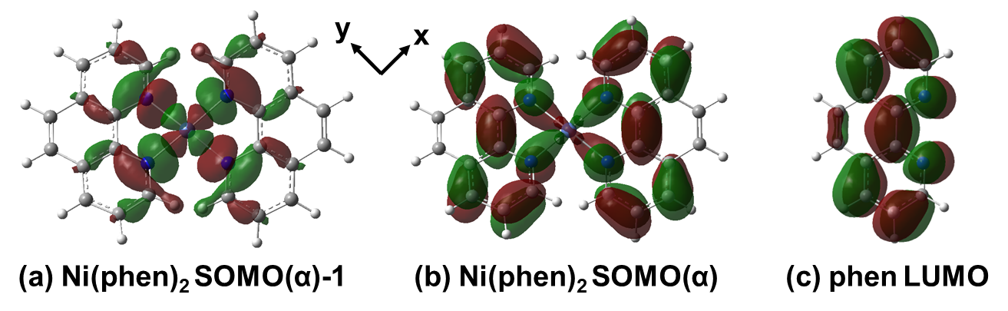
Figure S12. Molecular orbital of (a) SOMO(α)-1, (b) SOMO(α) of Ni(phen)₂, and (c) LUMO of the phenanthroline ligand (isosurface value is 0.02 Å⁻³).

