Supplementary data for
Highly effective photocatalytic system comprising semiconductor photocatalyst and supported bimetallic non-photocatalyst for selective reduction of nitrate to nitrogen in water

1. Analysis of gaseous products formed during the photocatalytic reduction of NO₃–

An experimental setup is illustared in Fig. A1.
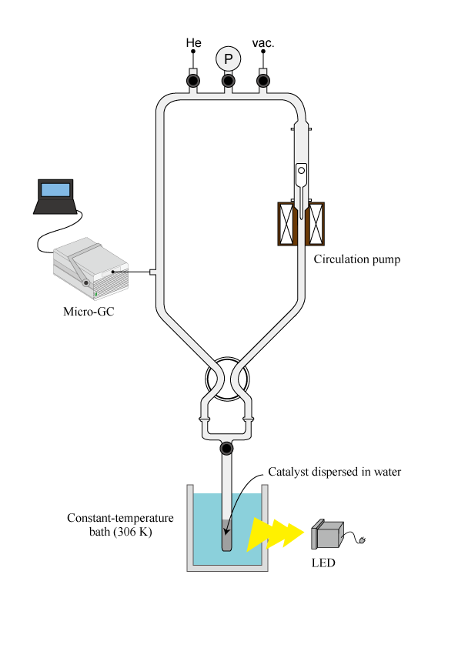

Fig. A1 Experimental setup for gaseous product analysis
2. Powder XRD patters of Pt/TiO₂ and Sn-Pd/Al₂O₃

Fig. A2 shows powder XRD patterns of Pt/TiO₂ and Sn-Pd/Al₂O₃. Pt/TiO₂ gave an XRD pattern assignable anatase and rutile phases as reported (Fig. A2(a)), but no diffraction line due to platinum particles was observed because of low loading amount. Sn-Pd/Al₂O₃ showed an XRD pattern identical to γ–Al₂O₃ (Fig. A2(b)). However, no diffraction line due to Pd-Sn alloy as well as Pd and Sn particles was observed, probably because of high dispersion.

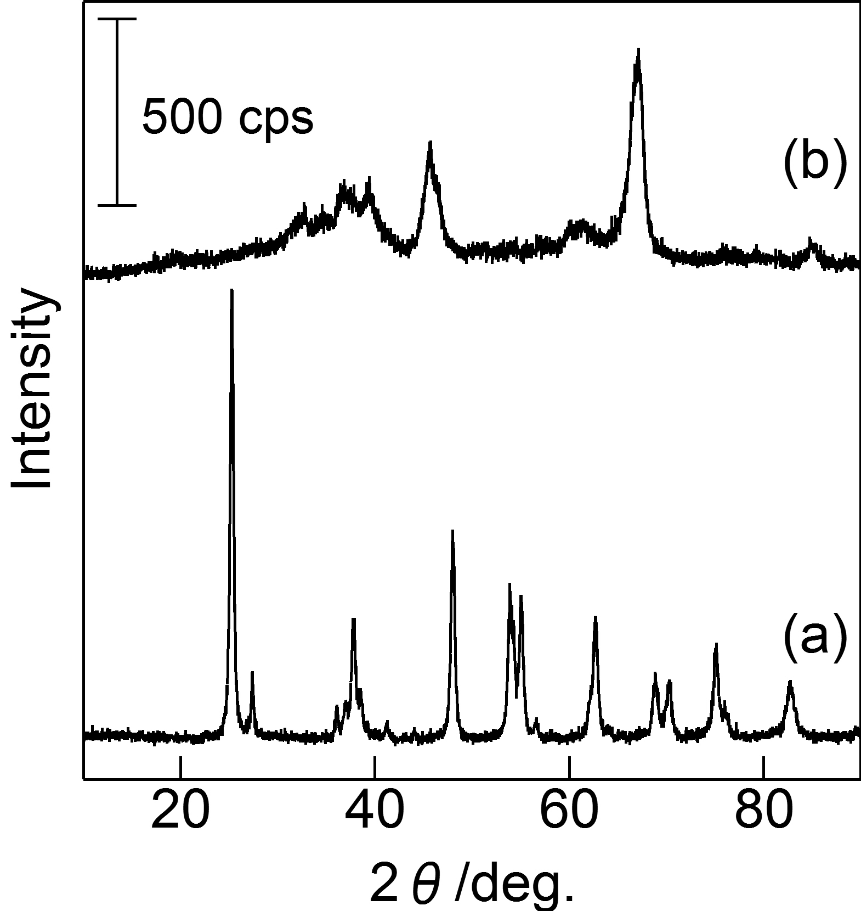

Fig. A2 Powder XRD patterns of (a) Pt/TiO₂ and (b) Sn-Pd/Al₂O₃.
3. Determination of the metals leached into the reaction solution during the photocatalytic reduction of NO₃– in the presence of Pt/TiO₂ and Sn-Pd/Al₂O₃

After the reaction in Entry 3 in Table 1, the concentrations of Sn, Pd, and Pt in the reaction solution were determined by using an inductively-coupled plasma atomic emission spectrometer (ICP-AES, Shimadzu ICPS-8000). The concentration of each element in the reaction solution was below the detection limit of the ICP-AES.

4. Photocatalytic reduction of NO₃– in the presence of Pt/TiO₂ and Sn-Pd/Al₂O₃ with continuous bubbling of O₂ and N₂

Photocatalytic reductions of NO₃– in water in the presence of Pt/TiO₂ and Sn-Pd/Al₂O₃ were carried out in a batch reactor with continuous bubbling of O₂ or N₂ gas. After Pt/TiO₂ (150 mg), Sn-Pd/Al₂O₃ (20 mg), an aqueous KNO₃ solution (10 cm³, 10 mmol dm^{–3}), and ethanol (5.0 mmol) were loaded into the reactor, O₂ or N₂ gas was bubbled at a rate of 5 cm³ min^{–1} for 15 min into the reaction suspension in the dark, where the amount of O₂ dissolved in water was determined to be ≥20 or 0.3 ppm, whereas the amount of O₂ without gas bubbling was 7.6 ppm. Then the reaction tube was irradiated at 380 nm with an LED (8 W) for 4 h with continuous bubbling of O₂ or N₂ gas (5 cm³ min^{–1}). After the reaction (4 h), the concentrations of NO₃–, NO₂–, and NH₄⁺ in the liquid phase were determined by using two ion-chromatographs (Tosoh Co. Ltd., IC-2001). The concentration of ethanol in the liquid phase was determined by using a gas chromatograph equipped with a flame-ionization detector (Shimadzu GC-2010).
Table A1 lists the photocatalytic results. When the reaction was conducted with continuous bubbling of O₂, the conversion of NO₃– decreased to about one-sixth of that without gas bubbling, whereas the conversion of ethanol was about double that without gas bubbling. On the other hand, when the photocatalytic reaction was carried out with N₂ bubbling, the conversion and selectivities were almost the same as those without gas bubbling.

Table A1
Influence of gas bubbling on the photocatalytic reduction of NO₃– in the presence of Pt/TiO₂ and Sn-Pd/Al₂O₃ under UV irradiation
Gas bubbling | NO₃– conv. | Selectivity/% |  |  | Ethanol conv.
 | /% | NO₂– | NH₄⁺ | gas^{b} | /%
w/o gas bubblingª | 49 | 4 | 2 | 94 | 8
O₂ | 8 | 0 | 0 | 100 | 18
N₂ | 43 | 5 | 3 | 92 | 8
Reaction conditions: catalyst weight, Pt/TiO₂ 150 mg; Sn-Pd/Al₂O₃ 20 mg; reactant NO₃–, 10 cm³ (10 mmol dm^{–3} aqueous KNO₃); ethanol/NO₃–, 50; and UV irradiation (LED, 8 W) for 4 h.
ªNo gas was bubbled into the reaction solution during the photocatalytic reduction of NO₃–.
^{b}Gaseous nitrogen-derived compounds.
5. Dependence of the loading amount of Sn-Pd on the photocatalytic reduction of NO₃– in the presence of Sn-Pd/TiO₂

Fig. A3 shows the dependence of the loading amount of Sn-Pd on the conversion and selectivities toward the photocatalytic reduction of NO₃– in water over Sn-Pd/TiO₂ under UV irradiation.

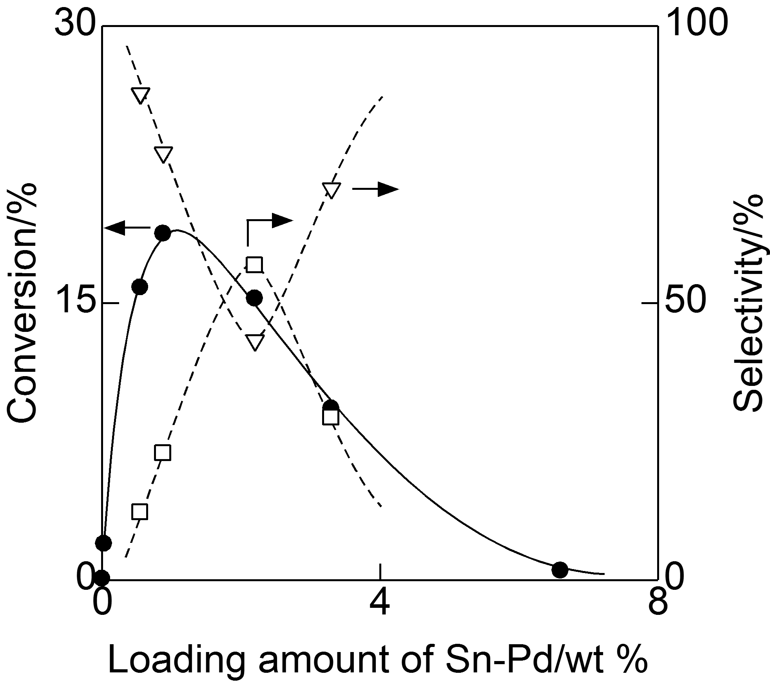

Fig. A3 Dependence of the loading amount of metals in Sn-Pd/TiO₂ on the conversion and selectivities toward the photocatalytic reduction of NO₃– in water over Sn-Pd/TiO₂ under UV irradiation. (●) Conversion of NO₃– and selectivities to (□) NH₄⁺ and (▽) gaseous nitrogen compounds. NO₂– was not detected regardless of the metal loading. Reaction conditions: catalyst weight, 150 mg; reactant NO₃–, 10 cm³ (10 mmol dm^{–3} aqueous KNO₃ solution); ethanol/NO₃–, 10; UV irradiation (8 mW LED); and reaction time, 4 h.
Unmodified TiO₂ exhibited only low photocatalytic activity. Modification of TiO₂ with a small amount of Sn-Pd significantly enhanced the photocatalytic activity, and 0.88 wt% Sn-Pd/TiO₂ exhibited the highest activity. Moreover, the selectivities changed depending on the metal loading, but 0.88 wt% Sn-Pd/TiO₂ showed decent selectivity toward gaseous nitrogen-derived compounds. Therefore, we determined that 0.88 wt% loading was optimal for the photocatalytic reduction of NO₃– in water over Sn-Pd/TiO₂ under UV irradiation.

