Validation of electron density and temperature observed by DEMETER

Yoshihiro Kakinami (kakinami.yoshihiro@kochi-tech.ac.jp)ª, Masashi Kamogawa (kamogawa@u-gakugei.ac.jp)^{b}, Tatsuo Onishi (tatsuo.onishi@gmail.com)^{c}, Kaori Mochizuki (m111813n@st.u-gakugei.ac.jp)^{b}, Jean-Pierre Lebreton (jean-pierre.lebreton@cnrs-orleans.fr)^{d}, Shigeto Watanabe (shw@ep.sci.hokudai.ac.jp)^{e}, Masa-Yuki Yamamoto (yamamoto.masa-yuki@kochi-tech.ac.jp)ª, and Toru Mogi (mogitisv@mail.sci.hokudai.ac.jp)^{f}

a School of Systems Engineering, Kochi University of Technology, Japan
b Department of Physics, Tokyo Gakugei University, Japan
c Laboratoire Atmosphères, Milieux, Observations Spatiales - Centre National de la Recherche Scientifique - Université de Versailles Saint-Quentin-en-Yvelines, France
d Laboratoire de Physique et Chimie de l'Environnement et de l'Espace, Centre National de la Recherche Scientifique - Université d'Orléans, France
e Department of Cosmoscience, Hokkaido University, Japan
f Institute of Seismology and Volcanology, Hokkaido University, Japan

Corresponding to Yoshihiro Kakinami
kakinami.yoshihiro@kochi-tech.ac.jp, TEL: +81-887-57-2231, FAX: +81-887-57-2120

Abstract
Measuring electron density (Ne) and temperature (Te) using a DC Langmuir probe in the ionosphere is very often degraded by the electrode contamination. In order to examine the accuracy of DEMETER observations, we compared DEMETER Ne and Te with several other satellites observations and IRI2012 as reference data. DEMETER Ne and Te show well-known dependencies on the solar irradiance except for the range of F10.7>100. However, DEMETER Ne are about 70% lower than those of IRI in day time data and its solar irradiance dependency is consistent with the reference data in night time data. It was confirmed that the negative slope appears in deep solar minimum solar cycle 23/24. DEMETER Te are higher than IRI data by 500-1500 K in day time and by 800 K in night time. The relation between Ne and Te is well defined by a negative slope both in DEMETER and IRI during day time, while such a similarity is not recognized in night time data. DEMETER Te is 700 K higher than IRI Te for the same value of Ne. When Ne is less than 10⁴ cm⁻³ in night time, significant reductions in DEMETER Te are observed, which is close to expected values. Such discrepancies from the reference data and some peculiar behaviors of DEMETER Te and Ne data necessitate a careful attention in using them in consideration of their data alterations. However, their relative variations and averaged behavior in time contain useful information for scientific studies such as dependencies on solar irradiance and wave-4 longitudinal structure under certain conditions (Ne>10⁴ cm⁻³ and F10.7<100).

Introduction
Electron density (Ne) and temperature (Te) in the ionosphere have been measured since 1960s using in-situ observations by rockets and satellites as well as ground-based remote sensing facilities. Although measuring accurate Ne and Te is one of the important tasks for the understanding of the underlying physics of the ionosphere, the measurement using a Langmuir probe often meets difficulties because of the contamination mainly due to water vapor [Oyama et al., 2012]. As a result, measurements with a Langmuir probe often suffer inaccuracy in Ne and Te [Oyama and Hirao 1976; Oyama, 1976; Oyama et al., 2012]. It is found that in-situ observations with Langmuir probes measured higher Te than that with incoherent scatter radars because of the contamination of probes [Bilitza et al. 2007 and references therein]. In order to avoid this problem, Oyama et al. [1988] developed a temperature probe for more accurate Te measurement. Results of long-term experiments with the temperature probe installed on Japanese satellites have confirmed the high reliability and stable performance [Oyama, 1991]. For instance, the temperature probe installed on HINOTORI revealed many phenomena in the topside ionosphere [e.g. Oyama et al., 1988; Watanabe et al., 1995; Oyama et al., 1996; Kakinami et al., 2010; Kakinami et al., 2011a; Kakinami et al., 2011b].
A Langmuir probe was onboard French micro-satellite DEMETER (Detection of Electro-Magnetic Emissions Transmitted from Earthquake Regions) which was launched in June 2004 into a circular and quasi-sun-synchronous orbit with an inclination of 98°. The local times (LT) of descending and ascending nodes are 1030 and 2230 LT, respectively. Its scientific mission ended in December 2010. DEMETER satellite was launched to the orbital altitude of 710 km, and it was lowered to 680 km in December 2005 and to 660km in January 2006. Preliminary results of current-voltage (I-V) curve observed by ISL (Langmuir probe instrument) showed a hysteresis effect with different characteristics for increasing and decreasing voltages, suggesting the contamination of the probe [Figure 5 of Lebreton et al., 2006]. The same effects were also observed by other satellites. Although absolute values might be inaccurate, relative variations still provide useful information on the topside ionosphere. For example, Ne and Te observed by DEMETER clearly show seasonal variations of the longitudinal structure of Ne and Te which is known as a Wave-4 structure [Kakinami et al., 2011a]. In this study, we will compare Ne and Te (Level 1: Physical data values processed from raw data; the level 1 processing does not account for the effect of the suspected dielectric layer on the surface of the probe on the derivation of the plasma parameters for the Langmuir probe I-V curve; this is the subject of current work which should lead to more reliable data) observed by the DEMETER satellite with other reference satellites and International Reference Ionosphere (IRI) and discuss the accuracy of DEMETER data.

Data analysis and discussion
Ne and Te observed by HINOTORI, AE-C, AE-D, AE-E and FORMOSAT3/COSMIC (F3C) are used as reference data in this study. F3C is composed with 6 micro-satellites which constituted a global positioning system (GPS) occultation experiment (GOX) payload. Altitude profiles of Ne are observed with the occultation technique. The other satellites had in-situ instruments for Ne and Te. More information on the satellites is shown in Table 1. Because DEMETER decreased the orbital altitude to 660 km in January 2006, we focus on the data obtained at 660 km in 2006-2009. For comparison, IRI2012 which has new Te option for solar irradiance dependency [Truhlik et al. 2012] are used in this study. For the comparison with DEMETER data, data from the reference satellites are accumulated and median values are calculated for the altitude of 610-710 km and during the period of 0930-1130 LT for day time observation (1030 LT) and 2130-2230 LT for nighttime observation (2230 LT) under a geomagnetically quiet condition (Kp<4). In Figures 1 to 4, median, 1st and 3rd quartile values of Ne and Te with respect to solar irradiance in each season are plotted. In Figure 5, Te-Ne correlations for DEMETER, HINOTORI and IRI2012 are plotted. In Figure 1-5, longitudinal variations are not considered because the tendencies with respect to solar irradiance are very similar in all longitudes. Note that data observed by HINOTORI and DEMETER satellites are obtained at altitudes of 600 km and 660 km, respectively. Discrepancy due to the altitude difference is expected accordingly. Ne and Te of IRI2012 are calculated during 1996-2007 which covers one solar cycle. Note that Te predicted by IRI2012 based on data before 2007 [Truhlik et al. 2012], Te by IRI2012 during the 23/24 solar minimum may not show real values. Indeed, the discrepancy between is-situ Ne observations and IRI predictions has been reported [Lühr and Xiong, 2010; Biliza et al., 2013].
Figure 1 shows seasonal variations of the solar irradiance dependence of Ne in the northern hemisphere (magnetic latitude=10°N~30°N, a-d), the magnetic equator (magnetic latitude=10°S~10°N, e-h) and the southern hemisphere (magnetic latitude=30°S~10°S, i-l) during day time (1030 LT). In all cases, Ne increases with F10.7 up to F10.7=180, above which Ne seems to saturate around F10.7=200. Similar saturations were reported in ionospheric electron content [Balan et al., 1993] and total electron content [Kakinami et al., 2009]. DEMETER Ne shows the lowest values among the data. DEMETER Ne is 50-80 % lower than IRI, while they are 10-50 % lower than the F3C Ne. Ne differences become larger at higher latitudes. When F10.7 exceeds 100 in September equinox, DEMETER Ne decrease as F10.7 increases (Figures 1c, 1g, and 1k). As discussed later, the low Ne is accompanied by high Te (Figure 3). HINOTORI Ne are always higher than IRI Ne except in Figure 1j because of its lower altitude observations. Although DE2 Ne shows high values in some seasons (Figure 1a, 1e and 1g), the data of other satellites match generally well with IRI2012.
Figure 2 displays seasonal variations of the solar irradiance dependence of Ne during night time (2230 LT). All Ne monotonically increase as F10.7 increases in the range below 180. Saturation similar to day time data shown in Figure 1 is also recognized for F10.7 over 180. DEMETER Ne matches well with other data except in the southern hemisphere cases (Figure 2i-k). DEMETER Ne does not show a noticeable variation in the southern hemisphere except in December solstice. DEMETER Ne is 50-70 % lower than IRI, while they are 10-40 % lower than the F3C Ne. Ne differences are smaller than those during day time. Although DEMETER Ne is smaller than F3C Ne, those are closer than IRI Ne. AE-C and AE-D Ne show similar values to DEMETER Ne. HINOTORI Ne is higher than IRI Ne because of its lower orbital altitude.
Figure 3 shows seasonal variations of the solar irradiance dependence of Te during day time (1030 LT). Production rate of electron is associated with solar EUV flux while Te is determined by heat conduction, local and non-local heating and cooling though Coulomb collisions with ions, rate of which is proportional to Ne² [Schunk and Nagy, 1978] in the topside ionosphere. Therefore, the solar irradiance dependence of Te is more complex than that of Ne. IRI Te is almost constant below F10.7 = 180. IRI Te slightly increases with an increase of F10.7 over 180 while DEMETER Te decreases except for low Ne region shown in Figure 1. Although it is difficult to conclude whether they are real signal because of the lack of data between F10.7 = 100 and 150, interestingly, HINOTORI Te decreases with an increase of F10.7 below 200 in some cases (Figures 4c, 4d, 4g 4i, 4j and 4k). According to Kakinami et al. [2011b], Te decreases with an increase of Ne for any value of F10.7 when Ne is lower than 10⁶ cm⁻³. Since Ne increases as F10.7 increases, the dependence of DEMETER Te is possibly correct and real. It should be confirmed by further studies. DEMETER Te are about 500-1500 K higher than IRI Te. Hinotori Te is lower than IRI Te in almost all cases because of higher Ne at its lower altitude. The other satellites Te are also higher than IRI Te.
Figure 4 displays seasonal variations of the solar irradiance dependence of Te during night time (2230 LT). Because there is no significant heat source for electrons during nighttime, Te decreases after sun set and then Te gets closer to the temperature of neutral spieces (Tn). Because Tn monotonically increases with F10.7, Te follows Tn and then increases with an increase of F10.7. DEMETER Te and the other satellites Te generally show this feature. DEMETER Te increases as F10.7 increases or remains constant except for March equinox in the northern hemisphere (Figure 4a). Furthermore, DEMETER Te decreases in September equinox when F10.7 is larger than 100. DEMETER Te is 700- 800 K higher than IRI Te.
Correlation between Ne and Te in the topside ionosphere is very stable regardless of conditions such as season, solar irradiance and magnetic disturbance [Kakinami et al., 2011b]. Using this feature, we confirm the reliability of correlation between Ne and Te observed by DEMETER. Figure 5 displays the correlation between Ne and Te observed by the DEMETER satellite (blue), HINOTORI satellite (red) and IRI2012 (black) for deferent magnetic latitude during day time and night time under Kp<4. The HINOTORI data are accumulated during 0930-1130 LT for day time and 2130-2230 LT for nighttime. The same database of Figures 1-4 are used for IRI2012. Although it is difficult to compare data from the two satellites at different altitudes, Ne-Te plots from both satellites match smoothly and are well defined by a negative slope in the Ne region below 10⁶ cm⁻³. Furthermore, DEMETER data also matches with IRI2012. These results indicate that the negative slope also exists during deep solar minimum and the relation between Ne and Te is reasonably reliable for day time. The data shown in Figure 5 are for 2230 LT which is transition LT from day time value to nighttime value (see Figure 1 of Kakinami et al., 2011b). Te especially in lower Ne is still transiting to night time value. Therefore, the negative slope, which is seen during day time, still remains in the case that Ne is less than 10⁵ cm⁻³. These tendencies are observed in all cases. Unlike data in day time, DEMETER Te in night time is about 800 K higher than IRI Te in the same Ne region. Furthermore, DEMETER Te reduces sharply for Ne less than 10⁴ cm⁻³ and the behavior is different from other density region. The results possibly suggest that DEMETER DC probe data approaches the expected value during night because of the lower electron density.

Summary and conclusions
We compared Ne and Te observed by the DEMETER satellite with those of the other satellites and IRI2012. DEMETER Ne is ~80% lower (average) than those of IRI for day time and ~40 % lower (average) for night time in its solar irradiance dependency. During deep solar minimum of solar cycle 23/24, Ne in the topside ionosphere decrease significantly. IRI model overestimates Ne in the topside ionosphere during the minimum of solar cycle 23/24 [Lühr and Xiong, 2010; Biliza et al., 2013]. Although IRI Ne in the topside ionosphere overestimates, DEMETER Ne is lower than that expected from observations by CHAMP and GRACE [Lühr and Xiong, 2010]. DEMETER Te is about 500-1500 K in day time and 700-800 K in night time higher than those of IRI. Since the negative slope clearly appears in Ne-Te plot, Te in solar minimum of solar cycle 23/24 is possibly higher than IRI prediction. The results should be confirmed after additional data correction in the future. When F10.7 exceeds 100 (mainly in 2006), DEMETER Ne and Te seem to show an unexpected dependency on the solar irradiance. The correlation between Ne and Te observed by DEMETER is very similar to IRI data during day time while DEMETER Te is about 700 K higher than that IRI Te during nighttime. DEMETER Te with Ne less than 10⁴ cm⁻³ sharply drops its value during night time, which suggests Te approach accurate value because of increase of sheath resistance, hence makes the probe less sensitive to contamination. Although absolute values are less reliable, relative variations and averaged behavior contain useful information for scientific research such as the solar irradiance dependency and wave-4 longitudinal structure.

Acknowledgements

Reference
Balan, N., G. J. Bailey, and B. Jayachandran (1993), Ionospheric evidence for a non-linear relationship between the solar EUV and 10.7 cm fluxes during an intense solar cycle, Planet. Space Sci., 41, 141–145, doi:10.1016/0032-0633(93)90043-2.

Bilitza, D., V. Truhlik, P. Richards, T. Abe, and L. Triskova (2007), Solar cycle variations of mid-latitude electron density and temperature: Satellite measurements and model calculations, Adv. Space Res., 39, 779-789.

Bilitza, D., S. A. Brown, M. Y. Wang, J. R. Souza, and P. A. Roddy (2013), Measurements and IRI Model Predictions during the Recent Solar Minimum, J. Atmos. Solar-Terr. Phys., doi: 10.1016/j.jastp.2012.06.010.

Emmert, J. T., J. L. Lean, and J. M. Picone (2010), Record‐low thermospheric density during the 2008 solar minimum, Geophys . Res. Lett., 37, L12102, doi:10.1029/2010GL043671.

Kakinami, Y., C. H. Chen, J. Y. Liu, K. -I. Oyama, W. H. Yang, and S. Abe (2009), Empirical models of Total Electron Content over Taiwan during geomagnetic quiet condition, Ann. Geophys., 27, 3321-3333.

Kakinami, Y., N. Balan, J. Y. Liu, and K.-I. Oyama (2010), Predawn ionospheric heating observed by Hinotori satellite, J. Geophys. Res., 115, A01304, doi:10.1029/2009JA014334.

Kakinami, Y., C. H. Lin, J. Y. Liu, M. Kamogawa, S. Watanabe, and M. Parrot (2011a), Daytime longitudinal structures of electron density and temperature in the topside ionosphere observed by the Hinotori and DEMETER satellites, J. Geophys. Res., 116, A05316, doi:10.1029/2010JA015632.

Kakinami, Y., S. Watanabe, J.-Y. Liu, and N. Balan (2011b), Correlation between electron density and temperature in the topside ionosphere, J. Geophys. Res., 116, A12331, doi:10.1029/2011JA016905.

Lebreton, J.-P., S. Stverak, P. Travnicek, M. Maksimovic, D. Klinge, S. Merikallio, D. Lagoutte, B. Poirier, P.-L. Blelly, Z. Kozacek, and M. Salaquarda (2006), The ISL Langmuir probe experiment processing onboard DEMETER: Scientific objectives, description and first results, Planet. Space Sci., 54, 472–486, doi:10.1016/j.pss.2005.10.017.

Lühr, H., and C. Xiong (2010), IRI‐2007 model overestimates electron density during the 23/24 solar minimum, Geophys. Res. Lett., 37, L23101, doi:10.1029/2010GL045430.

Oyama, K.-I. (1976), A systematic investigation of several phenomena associated with contaminated Langmuir probes, Planet. Space Sci., 24, 183-190.

Oyama, K.-I. (1991), Electron temperature measurements carried out by Japanese scientific satellites, Adv. Space Res., 11(10), 149–158.

Oyama, K.-I., and Kunio Hirao (1976), Inaccuracies in electron density estimated due to surface contamination of Langmuir probes, Planet. Space Sci., 24, 87-89.

Oyama, K.-I., K. Schlegel, and S. Watanabe (1988), Temperature structure of plasma bubbles in the low latitude ionosphere around 600 km altitude, Planet. Space Sci., 36(6), 553-567.

Oyama, K.-I., S. Watanabe, Y. Su, T. Takahashi, and K. Hirao (1996), Season, local time, and longitude variations of electron temperature at the height of ~ 600 km in the low latitude region, Adv. Space Res., 18 (6), 269-278.

Oyama, K.-I., C. H. Lee, H. K. Fang, and C. Z. Cheng (2012), Means to remove electrode contamination effect of Langmuir probe measurement in space, Rev. Sci. Instrum. 83, 055113.

Schunk, R. W., and A. F. Nagy (1978), Electron temperatures in the F region of the ionosphere: Theory and observations, Rev. Geophys., 16, 355–399, doi:10.1029/RG016i003p00355.

Truhlik, V., D. Bilitza, and L. Triskova (2012), A new global empirical model of the electron temperature with the inclusion of the solar activity variations for IRI, Earth Planets Space, 64, 531–543.

Watanabe, S., K.-I. Oyama, and M. A. Abdu (1995), Computer simulation of electron and ion densities and temperatures in the equatorial F region and comparison with Hinotori results, J. Geophys. Res., 100, 14,581–14,590.

Table 1 Time, altitude, latitude and local time coverage of satellites included in our data base. Altitude in F3C indicates altitude range which F3C observed by occultation.

Satellite | Time period | Altitude (km) | Latitude (deg) | LT (hr)
DEMETER | 1.2004~12.2010 | 710 (1.2004 ~12.2005)  680 (~1.2006)  650 (~12.2010) | -70~70 | 10.2, 22.5
AE-C | 12.1973~12.1978 | 128~4313 | -68~68 | 0~24
AE-D | 10.1975~1.1976 | 140~3737 | -90~90 | 0~24
AE-E | 12.1975~1.1981 | 134~2447 | -20~20 | 0~24
HINOTORI | 2.1981~6.1982 | 600 | -31~31 | 0~24
DE2 | 8.1981~2.1983 | 195~1020 | -90~90 | 0~24
F3C | 4.2006~now | 0~700 | -90~90 | 0~24

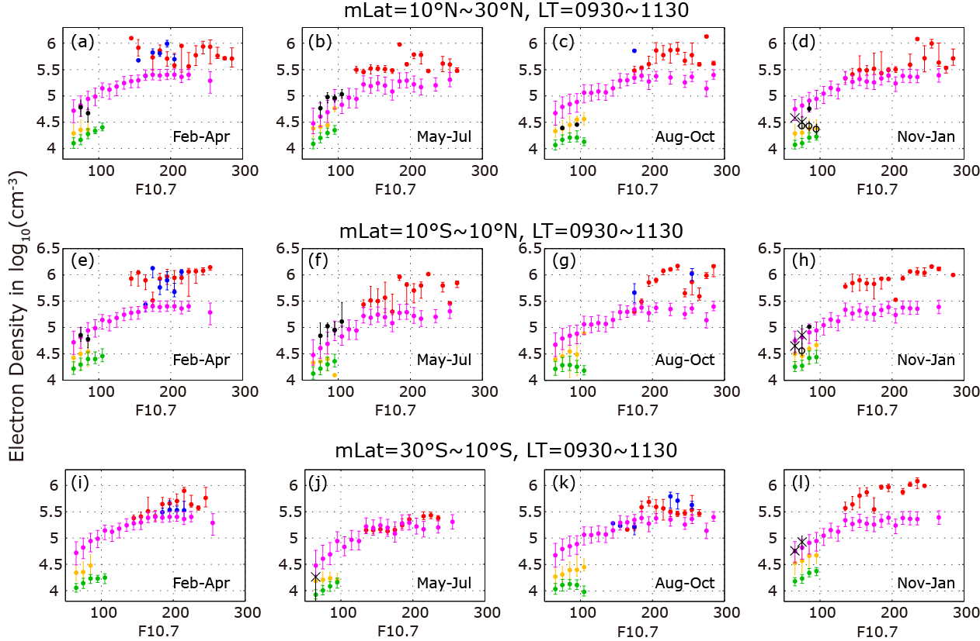
Figure 1. Solar irradiance dependence of Ne for each season during day time (LT=0930~1130) in three magnetic latitude ranges. DEMETER (green), HINOTORI (red), DE2(blue), F3C (yellow), AE-C (black dot), AE-D (black circle), AE-E (black cross), and IRI (magenta) are shown.

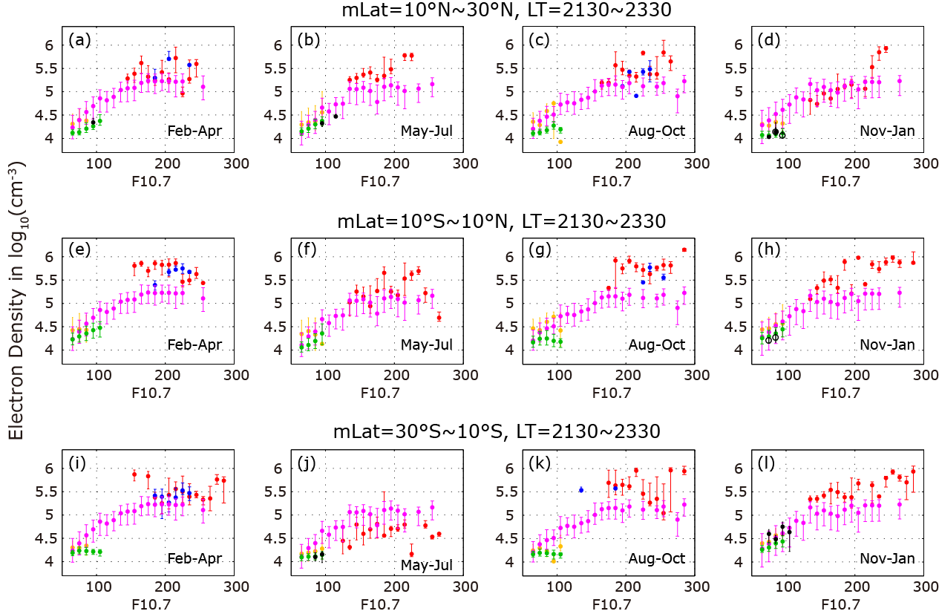
Figure 2. The same as Figure 1 but for night time (LT=2130~2330).

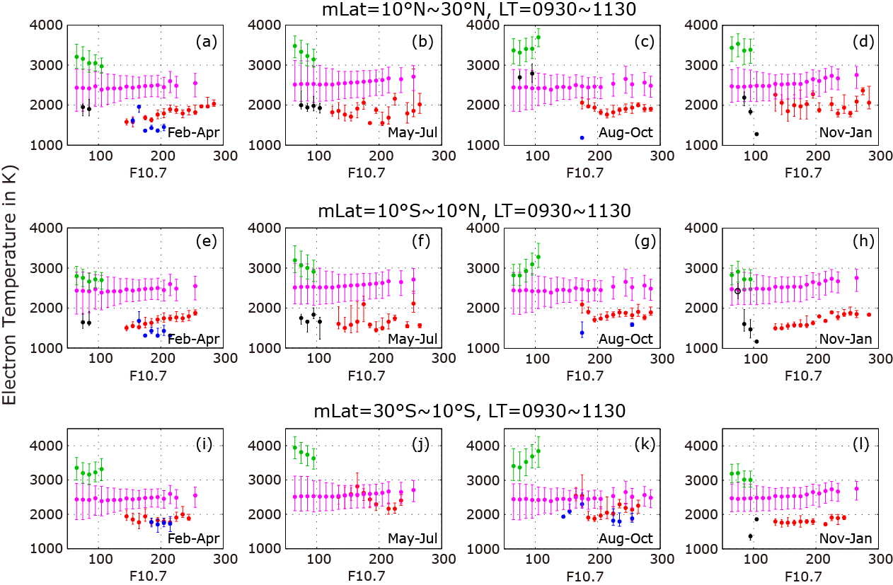

Figure 3. The same as Figure 1 but for Te.

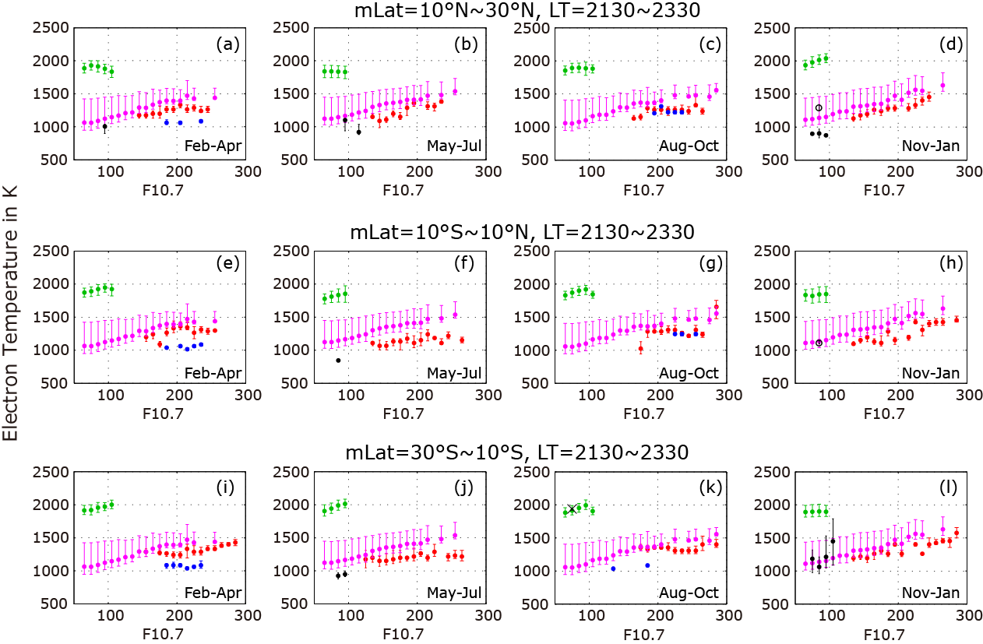
Figure 4. The same as Figure 3 but for night time (LT=2130~2330).

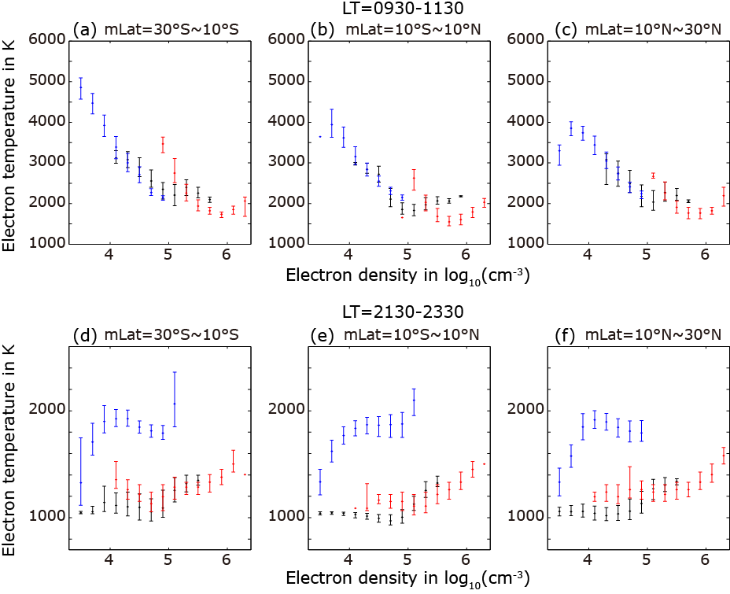

Figure 5. Correlation between Ne and Te for DEMETER (blue), HINOTORI (red) and IRI2012 (black) in three magnetic latitude ranges for day time (a-c) and nighttime (d-f).

