Selfing in a malacostracan crustacean: why a tanaidacean but not decapods
Naturwissenschaften
Keiichi Kakui^{1,}*, Chizue Hiruta²

¹Department of Natural History Sciences, Faculty of Science, Hokkaido University, Sapporo 060-0810, Japan. ²Okazaki Institute for Integrative Bioscience, National Institutes of Natural Sciences, Okazaki 444-8787, Japan
*k_kakui@mail.goo.ne.jp

Electronic Supplementary Material 1

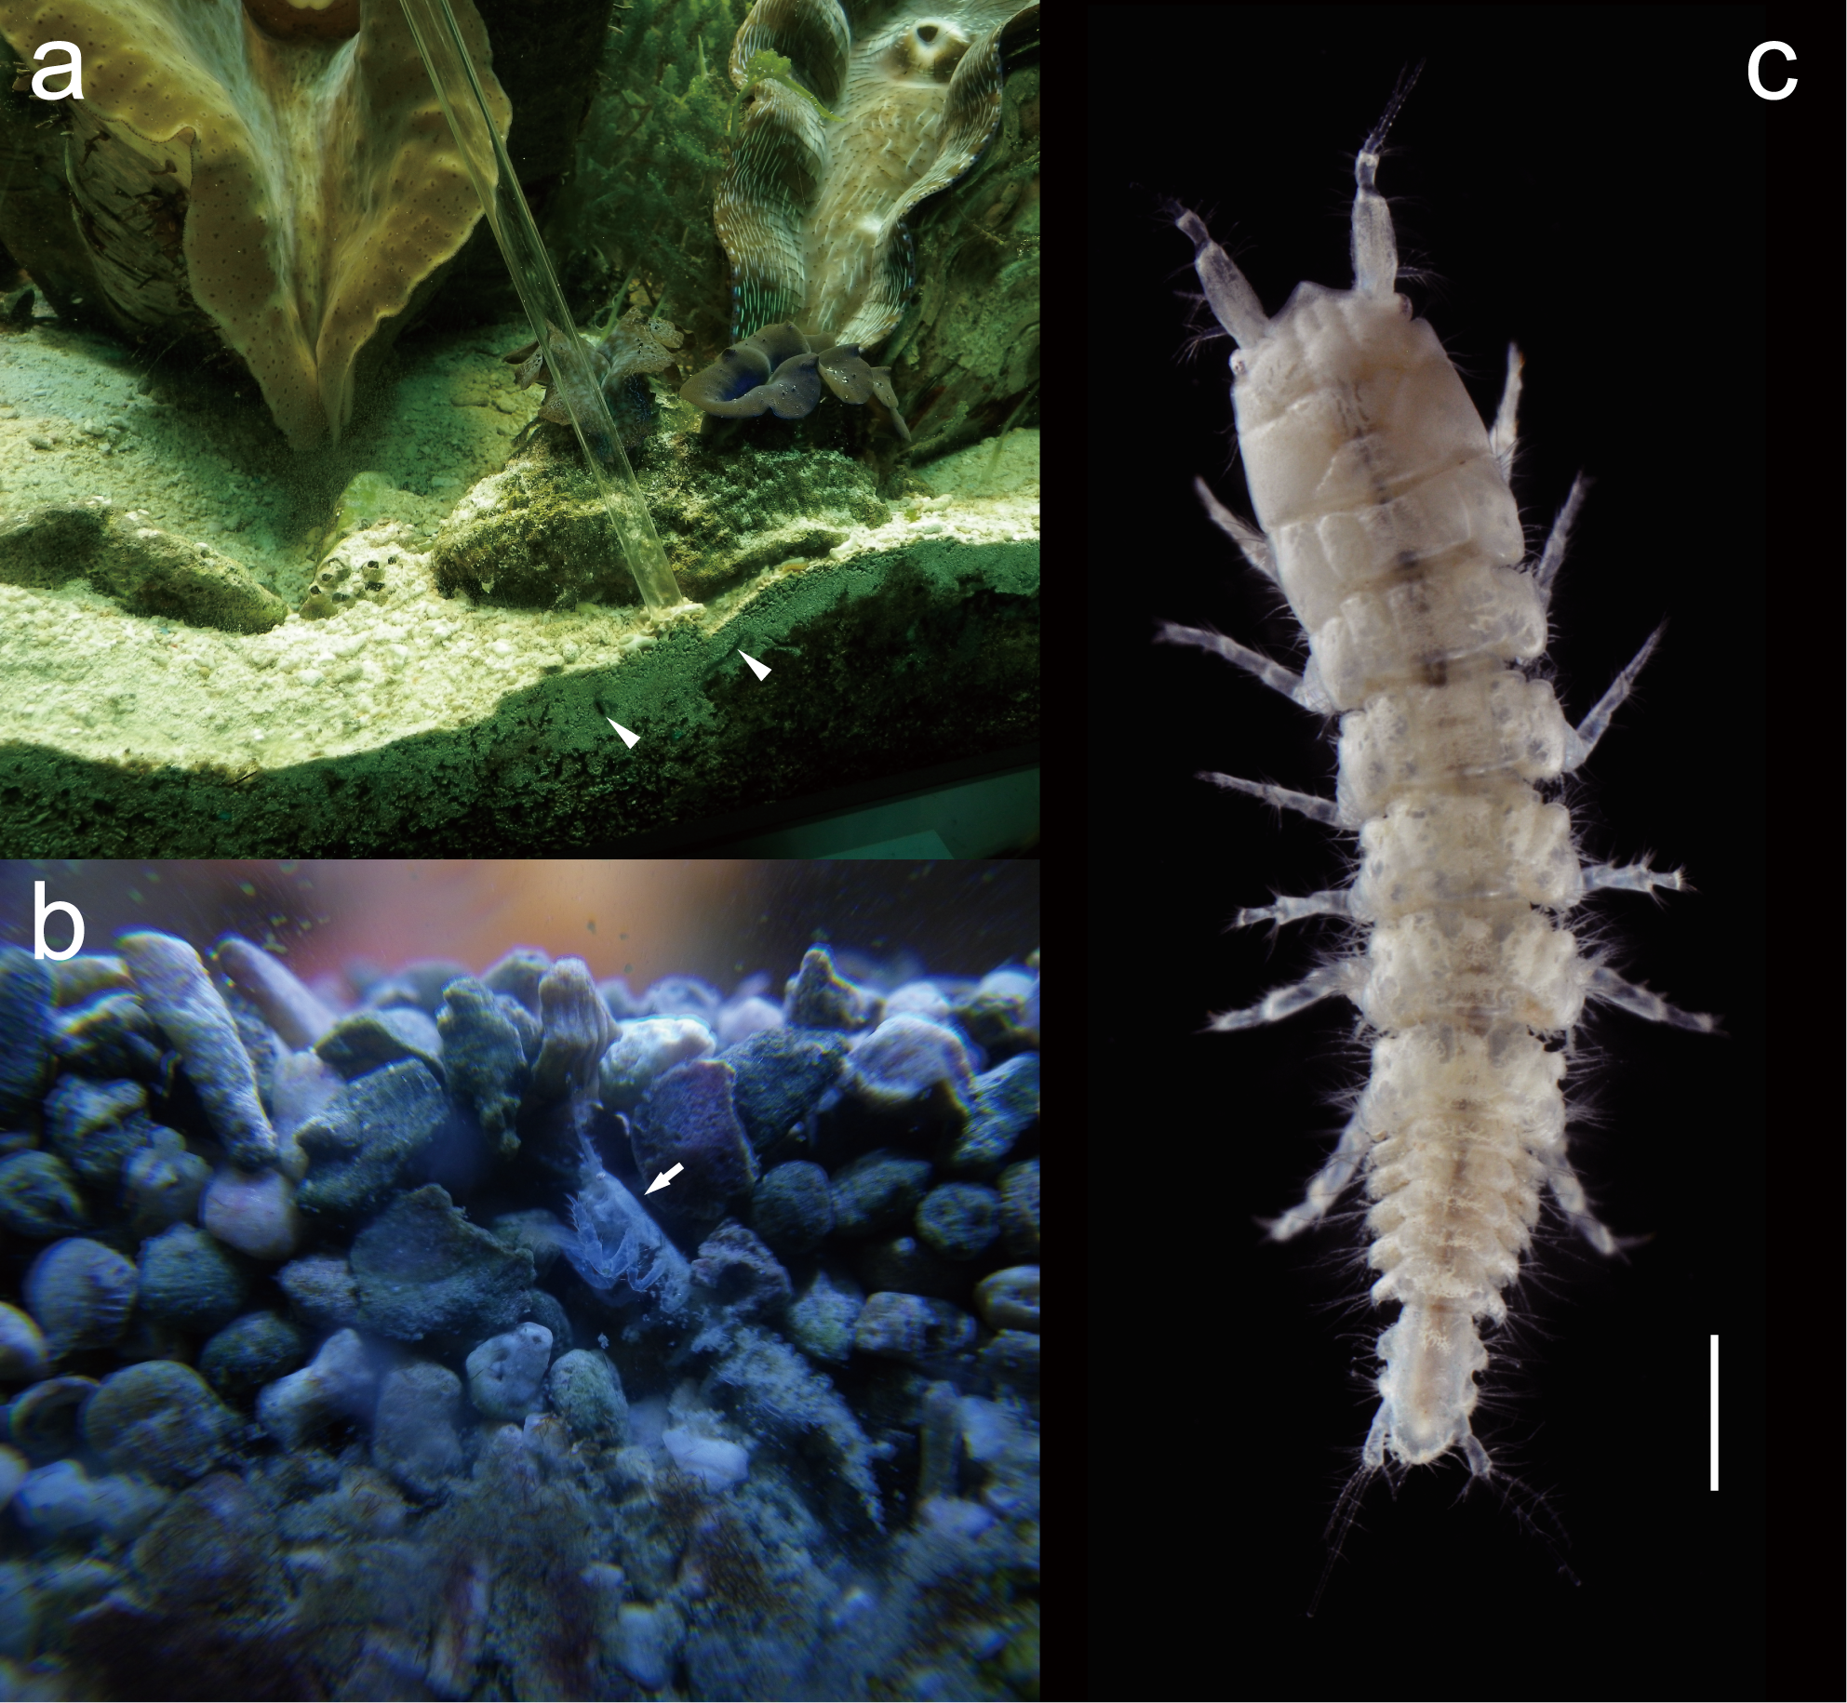
Fig. S1 Habitat and habitus of Apseudes sp.
a Habitat in the Port of Nagoya Public Aquarium. Arrowheads indicate tunnels of Apseudes sp. in the sand bottom. The glass tube between the arrowheads was used to collect specimens. b Apseudes sp. (arrow) in its tunnel. c Living adult, dorsal view. Scale bar: 1 mm
Electronic Supplementary Material 2

Different numbers of DAPI (4′,6-diamidino-2-phenylindole)-staining spots in eggs are expected through time among sexual pathway and three parthenogenetic pathways.
When simultaneously hermaphroditic individuals propagate independently, they produce offspring by either self-fertilization or parthenogenesis. Figure S2 shows the numbers of DAPI-staining spots (DAPI binds to DNA and fluoresces strongly when bound) expected through time for the sexual and three parthenogenetic pathways. In sexual reproduction, a sperm fertilizes the egg during meiotic arrest at metaphase I. Parthenogenesis encompasses three types of division (Suomalainen et al. 1987; Stenberg and Saura 2009). In apomixis, division occurs only once before the first cleavage, because the oocyte is produced by mitosis. In automixis, meiosis is maintained and the diploid stage is restored by the fusion of meiotic products or by duplication before the first cleavage. In premeiotic doubling, the divisions appear similar to those in normal meiosis, although the genome is doubled before meiosis and fertilization does not occur.

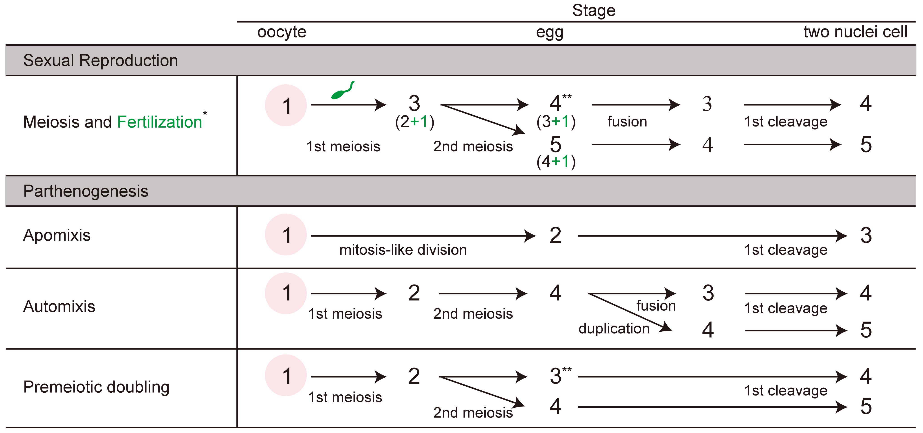
Fig. S2 Expected numbers of DAPI-staining spots during oogenesis and subsequent early development in four reproductive modes
*, In common with many other arthropods, the stage of meiotic arrest in oocytes at which sperm penetration occurs is expected to be first meiotic metaphase. **, It is not clear whether the first polar body divides; values in the upper row indicate no division of the first polar body, and those in the lower row indicate division

References

Suomalainen E, Saura A, Lokki J (1987) Cytology and evolution in parthenogenesis. CRC Press, Boca Raton
Stenberg P, Saura A (2009) Cytology of asexual animals. In: Schön I, Martens K, Dijk PV (eds) Lost sex: the evolutionary biology of parthenogenesis. Springer, New York, pp 63–74

