Supporting Information
Molecular Structure and Properties of Click Hydrogels with Controlled Dangling End Defect
Ao-kai Zhang^{1,2}, Jun Ling³, Kewen Li¹, Guo-Dong Fu*^{,1}, Tasuku Nakajima⁴, Takayuki Nonoyama⁴, Takayuki Kurokawa⁴, Jian Ping Gong*^{,4}

Calculation of overlap concentration
Relative viscosities of PEG2k-N₃/DMF solution were measured with an Ubbelohde viscometer at 25 °C. The viscosities (η) at several polymer concentrations were measured.
The specific viscosity (η_{sp}) was calculated as
$η_{sp}=\frac{η-η_{0}}{η_{0}}$ (S1)
where η₀ is the viscosity of the solvent. Fig. S1 shows the reduced viscosity η_{red}=η_{sp}/c as a function of c.
The intrinsic viscosity ([η]) was obtained from the intercept.
$\lim_{c→0}{\frac{η_{sp}}{c}}=\lim_{c→0}{η_{red}=[η]}$ (S2)
From Flory-Fox equation, the gyration radius (R_{g}) is obtained as¹
$\left[η\right]=Φ\frac{{(6R_{g}^{2})}^{3/2}}{M_{n}}$ (S3)
where Ф is the constant (2.7 × 10²³ mol⁻¹). The overlap concentration c* is calculated from the molar mass and the radius of the polymer coil:
$c_{R_{G}}^{*}=\frac{M_{w}}{\frac{4}{3}π{〈R_{g}^{2}〉}^{3/2}N_{A}}$ (S4)

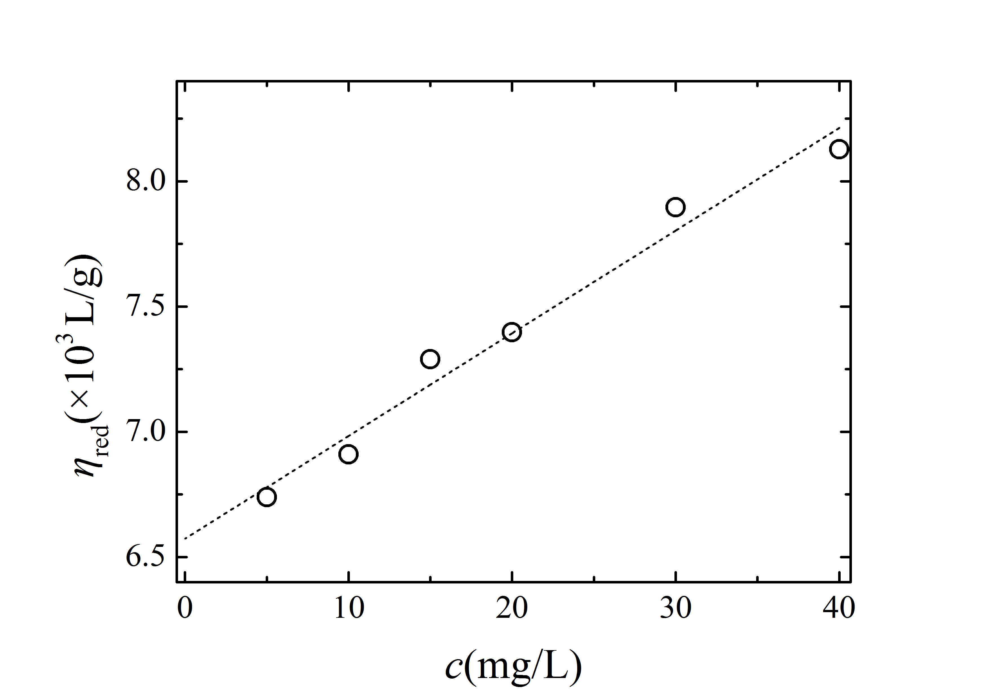
Figure S1. Reduced viscosity of PEG2k/DMF at different concentration.

Figure S2. FT-IR spectra of PEG2k-(azide)₂ (A) and G4-20 gel (B).

Brief description of simulation method
The algorithm to build a 3-D Monte Carlo network structure that reflects the molecular geometry of swollen hydrogels is based on our previous study. The overall method is illustrated in the flowchart in Fig. S3(a) and is briefly described here:
(I) Initially, N nodes are scattered randomly in a cubic box.
(II) A diffusion step expands the cross-linkers from a high-density random chain status. A Lennard-Jones potential energy is applied to evaluate the interactions between nodes:
$U_{diffusion}(r)=\left\{\begin{aligned}4ε\left[{\left(\frac{σ_{0}}{r}\right)}^{12}-{\left(\frac{σ_{0}}{r}\right)}^{6}\right], r<r_{cut_off} \\ 0, r≥r_{cut_off}\end{aligned}\right.$ (S5)
where σ₀ (the finite distance at which the inter-particle potential is zero), ε (the depth of the potential well), and r_{cut_off} (the cut-off distance) are arbitrarily defined as 5, 1, and 2σ₀.
(III) To introduce random dangling ends, certain percent of cross-link points are randomly chosen to be mono-functional, resembling the synthesis. The defect percentage in the simulation X_{sim} is calculated from: X_{sim} (%) = N_{mono}/N_{t}, where N_{mono} and N_{t} are the number of mono-functional nodes and total nodes, respectively.
(IV) A static cross-linking step is performed by simultaneously connecting the nodes under a “node with low functionality connecting first” rule (illustrated in Fig. S3(b)). The simultaneous cross-linking is not only consistent with the formation mechanism of CuAAC, but also reduces CPU time substantially.
(V) A relaxation step is performed to reach the energy minimum of the network. The relaxation step is carried out based on Hooke’s law:
$U_{relaxation}=\sum_{m=1}^{N_{spring}}{\frac{k_{spring}}{2}{(l_{m,spring}-l_{0})}^{2}}$ (S6)
where, N is the total number of springs in the network, and l₀, set as 2 (see below), is the unperturbed equilibrium spring length. k_{spring} is the Hookean constant which is arbitrarily defined as 100.
(VI). The density of bonds in the model is parameterized to that of PEG chain in swollen click gels to obtain the scale S (nm) that reflects the length in real gel that one unit in the model stands for.

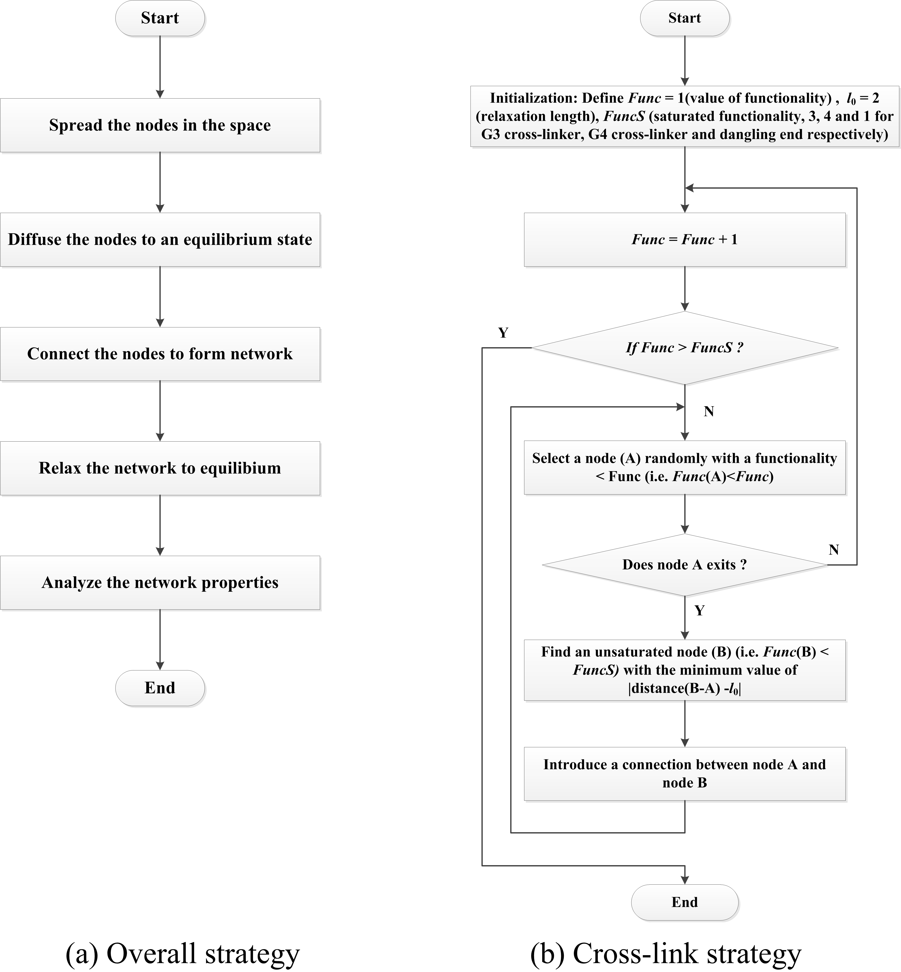
Figure S3. Flowchart of (a) overall strategy and (b) cross-link algorithm.

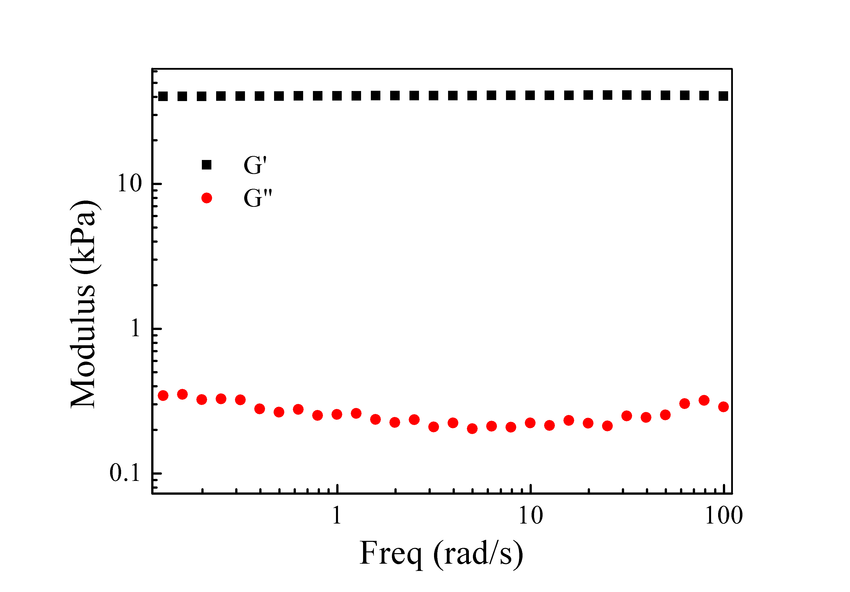
Figure S4. Plot of G’, G’’ with frequency for G4-20.

- M. Rubinstein and R. Colby, Polymers Physics, Oxford University: Oxford, U.K., 2003.

