**Supplemental Figure S1**



Pharmacological validity of the current mice RIT.

We confirmed the pharmacological validity of the mouse RIT, since this is the first time conducting the behavioral test in our laboratory. (**A**-**C**) Buspirone which is known to reduce agonistic behaviors (de Boer1 et al., 1990; Haller et al., 2007) were dissolved in physiological saline and administered intraperitoneally (10 ml/kg) 60 min prior to the RIT (n=6). Consistent with previous studies, 5 mg/kg of buspirone reduced (**A**) agonistic behaviors (*t*1, 5=4.56, *P*<0.05) and (**B**) prolonged agonistic latency (*t*1, 5=-2.61, *P*<0.05) without affecting (**C**) walking duration (*t*1, 5=0.90, *NS*). (**D-F**) Clonidine which is known to stimulate agonistic behaviors in rodents (David et al., 2003; Yamada et al., 2004) were dissolved in physiological saline and administered intraperitoneally (10 ml/kg) 60 min prior to the RIT (n=6). Consistent with previous studies, 20 g/kg of buspirone increased (**D**) agonistic behaviors (*t*1, 5=-2.55, *P*<0.05) without affecting (**E**) agonistic latency (*t*1, 5=0.89, *NS*) and (**F**) walking duration (*t*1, 5=0.43, *NS*).

The bars represent the mean, and the lines represent the SEM. \**P*<0.05 with paired *t*-test.

**Supplemental Figure S2**



Pharmacological validity of the current mice FST.

We confirmed the pharmacological validity of the mouse FST, since this is the first time conducting the behavioral test in mice in our laboratory. Bupropion which is known to reduce despair-like immobile behavior in the FST (de Boer1 et al., 1999; Haller et al., 2007) were dissolved in physiological saline and administered intraperitoneally (4 ml/kg) 30 min prior to the FST (n=8 per each group). Consistent with previous studies, 4 mg/kg of bupropion reduced (**A**, *left*) floating duration (*t*1, 5=3.21, *P*<0.05) but unchanged other parameters including (**A**, *middle*) kicking (*t*1, 5=-1.01, *NS*), (A, *right*) immobility duration (*t*1, 5=1.57, *NS*), (**B**) immobility latency (*t*1, 5=-0.83, *NS*), (**C**) swimming duration (*t*1, 5=-0.91, *NS*), and climbing duration (*t*1, 5=1.07, *NS*). The bars represent the mean, and the lines represent the SEM. \**P*<0.05 with paired *t*-test.

**Supplemental Figure S3**

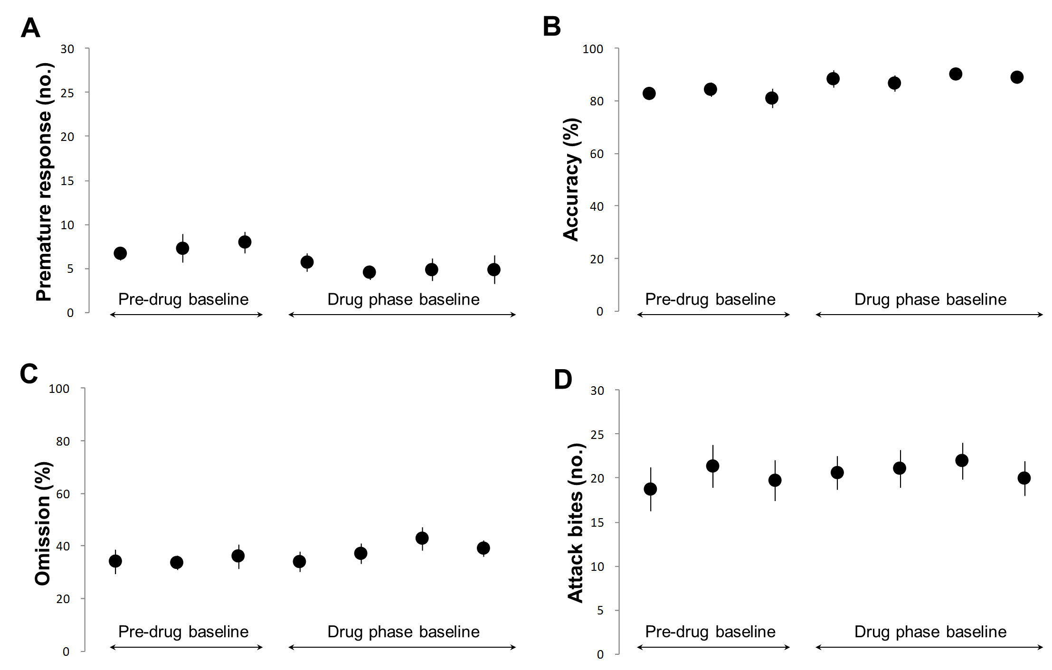

The basal performance in the 3-CSRTT and the RIT

Figure S3 show the pre-drug administration and drug administration basal performance levels for (**A**) premature responses, (**B**) %accuracy, (**C**) %omission, and (**D**) attack bites, which were assessed over seven sessions. Repeated measures ANOVA revealed no significant effects of days on premature responses (*F*6, 42 = 1.86, *NS*, Figure S3A), accuracy (*F*6, 42 = 2.00, *NS*, Figure S3B), omissions (*F*6, 42 = 0.82, *NS*, Figure S3C), or attack bites (*F*6, 42 = 1.69, *NS*, Figure S3D). This result indicated that basal performance remained stable throughout the experiments.

**Supplemental Figure S4**

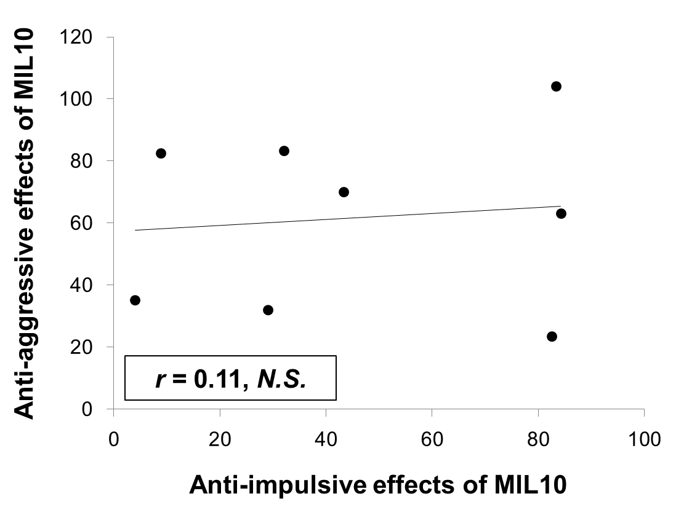

Scatterplot of anti-aggressive and anti-impulsive effects of milnacipran.

Pearson’s product-moment correlation coefficients between anti-aggressive and anti-impulsive effects of milnacipran (10 mg/kg) obtained by the same animal were calculated (n = 8).

Anti-aggressive effects of MIL10 = [the number of attack bites in milnacipran (10 mg/kg)/ the number of attack bites in saline]*100 . Anti-impulsive effects of MIL10 = [the number of premature responses in milnacipran (10 mg/kg)/ the number of premature responses in saline]*100.

There was no significant correlation between anti-aggressive and anti-impulsive effects of milnacipran (*r* = 0.11, *N.S.*).

**Supplemental references**

David DJ, Renard CE, Jolliet P, Hascoët M, Bourin M (2003) Antidepressant-like effects in various mice strains in the forced swimming test. Psychopharmacology (Berl). 166(4):373-82.

de Boer SF, Lesourd M, Mocaer E, Koolhaas JM (1999) Selective antiaggressive effects of alnespirone in resident-intruder test are mediated via 5-hydroxytryptamine1A receptors: A comparative pharmacological study with 8-hydroxy-2-dipropylaminotetralin, ipsapirone, buspirone, eltoprazine, and WAY-100635. J Pharmacol Exp Ther 288(3):1125-33.

Haller J, Horváth Z, Bakos N (2007) The effect of buspirone on normal and hypoarousal-driven abnormal aggression in rats. Prog Neuropsychopharmacol Biol Psychiatry 31(1):27-31.

Maj J, Rogóz Z, Dlaboga D, Dziedzicka-Wasylewska M (2000) Pharmacological effects of milnacipran, a new antidepressant, given repeatedly on the alpha1-adrenergic and serotonergic 5-HT2A systems. J Neural Transm 107(11):1345-59.

Scholtens J, Roozen M, Mirmiran M, van de Poll NE (1990) Role of noradrenaline in behavioral changes after defeat in male and female rats. Behavwural Bram Research 36: 199-202.

Yamada J, Sugimoto Y, Yamada S (2004) Involvement of dopamine receptors in the anti-immobility effects of dopamine re-uptake inhibitors in the forced swimming test.

Eur J Pharmacol 504(3):207-11.