Electronic supplementary material
Author: Akira Terui, Keita Ooue, Hirokazu Urabe, Futoshi Nakamura
Title: Parasite infection induces size-dependent host dispersal: consequences for parasite persistence
Journal: Proceedings of the Royal Society B: Biological Sciences
Article DOI: 10.1098/rspb.2017.1491

Derivation of Bernoulli observation process The Bernoulli distribution yields a “success” (recapture) with probability p and a “failure” (unrecapture) with probability 1 – p. In our sampling design, fish may be recaptured with probability φsD. However, fish may not be recaptured for several reasons, which include the following states:
1. Alive and stayed at the 1200-m study section, but not detected [(1−φ)sD]
2. Alive but left behind the 1200-m study section [s(1−D)]
3. Dead (1−s)
Since these states are mutually exclusive, the probability of “unrecapture” is the sum of the three probabilities, which can be reduced to 1−φsD. Therefore, the observation process can be described as the Bernoulli probability function g: g(k; φ, s, D) = (φsD)^{k}(1−φsD) ^{1−k} for k ϵ {0, 1}.

Estimation of capture probability Let n_{jk} denote the number of fish captured in the kth removal taken from the jth subsection. We modeled the matrix of observed fish numbers n_{jk} as a multinomial distribution, n_{jk}|N_{j}, π ~ Multinomial(N_{j}, π), conditional on the unknown number of fish N_{j} in the jth subsection and the conditional probabilities of capture π associated with the three-pass removal. We let θ_{j} represent the probability of capture during a single removal from the jth subsection. Then π_{jk} = θ_{j}(1−θ_{j})^{k−1} specifies the probability of capture of fish during the kth removal, given that they have not been captured in earlier removals. The parameter θ_{j} was assumed to vary among subsections as: logit(θ_{j}) = α + ε_{j}. The parameter ε_{j} is the random variation among subsections and was normally distributed as ε_{j} ~ Normal(0, σ_{ε}). The probability of capture with the three-pass removal at subsection j (φ_{j}) was given by φ_{j} = ∑θ_{j}(1−θ_{j})^{k−1} (k = 1–3). We assumed that the unknown number of fish N_{j} follows a Poisson distribution as: N_{j} ~ Poisson(λ).
The model was fitted to the data with JAGS ver. 4.1.0 and the package ‘‘runjags’’ in R 3.3.1. Vague priors were assigned to the parameters: i.e., normal distributions for log(λ) and α (mean = 0, variance = 10⁴) and a truncated normal distribution for σ_{ε} (mean = 0, variance = 10⁴, range = 0–100). Three Markov chain Monte Carlo chains were run jointly with the dispersal model in the main text.

Connection with traditional epidemiological parameters The basic reproductive number R₀ is a key epidemiological parameter that describes the average number of secondary infections caused by a single infected host in a wholly susceptible host group [1]. In our study system, however, it was impossible to define the statistic because of the lack of direct transmission among host individuals.
However, the R* statistic, a group-level equivalent of the basic reproductive number R₀ [2], can be expressed as a function of parameters presented in our simulation model: R* = (sωKC)/E, where ω = 1 − $\int_{μ_{i}-10}^{μ_{i}+10}{f_{L}(x, μ_{i}, exp⁡(-γ))}$dx. The parameter ω is the average emigration rate, and thus, ωK represents the expected number of infected hosts emigrating from a parasite-occupied patch per time step. This measure quantifies the average number of habitat patches (or host groups) “infected” by a single parasite-occupied patch in a wholly susceptible system. Since the parameters s, C, E were fixed in our model, higher values of γ and K correspond to higher values of R* (i.e., increase along the gradient of x-axis in each panel of Fig. 4).

References
1. Poulin R. 2007 Evolutionary ecology of parasites. Oxfordshire, UK, Princeton University Press.
2. Cross P.C., Lloyd-Smith J.O., Johnson P.L.F., Getz W.M. 2005 Duelling timescales of host movement and disease recovery determine invasion of disease in structured populations. Ecology Letters 8, 587-595.

Table S1 Results of the Bayesian model that explains individual-level variation in dispersal kernel (using a data set excluding two “super dispersers” with ≥ 180 m dispersal distance; see Fig. S1 for raw data). Posterior probability represents the proportion of parameter estimates (MCMC samples) assigned to be either negative or positive. Parameters with a posterior probability of > 0.95 are shown in bold. SE: standard error.
Effect | Estimate | SE | Posterior probability
 |  |  | Negative | Positive
Intercept (μ) | 2.402 | 0.095 | - | -
Infection (β₁) | 0.186 | 0.144 | 0.11 | 0.89
Body size (β₂) | 0.143 | 0.096 | 0.07 | 0.93
Infection · Size (β₃) | 0.613 | 0.200 | 0.00 | 1.00

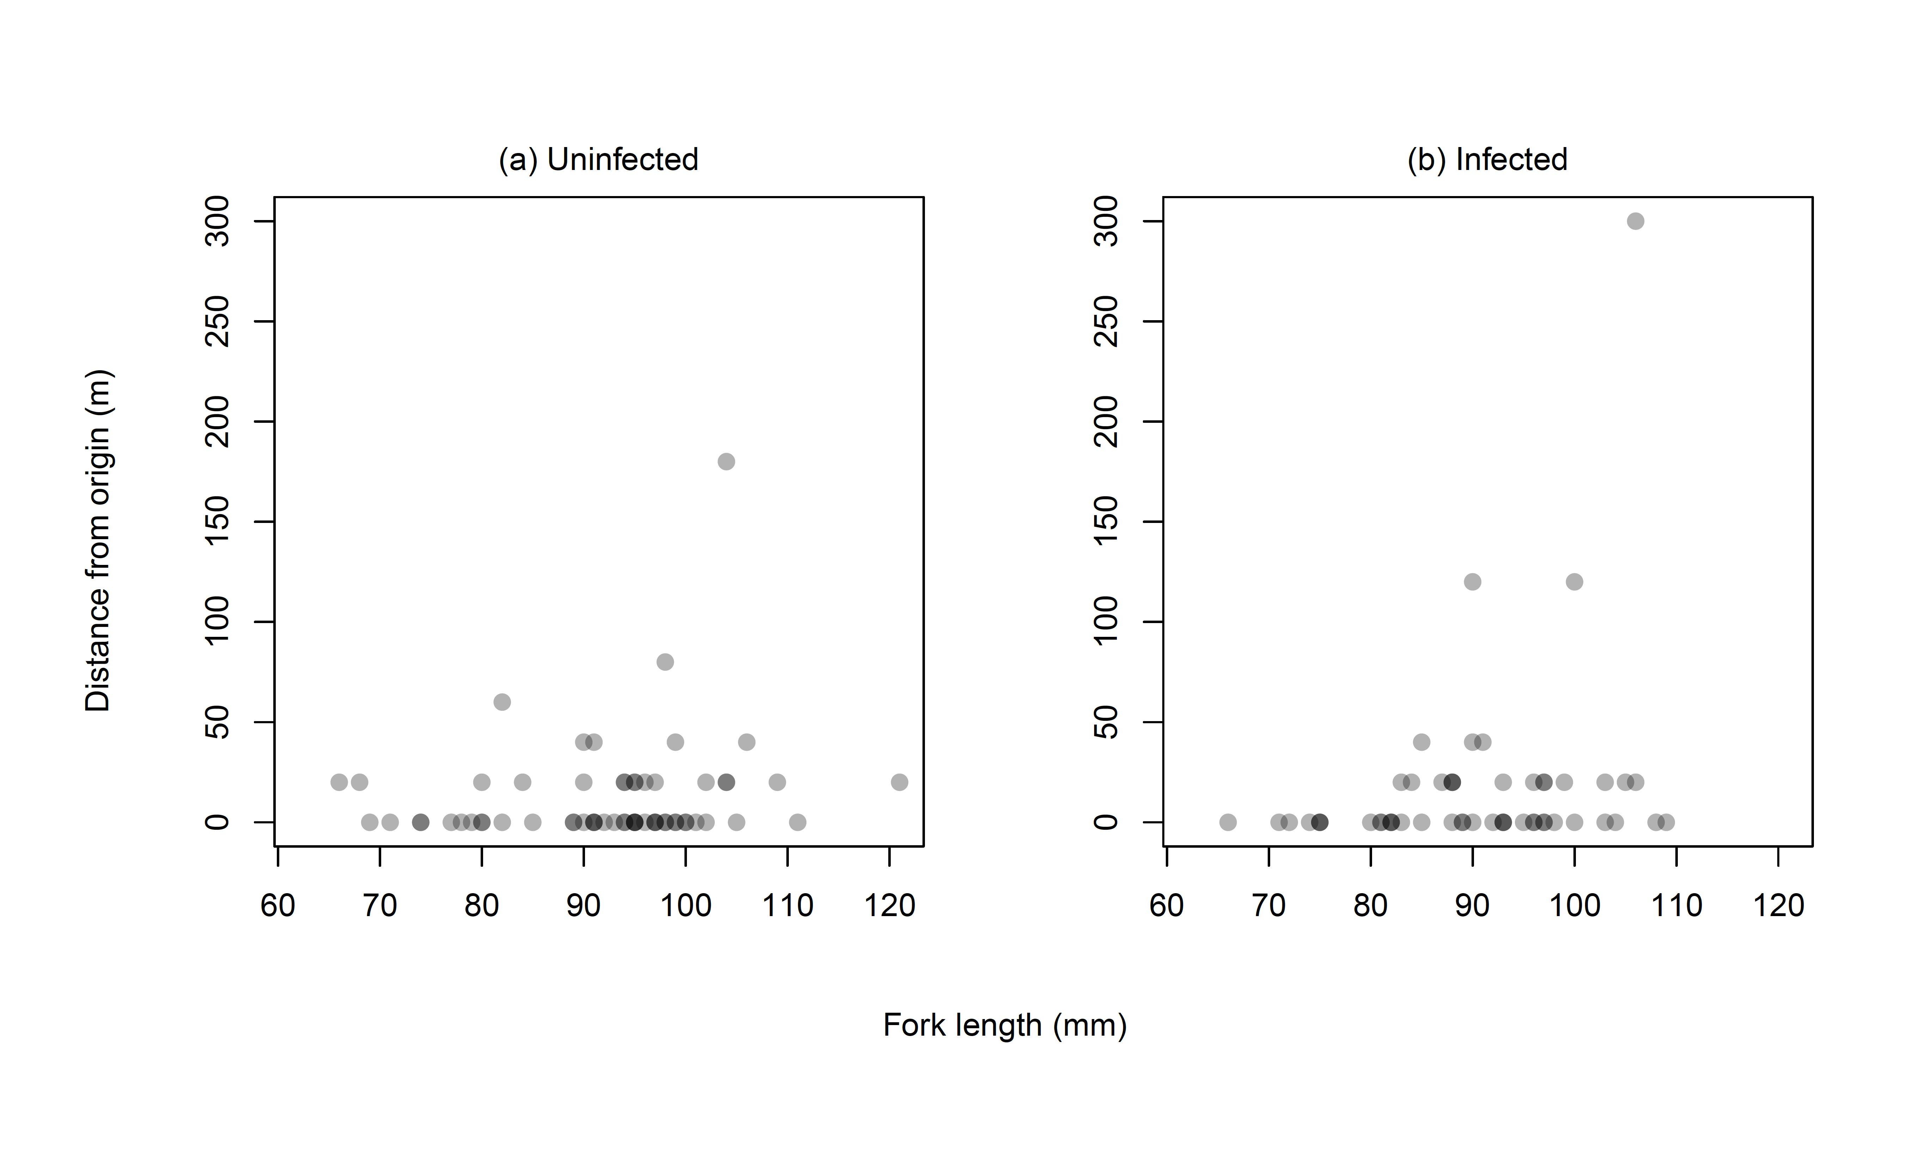
Fig. S1 Relationships between body size (fork length) and distance moved for uninfected (a) and infected fish host (b). Dots represent fish individuals.

