Additional File
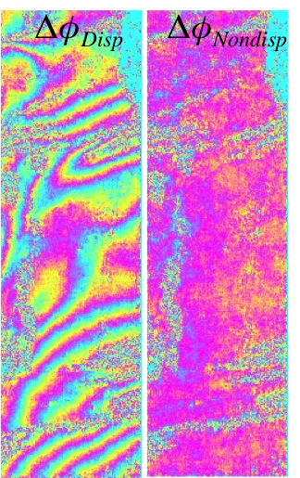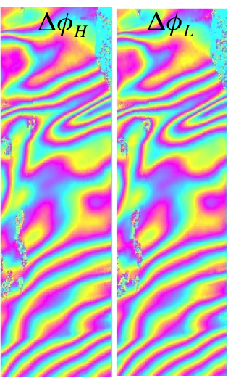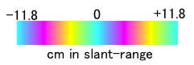Here we show two results that indicate distinct separation of dispersive and non-dispersive phases, based on the conventional two-unknowns scheme. Imaged area is Yamal Peninsula, Northwestern Siberia. Details of the data are shown in Table 1.

Fig S1: High- and Low-frequency unwrapped interferograms and the estimated dispersive and non-dispersive phases. Images are shown in radar coordinates.
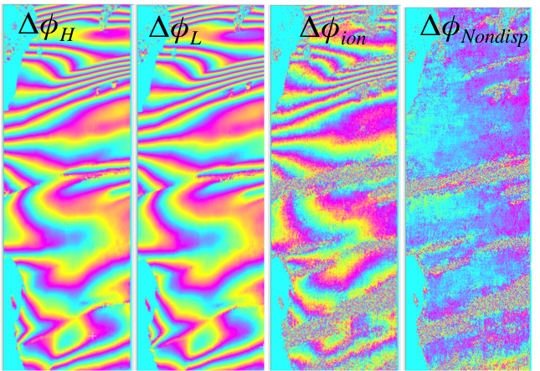
Fig S2: High- and Low-frequency unwrapped interferograms and the estimated dispersive and non-dispersive phases. Images are shown in radar coordinates.

