**Supplementary Material**

Dual Role of the Active-Center Cysteine in Human Peroxiredoxin-1: Peroxidase Activity and Heme Binding

Yuta Watanabe1, Koichiro Ishimori1,2, and Takeshi Uchida1,2

1Graduate School of Chemical Sciences and Engineering, Hokkaido University, Sapporo 060-0810, Japan

2Department of Chemistry, Faculty of Science, Hokkaido University, Sapporo 060-0810, Japan

C:\Users\Yuta Watanabe\Dropbox\202-Paper\4-Peroxiredoxin-1\Fig\161118-Revise\Fig.S1-Alignment.emf

**Figure S1: Amino acid sequence alignment of human PRX1 with rat HBP23.**

The alignment was performed using ClustalX (Version 2.1) (1). The CP motifs and other cysteine residues are shown in a black background and in red, respectively.

(1) M. A. Larkin, G. Blackshields, N. P. Brown, R. Chenna, P. A. McGettigan, H. McWilliam, F. Valentin, I. M. Wallace, A. Wilm, R. Lopez, J. D. Thompson, T. J. Gibson, D. G. Higgins, Clustal W and Clustal X version 2.0. *Bioinformatics*. **23**, 2947–2948 (2007).

**A**

**B**

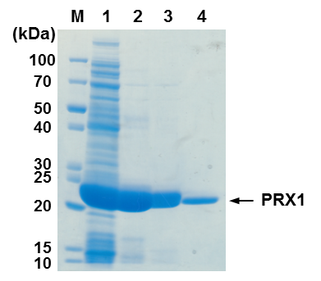

**Figure S2: Purification and size-exclusion chromatography**

(A) SDS-PAGE gel of PRX1 stained with CBB Stain One, including molecular mass marker (Lane M), whole-cell protein extracts (Lane 1), purified His-tagged PRX1 (Lane 2), purified His-tagged cleaved PRX1 (Lane 3), and purified PRX1 after gel-filtration chromatography (Lane 4). (B) Profile of PRX1 on a gel-filtration column (HiLoad 10/600 Superdex 200 pg) pre-equilibrated with 50 mM HEPES-NaOH/100 mM NaCl (pH 7.4). The retention times of standard proteins were as follows: thyroglobulin, 50.0 min; ferritin, 56.4 min; catalase, 66.7 min; aldose, 67.5 min; albumin, 76.3 min; ovalbumin, 81.8 min; chymotrypsinogen A, 92.5 min; and RNase A, 97.6 min.

**C:\Users\Yuta Watanabe\Dropbox\202-Paper\4-Peroxiredoxin-1\Fig\161118-Revise\Figure S2.emf**

**Figure S3: Dimerization assay and absorption spectra of purified PRX1.**

(A) Apo- or holo-dimeric or decameric PRX1 (10 μM) was treated with 30 μM H2O2 for 5 minutes at 25 °C in 50 mM HEPES-NaOH/100 mM NaCl (pH 7.4). The reaction was stopped by adding 1 μM catalase to quench excess H2O2, after which PRX1 was resolved by non-reducing SDS-PAGE and stained with Coomassie Brilliant Blue. The bands at ~60 kDa correspond to catalase. (B) UV-vis absorption spectra of PRX1 as purified in 50 mM HEPES-NaOH and 100 mM NaCl (pH 7.4).

C:\Users\Yuta Watanabe\Dropbox\202-Paper\3-Peroxiredoxin-1\Fig\160901\Fig.S3-Pyridine-hemochrome.eps

**Figure S4: Pyridine hemochrome assay of PRX1.**

PRX1 was mixed with 1.2-fold heme and applied the gel filtration column to remove the excess heme. The pyridine hemochrome assay was performed on the heme-PRX1 complex (solid line), Fe3+-hemochrome (dotted line) and Fe2+-hemochrome (dashed-dotted line). The amount of heme that is bound to PRX1 was calculated by following the absorbance change at 557 nm between oxidized and reduced hemochrome using an extinction coefficient of 28.15 mM-1 cm-1 (2). The assay was repeated for three times, and the average amount of heme was calculated to be 36.7 μM. Protein concentration was determined to be 30.7 μM by the Pierce 660 nm protein assay reagent (Thermo Scientific, Waltham, MA, USA) using BSA as a standard.

(2) E. A. Berry, B. L. Trumpower, Simultaneous determination of hemes *a*, *b*, and *c* from pyridine hemochrome spectra. *Anal. Biochem.* **161**, 1–15 (1987).



**Figure S5: Heme titration of the mutant PRX1.**

Absorption difference spectra following incremental addition of heme (2 – 30 μM) to C52S (A), C71A (B), C83A (C) and C173A (D) mutants (10 μM) in 50 mM HEPES-NaOH/100 mM NaCl (pH 7.4) against a blank containing buffer alone.

C:\Users\Yuta Watanabe\Dropbox\202-Paper\4-Peroxiredoxin-1\Fig\161118-Revise\Fig.S5-Oligomeric-Prx1.eps

**Figure S6: Oligomerization effect on the heme binding property.**

UV-vis absorption spectra of the heme-monomeric (black) and -decameric (red) PRX1 in 50 mM HEPES-NaOH/100 mM NaCl (pH 7.4).

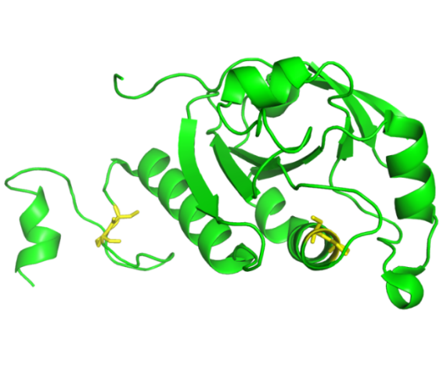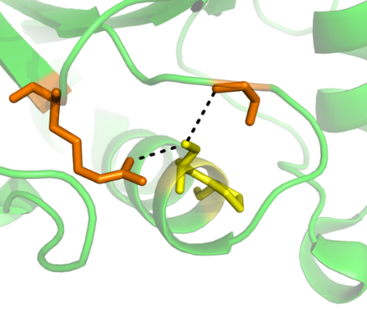

**Arg128**

**Pro45-CONH**

**Cys52-Pro53**

**Cys173-Pro174**

**Figure S7: Structure of human PRX4 (PDB ID: 2PN8)**

CP motifs and hydrogen-bond partners are highlighted in yellow and orange, respectively. Hydrogen bonds are depicted as dotted lines.

Table. S1: Oligonucleotide used for construction of expression vectors. The underlined bases signify the Gibson Assembly signal sequence (for cloning) and introduced mutations (for mutation). S : sense-strand, AS: anti-sense-strand

|  |  |  |  |
| --- | --- | --- | --- |
| Constructs | Strand | Primers(5’→ 3’) | Application |
| pET28b-PRX1 | S | CCAGGGGCCCCATATGTCGAGTGGCAACGCGAAAA | Cloning |
| AS | GGAGCTCGAATTCTCATTTCTGTTTGGAAAAGTAC |
| C52S | S | TTTGTGAGTCCGACGGAAATCATTGCC | Mutation |
| AS | CGTCGGACTCACAAAGGTAAAATCGAG |
| C71A | S | CTGAATGCCCAAGTGATTGGCGCAAGC | Mutation |
| AS | CACTTGGGCATTCAGTTTCTTGAACTC |
| C83A | S | CACTTTGCCCACTTGGCGTGGGTCAATAC | Mutation |
| AS | CAAGTGGGCAAAGTGGGAATCAACGCT |
| C173A | S | GAAGTGGCTCCAGCTGGTTGGAAACCA | Mutation |
| AS | AGCTGGAGCCACTTCGCCATGTTTGTC |