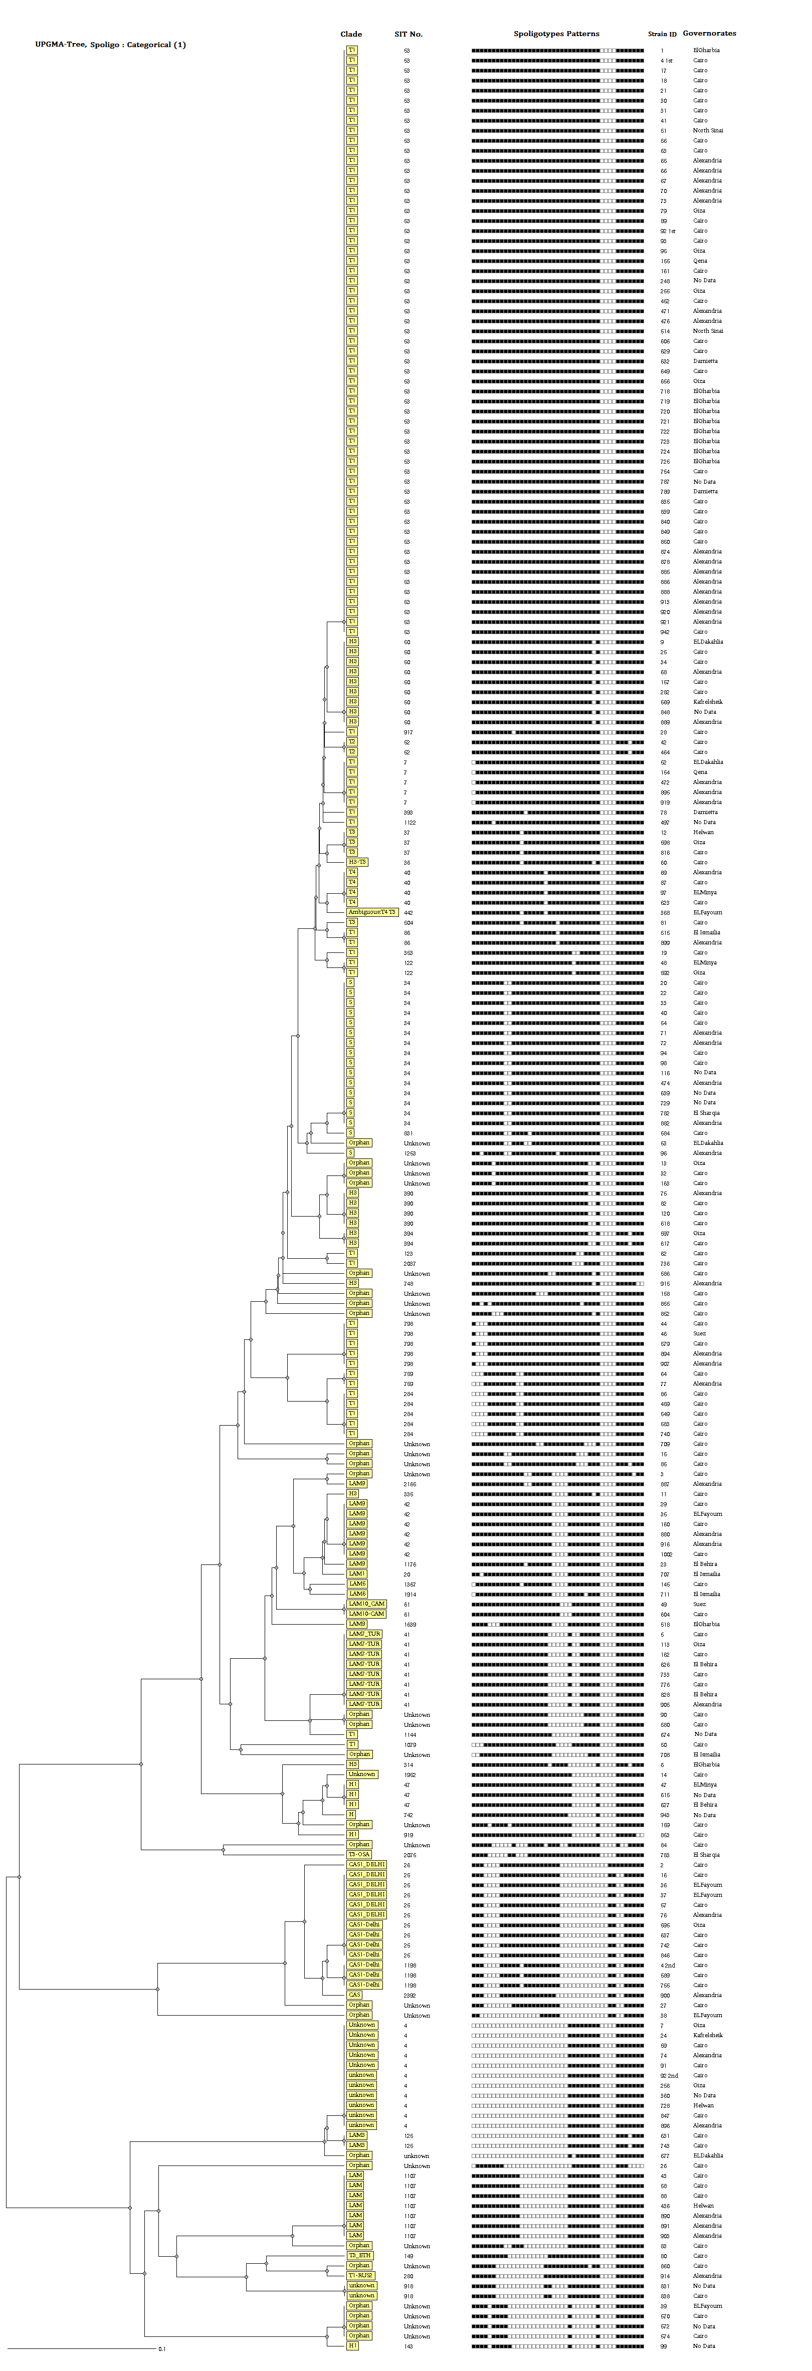
Supplementary Figure 1. UPGMA tree dendrogram showing spoligotyping patterns and clustering analysis of the 230 Mycobacterium tuberculosis isolates from Egypt. The categorical-based UPGMA tree was generated by an MIRU-VNTRplus database application available online at (http://www.miru-vntrplus.org/).

Supplementary Table 1 Frequency distribution of MTB isolates [SIT53T1 + SIT34/S + SIT4/Unknown] versus independent SIT53/T1 in the selected 12 MIRU-VNTR loci.
 |  |  |  | SIT53/T1 + SIT34/S + SIT4/unknown clade *
MIRU -VNTR † |  | No of isolates |  |  |  | Number of repeats
locus | Alias | ( N=77) | 0 | 1 | 2 | 3 | 4 | 5 | 6 | 7 | 8 | 9
960 | MIRU10 | 77 |  |  | 14 | 50 | 11 | 2
1644 | MIRU16 | 77 |  | 46 | 6 | 25
2996 | MIRU26 | 77 |  | 2 |  | 4 | 7 | 64
802 | MIRU40 | 77 |  | 1 | 7 | 7 | 57 | 3 | 1 | 1
424 | Mtub04 | 77 |  | 5 | 53 | 17 | 2
1955 | Mtub21 | 77 |  | 25 | 51 | 1
2401 | Mtub30 | 77 |  |  | 75 |  | 2
3690 | Mtub39 | 77 |  | 6 | 2 | 39 | 21 | 5 | 3 | 1
2165 | ETR-A | 77 |  | 3 | 26 | 24 | 24
2163b | QUB-11b | 77 |  | 1 | 5 | 31 | 38 | 2
4052 | QUB-26 | 77 |  |  | 3 | 9 | 16 | 31 | 3 | 11 | 2 | 2
4156 | QUB-4156 | 77 | 2 | 3 | 70 | 2
 |  |  |  | SIT53/T1
MIRU -VNTR † |  | No of isolates |  |  |  | Number of repeats
locus | Alias | ( N=77) | 0 | 1 | 2 | 3 | 4 | 5 | 6 | 7 | 8 | 9
960 | MIRU10 | 52 |  |  | 6 | 44 |  | 2
1644 | MIRU16 | 52 |  | 46 | 3 | 3
2996 | MIRU26 | 52 |  | 2 |  | 2 | 4 | 44
802 | MIRU40 | 52 |  | 1 | 5 | 1 | 43 | 1 |  | 1
424 | Mtub04 | 52 |  | 3 | 46 | 3
1955 | Mtub21 | 52 |  |  | 51 | 1
2401 | Mtub30 | 52 |  |  | 50 |  | 2
3690 | Mtub39 | 52 |  | 6 | 2 | 23 | 12 | 5 | 3 | 1
2165 | ETR-A | 52 |  | 3 | 26 | 23
2163b | QUB-11b | 52 |  | 1 | 5 | 20 | 26
4052 | QUB-26 | 52 |  |  | 3 | 9 | 10 | 29 |  |  | 1
4156 | QUB-4156 | 52 |  | 2 | 48 | 2

ª SIT: Spoligotyping International Type number.
^{b} : MIRU-VNTR: Mycobacterial Interspersed Repetitive Unit–Variable Number Tandem Repeat.
^{c} : HGDI: Hunter–Gaston Diversity Index.

