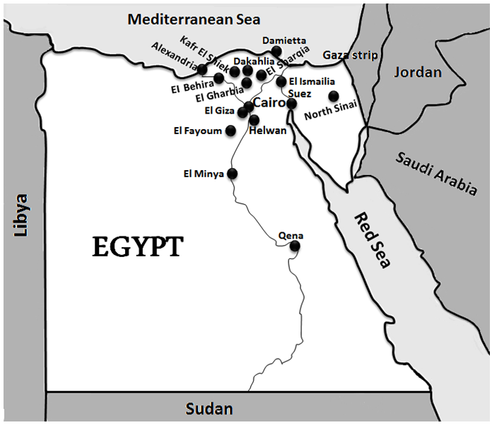

Fig 1. Geographical distribution of M. tuberculosis isolates from the 16 Egyptian governorates used in the present study.

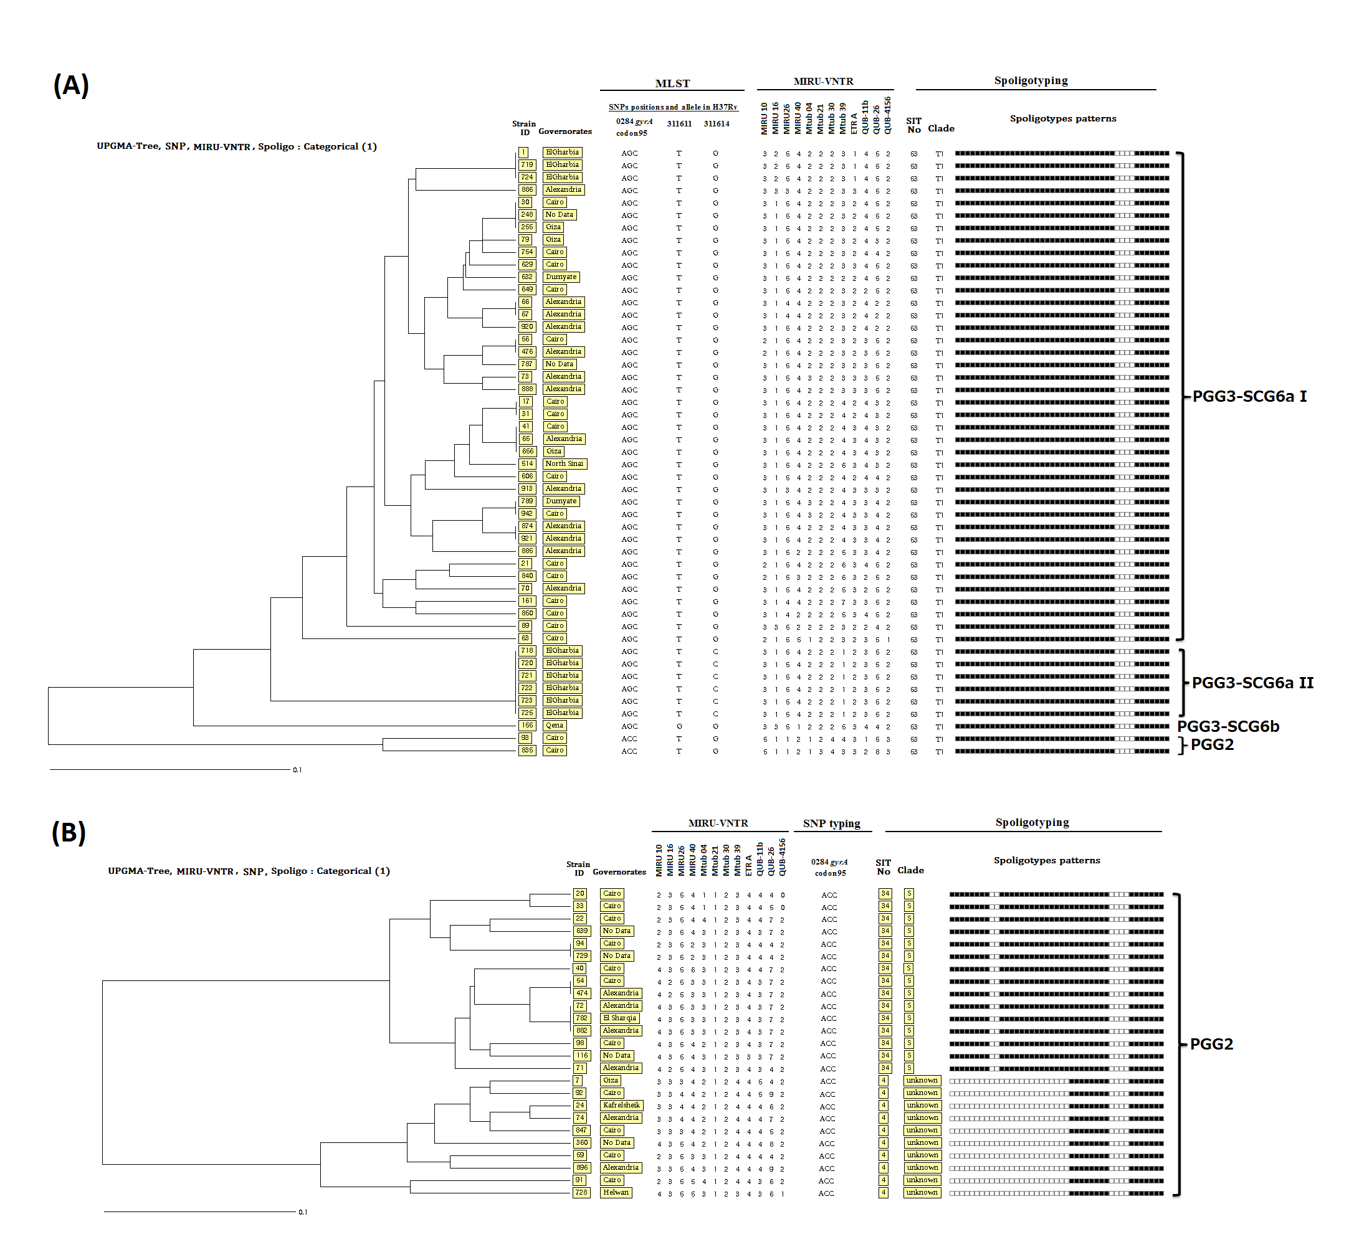

Figure 2. UPGMA-tree dendrograms. (A) Phylogenetic analysis based on Multi-Locus Sequence Typing (MLST), 12 MIRU-VNTR loci and spoligotyping patterns of Mycobacterium tuberculosis isolates representing the largest spoligotype-defined cluster SIT53/T1. (B) Strains diversity based on combined results of 12 MIRU-VNTR loci, SNP typing, and spoligotyping analysis of isolates representing the spoligotype-defined clusters included (SIT34/S and SIT4/unknown clade). The categorical-based UPGMA tree was generated by an MIRU-VNTRplus database application available online (http://www.miru-vntrplus.org/).

