Supplementary Figure 1

a
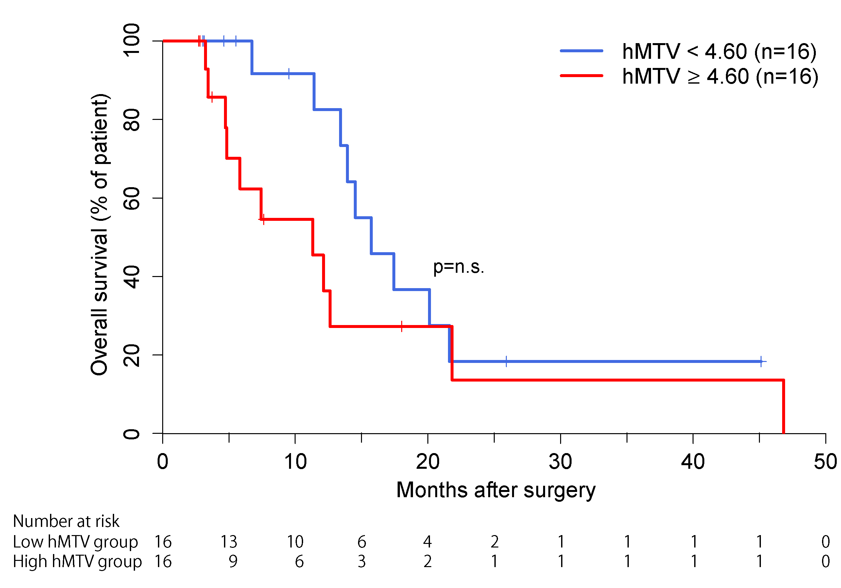
b
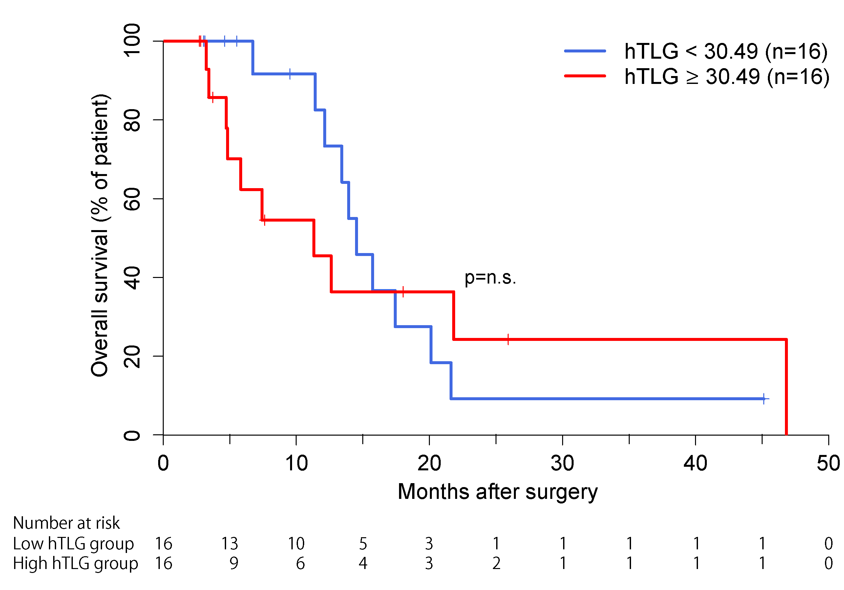
n.s.: not significant

The Kaplan-Meier analysis using medians of hMTV (a) and hTLG (b) as the thresholds did not reach statistical significance.

