[Geophysical Research Letters]
Supporting Information for
Rheological properties of composite smectite–quartz suspensions
Kameda J.¹ and Morisaki, T.¹
¹Earth and Planetary System Science, Graduate School of Science, Hokkaido University,
N10W8, Kita-ku, Sapporo, 060-0810, Japan

Contents of this file

Figure S1, Figure S2, Tables S1

Introduction
Figure S1 provides XRD patterns for specimens of smectite (Kunipia-F) and quartz. Figure S2 shows the comparison between the flow curves obtained using the normal procedure and that with preshearing. Table S1 provides detailed information concerning the tested suspensions and the determined rheological parameters.

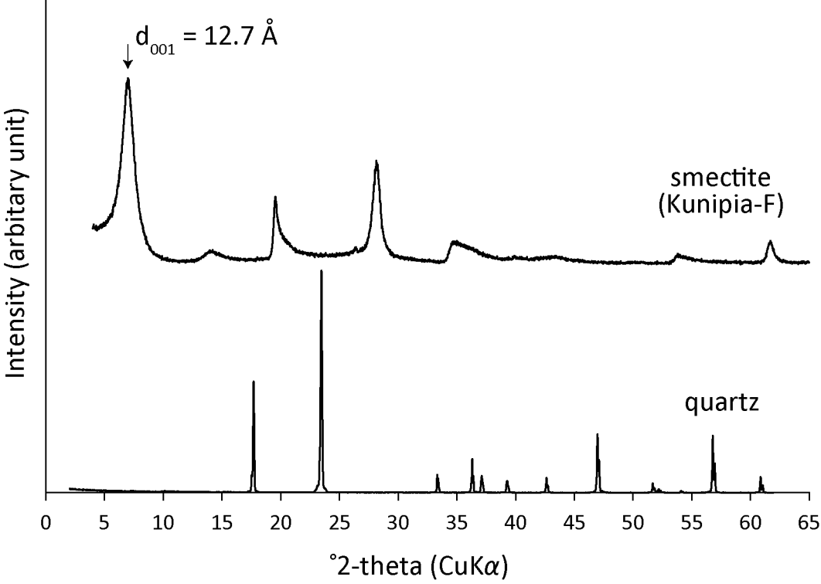
Figure S1. XRD patterns for specimens of smectite (Kunipia-F) and quartz. Impurities were not detected.

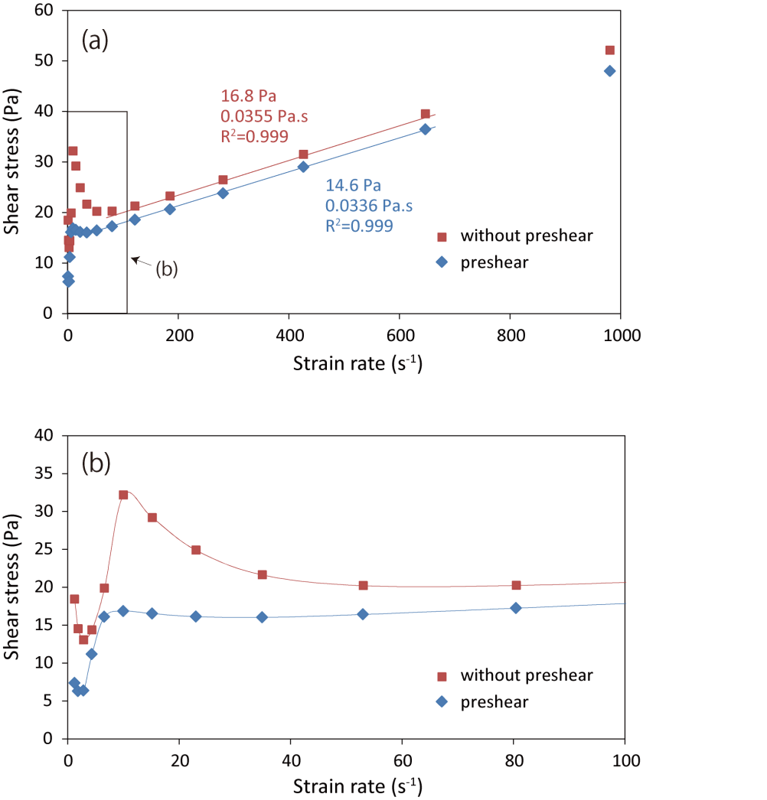
Figure S2. (a) Flow curves (strain rate vs. shear stress) for the 50 w/v% suspension containing 25 wt% smectite in the solid component. The red and blue symbols indicate data obtained using the normal procedure (also shown in Fig. 2) and that with preshearing, respectively. The yield stress and dynamic viscosity were determined by fitting the data using the Bingham fluid model (solid lines). (b) An enlarged portion of (a) for strain rate between 0 and 100 sec^{–1}.

Sample | Smectite (wt%) | Quartz (wt%) | w/v (%) | Temperature (℃) | NaCl concentration (M) | pH | Yield stress (Pa) | Viscosity (Pa.s) | Strain rate range for fitting (s⁻¹) | R²
K100-10wv | 100 | 0 | 10 | 7 | 0.6 | - | 0.09 | 0.0062 | 01-654 | 0.995
K100-15wv | 100 | 0 | 15 | 7 | 0.6 | - | 4.16 | 0.0194 | 81-654 | 0.998
K100-20wv | 100 | 0 | 20 | 7 | 0.6 | - | 15.16 | 0.0275 | 123-654 | 0.998
K100-25wv | 100 | 0 | 25 | 7 | 0.6 | - | 21.69 | 0.0369 | 186-654 | 0.999
K100-30wv | 100 | 0 | 30 | 7 | 0.6 | - | 30.35 | 0.0499 | 185-981 | 0.997
K100-30.5wv | 100 | 0 | 30.5 | 7 | 0.6 | - | 41.73 | 0.0617 | 185-965 | 0.999
K100-31.1wv | 100 | 0 | 31.1 | 7 | 0.6 | - | 71.68 | 0.1031 | 179-981 | 0.997
K80-26.7wv | 80 | 20 | 26.7 | 7 | 0.6 | - | 11.67 | 0.0207 | 122-981 | 0.995
K80-30wv | 80 | 20 | 30 | 7 | 0.6 | - | 17.90 | 0.0300 | 185-981 | 0.994
K80-34.3wv | 80 | 20 | 34.3 | 7 | 0.6 | - | 31.49 | 0.0532 | 185-981 | 0.994
K60-26.7wv | 60 | 40 | 26.7 | 7 | 0.6 | - | 3.51 | 0.0177 | 80-647 | 0.998
K60-30wv | 60 | 40 | 30 | 7 | 0.6 | - | 10.16 | 0.0197 | 92-981 | 0.995
K60-34.3wv | 60 | 40 | 34.3 | 7 | 0.6 | - | 15.10 | 0.0300 | 122-647 | 0.997
K60-37wv | 60 | 40 | 37 | 7 | 0.6 | - | 27.44 | 0.0499 | 115-981 | 0.999
K40-34.3wv | 40 | 60 | 34.3 | 7 | 0.6 | - | 4.28 | 0.0137 | 80-647 | 0.999
K40-40wv | 40 | 60 | 40 | 7 | 0.6 | - | 7.07 | 0.0272 | 80-647 | 0.998
K40-48wv | 40 | 60 | 48 | 7 | 0.6 | - | 20.34 | 0.0486 | 122-647 | 0.998
K40-50wv | 40 | 60 | 50 | 7 | 0.6 | - | 41.48 | 0.1240 | 122-647 | 0.998
K25-40wv | 25 | 75 | 40 | 7 | 0.6 | - | 1.09 | 0.0120 | 185-981 | 0.993
K25-50wv | 25 | 75 | 50 | 7 | 0.6 | 8.91 | 16.76 | 0.0355 | 76-656 | 0.998
K25-60wv | 25 | 75 | 57.1 | 7 | 0.6 | - | 31.35 | 0.0586 | 76-656 | 0.998
K25-61.5wv | 25 | 75 | 61.5 | 7 | 0.6 | - | 42.64 | 0.0916 | 123-647 | 0.999
K10-50wv | 10 | 90 | 50 | 7 | 0.6 | - | 0.23 | 0.0098 | 34-980 | 0.984
K10-66.7wv | 10 | 90 | 66.7 | 7 | 0.6 | - | 2.26 | 0.0234 | 15-981 | 0.999
K10-80wv | 10 | 90 | 80 | 7 | 0.6 | - | 25.90 | 0.1096 | 82-981 | 0.999
T-2 | 40 | 60 | 40 | 2 | 0.6 | - | 7.72 | 0.0315 | 53-647 | 0.997
T-15 | 40 | 60 | 40 | 15 | 0.6 | - | 6.51 | 0.0244 | 122-647 | 0.998
T-25 | 40 | 60 | 40 | 25 | 0.6 | - | 8.03 | 0.0255 | 122-981 | 0.987
T-30 | 40 | 60 | 40 | 30 | 0.6 | - | 8.54 | 0.0281 | 185-647 | 0.996
M-0.2 | 10 | 90 | 50 | 7 | 0.2 | - | 77.93 | 1.3562 | 49-981 | 0.999
M-0.3 | 10 | 90 | 50 | 7 | 0.3 | - | 43.27 | 0.1196 | 116-656 | 0.999
M-0.4 | 10 | 90 | 50 | 7 | 0.4 | - | 8.20 | 0.0152 | 23-981 | 0.999
M-0.5 | 10 | 90 | 50 | 7 | 0.5 | - | 0.23 | 0.0136 | 07-80 | 0.985
pH-1 | 25 | 75 | 50 | 7 | 0.6 | 1.14 | 8.42 | 0.0240 | 80-981 | 0.999
pH-3 | 25 | 75 | 50 | 7 | 0.6 | 3.03 | 8.51 | 0.0254 | 80-981 | 0.998
pH-5 | 25 | 75 | 50 | 7 | 0.6 | 5.76 | 10.51 | 0.0245 | 53-647 | 0.999
pH-7 | 25 | 75 | 50 | 7 | 0.6 | 7.14 | 11.50 | 0.0246 | 53-647 | 0.999

Table S1. Details of the tested suspensions and the determined rheological parameters.

