[JGR-Atmospheres]
Supporting Information for
Atmospheric transport of soil microorganisms and higher plant waxes in the East Asian outflow to the North Pacific Rim using hydroxy fatty acids: year round observations atGosan, Jeju Island

Poonam Tyagi^{1,2}, Kimitaka Kawamura^{2,3}*, Tadashi Kariya^{1,2}, Srinivas Bikkina^{2,4}, Pingqing Fu⁵ and Meehye Lee⁶

¹Graduate School of Environmental Sciences, Hokkaido University, Sapporo 060-0810, Japan
²Institute of Low Temperature Sciences, Hokkaido University, Sapporo 060-0819, Japan
³Now atChubu Institute for Advanced Studies, Chubu University, Kasugai487-8501, Japan
⁴Now at Department of Environmental Science and Analytical Chemistry (ACES), Bolin Centre for Climate Research, Stockholm University, Stockholm 106 19, Sweden
⁵State Key Laboratory of Atmospheric Boundary Layer Physics and Atmospheric Chemistry,Institute of Atmospheric Physics, Chinese Academy of Sciences, Beijing 10-029, China
⁶Department of Earth and Environmental Sciences, Korea University,Seoul 136-701, South Korea

Contents of this file

Figures S1 to S3

Introduction
This supporting information contains three figure (one on seasonal clusters of air mass back trajectories, 2) seasonal distributions of a-, b- and w- hydroxy FAs, 3) back trajectory cluster for dust events) that are useful for better understanding the data discussed in the main MS.

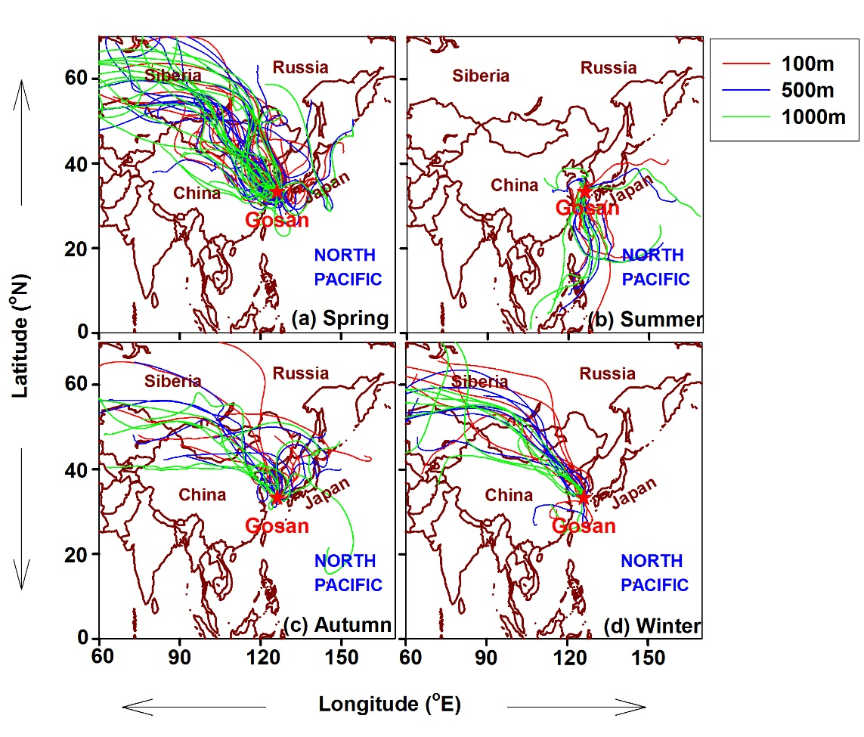

Figure S1. 7-day isentropic air mass back-trajectories computed at arrival heights of 100, 500 and 1000 musing HYSPLIT model for the sampling days (April, 2001-March, 2002) over Gosan, Jeju Island.

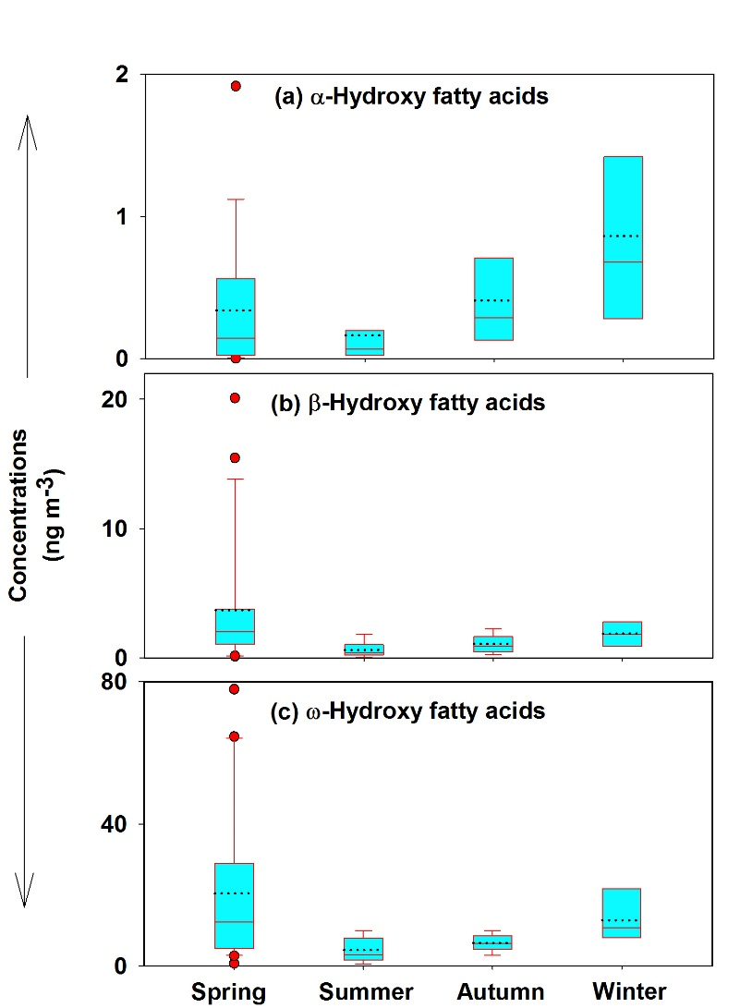

Figure S2. Box plots, showing the seasonal variability of mean atmospheric concentrations of measured α-, β- and ω-hydroxy FAs in TSP samples collected over Gosan, Jeju Island during April, 2001–March, 2002. The lower and upper edges of the boxes represent 25 and 75 percentile data, respectively. Likewise, the bottom and top whiskers correspond to 5 and 95 percentile data, respectively. The solid and dotted lines in each box refer to median and mean concentrations, respectively.

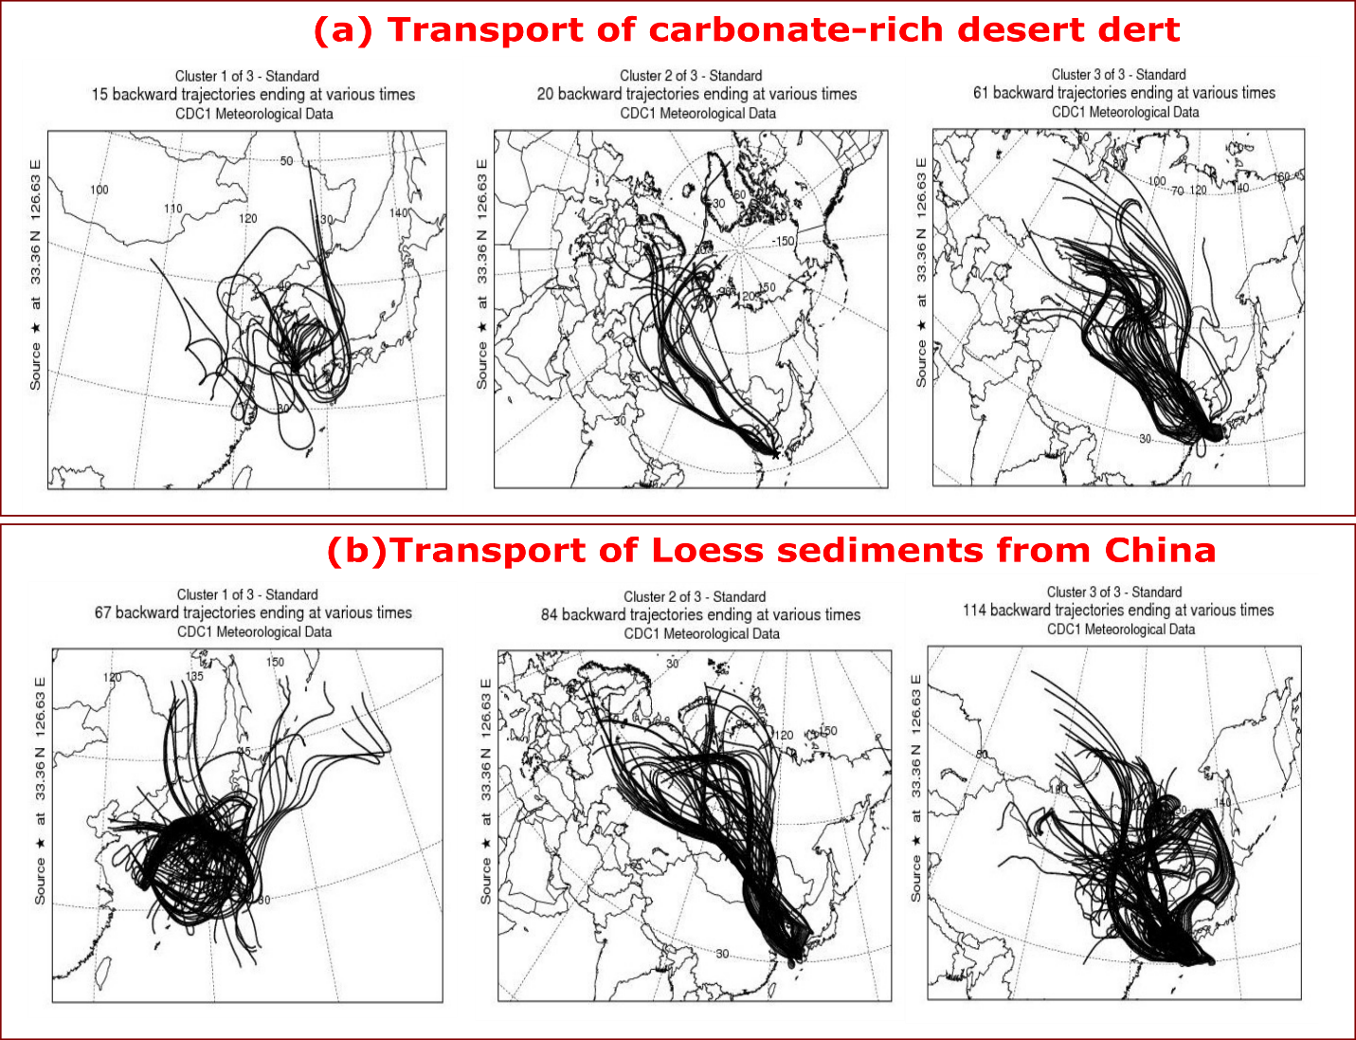

Figure S3. Individual cluster of trajectories for Figure 9.

