Supplementary Information

Model selection and confirmation of model fitting

Naoki Hashimoto¹, Yoichi M. Ito², Naohiro Okada³, Hidenaga Yamamori⁴, Yuka Yasuda⁴, Michiko Fujimoto⁴, Noriko Kudo⁵, Ariyoshi Takemura⁶, Shuraku Son⁶, Hisashi Narita¹, Maeri Yamamoto⁷, Khin Khin Tha⁸, Asuka Katsuki⁹, Kazutaka Ohi¹⁰, Fumio Yamashita¹¹, Shinsuke Koike^{3, 12}, Tsutomu Takahashi¹³, Kiyotaka Nemoto¹⁴, Masaki Fukunaga¹⁵, Toshiaki Onitsuka¹⁶, Yoshiyuki Watanabe¹⁷, Hidenori Yamasue^{3,18}, Michio Suzuki¹³, Kiyoto Kasai³, Ichiro Kusumi¹, Ryota Hashimoto^{4, 5}; COCORO

¹ Department of Psychiatry, Hokkaido University Graduate School of Medicine, Hokkaido, Japan. ² Department of Biostatistics, Hokkaido University Graduate School of Medicine, Hokkaido, Japan. ³ Department of Neuropsychiatry, Graduate School of Medicine, The University of Tokyo, Tokyo, Japan. ⁴ Department of Psychiatry, Osaka University Graduate School of Medicine, Osaka, Japan. ⁵ Molecular Research Center for Children's Mental Development, United Graduate School of Child Development, Osaka University, Osaka, Japan. ⁶ Department of Psychiatry, Graduate School of Medicine, Kyoto University, Kyoto, Japan. ⁷ Department of Psychiatry, Nagoya University Graduate School of Medicine, Aichi, Japan. ⁸ Department of Radiation Medicine, Hokkaido University Graduate School of Medicine, Hokkaido, Japan. ⁹ Department of Psychiatry, University of Occupational and Environmental Health, Fukuoka, Japan. ¹⁰ Department of Neuropsychiatry, Kanazawa Medical University, Ishikawa, Japan. ¹¹ Division of Ultrahigh Field MRI, Institute for Biomedical Sciences, Iwate Medical University, Iwate, Japan. ¹² Office for Mental Health Support, Division for Counseling and Support, The University of Tokyo, Tokyo, Japan. ¹³ Department of Neuropsychiatry, University of Toyama Graduate School of Medicine and Pharmaceutical Sciences, Toyama, Japan. ¹⁴ Department of Neuropsychiatry, Division of Clinical Medicine, Faculty of Medicine, University of Tsukuba, Ibaraki, Japan. ¹⁵ Division of Cerebral Integration, National Institute for Physiological Sciences, Aichi, Japan.¹⁶ Department of Neuropsychiatry, Graduate School of Medical Sciences, Kyushu University, Fukuoka, Japan. ¹⁷ Department of Radiology, Osaka University Graduate School of Medicine, Osaka, Japan. ¹⁸ Department of Psychiatry, Hamamatsu University School of Medicine, Hamamatsu, Japan.

Table of Contents

Supplementary Methods ……………………………………………...…….. 5
Supplementary Figures ……………………………………………...…….. 11
Supplementary Tables ……………………………………………...…….. 29

Supplementary Methods

1 Hypothesized models

In analysis of the effect of daily dose of antipsychotics and duration of illness, we firstly considered a fixed effect model (f). In this model, the volumes of subcortical structures were used as a dependent variable and age, sex, duration of illness, chlorpromazine equivalent total daily dose of antipsychotics and intracranial volume (ICV) were used as independent variables. In the next step, we considered a random intercept model where type of protocol was incorporated into model f as a random effect for intercept only (m1). Then we made a random intercept and random slope model where type of protocol was incorporated as a random effect for intercept and slope of independent variables. In this step, random slope was incorporated for all independent variables one by one: random intercept and random slope for daily dose of antipsychotics (m2), for duration of illness (m3), for age (m4), for sex (m5), for ICV (m6), and for all of them (m7).
In the analysis of effect of type of antipsychotics, we made models, f (fixed effect), m1 (random intercept), m2 (random intercept + random slope for type of antipsychotics), m3 (random intercept + random slope for daily dose of antipsychotics), m4 (random intercept + random slope for duration of disease), m5 (random intercept + random slope for age), m6 (random intercept + random slope for sex), m7 (random intercept + random slope for ICV), m8 (random intercept + random slope for all independent variables). When we used ICV or LI as a dependent variable, ICV was removed from independent variables, as well as mixed effect model with random slope for ICV.

2 Model selection

To avoid the asymptotic assumptions of the likelihood ratio test in mixed effect model (1), we adopted parametric bootstrapping test for model selection. The number of resampling was set to 1000 and log likelihood was estimated at each time. The log likelihood of two models were used to calculate likelihood ratio, and 95% confidence interval of likelihood ratio were obtained from the null distribution.
In the analysis of the effect of daily dose of antipsychotics and duration of illness on the volumes of subcortical structures, we firstly compared model m1 to f, then compared all other models (m2 - m7) to m1 (supplementary tables 5). Model m1 showed better fitting than f in right hippocampus, left accumbens, right globus pallidus, left and right lateral ventricles. Models m2 to m7 did not show significant better fitting than m1 in any region.
In the analysis of effect of type of antipsychotics on the volume of subcortical structures, we firstly compared model m1 to f, then compared all other models (m2 – m8) to m1 (supplementary tables 6). Model m1 showed better fitting than f in left accumbens. Models m2 to m8 did not show significant better fitting than m1 in any region.
In the analysis of effect of daily dose of antipsychotics and duration of illness on LI of globus pallidus, m1 did not show better fitting than f and any model from m2 to m8 did not show better fitting than m1 (supplementary table 7).
In the analysis of effect of type of antipsychotic on LI of globus pallidus, m1 did not show better fitting than f and any model from m2 to m8 did not showed better fitting than m1(supplementary table 8).
In the current study, we adopted model m1 in all analyses because at least one region showed better fitting of m1 compared to f in analysis on the volumes of subcortical structures, and using the same model in all analysis makes the comparison of the results easier. At the same time, we compute the result of fixed effect model for reference (supplementary tables 9 (b), 9 (c), 10 (b), 11 (b), 11 (c), 12 (b)).
All mixed liner model effect model analyses were conducted using lmer function in the lme4 (1) package and fixed effect model were computed using lm function. The bootMer function in the lme4 package was used to implement parametric bootstrapping in mixed linear model and boot function in the boot package in fixed model.

3 Diagnostic plots of model m1 and coefficient of determination of model f

The standard fitted versus residuals plots (supplementary figures 1, 3) and quantile-quantile plots (supplementary figures 2, 4) were made to confirm the fitting of model m1 in all analysis. The coefficient of determination and its significance in fixed effect model were also shown in tables 9 (a), 10 (a), 11 (a), 12 (a).

4 Reference

1. Douglas Bates MM, Benjamin M. Bolker, Steven C. Walker (2015): Fitting Linear Mixed-Effects Models Using lme4. Journal of Statistical Software. 67.

Supplementary Figures

Supplementary Figures 1(a)-(e) The fitted versus residual plots in model m1 in the analysis of the effect of daily dose of antipsychotics and duration of illness on the volumes of subcortical structures. (a) left and right hippocampus, left and right amygdala, (b) left and right thalamus, left and right accumbens, (c) left and right caudate, left and right putamen, (d) left and right globus pallidus, left and right lateral ventricle, (e) intracranial volume.

Supplementary Figures 1 (a)
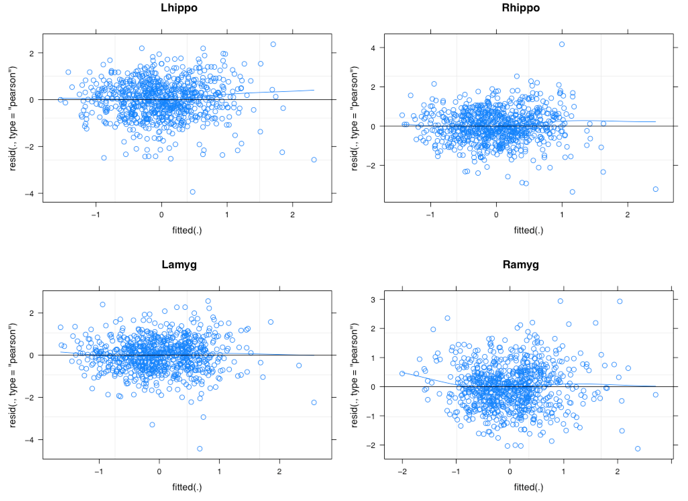

Supplementary Figures 1 (b)
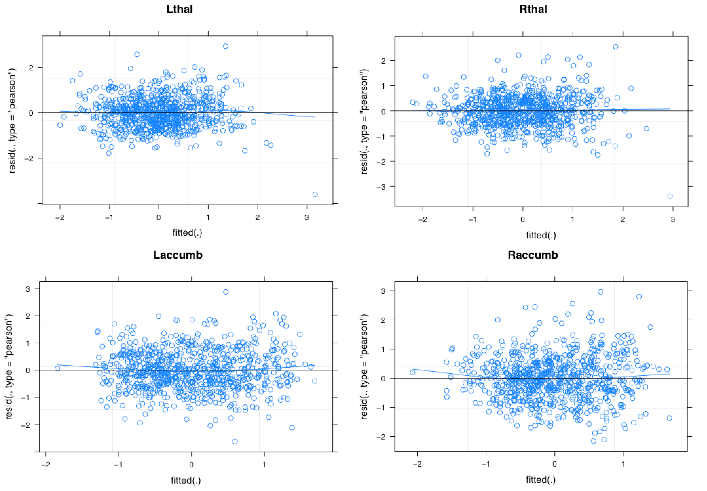

Supplementary Figures 1 (c)
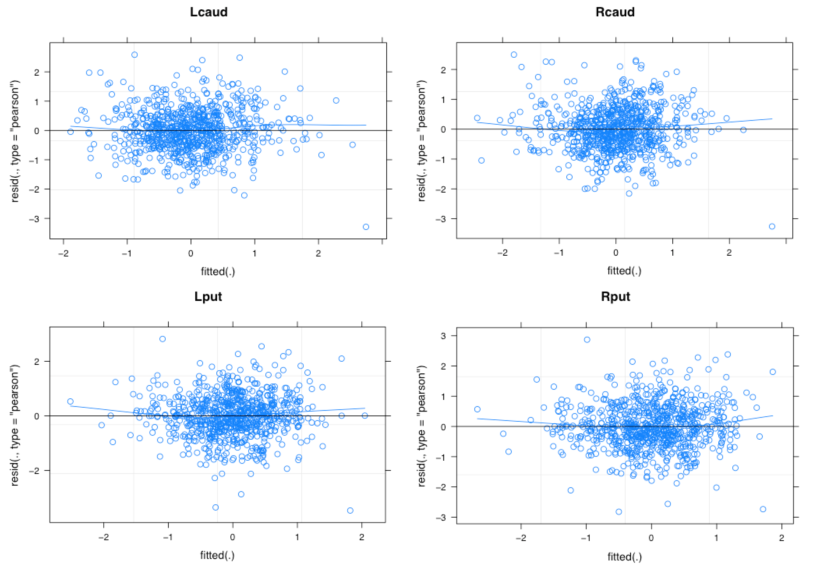

Supplementary Figures 1 (d)
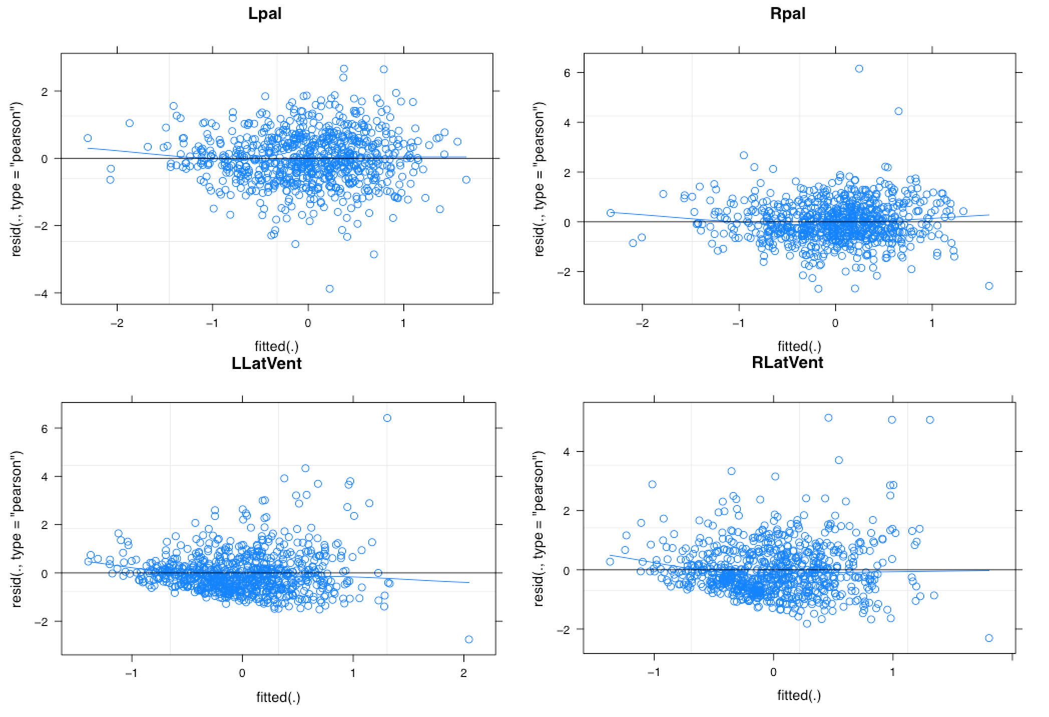

Supplementary Figures 1 (e)
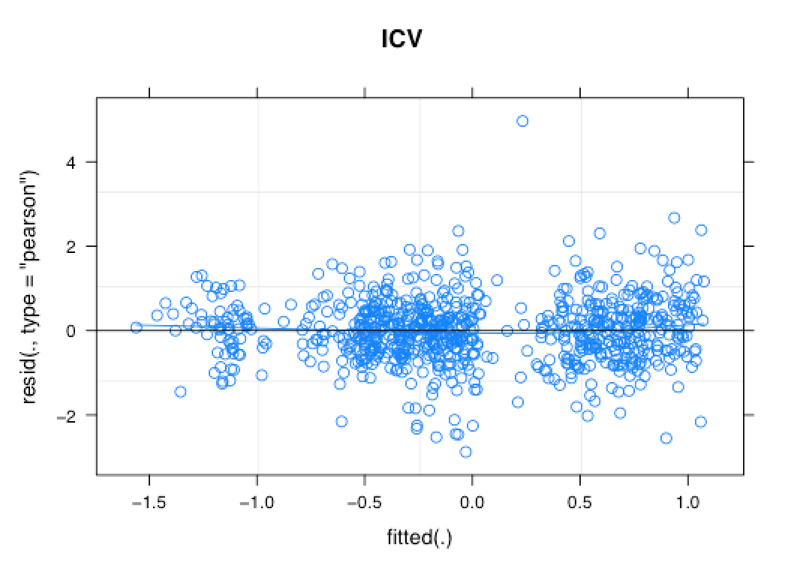

Abbreviations: Lhippo, left hippocampus; Rhippo, right hippocampus; Lamyg, left amygdala; Ramyg, right amygdala; Lthal, left thalamus; Rthal, right thalamus; Laccumb, left accumbens; Raccumb, right accumbens; ICV, intracranial volume; Lcaud, left caudate; Rcaud, right caudate; Lput, left putamen; Rput, right putamen; Lpal, left globus pallidus; Rpal, right globus pallidus; LLatVent, left lateral ventricle; RLatVent, right lateral ventricle

Supplementary Figures 2(a)-(e) The quantile-quantile plots in model m1 in the analysis of the effect of daily dose of antipsychotics and duration of illness on the volumes of subcortical structures. (a) left and right hippocampus, left and right amygdala, (b) left and right thalmus, left and right accumbens, (c) left and right caudate, left and right putamen, (d) left and right globus pallidus, left and right lateral ventricle, (e) intra cranial volume.

Supplementary Figures 2 (a)
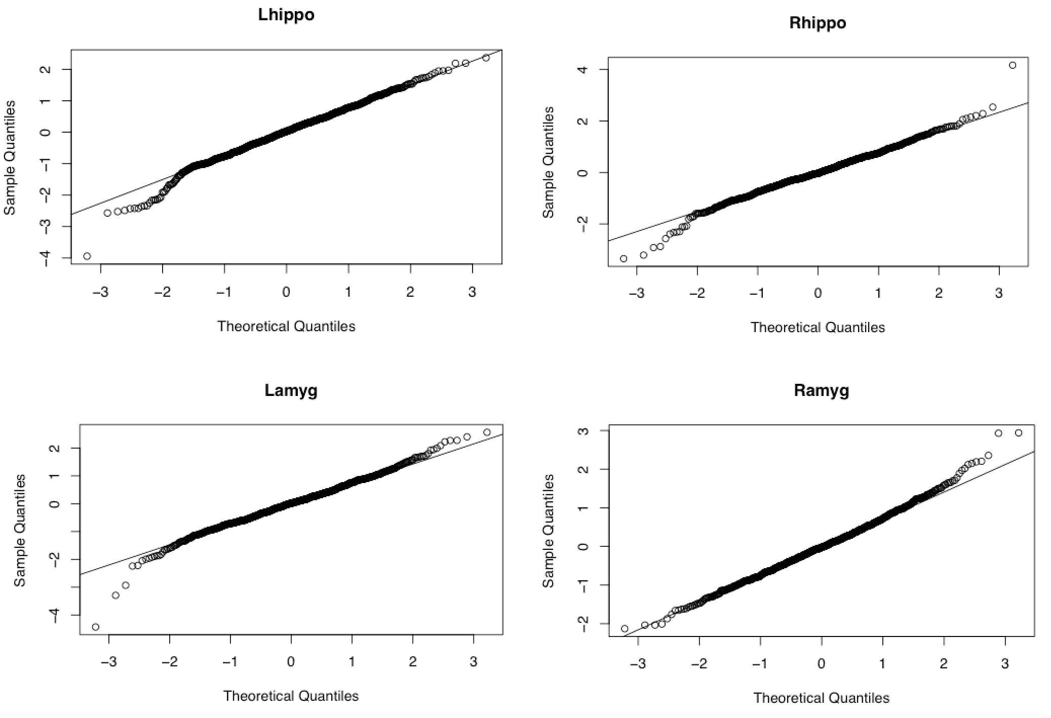

Supplementary Figures 2 (b)
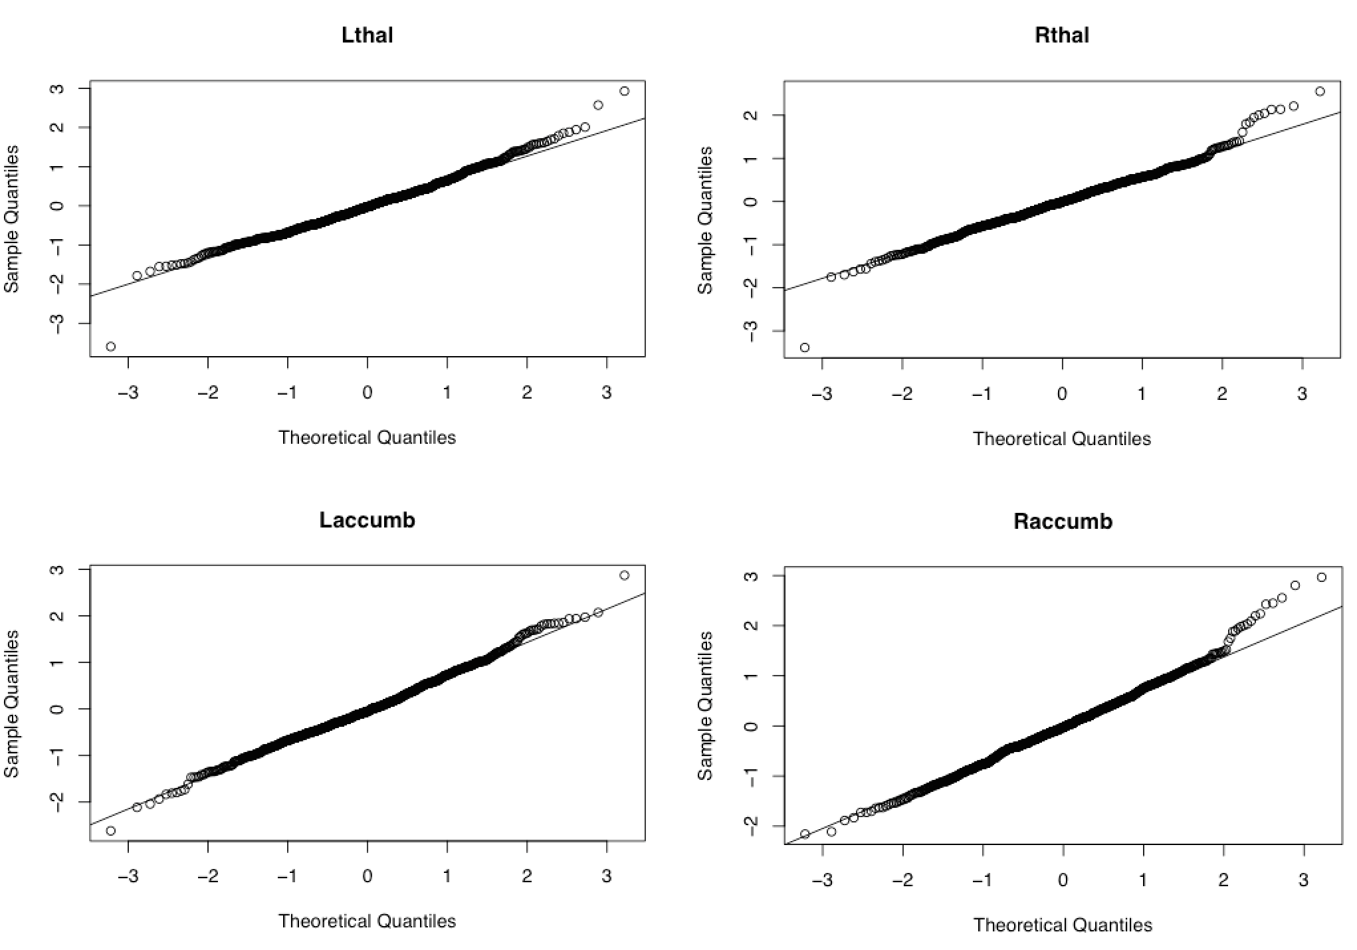

Supplementary Figures 2 (c)
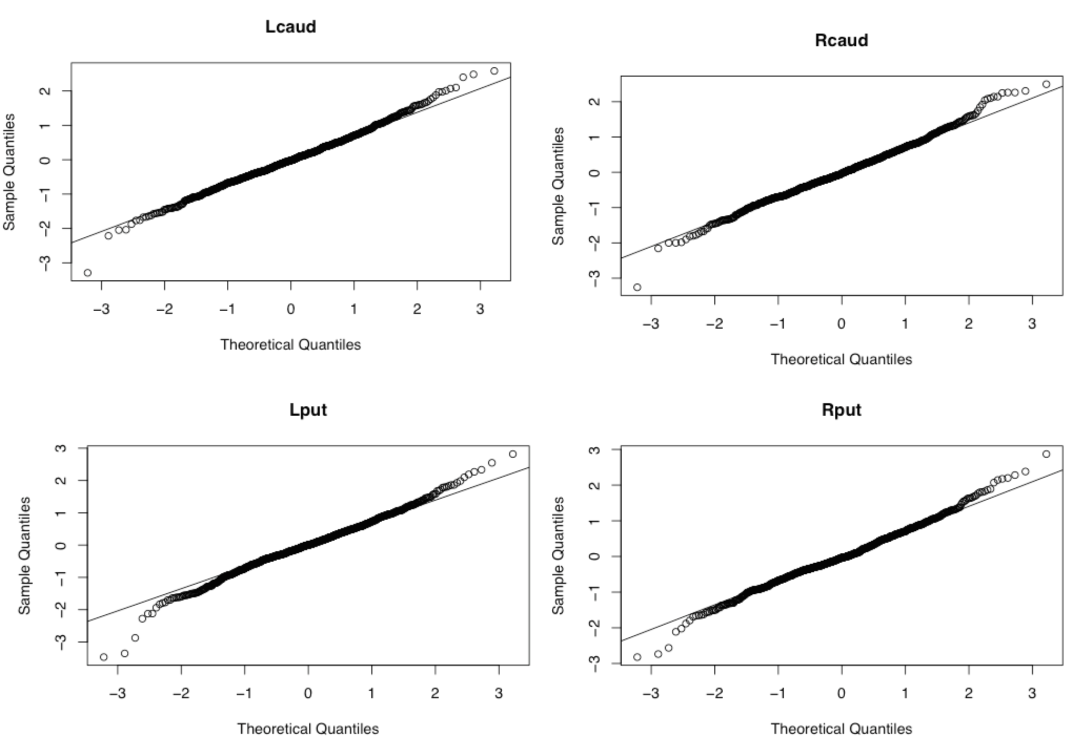

Supplementary Figures 2 (d)
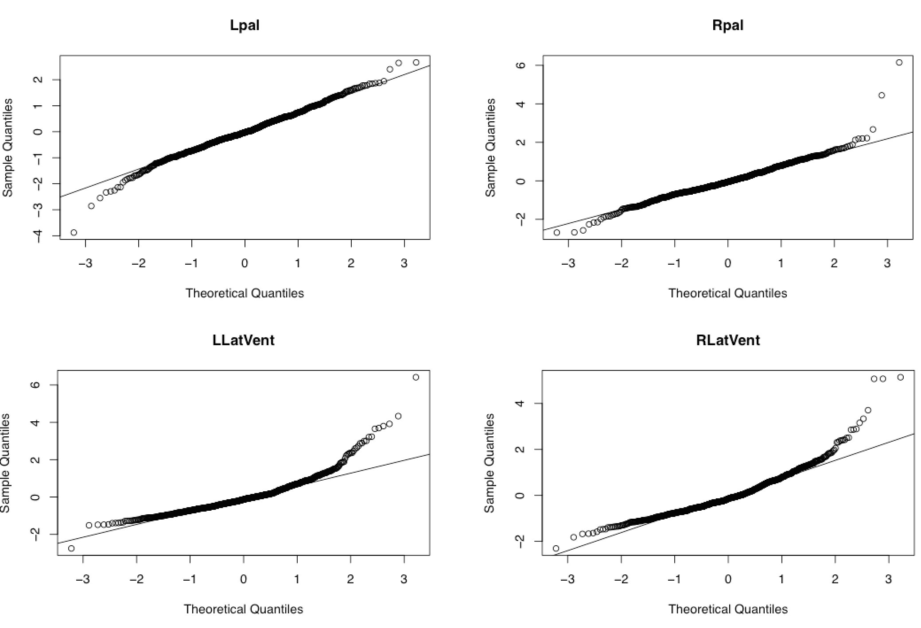

Supplementary Figure 2 (e)
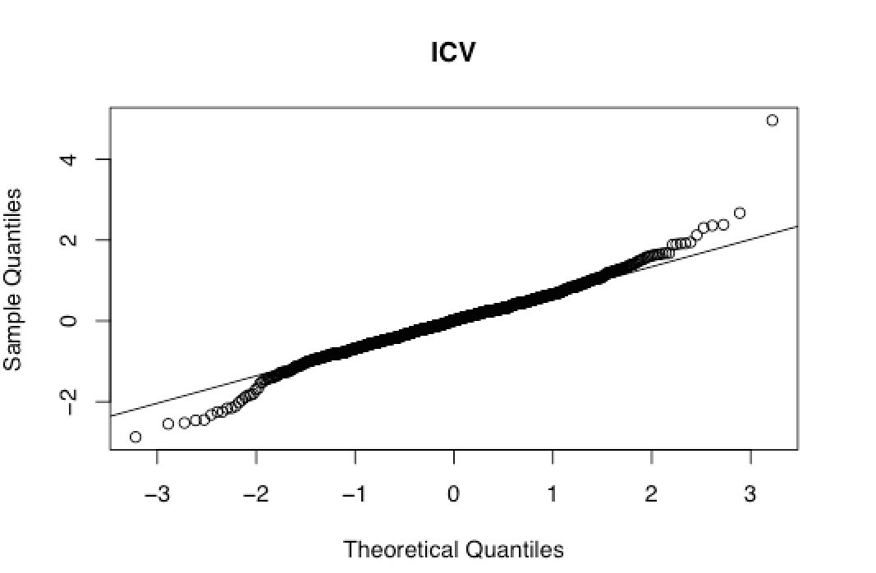

Abbreviations: Lhippo, left hippocampus; Rhippo, right hippocampus; Lamyg, left amygdala; Ramyg, right amygdala; Lthal, left thalamus; Rthal, right thalamus; Laccumb, left accumbens; Raccumb, right accumbens; ICV, intracranial volume; Lcaud, left caudate; Rcaud, right caudate; Lput, left putamen; Rput, right putamen; Lpal, left globus pallidus; Rpal, right globus pallidus; LLatVent, left lateral ventricle; RLatVent, right lateral ventricle

Supplementary Figures 3 (a)-(e) The fitted versus residual plots in model m1 in the analysis of the effect of type of antipsychotics on the volumes of subcortical structures. (a) left and right hippocampus, left and right amygdala, (b) left and right thalamus, left and right accumbens, (c) left and right caudate, left and right putamen, (d) left and right globus pallidus, left and right lateral ventricle, (e) intra cranial volume.

Supplementary Figures 3 (a)
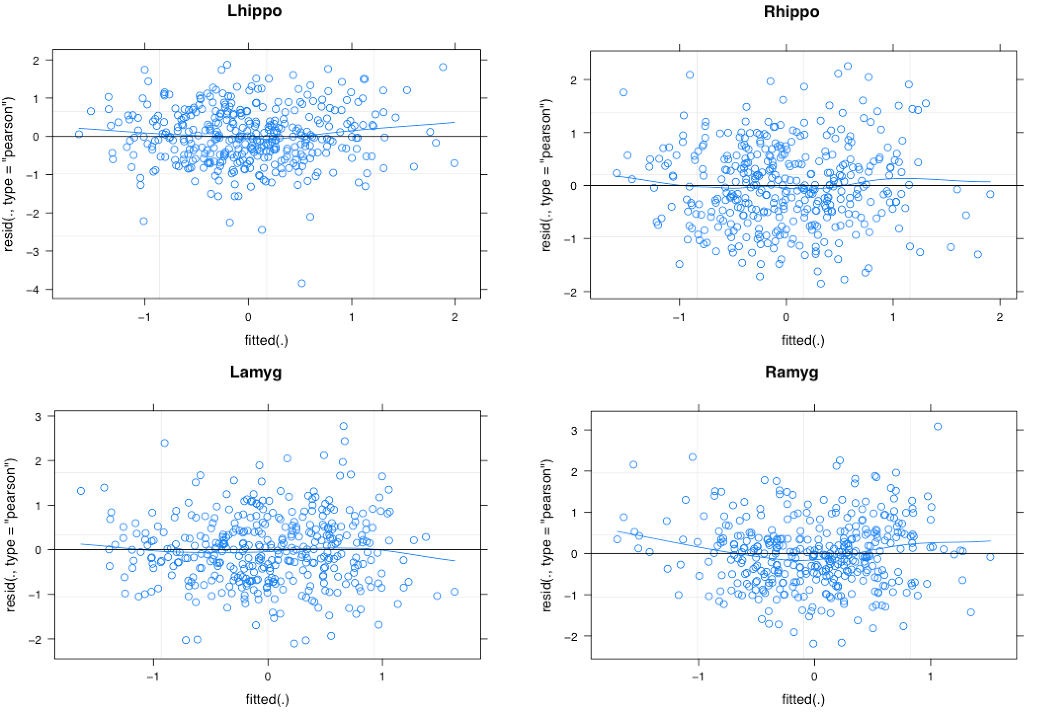

Supplementary Figures 3 (b)
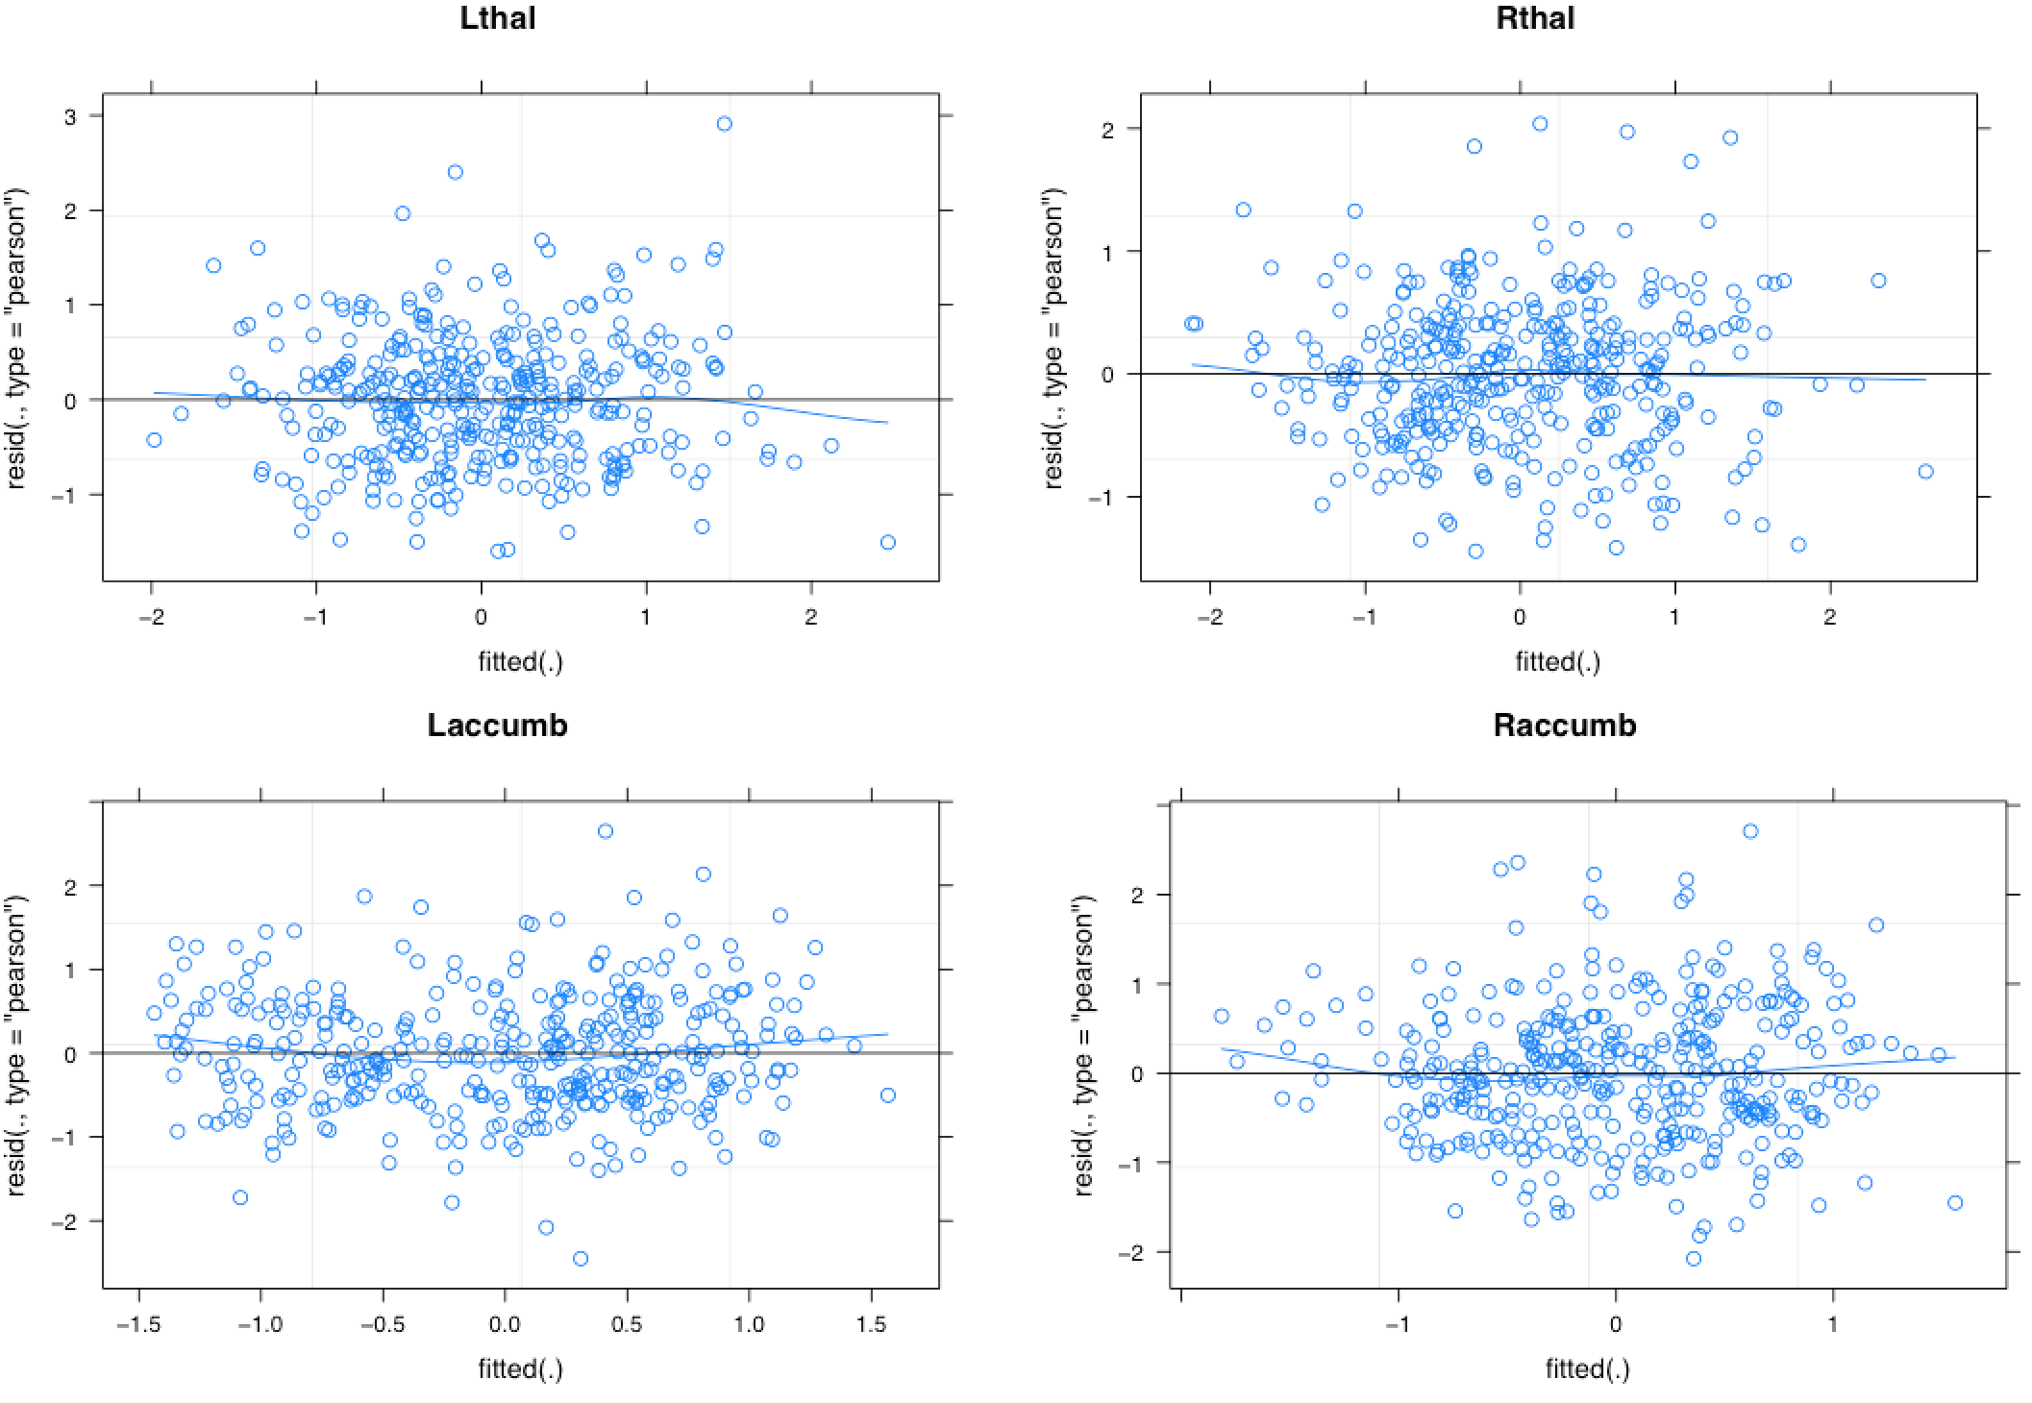

Supplementary Figures 3 (c)
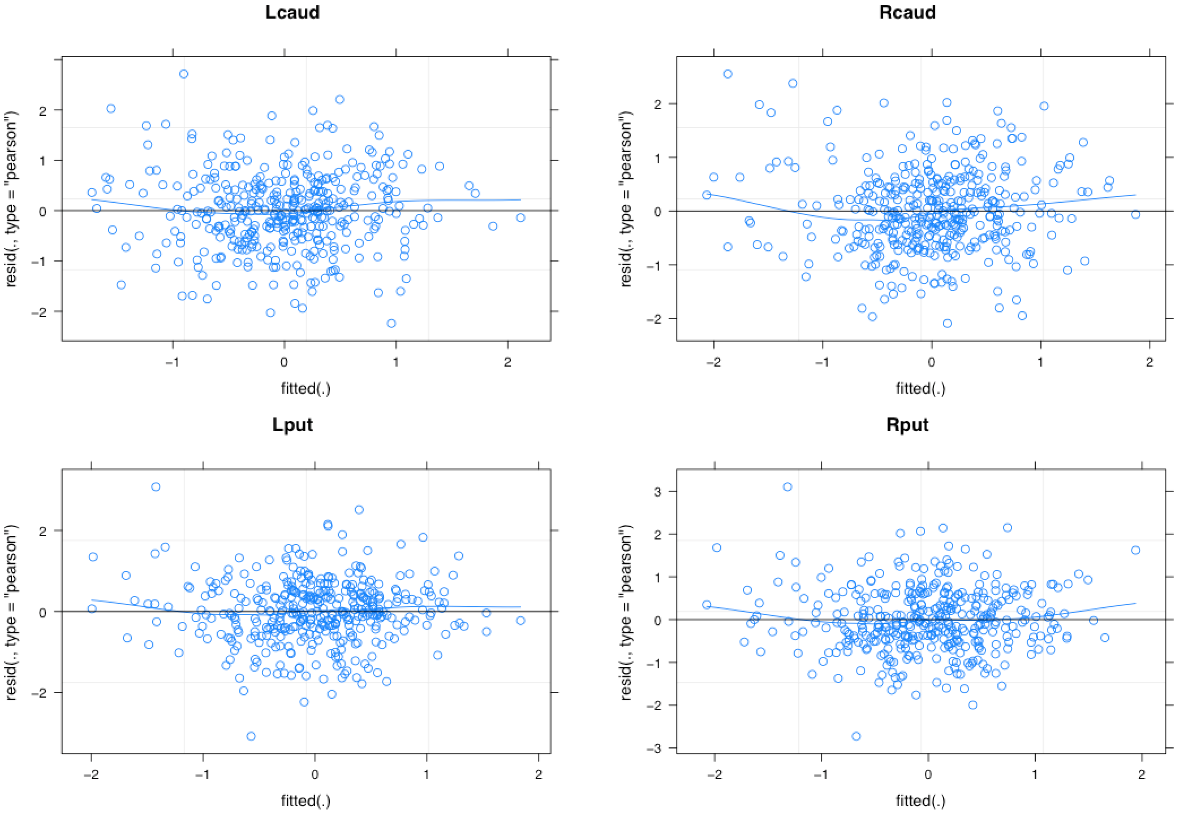

Supplementary Figures 3 (d)
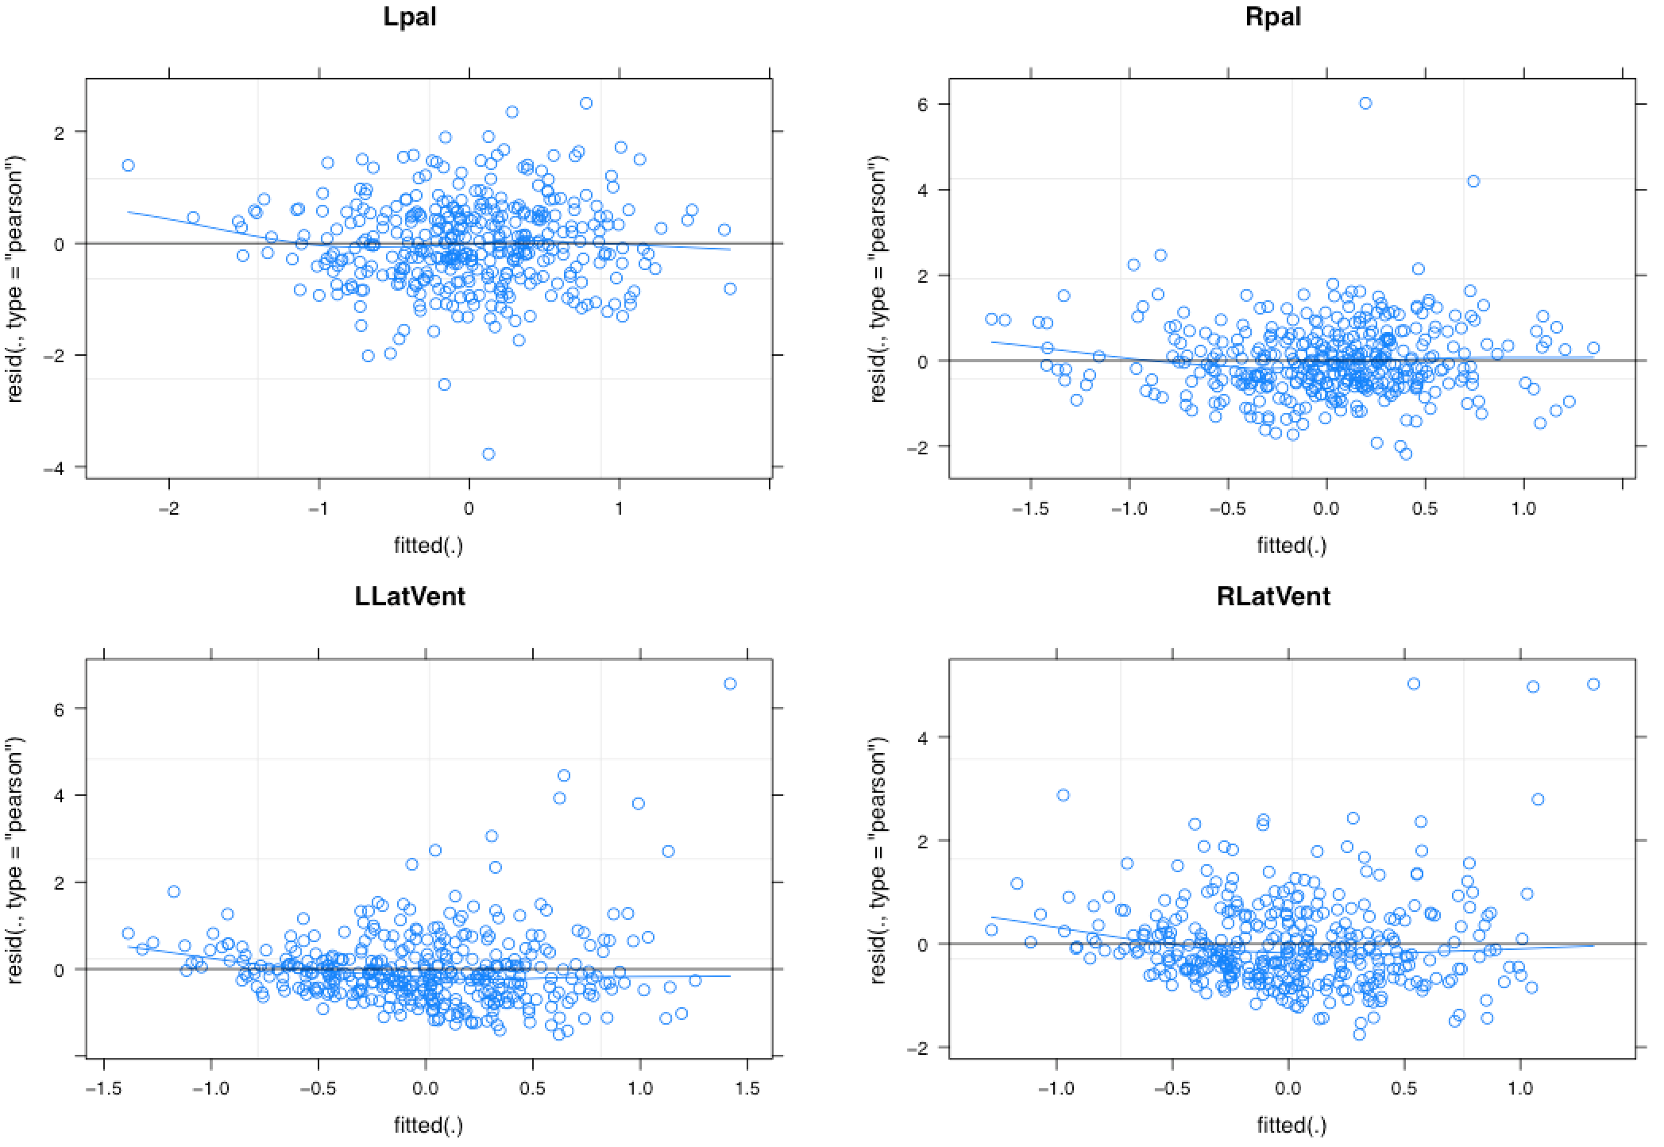

Supplementary Figure 3 (e)
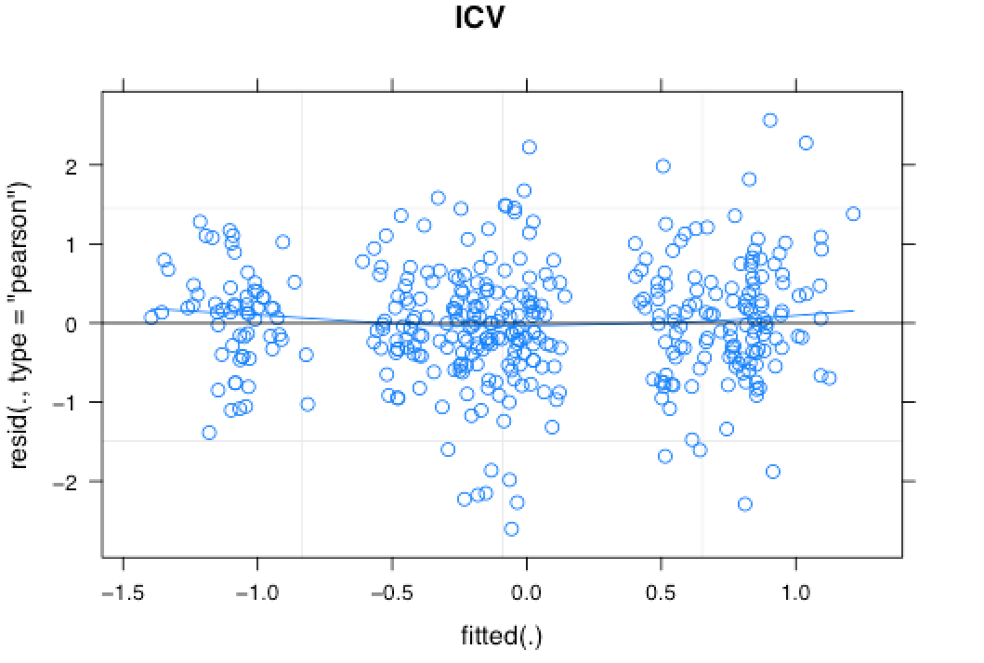

Abbreviations: Lhippo, left hippocampus; Rhippo, right hippocampus; Lamyg, left amygdala; Ramyg, right amygdala; Lthal, left thalamus; Rthal, right thalamus; Laccumb, left accumbens; Raccumb, right accumbens; ICV, intracranial volume; Lcaud, left caudate; Rcaud, right caudate; Lput, left putamen; Rput, right putamen; Lpal, left globus pallidus; Rpal, right globus pallidus; LLatVent, left lateral ventricle; RLatVent, right lateral ventricle

Supplementary Figures 4 (a)-(e) The quantile-quantile plots in model m1 in the analysis of the effect of type of antipsychotics on the volumes of subcortical structures. (a) left and right hippocampus, left and right amygdala, (b) left and right thalamus, left and right accumbens, (c) left and right caudate, left and right putamen, (d) left and right globus pallidus, left and right lateral ventricle, (e) intra cranial volume.

Supplementary Figures 4 (a)
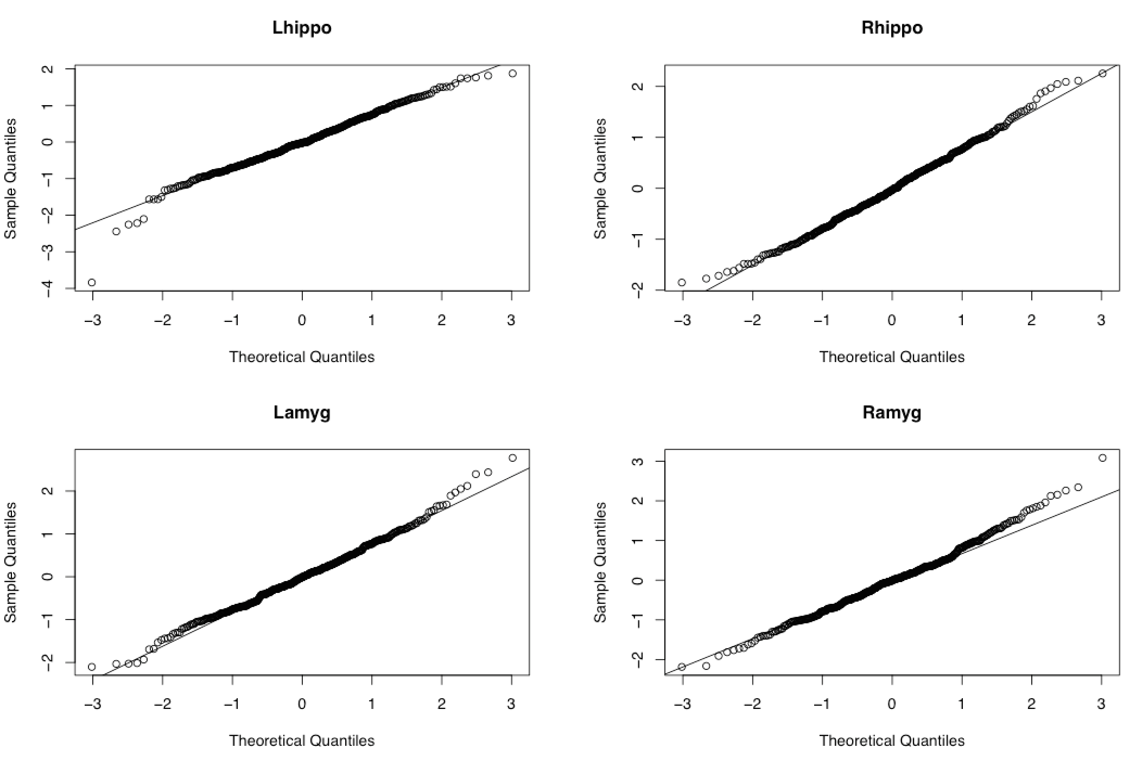

Supplementary Figures 4 (b)
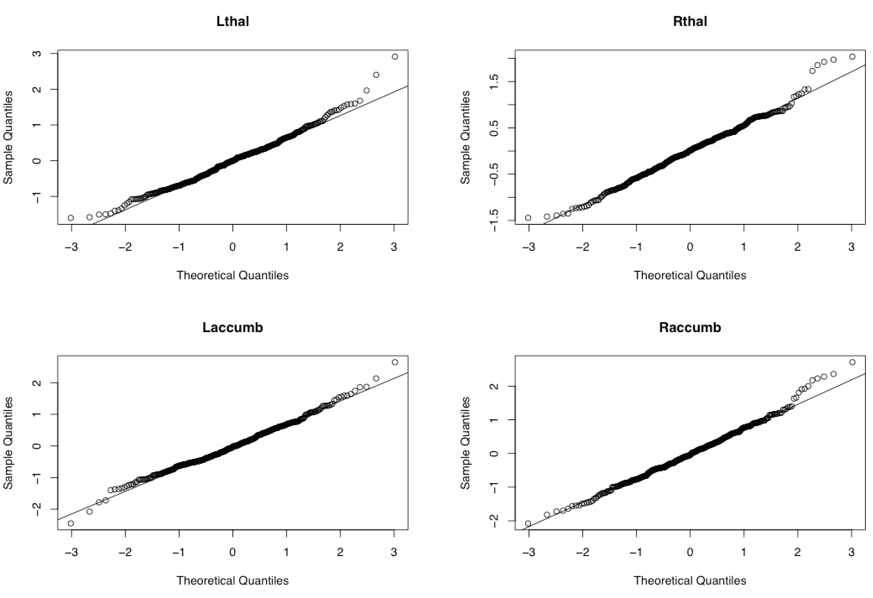

Supplementary Figures 4 (c)
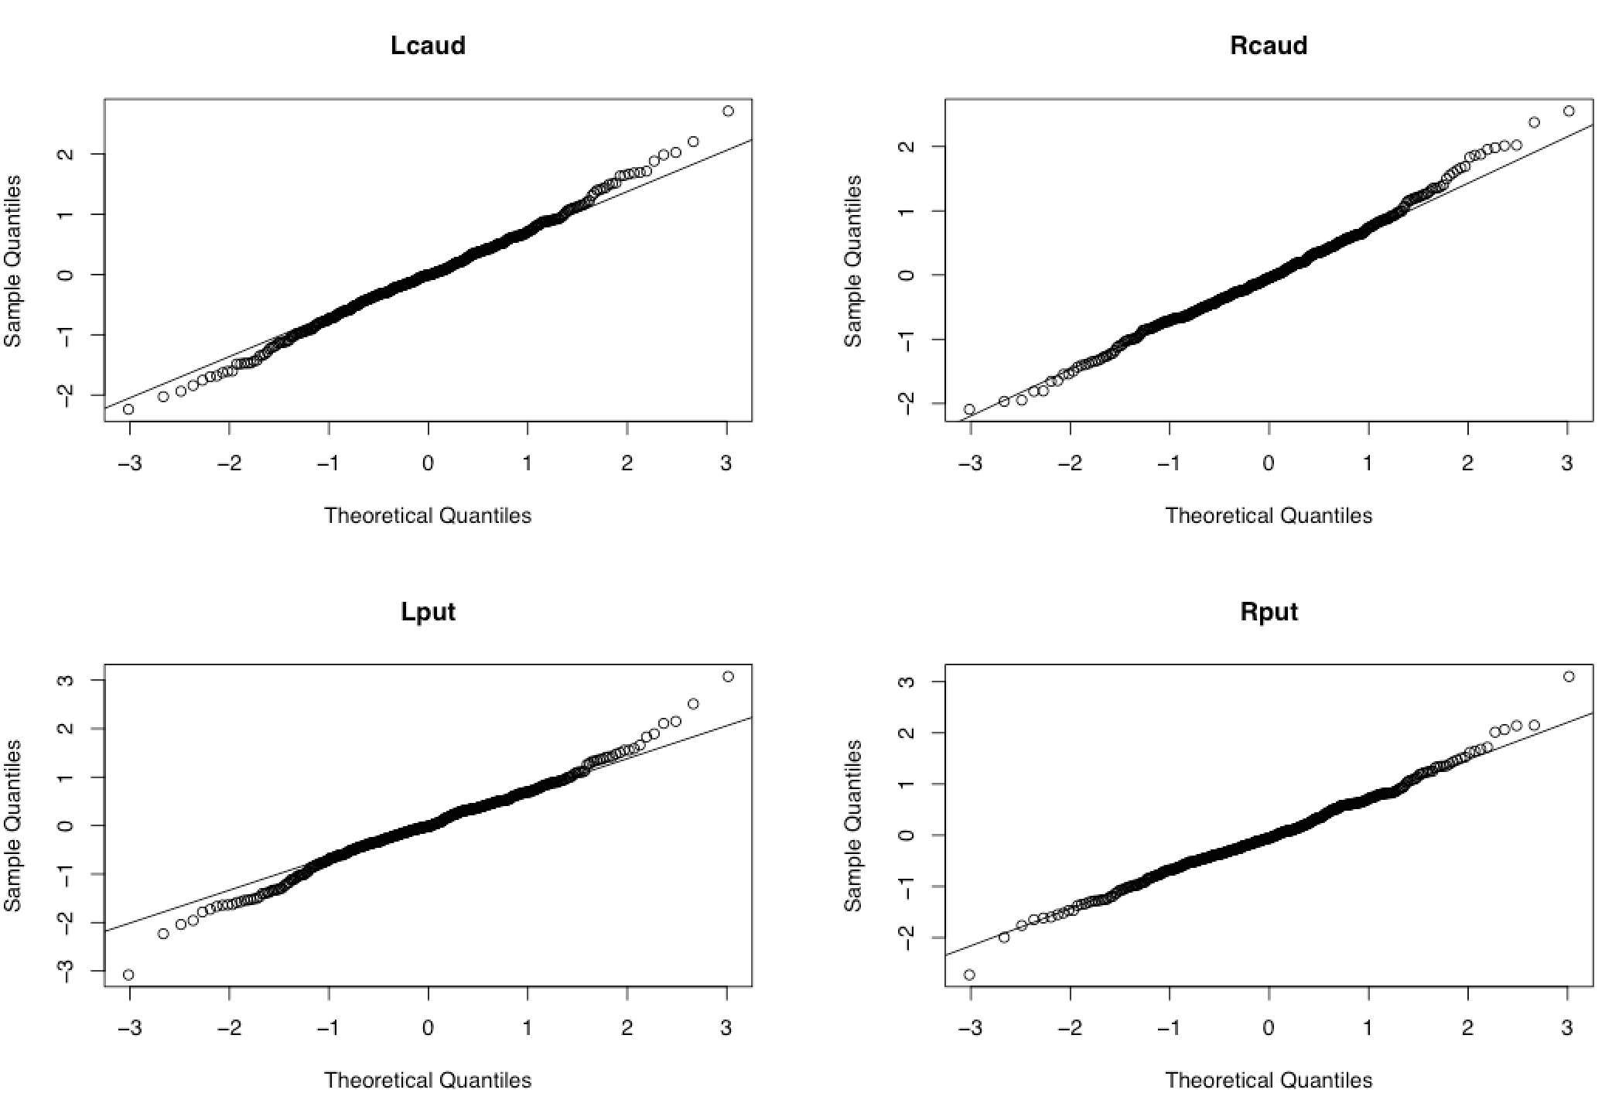

Supplementary Figures 4 (d)
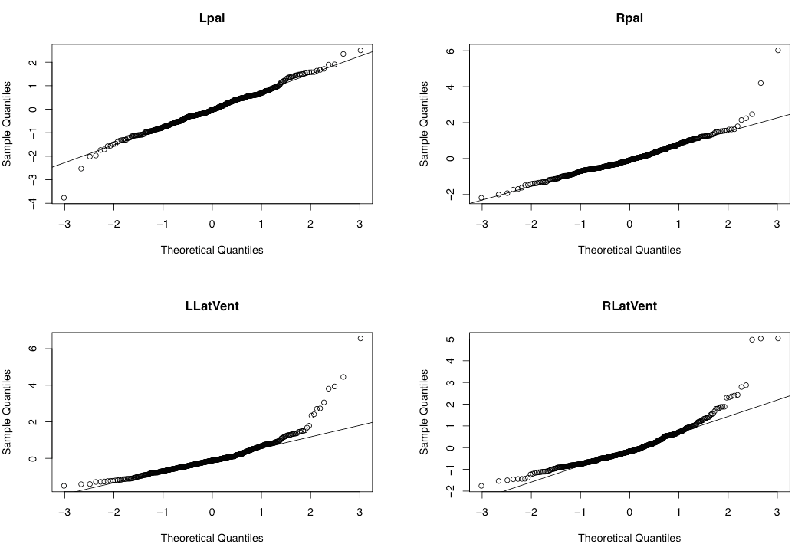

Supplementary Figure 4 (e)
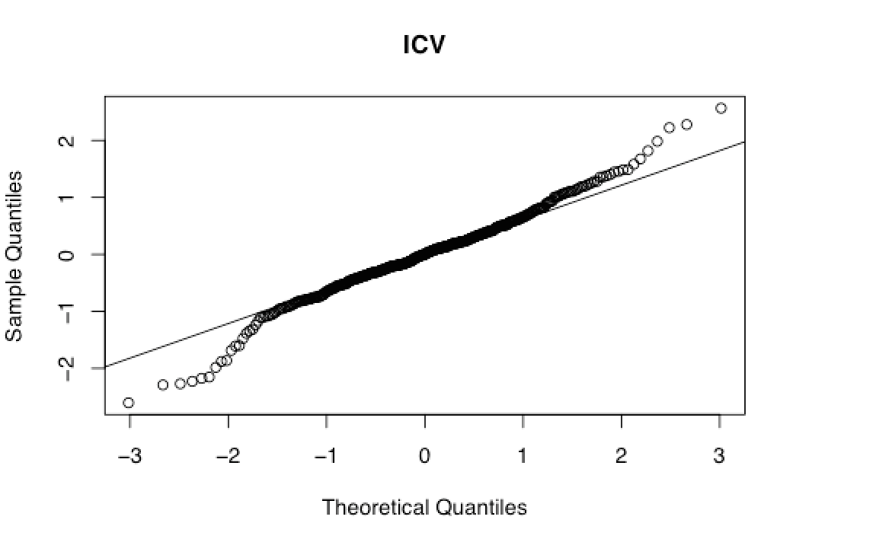

Abbreviations: Lhippo, left hippocampus; Rhippo, right hippocampus; Lamyg, left amygdala; Ramyg, right amygdala; Lthal, left thalamus; Rthal, right thalamus; Laccumb, left accumbens; Raccumb, right accumbens; ICV, intracranial volume; Lcaud, left caudate; Rcaud, right caudate; Lput, left putamen; Rput, right putamen; Lpal, left globus pallidus; Rpal, right globus pallidus; LLatVent, left lateral ventricle; RLatVent, right lateral ventricle

Supplementary Figures 5 The fitted versus residual plots and the quantile-quantile plots in model m1 in the analysis of the effect of daily dose of antipsychotics and duration of illness on the LI of globus pallidus.
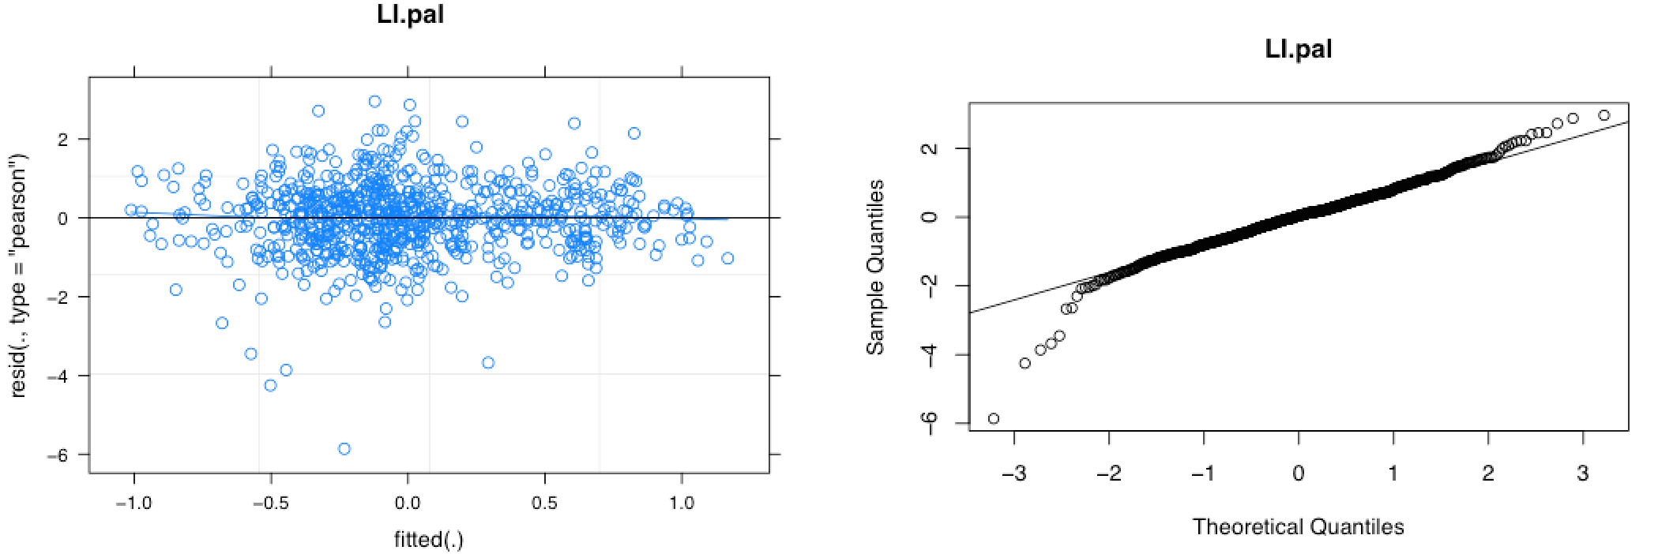

Abbreviations: LI.pal, laterality index of globus pallidus

Supplementary Figures 6 The fitted versus residuals plots and the quantile-quantile plots in model m1 in the analysis of type of antipsychotics on the LI of globus pallidus.
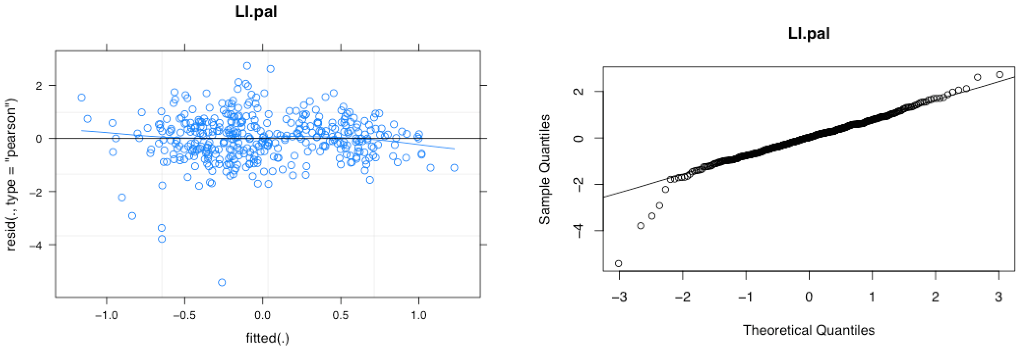

Abbreviations: LI.pal, laterality index of globus pallidus

Supplementary Figure 7. Best linear unbiased estimates of the fixed effect of duration of illness on right and left globus pallidus.

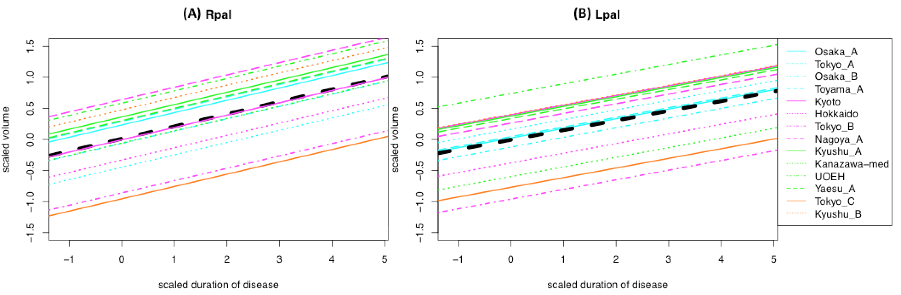

Bold black dashed line showed the best linear unbiased estimates of fixed effect and thin colored solid line showed the best linear unbiased prediction of each site. Abbreviations: Lpal, left globus pallidus; Rpal, right globus pallidus

Supplementary Figure 8. Best linear unbiased estimates of the fixed effect of daily dose of antipsychotics on left globus pallidus and right hippocampus.

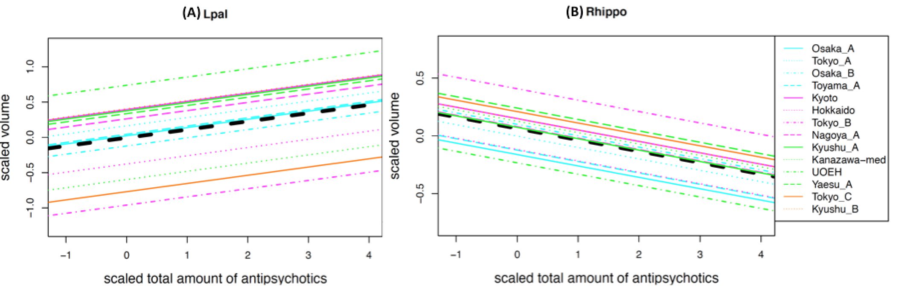

Bold black dashed line showed the best linear unbiased estimates of fixed effect and thin colored solid line showed the best linear unbiased prediction of each site. Abbreviations: Lpal, left globus pallidus; Rhippo, right hippocampus

Supplementary Tables

Supplementary Table 1. All prescribed antipsychotics at the time of scanning and their chlorpromazine equivalent daily dose.

drug | N | CP_equivalent (mg)^{*1} |  | drug | N | CP_equivalent (mg)^{*1}
 |  | Mean | S.D. |  |  | Mean | S.D.
risperidone | 291 | 489.6 | 334.2 | clozapine | 8 | 1062.5 | 165.4
olanzapine | 180 | 526.1 | 278.2 | nemonapride | 8 | 435.7 | 417.2
haroperidol | 133 | 504.5 | 401.8 | propericiazine | 7 | 292.9 | 304.1
quetiapine | 120 | 469.7 | 369.9 | sultopride | 7 | 528.6 | 306.9
Aripiprazole | 116 | 389.5 | 227.0 | PZC | 4 | 150.0 | 76.8
levomepromazine | 102 | 59.0 | 76.5 | tiapride | 4 | 112.5 | 37.5
Chlorpromazine | 77 | 173.1 | 162.0 | pimozide | 2 | 175.0 | 25.0
perospirone | 64 | 325.0 | 204.1 | thioridazine | 2 | 150.0 | 100.0
Bronanselin | 41 | 354.9 | 185.4 | timiperone | 2 | 307.6 | 153.8
sulpiride | 40 | 116.3 | 86.3 | clocapramine | 1 | 75.0 | -
zotepine | 36 | 194.2 | 141.5 | mosapramine | 1 | 225.0 | -
Impromen | 22 | 479.5 | 343.7 | pipamperone | 1 | 75.0 | -
paliperidone | 16 | 487.7 | 172.8 | reserpine | 1 | 1333.4 | -
fluphenazine | 10 | 193.5 | 238.7

*1: chlorpromazine equivalent daily dose (mg)

Supplementary table 2. Characteristics of the included protocols for analysis of the effect of type of antipsychotics

Protocol Name |  |  |  | Age |  | Duration of disease^{*1} |  | Daily dose of antipsychotics ^{*2} |  | Type of Antipsychotics |  | Vendor | MFS
 | N | Male | Female | Mean | s.d. | Mean | s.d. | Mean | s.d. | Typical | Atypical
Osaka_A | 97 | 50 | 47 | 35.7 | 12.1 | 12.1 | 10 | 501.2 | 447 | 6 | 93 | GE | 1.5T
Tokyo_A | 74 | 41 | 33 | 33.1 | 8.8 | 10.7 | 7.8 | 805.5 | 639.3 | 57 | 17 | GE | 1.5T
Toyama_A | 86 | 44 | 42 | 26.8 | 6.1 | 3.9 | 4.8 | 427.2 | 344.9 | 41 | 45 | Siemens | 1.5T
Kyoto | 73 | 37 | 36 | 35.8 | 9.2 | 12.4 | 8.6 | 536.8 | 353.4 | 9 | 64 | Siemens | 3.0T
Tokyo_B | 26 | 17 | 9 | 29.7 | 8.3 | 8.5 | 7.2 | 616.1 | 554.2 | 6 | 20 | GE | 3.0T
Nagoya_A | 33 | 17 | 16 | 43.3 | 11.1 | 18.2 | 11.3 | 508 | 314.9 | 5 | 28 | Siemens | 3.0T
Total | 389 | 206 | 183 | 34.1 | 9.3 | 11.0 | 8.3 | 565.8 | 442.3

Abbreviations: MFS, magnetic field strength
*1: years
*2: chlorpromazine equivalent daily dose of antipsychotics at the time of scan

Supplementary Table 3 The Number of subjects who were prescribed antipsychotics at the date of scan and who were nor.

 | Antipsychotic (+) | Antipsychotic free | Total
Osaka A | 123 | 13 | 136
Tokyo A | 100 | 0 | 100
Osaka B | 68 | 7 | 75
Toyama A | 111 | 6 | 117
Kyoto | 83 | 0 | 83
Hokkaido | 92 | 25 | 117
Tokyo B | 42 | 1 | 43
Nagoya A | 43 | 0 | 43
Kyushu A | 25 | 1 | 26
Kanazawa-med | 34 | 0 | 34
UOEH | 11 | 2 | 13
Yaesu A | 11 | 0 | 11
Tokyo C | 11 | 1 | 12
Kyushu B | 24 | 1 | 25
Total | 778 | 57 | 835

Supplementary Table 4 The demographics of comparison between subjects who were prescribed antipsychotics at the date of scan and who were nor.

 | N  (Male) |  | P value^{*1} | Age  Mean  (s.d.) |  | P value^{*2} | Duration of illness^{*3}  Mean(s.d.) |  | P value^{*2} | Daily dose of Antipsychotics^{*4}  Mean(s.d.)
Antipsychotics | (+) | (-) |  | (+) | (-) |  | (+) | (-) |  | (+)
Protocol Name
Osaka A | 123  (71) | 13  (9) | 0.61 | 35.9  (11.8) | 40.8  (14.4) | 0.24 | 9.7  (12.2) | 9.3  (6.5) | 0.54 | 505.4  (425.0)
Osaka B | 68  (33) | 7  (2) | 0.54 | 33.2  (10.9) | 37.0  (15.7) | 0.68 | 8.9  (11.6) | 9.7  (7.1) | 0.94 | 839.5  (683.0)
Toyama A | 111  (58) | 6  (2) | 0.63 | 26.6  (4.1) | 28.6  (5.5) | 0.36 | 5.1  (6.3) | 6.3  (7.0) | 0.29 | 550  (440.7)
Hokkaido | 92  (32) | 25  (11) | 0.54 | 35.2  (8.6) | 34.3  (13.9) | 0.73 | 9.7  (12) | 3.3  (5.8) | <0.01 | 749.3  (582.6)
Total | 394  (194) | 51  (24) | 0.89 | 34.5  (9.9) | 35.7  (14.1) | 0.20 | 7.8  (10.1) | 6.1  (6.9) | 0.05 | 585.0  (559.2)

*1: chi-square test, *2:Wilcoxon test, *3: years
*4: chlorpromazine equivalent daily dose of antipsychotics at the time of scan

Supplementary Tables 5(a)-(h). Model comparison in the analysis of effect of daily dose of antipsychotics and duration of illness on the volumes of subcortical structures. Parametric bootstrapping was used to implement likelihood ratio test. (a) m1 vs f, (b) m2 vs m1, (c) m3 vs m1, (d) m4 vs m1, (e) m5 vs m1, (f) m6 vs m1, (g) m7 vs m1.

Supplementary table 5 (a)
region | models | LRT | 95% CI
Lhippo | m1 vs f | -7.8 | (-105.9 - 118.1)
Rhippo | m1 vs f | -240.1 | (-337.9 - -118.6)
Lamyg | m1 vs f | -84.2 | (-201.7 - 55.2)
Ramyg | m1 vs f | -122.1 | (-221.4 - 7)
Lthal | m1 vs f | 5.2 | (-146.7 - 210.1)
Rthal | m1 vs f | 18.3 | (-116.4 - 185.5)
Laccumb | m1 vs f | -338.0 | (-431.8 - -213.7)
Raccumb | m1 vs f | -92.8 | (-189.9 - 32.8)
ICV | m1 vs f | -100.4 | (-221.5 - 25.7)
Lcaud | m1 vs f | -62.3 | (-181 - 79.4)
Rcaud | m1 vs f | -57.4 | (-167.4 - 77.4)
Lput | m1 vs f | -46.7 | (-156.4 - 82.6)
Rput | m1 vs f | 11.6 | (-96 - 148.9)
Lpal | m1 vs f | 0.4 | (-101.7 - 151.5)
Rpal | m1 vs f | -149.3 | (-249.4 - -25.9)
LLatVent | m1 vs f | -295.6 | (-409.8 - -156.5)
RLatVent | m1 vs f | -179.8 | (-296.8 - -35.3)

Supplementary table 5 (b)
reg | formula | LRT | 95% CI
Lhippo | m2 vs m1 | -2.4 | (-113 - 104.3)
Rhippo | m2 vs m1 | 0.0 | (-107.5 - 104.4)
Lamyg | m2 vs m1 | 0.0 | (-104 - 114.7)
Ramyg | m2 vs m1 | -0.1 | (-117.4 - 114.7)
Lthal | m2 vs m1 | -0.2 | (-106.6 - 114.7)
Rthal | m2 vs m1 | -0.2 | (-119.9 - 105.3)
Laccumb | m2 vs m1 | 0.0 | (-113.3 - 112.3)
Raccumb | m2 vs m1 | 0.0 | (-101.8 - 108.5)
ICV | m2 vs m1 | -0.6 | (-118 - 103.6)
Lcaud | m2 vs m1 | 0.0 | (-106.8 - 119.1)
Rcaud | m2 vs m1 | -0.1 | (-113.9 - 100.1)
Lput | m2 vs m1 | -2.9 | (-109 - 107.2)
Rput | m2 vs m1 | -1.2 | (-111.6 - 99.5)
Lpal | m2 vs m1 | 0.0 | (-104.6 - 108.1)
Rpal | m2 vs m1 | -0.1 | (-109.5 - 112.2)
LLatVent | m2 vs m1 | -0.7 | (-114.5 - 100.4)
RLatVent | m2 vs m1 | 0.0 | (-110.5 - 110.7)

Supplementary table 5(c)
region | models | LRT | 95% CI
Lhippo | m3 vs m1 | 0.0 | (-109.4 - 101)
Rhippo | m3 vs m1 | -3.1 | (-108.7 - 99.3)
Lamyg | m3 vs m1 | -0.2 | (-105.3 - 109.7)
Ramyg | m3 vs m1 | -4.3 | (-114.6 - 99.7)
Lthal | m3 vs m1 | 0.0 | (-105.6 - 110.4)
Rthal | m3 vs m1 | -0.5 | (-120.1 - 104.5)
Laccumb | m3 vs m1 | -2.9 | (-113 - 102.1)
Raccumb | m3 vs m1 | -0.4 | (-108.2 - 111.1)
ICV | m3 vs m1 | -2.0 | (-119.8 - 109.5)
Lcaud | m3 vs m1 | 0.0 | (-105.3 - 110.5)
Rcaud | m3 vs m1 | -1.6 | (-119.2 - 110)
Lput | m3 vs m1 | 0.0 | (-106.5 - 109.7)
Rput | m3 vs m1 | 0.0 | (-110.2 - 116.3)
Lpal | m3 vs m1 | -1.2 | (-109 - 106.7)
Rpal | m3 vs m1 | -0.2 | (-122.4 - 107.4)
LLatVent | m3 vs m1 | 0.0 | (-105.1 - 98.1)
RLatVent | m3 vs m1 | 0.0 | (-111.6 - 110.4)

Supplementary table 5(d)
region | models | LRT | 95% CI
Lhippo | m4 vs m1 | 0.0 | (-127.5 - 107.6)
Rhippo | m4 vs m1 | -2.7 | (-113.1 - 102.5)
Lamyg | m4 vs m1 | -0.1 | (-111.8 - 111.2)
Ramyg | m4 vs m1 | -4.7 | (-122.4 - 105.6)
Lthal | m4 vs m1 | 0.0 | (-111.4 - 108.8)
Rthal | m4 vs m1 | -2.7 | (-118.4 - 101.9)
Laccumb | m4 vs m1 | -2.6 | (-111 - 99.6)
Raccumb | m4 vs m1 | -0.6 | (-108.7 - 99.8)
ICV | m4 vs m1 | -0.9 | (-111.5 - 100.9)
Lcaud | m4 vs m1 | 0.0 | (-106.7 - 112.3)
Rcaud | m4 vs m1 | 0.0 | (-116.2 - 103.2)
Lput | m4 vs m1 | 0.0 | (-112.8 - 114.7)
Rput | m4 vs m1 | 0.0 | (-112.8 - 109.1)
Lpal | m4 vs m1 | -0.4 | (-107.1 - 108.7)
Rpal | m4 vs m1 | 0.0 | (-108 - 104.9)
LLatVent | m4 vs m1 | -0.4 | (-105.8 - 114.8)
RLatVent | m4 vs m1 | -1.2 | (-119.5 - 102.9)

Supplementary table 5(e)
region | models | LRT | 95% CI
Lhippo | m5 vs m1 | -0.7 | (-123 - 103)
Rhippo | m5 vs m1 | -0.6 | (-111.8 - 105.2)
Lamyg | m5 vs m1 | -1.7 | (-123.1 - 101)
Ramyg | m5 vs m1 | -1.5 | (-118.7 - 109.5)
Lthal | m5 vs m1 | 0.0 | (-111.1 - 108.6)
Rthal | m5 vs m1 | 0.0 | (-114.2 - 109.7)
Laccumb | m5 vs m1 | -0.8 | (-114.9 - 113.8)
Raccumb | m5 vs m1 | 0.0 | (-110.2 - 112.4)
ICV | m5 vs m1 | -4.9 | (-117.4 - 105.4)
Lcaud | m5 vs m1 | -1.4 | (-111.5 - 107.1)
Rcaud | m5 vs m1 | -0.1 | (-109.9 - 110.6)
Lput | m5 vs m1 | 0.0 | (-112.7 - 110.5)
Rput | m5 vs m1 | -4.5 | (-116.4 - 111)
Lpal | m5 vs m1 | 0.0 | (-106.5 - 111.2)
Rpal | m5 vs m1 | -2.1 | (-108 - 107.7)
LLatVent | m5 vs m1 | 0.0 | (-106.2 - 109.6)
RLatVent | m5 vs m1 | -2.0 | (-112.1 - 105.8)

Supplementary table 5(f)
region | models | LRT | 95% CI
Lhippo | m6 vs m1 | -0.8 | (-109.4 - 104.4)
Rhippo | m6 vs m1 | -2.0 | (-113.3 - 111.4)
Lamyg | m6 vs m1 | -6.7 | (-111.3 - 93)
Ramyg | m6 vs m1 | -22.9 | (-134.3 - 85.2)
Lthal | m6 vs m1 | 0.0 | (-107.9 - 114.5)
Rthal | m6 vs m1 | -1.5 | (-109.9 - 108.6)
Laccumb | m6 vs m1 | -1.8 | (-116.1 - 101.1)
Raccumb | m6 vs m1 | -1.6 | (-106.3 - 110.7)
ICV | m6 vs m1 | - | -
Lcaud | m6 vs m1 | -10.3 | (-120.6 - 104.5)
Rcaud | m6 vs m1 | -12.2 | (-128.6 - 97.1)
Lput | m6 vs m1 | 0.0 | (-112.9 - 108.7)
Rput | m6 vs m1 | -9.4 | (-124.8 - 99.9)
Lpal | m6 vs m1 | -1.2 | (-115.2 - 113.6)
Rpal | m6 vs m1 | -17.0 | (-118.7 - 86)
LLatVent | m6 vs m1 | 0.0 | (-111.2 - 105.9)
RLatVent | m6 vs m1 | -23.5 | (-132.9 - 86.6)

Supplementary table 5(g)
region | models | LRT | 95% CI
Lhippo | m7 vs m1 | -3.4 | (-116.3 - 107.8)
Rhippo | m7 vs m1 | -5.2 | (-120.3 - 104.3)
Lamyg | m7 vs m1 | -7.0 | (-119.1 - 93.8)
Ramyg | m7 vs m1 | -27.3 | (-148.2 - 70.5)
Lthal | m7 vs m1 | -0.2 | (-115.8 - 111.4)
Rthal | m7 vs m1 | -4.8 | (-124.1 - 98.6)
Laccumb | m7 vs m1 | -4.6 | (-124.2 - 104)
Raccumb | m7 vs m1 | -2.0 | (-117.9 - 104.5)
ICV | m7 vs m1 | -7.7 | (-113.1 - 94.1)
Lcaud | m7 vs m1 | -10.4 | (-127.7 - 99.6)
Rcaud | m7 vs m1 | -15.0 | (-130.6 - 87.3)
Lput | m7 vs m1 | -3.0 | (-109.1 - 102.9)
Rput | m7 vs m1 | -10.9 | (-125.5 - 93.8)
Lpal | m7 vs m1 | -2.5 | (-109.2 - 104)
Rpal | m7 vs m1 | -18.4 | (-137.2 - 88.6)
LLatVent | m7 vs m1 | -1.2 | (-115.2 - 107.4)
RLatVent | m7 vs m1 | -24.1 | (-139.5 - 80.4)

Abbreviations: Lhippo, left hippocampus; Rhippo, right hippocampus; Lamyg, left amygdala; Ramyg, right amygdala; Lthal, left thalamus; Rthal, right thalamus; Laccumb, left accumbens; Raccumb, right accumbens; ICV, intracranial volume; Lcaud, left caudate; Rcaud, right caudate; Lput, left putamen; Rput, right putamen; Lpal, left globus pallidus; Rpal, right globus pallidus; LLatVent, left lateral ventricle; RLatVent, right lateral ventricle; LRT: mean result of likelihood ratio test; 95% CI: 95% confidence interval of likelihood ratio test

Supplementary Tables 6(a)-(h). Model comparison in the analysis of effect of type of antipsychotics on the volume of subcortical structures. Parametric bootstrapping was used to implement likelihood ratio test. (a) m1 vs f, (b) m2 vs m1, (c) m3 vs m1, (d) m4 vs m1, (e) m5 vs m1, (f) m6 vs m1, (g) m7 vs m1, (h) m8 vs m1.

Supplementary table 6(a)
region | models | LRT | 95% CI
Lhippo | m1 vs f | 9.5 | (-55.8 - 99.7)
Rhippo | m1 vs f | 17.0 | (-49.6 - 106.4)
Lamyg | m1 vs f | 3.5 | (-65.5 - 106.1)
Ramyg | m1 vs f | 5.4 | (-55.8 - 102)
Lthal | m1 vs f | -0.5 | (-73.5 - 100.8)
Rthal | m1 vs f | -41.7 | (-114.5 - 57.7)
Laccumb | m1 vs f | -177.9 | (-241.4 - -82.6)
Raccumb | m1 vs f | -87.6 | (-150.7 - 2.6)
ICV | m1 vs f | -36.6 | (-107.8 - 55.9)
Lcaud | m1 vs f | 15.9 | (-48.2 - 120.4)
Rcaud | m1 vs f | -39.4 | (-106.3 - 57.9)
Lput | m1 vs f | -33.9 | (-95.7 - 61.1)
Rput | m1 vs f | -53.2 | (-120.2 - 39.2)
Lpal | m1 vs f | -11.3 | (-85.4 - 88.2)
Rpal | m1 vs f | -19.2 | (-120.9 - 116)
LLatVent | m1 vs f | 17.7 | (-97.7 - 196.6)
RLatVent | m1 vs f | 19.5 | (-89.7 - 168.4)

Supplementary table 6(b)
region | models | LRT | 95% CI
Lhippo | m2 vs m1 | 0.0 | (-75 - 80.9)
Rhippo | m2 vs m1 | 0.0 | (-79.1 - 81.1)
Lamyg | m2 vs m1 | 0.0 | (-76.8 - 73.1)
Ramyg | m2 vs m1 | 0.0 | (-74.9 - 76.1)
Lthal | m2 vs m1 | 0.0 | (-84.9 - 76.7)
Rthal | m2 vs m1 | -0.7 | (-73.6 - 74.8)
Laccumb | m2 vs m1 | 0.0 | (-74 - 78.1)
Raccumb | m2 vs m1 | -1.0 | (-82.7 - 76.7)
ICV | m2 vs m1 | 0.0 | (-82.9 - 75.1)
Lcaud | m2 vs m1 | 0.0 | (-72.1 - 75.6)
Rcaud | m2 vs m1 | 0.0 | (-77.5 - 74.1)
Lput | m2 vs m1 | 0.0 | (-78.9 - 77.6)
Rput | m2 vs m1 | 0.0 | (-77.7 - 78.3)
Lpal | m2 vs m1 | 0.0 | (-71.4 - 82.9)
Rpal | m2 vs m1 | 0.0 | (-75.4 - 74.2)
LLatVent | m2 vs m1 | -0.3 | (-77.5 - 79.6)
RLatVent | m2 vs m1 | 0.0 | (-73.5 - 77.9)

Supplementary table 6(c)
region | models | LRT | 95% CI
Lhippo | m3 vs m1 | 0.0 | (-76.4 - 76.6)
Rhippo | m3 vs m1 | 0.0 | (-75 - 80.7)
Lamyg | m3 vs m1 | -0.2 | (-73.6 - 74.8)
Ramyg | m3 vs m1 | -0.2 | (-79.3 - 75.6)
Lthal | m3 vs m1 | 0.0 | (-77.6 - 80.4)
Rthal | m3 vs m1 | 0.0 | (-77.5 - 79.2)
Laccumb | m3 vs m1 | 0.0 | (-79.5 - 76.7)
Raccumb | m3 vs m1 | 0.0 | (-80.7 - 72)
ICV | m3 vs m1 | -0.2 | (-79 - 82.9)
Lcaud | m3 vs m1 | 0.0 | (-81.5 - 77.3)
Rcaud | m3 vs m1 | 0.0 | (-77.6 - 75.6)
Lput | m3 vs m1 | -0.5 | (-76.2 - 71.1)
Rput | m3 vs m1 | 0.0 | (-78.2 - 75.8)
Lpal | m3 vs m1 | 0.0 | (-78.2 - 73.5)
Rpal | m3 vs m1 | 0.0 | (-86.1 - 79.2)
LLatVent | m3 vs m1 | -0.4 | (-72.6 - 82.3)
RLatVent | m3 vs m1 | -1.5 | (-79.6 - 77.1)

Supplementary table 6(d)
region | models | LRT | 95% CI
Lhippo | m4 vs m1 | 0.0 | (-73.1 - 78.5)
Rhippo | m4 vs m1 | 0.0 | (-76.2 - 74.8)
Lamyg | m4 vs m1 | -1.8 | (-84.1 - 71.5)
Ramyg | m4 vs m1 | -1.0 | (-75.2 - 81.4)
Lthal | m4 vs m1 | 0.0 | (-80.4 - 77.3)
Rthal | m4 vs m1 | -0.4 | (-74.9 - 74.9)
Laccumb | m4 vs m1 | -0.7 | (-73.6 - 69.7)
Raccumb | m4 vs m1 | -0.8 | (-86.8 - 75.7)
ICV | m4 vs m1 | -0.6 | (-78.4 - 74.2)
Lcaud | m4 vs m1 | 0.0 | (-78.3 - 79.6)
Rcaud | m4 vs m1 | 0.0 | (-79.7 - 73.8)
Lput | m4 vs m1 | -1.2 | (-76.5 - 74.4)
Rput | m4 vs m1 | -0.1 | (-76.6 - 81.4)
Lpal | m4 vs m1 | 0.0 | (-74.3 - 80.9)
Rpal | m4 vs m1 | 0.0 | (-78.5 - 79)
LLatVent | m4 vs m1 | 0.0 | (-76.8 - 80.4)
RLatVent | m4 vs m1 | -0.5 | (-79.9 - 79)

Supplementary table 6(e)
region | models | LRT | 95% CI
Lhippo | m5 vs m1 | 0.0 | (-73.1 - 80.7)
Rhippo | m5 vs m1 | 0.0 | (-72.6 - 71.2)
Lamyg | m5 vs m1 | 0.0 | (-77.2 - 80)
Ramyg | m5 vs m1 | -1.1 | (-79.6 - 76.1)
Lthal | m5 vs m1 | 0.0 | (-78.2 - 74.3)
Rthal | m5 vs m1 | 0.0 | (-78.9 - 77)
Laccumb | m5 vs m1 | -3.2 | (-81 - 74)
Raccumb | m5 vs m1 | -3.2 | (-82.7 - 71.6)
ICV | m5 vs m1 | -0.8 | (-85.1 - 74)
Lcaud | m5 vs m1 | 0.0 | (-83.8 - 78.5)
Rcaud | m5 vs m1 | 0.0 | (-74.3 - 71.8)
Lput | m5 vs m1 | -1.6 | (-77.4 - 77)
Rput | m5 vs m1 | -0.1 | (-84.6 - 79.5)
Lpal | m5 vs m1 | -0.1 | (-74.8 - 74.2)
Rpal | m5 vs m1 | -1.4 | (-82.1 - 81.7)
LLatVent | m5 vs m1 | -1.1 | (-79.2 - 82.1)
RLatVent | m5 vs m1 | -1.9 | (-79.5 - 78.5)

Supplementary table 6(f)
region | models | LRT | 95% CI
Lhippo | m6 vs m1 | -1.1 | (-77.9 - 77.4)
Rhippo | m6 vs m1 | -1.2 | (-77.8 - 71.9)
Lamyg | m6 vs m1 | 0.0 | (-73.4 - 77.6)
Ramyg | m6 vs m1 | 0.0 | (-76 - 74.2)
Lthal | m6 vs m1 | 0.0 | (-82.8 - 79.5)
Rthal | m6 vs m1 | 0.0 | (-76.9 - 76.7)
Laccumb | m6 vs m1 | -0.4 | (-76.2 - 73.2)
Raccumb | m6 vs m1 | -0.8 | (-75.2 - 74.4)
ICV | m6 vs m1 | -5.6 | (-80.1 - 73.1)
Lcaud | m6 vs m1 | -0.8 | (-82.1 - 77.7)
Rcaud | m6 vs m1 | -1.5 | (-83.9 - 82.7)
Lput | m6 vs m1 | -1.9 | (-78.5 - 72.2)
Rput | m6 vs m1 | -0.9 | (-79.5 - 70.6)
Lpal | m6 vs m1 | 0.0 | (-78.1 - 74.8)
Rpal | m6 vs m1 | 0.0 | (-80.2 - 75.6)
LLatVent | m6 vs m1 | 0.0 | (-74.8 - 77.8)
RLatVent | m6 vs m1 | 0.0 | (-83 - 80.2)

Supplementary table 6(g)
region | models | LRT | 95% CI
Lhippo | m7 vs m1 | -1.4 | (-80.7 - 75.9)
Rhippo | m7 vs m1 | -1.7 | (-79.7 - 78.6)
Lamyg | m7 vs m1 | -0.4 | (-72.1 - 74.6)
Ramyg | m7 vs m1 | -12.8 | (-87.2 - 67.1)
Lthal | m7 vs m1 | -4.5 | (-79.5 - 71.2)
Rthal | m7 vs m1 | -0.5 | (-77.9 - 78)
Laccumb | m7 vs m1 | -0.7 | (-82.5 - 74.9)
Raccumb | m7 vs m1 | -0.3 | (-80 - 76.7)
ICV | m7 vs m1 | - | -
Lcaud | m7 vs m1 | -0.2 | (-80.3 - 78.1)
Rcaud | m7 vs m1 | -4.0 | (-80.8 - 75.7)
Lput | m7 vs m1 | -5.2 | (-77.8 - 69.2)
Rput | m7 vs m1 | -5.2 | (-80.1 - 71.1)
Lpal | m7 vs m1 | -0.1 | (-79.7 - 79.5)
Rpal | m7 vs m1 | -0.8 | (-81.6 - 73.9)
LLatVent | m7 vs m1 | 0.0 | (-73.1 - 78.7)
RLatVent | m7 vs m1 | -1.4 | (-86 - 76)

Supplementary table 6(h)
region | models | LRT | 95% CI
Lhippo | m8 vs m1 | -1.4 | (-80.3 - 69.7)
Rhippo | m8 vs m1 | -2.1 | (-77.8 - 72.9)
Lamyg | m8 vs m1 | -2.3 | (-76.8 - 70.4)
Ramyg | m8 vs m1 | -14 | (-95.2 - 60)
Lthal | m8 vs m1 | -4.5 | (-83.5 - 67.2)
Rthal | m8 vs m1 | -1.5 | (-81.3 - 72.2)
Laccumb | m8 vs m1 | -4.0 | (-86.8 - 68.9)
Raccumb | m8 vs m1 | -5.2 | (-91 - 68.9)
ICV | m8 vs m1 | -7.0 | (-94.8 - 72.9)
Lcaud | m8 vs m1 | -0.8 | (-75.4 - 76.3)
Rcaud | m8 vs m1 | -4.8 | (-87.8 - 74.7)
Lput | m8 vs m1 | -7.9 | (-92.3 - 71)
Rput | m8 vs m1 | -5.2 | (-82.4 - 72.5)
Lpal | m8 vs m1 | -0.2 | (-84.7 - 73.2)
Rpal | m8 vs m1 | -2.8 | (-84.8 - 70.4)
LLatVent | m8 vs m1 | -2.1 | (-81.4 - 71.1)
RLatVent | m8 vs m1 | -5.3 | (-88.6 - 74.8)

Abbreviations: Lhippo, left hippocampus; Rhippo, right hippocampus; Lamyg, left amygdala; Ramyg, right amygdala; Lthal, left thalamus; Rthal, right thalamus; Laccumb, left accumbens; Raccumb, right accumbens; ICV, intracranial volume; Lcaud, left caudate; Rcaud, right caudate; Lput, left putamen; Rput, right putamen; Lpal, left globus pallidus; Rpal, right globus pallidus; LLatVent, left lateral ventricle; RLatVent, right lateral ventricle; LRT: mean result of likelihood ratio test; 95% CI: 95% confidence interval of likelihood ratio test

Supplementary Table 7. Model comparison in the analysis of effect of daily dose of antipsychotics and duration of illness on the LI of globus pallidus. Parametric bootstrapping was used to implement likelihood ratio test.

region | models | LRT | 95%CI
LI.pal | m1 vs f | -73.7 | (-220.5 - 74.1)
LI.pal | m2 vs m1 | 0.0 | (-117.5 - 113.7)
LI.pal | m3 vs m1 | -6.4 | (-113.9 - 87.7)
LI.pal | m4 vs m1 | -12.2 | (-124 - 83.9)
LI.pal | m5 vs m1 | -0.1 | (-102.8 - 107.6)
LI.pal | m6 vs m1 | -12.3 | (-125.4 - 97.8)

Abbreviations: LI.pal, laterality index of globus pallidus; LRT: mean result of likelihood ratio test; 95% CI: 95% confidence interval of likelihood ratio test

Supplementary Table 8. Model comparison in the analysis of type of antipsychotics on the LI of globus pallidus. Parametric bootstrapping was used to implement likelihood ratio test.

region | models | LRT | 95%CI
LI.pal | m1 vs f | -30.7 | (-129.5 - 92.2)
LI.pal | m2 vs m1 | -0.4 | (-72.3 - 81)
LI.pal | m3 vs m1 | -0.1 | (-75.6 - 78.2)
LI.pal | m4 vs m1 | -5.4 | (-81 - 77.7)
LI.pal | m5 vs m1 | -12.8 | (-90.9 - 64)
LI.pal | m6 vs m1 | 0.0 | (-73.9 - 80.2)
LI.pal | m7 vs m1 | -13.3 | (-94.3 - 59)

Abbreviations: LI.pal, laterality index of globus pallidus; LRT: mean result of likelihood ratio test; 95% CI: 95% confidence interval of likelihood ratio test

Supplementary Tables 9 (a)-(c) Results of fixed effect model (f) in the analysis of the effect of daily dose of antipsychotics and duration of illness on the volumes of subcortical structures. (a) model fitting, (b) beta coefficients of daily dose of antipsychotics, (c) beta coefficients of duration of illness.

Supplementary Table 9(a) model fitting
 | R² | F_value | df1 | df2 | p value
Lhippo | 0.28 | 59.7 | 5 | 772 | < 1.0x10⁻⁴
Rhippo | 0.27 | 57.2 | 5 | 772 | < 1.0x10⁻⁴
Lamyg | 0.24 | 49.4 | 5 | 772 | < 1.0x10⁻⁴
Ramyg | 0.2 | 38.7 | 5 | 772 | < 1.0x10-⁴
Lthal | 0.45 | 125.7 | 5 | 772 | < 1.0x10⁻⁴
Rthal | 0.49 | 146.8 | 5 | 772 | < 1.0x10⁻⁴
Laccumb | 0.09 | 15.5 | 5 | 772 | 3.3x10⁻⁴
Raccumb | 0.14 | 24.4 | 5 | 772 | < 1.0x10⁻⁴
ICV | 0.26 | 67.8 | 4 | 773 | < 1.0x10⁻⁴
Lcaud | 0.34 | 78.1 | 5 | 772 | < 1.0x10⁻⁴
Rcaud | 0.25 | 50.1 | 5 | 772 | < 1.0x10⁻⁴
Lput | 0.2 | 38.5 | 5 | 772 | < 1.0x10⁻⁴
Rput | 0.24 | 49.8 | 5 | 772 | < 1.0x10⁻⁴
Lpal | 0.24 | 48.4 | 5 | 772 | < 1.0x10⁻⁴
Rpal | 0.17 | 32.2 | 5 | 772 | < 1.0x10⁻⁴
LLatVent | 0.21 | 40.2 | 5 | 772 | < 1.0x10⁻⁴
RLatVent | 0.21 | 40.4 | 5 | 772 | < 1.0x10⁻⁴

Supplementary Table 9(b) beta coefficients of daily dose of antipsychotics
 | Beta(mm3) | SE(mm3) | t value | p value
Lhippo | -0.058 | 0.032 | -1.8 | 0.07
Rhippo | -0.092 | 0.032 | -2.8 | 4.5x10⁻³
Lamyg | -0.037 | 0.033 | -1.1 | 0.26
Ramyg | -0.041 | 0.034 | -1.2 | 0.22
Lthal | -0.015 | 0.028 | -0.5 | 0.61
Rthal | 0.041 | 0.027 | 1.5 | 0.13
Laccumb | -0.065 | 0.036 | -1.8 | 0.07
Raccumb | -0.148 | 0.035 | -4.2 | 3.0x10⁻⁵
ICV | 0.048 | 0.033 | 1.5 | 0.14
Lcaud | 0.003 | 0.031 | 0.1 | 0.91
Rcaud | -0.06 | 0.033 | -1.8 | 0.07
Lput | -0.041 | 0.034 | -1.2 | 0.22
Rput | -0.031 | 0.033 | -1 | 0.34
Lpal | 0.071 | 0.033 | 2.1 | 0.03
Rpal | -0.001 | 0.034 | 0 | 0.98
LLatVent | 0.031 | 0.034 | 0.9 | 0.36
RLatVent | 0.058 | 0.034 | 1.7 | 0.08

Supplementary Table 9(c) beta coefficients of daily dose of antipsychotics
 | Beta(mm3) | SE(mm3) | t value | p value
Lhippo | -0.042 | -0.999 | -1.0 | 0.32
Rhippo | -0.067 | -1.560 | -1.6 | 0.12
Lamyg | 0.039 | 0.888 | 0.9 | 0.37
Ramyg | 0.057 | 1.266 | 1.3 | 0.21
Lthal | -0.062 | -1.657 | -1.7 | 0.1
Rthal | -0.045 | -1.245 | -1.2 | 0.21
Laccumb | 0.076 | 1.596 | 1.6 | 0.11
Raccumb | 0.09 | 1.941 | 1.9 | 0.05
ICV | 0.003 | 0.077 | 0.1 | 0.94
Lcaud | 0.011 | 0.257 | 0.3 | 0.8
Rcaud | 0.092 | 2.115 | 2.1 | 0.03
Lput | 0.089 | 1.997 | 2.0 | 0.05
Rput | 0.133 | 3.053 | 3.1 | 2.4x10⁻³
Lpal | 0.195 | 4.467 | 4.5 | 9.1x10⁻⁵
Rpal | 0.228 | 5.009 | 5.0 | 6.8x10⁻⁷
LLatVent | 0.065 | 1.453 | 1.5 | 0.15
RLatVent | 0.077 | 1.732 | 1.7 | 0.08

Abbreviations: Lhippo, left hippocampus; Rhippo, right hippocampus; Lamyg, left amygdala; Ramyg, right amygdala; Lthal, left thalamus; Rthal, right thalamus; Laccumb, left accumbens; Raccumb, right accumbens; ICV, intracranial volume; Lcaud, left caudate; Rcaud, right caudate; Lput, left putamen; Rput, right putamen; Lpal, left globus pallidus; Rpal, right globus pallidus; LLatVent, left lateral ventricle; RLatVent, right lateral ventricle; R², coefficient of determination; df1, degree of freedom for factor; df2, degree of freedom for error; Beta, beta value; SE, standard error

Supplementary Tables 10 (a) - (b) Results of fixed effect model (f) in the analysis of the effect of type of antipsychotics on the volumes of subcortical structures. (a) model fitting, (b) beta coefficients of type of antipsychotics.

Supplementary Table 10 (a) model fitting
 | R² | F_value | df1 | df2 | p value
Lhippo | 0.38 | 38.5 | 6 | 382 | < 1.0x10⁻⁴
Rhippo | 0.37 | 36.7 | 6 | 382 | < 1.0x10⁻⁴
Lamyg | 0.32 | 30.5 | 6 | 382 | < 1.0x10⁻⁴
Ramyg | 0.27 | 23.5 | 6 | 382 | < 1.0x10⁻⁴
Lthal | 0.49 | 60.0 | 6 | 382 | < 1.0x10⁻⁴
Rthal | 0.56 | 80.5 | 6 | 382 | < 1.0x10⁻⁴
Laccumb | 0.10 | 7.3 | 6 | 382 | 3.3x10⁻⁴
Raccumb | 0.17 | 12.7 | 6 | 382 | < 1.0x10⁻⁴
ICV | 0.32 | 36.8 | 5 | 383 | < 1.0x10⁻⁴
Lcaud | 0.37 | 37.7 | 6 | 382 | < 1.0x10⁻⁴
Rcaud | 0.25 | 21.5 | 6 | 382 | < 1.0x10⁻⁴
Lput | 0.24 | 19.6 | 6 | 382 | < 1.0x10⁻⁴
Rput | 0.26 | 22.9 | 6 | 382 | < 1.0x10⁻⁴
Lpal | 0.28 | 25.0 | 6 | 382 | < 1.0x10⁻⁴
Rpal | 0.14 | 10.7 | 6 | 382 | < 1.0x10⁻⁴
LLatVent | 0.22 | 17.9 | 6 | 382 | < 1.0x10⁻⁴
RLatVent | 0.18 | 13.9 | 6 | 382 | < 1.0x10⁻⁴

Supplementary Table 10 (b) beta coefficients of type of antipsychotics
 | Beta(mm³) | SE(mm³) | t value | p value
Lhippo | -0.114 | 0.090 | -1.3 | 0.20
Rhippo | 0.055 | 0.091 | 0.6 | 0.54
Lamyg | 0.012 | 0.093 | 0.1 | 0.90
Ramyg | 0.183 | 0.097 | 1.9 | 0.06
Lthal | 0.040 | 0.082 | 0.5 | 0.63
Rthal | -0.133 | 0.076 | -1.8 | 0.08
Laccumb | 0.271 | 0.108 | 2.5 | 0.01
Raccumb | 0.428 | 0.104 | 4.1 | 4.6x10⁻⁵
ICV | -0.303 | 0.092 | -3.3 | 1.1x10⁻³
Lcaud | 0.174 | 0.090 | 1.9 | 0.05
Rcaud | 0.222 | 0.098 | 2.3 | 0.02
Lput | 0.155 | 0.099 | 1.6 | 0.12
Rput | 0.203 | 0.097 | 2.1 | 0.04
Lpal | -0.105 | 0.096 | -1.1 | 0.28
Rpal | 0.029 | 0.105 | 0.3 | 0.79
LLatVent | 0.292 | 0.100 | 2.9 | 3.9x10⁻³
RLatVent | 0.147 | 0.103 | 1.4 | 0.15

Abbreviations: Lhippo, left hippocampus; Rhippo, right hippocampus; Lamyg, left amygdala; Ramyg, right amygdala; Lthal, left thalamus; Rthal, right thalamus; Laccumb, left accumbens; Raccumb, right accumbens; ICV, intracranial volume; Lcaud, left caudate; Rcaud, right caudate; Lput, left putamen; Rput, right putamen; Lpal, left globus pallidus; Rpal, right globus pallidus; LLatVent, left lateral ventricle; RLatVent, right lateral ventricle; R², coefficient of determination; df1, degree of freedom for factor; df2, degree of freedom for error; Beta, beta value; SE, standard error

Supplementary Tables 11 (a)-(c) Results of fixed effect model (f) in the analysis of the effect of daily dose of antipsychotics and duration on the LI of globus pallidus. (a) model fitting, (b) beta coefficients of daily dose of antipsychotics, (c) beta coefficients of duration of illness.

Supplementary Table 11 (a) model fitting
 | R² | F_value | df1 | df2 | p value
LI.pal | 0.04 | 7.5 | 4 | 773 | < 1.0x10⁻⁴

Supplementary Table 11 (b) beta coefficients of daily dose of antipsychotics
CP | Beta(mm3) | SE(mm3) | df^{*1} | t value | p value
LI.pal | 0.083 | 0.035 | 768.8 | 2.3 | 0.02

Supplementary Table 11 (c) beta coefficients of duration of illness
CP | Beta(mm3) | SE(mm3) | df^{*1} | t value | p value
LI.pal | -0.008 | 0.047 | 771.7 | -0.2 | 0.87

Abbreviations: LI.pal, laterality index of globus pallidus; R², coefficient of determination; df1, degree of freedom for factor; df2, degree of freedom for error; Beta, beta value; SE, standard error
*1: the Satterthwaite approximated degree of freedom

Supplementary Tables 12 (a)-(b) Result of fixed effect model (f) in the analysis of the effect of type of antipsychotics on the LI of globus pallidus. (a) model fitting, (b) beta coefficients of type of antipsychotics.

Supplementary Table 12 (a) model fitting
 | R² | F_value | df1 | df2 | p value
LI.pal | 0.08 | 6.4 | 5 | 383 | < 1.0x10⁻⁴

Supplementary Table 12 (b) beta coefficients of type of antipsychotics
CP | Beta(mm³) | SE(mm³) | df^{*1} | t value | p value
LI.pal | -0.067 | 0.121 | 373.2 | -0.6 | 0.58

Abbreviations: LI.pal, laterality index of globus pallidus; R², coefficient of determination; df1, degree of freedom for factor; df2, degree of freedom for error; Beta, beta value; SE, standard error

*1: the Satterthwaite approximated degree of freedom

Supplementary Table 13. The statistical significance of beta coefficient of duration of illness on subcortical structure volumes in t-test and parametric bootstrapping test
 |  |  | t test |  |  | parametric bootstrapping
 | Beta(mm³) | SE(mm3) | df^{*1} | t value | p value^{*2} | mean | 95%CI
Lhippo | -0.055 | 0.042 | 771.8 | -1.3 | 0.19 | -0.05 | (-0.14 - 0.04)
Rhippo | -0.086 | 0.043 | 769.7 | -2.0 | 0.05* | -0.09 | (-0.17 - 0.00)
Lamyg | -0.002 | 0.041 | 763.6 | -0.1 | 0.96 | 0.00 | (-0.08 - 0.08)
Ramyg | 0.013 | 0.040 | 761.9 | 0.3 | 0.75 | 0.01 | (-0.06 - 0.09)
Lthal | -0.065 | 0.036 | 771.2 | -1.8 | 0.07 | -0.07 | (-0.14 - 0.01)
Rthal | -0.047 | 0.033 | 767.9 | -1.4 | 0.15 | -0.05 | (-0.11 - 0.02)
Laccumb | 0.020 | 0.038 | 763.8 | 0.5 | 0.60 | 0.02 | (-0.05 - 0.10)
Raccumb | 0.046 | 0.040 | 765.4 | 1.2 | 0.25 | 0.04 | (-0.04 - 0.12)
ICV | 0.043 | 0.041 | 771.4 | 1.1 | 0.29 | 0.04 | (-0.03 - 0.12)
Lcaud | 0.020 | 0.039 | 763.3 | 0.5 | 0.62 | 0.02 | (-0.06 - 0.10)
Rcaud | 0.086 | 0.039 | 762.4 | 2.2 | 0.03* | 0.09 | (0.01 - 0.16)
Lput | 0.059 | 0.041 | 764.3 | 1.4 | 0.15 | 0.06 | (-0.03 - 0.14)
Rput | 0.097 | 0.039 | 764.7 | 2.5 | 0.01 | 0.10 | (0.02 - 0.18)
Lpal | 0.155 | 0.041 | 765.5 | 3.8 | 1.7x10⁻⁴ ** | 0.16 | (0.08 - 0.24)
Rpal | 0.198 | 0.043 | 765.8 | 4.6 | 4.7x10⁻⁶** | 0.20 | (0.12 - 0.28)
LLatVent | 0.022 | 0.045 | 770.4 | 0.5 | 0.63 | 0.02 | (-0.06 - 0.12)
RLatVent | 0.060 | 0.045 | 758.2 | 1.3 | 0.18 | 0.06 | (-0.03 - 0.15)

Abbreviations:Lhippo, left hippocampus; Rhippo, right hippocampus; Lamyg, left amygdala; Ramyg, right amygdala; Lthal, left thalamus; Rthal, right thalamus; Laccumb, left accumbens; Raccumb, right accumbens; ICV, intracranial volume; Lcaud, left caudate; Rcaud, right caudate; Lput, left putamen; Rput, right putamen; Lpal, left globus pallidus; Rpal, right globus pallidus; LLatVent, left lateral ventricle; RLatVent, right lateral ventricle; 95% CI, 95% confidence interval*1: the Satterthwaite approximated degree of freedom, *2: *; 0.0029≤p<0.05, **;p<0.0029
Supplementary Table 14. The statistical significance of beta coefficient of daily dose of antipsychotics on subcortical structure volumes in t-test and parametric bootstrapping test
 |  |  | t test |  |  | parametric bootstrapping
 | Beta(mm³) | SE(mm3) | df^{*1} | t value | p value^{*2} | mean | 95%CI
Lhippo | -0.068 | 0.032 | 769.0 | -2.2 | 0.03* | -0.07 | (-0.13 - -0.01)
Rhippo | -0.099 | 0.032 | 771.9 | -3.0 | 2.4x10⁻³ ** | -0.10 | (-0.16 - -0.03)
Lamyg | -0.004 | 0.031 | 761.1 | -0.1 | 0.89 | 0.00 | (-0.06 - 0.05)
Ramyg | 0.007 | 0.030 | 760.4 | 0.2 | 0.80 | 0.01 | (-0.05 - 0.06)
Lthal | -0.048 | 0.027 | 768.4 | -1.8 | 0.07 | -0.05 | (-0.10 - 0.01)
Rthal | -0.008 | 0.024 | 764.9 | -0.3 | 0.74 | -0.01 | (-0.06 - 0.04)
Laccumb | -0.015 | 0.029 | 761.9 | -0.5 | 0.61 | -0.01 | (-0.07 - 0.04)
Raccumb | -0.066 | 0.030 | 762.9 | -2.2 | 0.03 * | -0.06 | (-0.12 - -0.01)
ICV | -0.010 | 0.030 | 768.4 | -0.3 | 0.73 | -0.01 | (-0.07 - 0.05)
Lcaud | 0.023 | 0.029 | 760.7 | 0.8 | 0.44 | 0.02 | (-0.04 - 0.07)
Rcaud | 0.011 | 0.029 | 760.5 | 0.4 | 0.70 | 0.01 | (-0.05 - 0.07)
Lput | 0.034 | 0.031 | 761.7 | 1.1 | 0.28 | 0.04 | (-0.03 - 0.10)
Rput | 0.043 | 0.029 | 762.1 | 1.5 | 0.14 | 0.04 | (-0.01 - 0.10)
Lpal | 0.116 | 0.031 | 762.6 | 3.8 | 2.0x10⁻⁴** | 0.12 | (0.06 - 0.18)
Rpal | 0.065 | 0.032 | 762.8 | 2.0 | 0.04* | 0.06 | (0.00 - 0.13)
LLatVent | 0.052 | 0.034 | 771.8 | 1.5 | 0.12 | 0.05 | (-0.02 - 0.12)
RLatVent | 0.075 | 0.034 | 769.4 | 2.2 | 0.03* | 0.07 | (0.01 - 0.14)

Abbreviations:Lhippo, left hippocampus; Rhippo, right hippocampus; Lamyg, left amygdala; Ramyg, right amygdala; Lthal, left thalamus; Rthal, right thalamus; Laccumb, left accumbens; Raccumb, right accumbens; ICV, intracranial volume; Lcaud, left caudate; Rcaud, right caudate; Lput, left putamen; Rput, right putamen; Lpal, left globus pallidus; Rpal, right globus pallidus; LLatVent, left lateral ventricle; RLatVent, right lateral ventricle; 95% CI, 95% confidence interval; *1, the Satterthwaite approximated degree of freedom; *2, *, 0.0029≤p<0.05; **, p<0.0029
Supplementary Table 15. The statistical significance of beta coefficient of daily dose of antipsychotics on subcortical structure volumes in t-test and parametric bootstrapping test using medicated subjects and drug free subjects
 |  |  | t test |  |  | parametric bootstrapping
 | Beta(mm³) | SE(mm3) | df^{*1} | t value | p value^{*2} | Mean | 95%CI
Lhippo | -0.076 | 0.03 | 814.3 | -2.5 | 0.01* | -0.07 | (-0.14 -0.02)
Rhippo | -0.105 | 0.031 | 672.5 | -3.4 | 6.3x10⁻⁴ ** | -0.1 | (-0.16 -0.04)
Lamyg | -0.008 | 0.029 | 58.5 | -0.3 | 0.78 | -0.01 | (-0.07 0.05)
Ramyg | -0.002 | 0.028 | 18.8 | -0.1 | 0.95 | 0 | (-0.06 0.05)
Lthal | -0.049 | 0.025 | 781.9 | -1.9 | 0.05 | -0.05 | (-0.1 0)
Rthal | -0.018 | 0.023 | 470.1 | -0.8 | 0.45 | -0.02 | (-0.06 0.03)
Laccumb | -0.017 | 0.027 | 264.7 | -0.6 | 0.53 | -0.02 | (-0.07 0.03)
Raccumb | -0.065 | 0.028 | 824.6 | -2.3 | 0.02 | -0.06 | (-0.12 -0.01)
ICV | -0.014 | 0.029 | 824.2 | -0.5 | 0.64 | -0.01 | (-0.06 0.04)
Lcaud | 0.044 | 0.028 | 468.7 | 1.6 | 0.12 | 0.04 | (-0.01 0.1)
Rcaud | 0.031 | 0.028 | 808.4 | 1.1 | 0.27 | 0.03 | (-0.02 0.08)
Lput | 0.042 | 0.029 | 76 | 1.4 | 0.15 | 0.04 | (-0.01 0.1)
Rput | 0.047 | 0.028 | 828.7 | 1.7 | 0.09 | 0.05 | (-0.01 0.1)
Lpal | 0.119 | 0.029 | 815.6 | 4.1 | 4.0x10⁻⁵ ** | 0.12 | (0.06 0.18)
Rpal | 0.073 | 0.03 | 727.4 | 2.4 | 0.02* | 0.07 | (0.01 0.13)
LLatVent | 0.064 | 0.032 | 805.8 | 2 | 0.04* | 0.06 | (0 0.13)
RLatVent | 0.09 | 0.032 | 767.4 | 2.8 | 0.01* | 0.09 | (0.03 0.16)
Abbreviations:Lhippo, left hippocampus; Rhippo, right hippocampus; Lamyg, left amygdala; Ramyg, right amygdala; Lthal, left thalamus; Rthal, right thalamus; Laccumb, left accumbens; Raccumb, right accumbens; ICV, intracranial volume; Lcaud, left caudate; Rcaud, right caudate; Lput, left putamen; Rput, right putamen; Lpal, left globus pallidus; Rpal, right globus pallidus; LLatVent, left lateral ventricle; RLatVent, right lateral ventricle; 95% CI, 95% confidence interval; *1, the Satterthwaite approximated degree of freedom; *2, *, 0.0029≤p<0.05; **, p<0.0029
Supplementary Table 16. The statistical significance of beta coefficient of type of antipsychotics on subcortical structure volumes in t-test and parametric bootstrapping test

 |  |  | t test |  |  | parametric bootstrapping
 | Beta(mm³) | SE(mm³) | df^{*1} | t value | p value^{*2} | mean | 95%CI
Lhippo | -0.106 | 0.103 | 365.0 | -1.0 | 0.31 | -0.10 | (-0.31 - 0.10)
Rhippo | 0.062 | 0.104 | 302.1 | 0.6 | 0.56 | 0.06 | (-0.14 - 0.26)
Lamyg | -0.004 | 0.107 | 362.7 | 0.0 | 0.97 | 0.00 | (-0.21 - 0.21)
Ramyg | 0.075 | 0.112 | 367.0 | 0.7 | 0.50 | 0.07 | (-0.15 - 0.28)
Lthal | 0.053 | 0.092 | 357.6 | 0.6 | 0.57 | 0.06 | (-0.11 - 0.24)
Rthal | 0.060 | 0.082 | 379.6 | 0.7 | 0.46 | 0.06 | (-0.10 - 0.22)
Laccumb | 0.047 | 0.098 | 380.9 | 0.5 | 0.63 | 0.04 | (-0.15 - 0.23)
Raccumb | 0.098 | 0.106 | 382.0 | 0.9 | 0.36 | 0.10 | (-0.10 - 0.31)
ICV | -0.050 | 0.102 | 378.7 | -0.5 | 0.62 | -0.05 | (-0.26 - 0.15)
Lcaud | 0.046 | 0.103 | 292.7 | 0.4 | 0.66 | 0.05 | (-0.16 - 0.25)
Rcaud | 0.034 | 0.107 | 381.8 | 0.3 | 0.75 | 0.03 | (-0.18 - 0.23)
Lput | -0.185 | 0.109 | 381.6 | -1.7 | 0.09 | -0.19 | (-0.42 - 0.03)
Rput | -0.118 | 0.104 | 381.9 | -1.1 | 0.26 | -0.11 | (-0.31 - 0.10)
Lpal | -0.161 | 0.109 | 379.7 | -1.5 | 0.14 | -0.16 | (-0.39 - 0.05)
Rpal | -0.135 | 0.118 | 380.7 | -1.1 | 0.25 | -0.14 | (-0.36 - 0.08)
LLatVent | 0.082 | 0.116 | 297.3 | 0.7 | 0.48 | 0.09 | (-0.14 - 0.33)
RLatVent | -0.026 | 0.118 | 365.0 | -0.2 | 0.83 | -0.03 | (-0.28 - 0.21)

Abbreviations:Lhippo, left hippocampus; Rhippo, right hippocampus; Lamyg, left amygdala; Ramyg, right amygdala; Lthal, left thalamus; Rthal, right thalamus; Laccumb, left accumbens; Raccumb, right accumbens; ICV, intracranial volume; Lcaud, left caudate; Rcaud, right caudate; Lput, left putamen; Rput, right putamen; Lpal, left globus pallidus; Rpal, right globus pallidus; LLatVent, left lateral ventricle; RLatVent, right lateral ventricle; 95% CI, 95% confidence interval; *1, the Satterthwaite approximated degree of freedom; *2, *, 0.0029≤p<0.05; **, p<0.0029

Supplementary Table 17. The statistical significance of beta coefficient of medication on subcortical structure volumes in t-test and parametric bootstrapping test
 |  |  | t test^{*1} |  |  | parametric bootstrapping^{*2}
 | Beta(mm³) | SE(mm3) | df^{*1} | 95%CI | p value^{*2} | mean | 95%CI
Lhippo | -0.191 | 0.128 | 413.3 | -1.5 | 0.14 | -0.19 | (-0.43 0.05)
Rhippo | -0.212 | 0.124 | 172.3 | -1.7 | 0.09 | -0.21 | (-0.47 0.02)
Lamyg | -0.106 | 0.115 | 427 | -0.9 | 0.36 | -0.1 | (-0.33 0.13)
Ramyg | -0.223 | 0.121 | 438.1 | -1.8 | 0.07 | -0.22 | (-0.45 0.02)
Lthal | 0.032 | 0.099 | 62.3 | 0.3 | 0.75 | 0.04 | (-0.15 0.23)
Rthal | -0.089 | 0.088 | 9.2 | -1 | 0.34 | -0.09 | (-0.25 0.09)
Laccumb | -0.046 | 0.108 | 3.7 | -0.4 | 0.7 | -0.04 | (-0.25 0.17)
Raccumb | -0.034 | 0.114 | 4.5 | -0.3 | 0.78 | -0.02 | (-0.25 0.2)
ICV | 0.018 | 0.116 | 298 | 0.2 | 0.88 | 0.02 | (-0.21 0.26)
Lcaud | 0.299 | 0.113 | 238.3 | 2.6 | 8.7x10⁻³** | 0.3 | (0.09 0.52)
Rcaud | 0.309 | 0.115 | 338.8 | 2.7 | 7.3x10⁻³** | 0.31 | (0.08 0.54)
Lput | 0.128 | 0.113 | 439 | 1.1 | 0.26 | 0.12 | (-0.08 0.33)
Rput | 0.133 | 0.105 | 432.4 | 1.3 | 0.21 | 0.14 | (-0.05 0.34)
Lpal | 0.182 | 0.125 | 387.2 | 1.5 | 0.15 | 0.18 | (-0.06 0.43)
Rpal | 0.249 | 0.123 | 328.5 | 2 | 0.04* | 0.25 | (0.02 0.49)
LLatVent | 0.223 | 0.128 | 247.3 | 1.8 | 0.07 | 0.24 | (-0.02 0.47)
RLatVent | 0.242 | 0.134 | 338.2 | 1.8 | 0.07 | 0.25 | (0 0.5)
Abbreviations:Lhippo, left hippocampus; Rhippo, right hippocampus; Lamyg, left amygdala; Ramyg, right amygdala; Lthal, left thalamus; Rthal, right thalamus; Laccumb, left accumbens; Raccumb, right accumbens; ICV, intracranial volume; Lcaud, left caudate; Rcaud, right caudate; Lput, left putamen; Rput, right putamen; Lpal, left globus pallidus; Rpal, right globus pallidus; LLatVent, left lateral ventricle; RLatVent, right lateral ventricle; 95% CI, 95% confidence interval; *1, the Satterthwaite approximated degree of freedom; *2, *, 0.0029≤p<0.05; **, p<0.0029

