Appendix 1
In the LKB model, a power-law relationship with a volume effect ($n$) is used for DVH reduction into a single parameter. The LKB NTCP model is expressed as follows:
NTCP = $\frac{1}{\sqrt{2π}}\int_{-∞}^{t}{e^{-{x^{2}}/2}}dx$ (1)
where
t = $\frac{[D-{TD}_{50 }\left(v\right)]}{m ∙{TD}_{50}\left(v\right)}$ (2)
${TD}_{50}\left(v\right)$ = ${TD}_{50}\left(1\right)$ $×v^{-n}$ (3)
$v$ = V_{eff} = $\sum_{i}{v_{i}{\left({D_{i}}/D\right)}^{\frac{1}{n}}}$ (4)
where ${TD}_{50}\left(v\right)$ is the 50% tolerance dose for uniform distribution of partial volume ($v$) and ${TD}_{50}\left(1\right)$ represents whole organ tolerance dose. The parameter $m$ is the steepness of dose-response curve at ${TD}_{50}\left(1\right)$ and $n$represents the volume effect which relates the tolerance dose to uniform whole organ irradiation to uniform partial organ irradiation. $v_{i}$ is the irradiated volume with dose $D_{i}$ in the i ^{th} bin.
The DVH of a 3D non-uniform dose distribution of a partial volume irradiated OAR can be replaced by a DVH of a uniform dose distribution to the whole organ, so called the generalized equivalent uniform dose (gEUD). gEUD is the dose that, when given as a uniform dose to the entire organ, would produce the same NTCP as the inhomogeneous dose distribution. The gEUD can be calculated by:
gEUD = ${\left(\sum_{i}{{v_{i}D}_{i}^{\frac{1}{n}}}\right)}^{n}$ (5)
To obtain the gEUD of proton therapy (gEUD_{PBT}, the relative biological effectiveness (RBE) value of 1.1 is assumed for calculation into Cobalt-Grey equivalent dose (CGE) to compare the biological effectiveness between XRT and PBT at varying absorbed dose.
Due to the variety of radiation regimen, the fraction-size equivalent dose (FED) which considers the fraction size and number of fraction as followed:
${FED}_{α/β}^{fs}$ = ${nd\left(\frac{1+\frac{d}{α/β}}{1+\frac{fs}{α/β}}\right)}^{}$ (6)
where $fs$ denotes a reference fraction size (1.5 in this study because we applied Michigan model), $d$is the physical dose per fraction, $n$ is the number of fractions and $α/β$ is the ratio of the linear quadratic model parameters for organ at risk. The mean FED can be then calculated by:
${Mean FED}_{α/β}^{fs}= \sum_{n=1}^{N_{b}}{{\left[{FED}_{α/β}^{fs}\right]}_{i}V_{i}}$ (7)
Where $N_{b}$ denotes the total number of dose bins in the differential DVH, ${\left[{FED}_{α/β}^{fs}\right]}_{i}$ is the FED in the ith dose bin and $V_{i}$ is the partial volume in the ith dose bin.

Appendix 2
Reference dataset
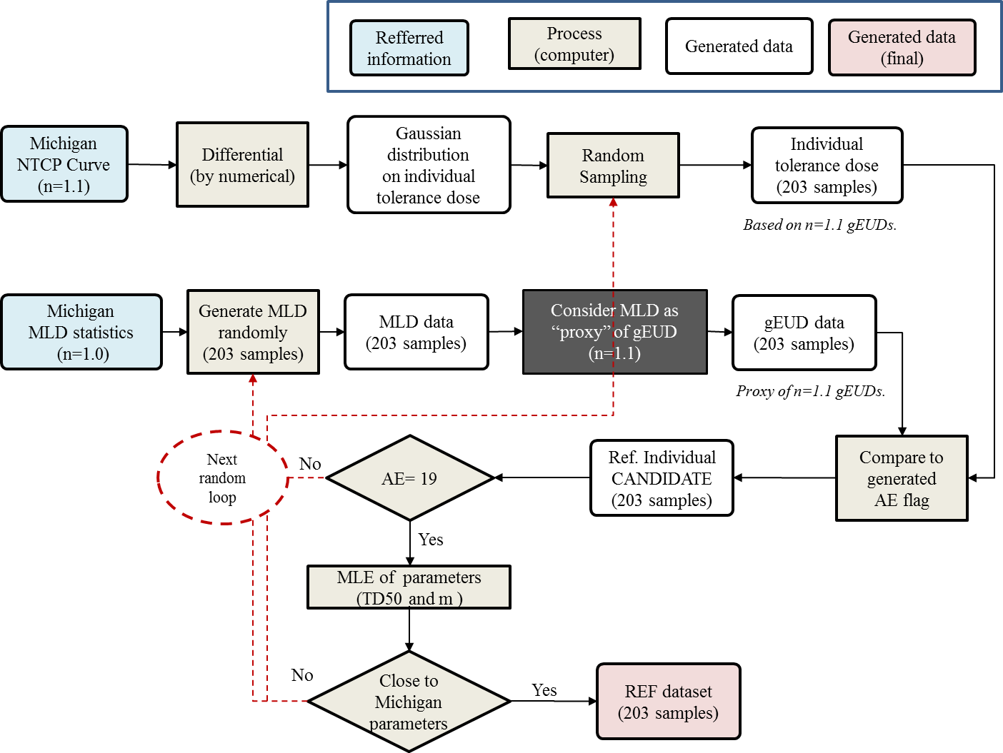
First, for a set of virtual patients, gEUDs were assigned by random generation algorithm so that its statistics (minimum, maximum, and median) are similar to the mean normal liver dose (MNLD) statistics of the 203 patients of the Michigan data. In this step, MNLD, which is equivalent to gEUD calculated from $n$=1.0 of the LKB model, was regarded as a proxy of gEUD calculated with $n$=1.1 for the Michigan's parameter. Then, for each of 203 virtual patients, along with the probability calculated from the Michigan's NTCP parameters, ${TD}_{50}(1)$=43.3 Gy and $m$= 0.18, occurrence (Adverse effect, AE=1) or non-occurrence (AE=0) was assigned by Monte-Carlo fashion; i.e. when a random number uniformly generated within the range of 0 to 1 is smaller than the NTCP at "his/her" gEUD, AE is 1, and vice versa. After that, for some sets of 203 virtual patient data generated from the difference random seeds, again statistics were checked if it is similar to the Michigan data. Finally, a set of data that was similar to the Michigan data were selected as a virtual reference dataset (REF dataset).

Dose-bin dataset
Dose-bin[Gy] |  |  | No. of Patients
#Bin | Lower | Upper | AE | All
1 | 15.0 | 20.0 | 0 | 15
2 | 20.0 | 25.0 | 0 | 32
3 | 25.0 | 30.0 | 1 | 56
4 | 30.0 | 35.0 | 4 | 53
5 | 35.0 | 40.0 | 8 | 32
6 | 40.0 | 45.0 | 6 | 15

Abbreviation: NTCP=normal tissue complication probability; MLD=mean liver dose; gEUD= generalized equivalent uniform dose; AE=number of adverse events; MLE=maximal likelihood estimation; ${TD}_{50}(1)$= the 50% tolerance dose for whole organ; $n$=volume effect; REF dataset =reference dataset

