miR-203 inhibits ovarian tumor metastasis by targeting BIRC5 and attenuating the TGFβ pathway
*Baojin Wang^{1,2,3}, Xia Li^{1,2,3}, Guannan Zhao^{2,3}, Huan Yan^{1,2,3}, Peixin Dong⁶, Hidemichi Watari⁶, Michelle Sims^{2,3}, Wei Li⁷, Lawrence M. Pfeffer^{2,3}, *Yuqi Guo^{4,5}, *Junming Yue^{2,3}
Correspondence to Junming Yue, Email: jyue@uthsc.edu
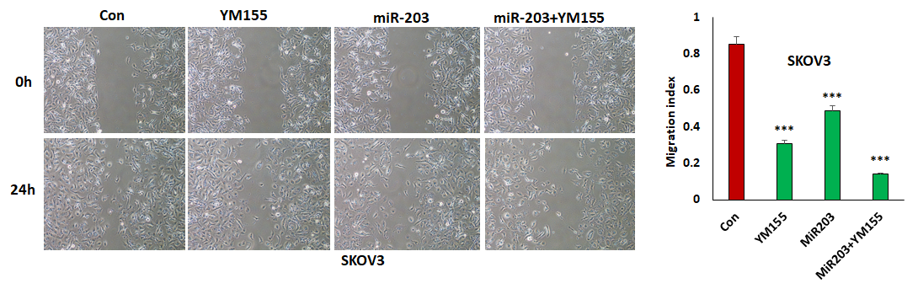Fig.S1A. miR-203 expression significantly enhanced the efficacy of YM155 in inhibiting SKOV3 cell migration
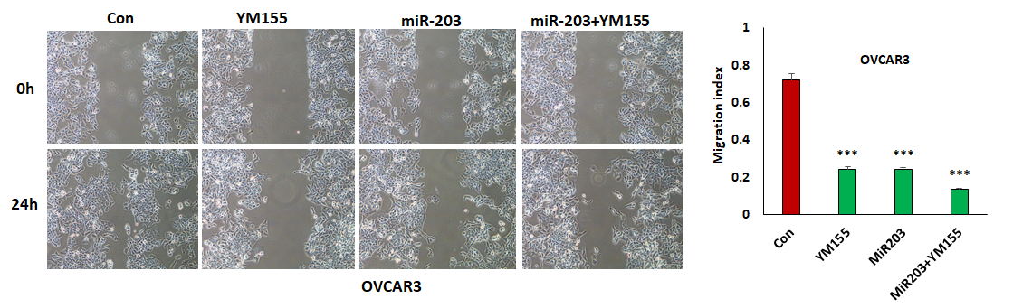Fig.S1B. miR-203 expression significantly enhanced the efficacy of YM155 in inhibiting OVCAR3 cell migration

