Supplemental data (Three figures and four tables)

Fig. S1 Brief flow chart of the primer design
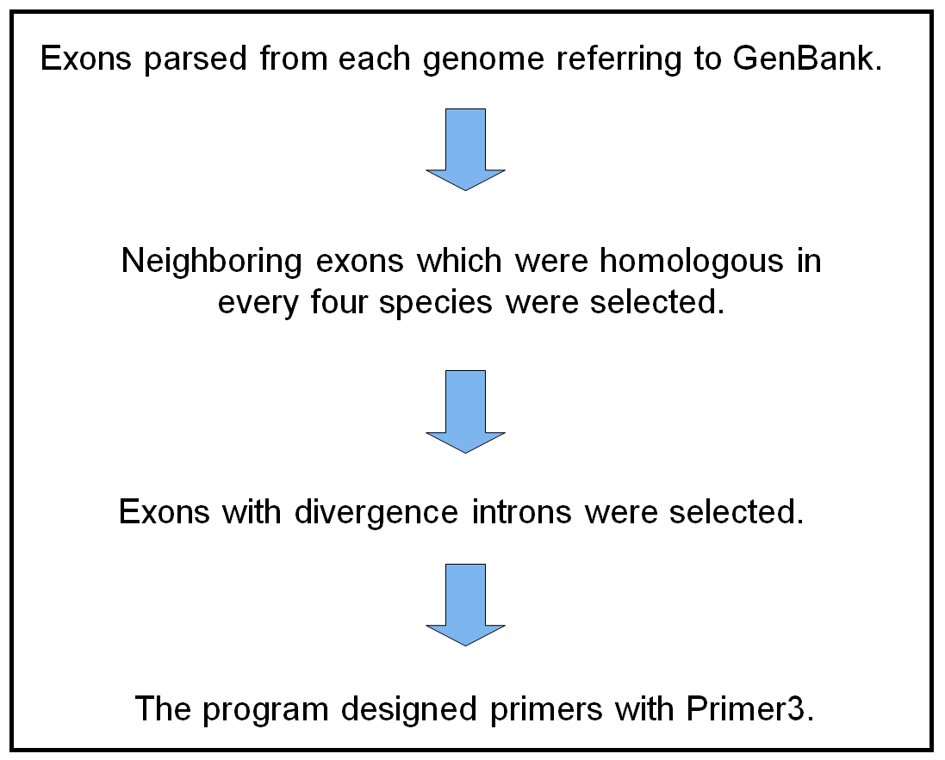

Table S1 Number of genes, exons
 | chicken | turkey | zebra finch | flycatcher
Number of genes | 15,262 | 11,610 | 12,622 | 14,264
Number of exons | 158,376 | 150,092 | 144,565 | 153,091
Number of common exons | 59,274
Number of common exons with a downstream intron | 53,381
Number of common exons with under 1kbp downstream intron | 25,123
Number of common exons with under 1kbp-downstream-polymorphic intron | 19,821
Percentages of exons (exon sets) adopted for EPIC analysis (%) | 12.52 | 13.21 | 13.71 | 12.95

Table S2 Designed primers for PCR experiment
Primer name | Forward | Reverse
TEAD3* | CTCGAGTACTCYGCCTTCATGGAGG | CAAAACTTGACGAGRAAGAAGGAGT
TBC1D22B* | CAGTTTGCCTTTCGYTGGATGAACA | GATCTCCTTCCGCCACTTGATCARG
CACNA1S_1 | CAGGGATGTGGTGAARTCCAAGTTC | TGTTCATGCCCTCAATTTCATACAR
CACNA1S_2 | TGAAGATCCTSCGGGTGCTGAG | AGGAGCCTTTGTGCAGGAAAGCA
KIF21B_1 | GAGTTCAAAGTCAGCGCCCARTTC | ACGTGTCCARGTCAAAGACAAAGTC
KIF21B_2 | CCACBGCCAGCACCCAGATGAA | ATTTTGATGTTGGATTTGCGGTGRC
KIF21B_3 | CAAGTTTCACTTTGTGGACCTGG | ATCTGGGTGCTGGCVGTGGTGC
IPO9_1 | TCCTKCTTTACATGCAGATCACAGA | TCRGAATCCACAGGATCCTCCACCT
IPO9_2 | GTTGTTGCTTCTCTTGCCCARGATA | GGGTGCTCTCRGAGATCTTCAGCTG
IPO9_3 | CAGTGCAGCYTGAACACAGATGACA | CAGGCTTCTATYTGAGCTAGCTCCT
IPO9_4 | RGATGCATTAAAGGACCCTCTTTAC | ATCTGAYAAGAACTGTCCTGCTAAG
TMEM183A | GCTTTTCTGGTGCAAAAAGATTGWA | TGAAGTTRAAGGTGGTGATCTGCA
DENND2D | GATGGCAGCAGGAAGATTGGYTACT | CRGGGAAGCAGAAGAGGGGGATGG
LOC395100* | CTCCAAGGGCAGCTGYTGTGGAG | CYTCCCAGCTGATCCAAAGGTCCC
ADIPOR1_1 | CTGGCGTGTGATCCCVTACGATGT | ACACRAACTCTTCCATCTTCTCCAT
ADIPOR1_2 | CACTCAGAGAAGGTCTCRCGGACTT | GTABGGGATCACACGCCAGCGY
AHCYL1_1* | TACGTCACVGAGATCGACCCCATCT | TTCRCTCAGCTTCACCACCCGAAAT
AHCYL1_2* | AACATCTACTCCACCCAGAACGARG | ACCACCAGAARTCATCCTCTGACTC
ETV7 | GAGAAGATGTCMCGAGCGCTCAGAC | CTCCCACYTGATGTAGGGCTCGTAG
STK38 | AGAGACCTGCTGCRATTTCAATAGA | ACTCTTTATTTCCTCCACACCAGAT
PHTF1_1* | TGTTTTTCTTYATGATGTGTGTTGC | GACTGAARAGCTTGGCAAACAAAA
PHTF1_2* | GAATGACTGYAAGAAGGTGGACATG | GCAACACACATCATRAAGAAAAACA
RSBN1_1* | TCCCMACAGCTGATATGCCAAAATC | GGTCCGAGGTAGGTACTGSAGRT
RSBN1_2 | GTACTGCTGTGGMACCTACAGAG | TATCAGCTGTKGGGATCATCTGCTC
HIPK1_1 | AGGGACYGACATGTTGGCAGAGAAG | CGCCATATCATCCAAACAGTTGAAT
HIPK1_2 | CAAGCACAAAYCTGACAATGAGCTT | CTTCTCTGCCAACATGTCRGTCCCT
HIPK1_3 | ATTCYACTGCTGCTGCTACTCTTTC | TTTGTGCTTGTRTTAGGAGCAACGT
HIPK1_4 | AATGCTGTCCCAATTGTRCCACAAG | AAGAGTAGCAGCAGCAGTRGAATTG
AMPD1* | AGAAATGAGCCAAAGGACCTGCCYT | TCTCCTCCATCTCATTKAGCATTTC
CSDE1* | CTTCKGATCGCCGAACTGGAAAACC | CTCTCTAAATTGTGAGGAACAGCAC
PPARD | CAAGCACATCTACAAYGCCTACCTG | ARCGAGAGGCATTTCTGGAAGCG
PDXDC1* | TTAGAAAAGGGATACAGGAAGCACA | GAAKGGAGAAAACCAGTTCAGCACA
RRN3_1 | CGAGAGGTAGTGGAAGAATATCTGG | TTCATGCAGCCARTTAATGATCTGG
RRN3_2 | TCAGAGAAGATGATGTGGAYATTTCA | CCAGATATTCTTCCACTACCTCTCG
RRN3_3 | ATCTGCAGAGTTTRAATTTTGAGCG | GCCCATGGAGAGCTACATCACARTA
GSPT1_1 | AATGATGGAAGAGGAGGAGGAAATR | TGAAATTTCCATGTTAACAGCAGCA
GSPT1_2 | TGAAACTGGATTTGARAAAGGTGGA | CCAGGAGCATCTARAATAGTGAAGT
GSPT1_3 | GCCAAACTTCAACCGTTCAGYTGAT | TGTTCTTTAAGGTTTGCTCCAGTSA
GSPT1_4 | CAAAGGACARCAGCTTGTGATGATG | CCATCARCTGAACGGTTGAAGTTTG
GSPT1_5 | ATTGAGCACAAATCCATTATCTGCC | ATCAGAAAGRATTCCAAGAACTTCCA
GSPT1_6 | AGATCAAGTMTGCATTGCCCGTTTA | GGCAGATAATGGATTTGTGCTCAAT
PARN | TCCAAAACCCTTTAACAGAARTTCACC | TTAAAAGTGCAAAGGCCAAACTGAA
BFAR* | YCCAGGAAAATCACTCTTTCTT | AAGGAGAATAATTCCAGAACAGAGAG
CCZ1_1 | ACCTTTAGYCCAACAAAACCTGCAA | ACTTCATTTGGGTGATAGAAGAGAA
CCZ1_2 | TGGAAAGCCAGTCTATGAATAYCAGG | YTCTTCAGGTTCATGGAAAAACTGYC
OCM | TATTTCCTTCAGAGGTTTGAGTGTG | CCTTGAGCTGGCTRCTACTCTTTTT
LOC396531 | AAAGTTTTTGGRATCCTTGATCAGG | AGCTGGAGAGAGCAGATTCAATATC
BAIAP2L1 | ATCMGAAGGAAAAGCCAAGGAGCAC | GGTCTGTTTTCTTCTCCAGTTCAGA
TMEM130 | CAGATTACCAAGGARCCCTTTGTCT | TCTGCTGTCTTCTATCTGGGCWATG
FAM20C_1* | ACATGGATCGACATCACTAYGAAACC | AAGGCACCAATATGGAAAGTTCATC
FAM20C_2* | AGGAAAACCTGGAGAAACCCYTGGA | GGGTGTTTGTTTAACCTCTTCACAA
LOC427656 | ATCAAATCAAAGRGCCTGGCAGAAC | CATTTTCACACGTGCTGTTTCAATT
GET4_1* | ACAGTRTTGTGTGAACAGTATCAACC | RAAGAAAAGCTGTCCTATTCTATCT
GET4_2 | CCACTGCTAAACTTCATCTGGTTTC | GGTTGATACTGTTCACACAAYACTG
GET4_3* | GCTGATCTGTCCATGYTGGTTTTGG | TTCCACAGGGTAATRGCTAGTAACTG
*: PCR products over 10 species found

Table S3 Exons where the designed primers are localized in each reference species
 | gallus |  | ficedulla |  | meleagris |  | taeniopygia
primer_name | forward | reverse | forward | reverse | forward | reverse | forward | reverse
TBC1D22B | chr26|TBC1D22B|9 | chr26|TBC1D22B|10 | chr1A|TBC1D22A|11 | - | chr28|TBC1D22B|10 | chr28|TBC1D22B|11 | chr26|TBC1D22B|12 | chr26|TBC1D22B|13
CACNA1S_1 | chr26|CACNA1S|10 | chr26|CACNA1S|9 | chr26|CACNA1S|10 | chr26|CACNA1S|9 | chr28|CACNA1S|8 | chr28|CACNA1S|7 | chr26|CACNA1S|12 | chr26|CACNA1S|11
TEAD3 | chr26|TEAD3|7 | chr26|TEAD3|8 | chr26|TEAD3|9 | chr26|TEAD3|10 | chr28|TEAD3|9 | chr28|TEAD3|10 | chr26|TEAD3|8 | chr26|TEAD3|9
CACNA1S_2 | chr26|CACNA1S|21 | chr26|CACNA1S|20 | chr26|CACNA1S|21 | chr26|CACNA1S|20 | chr28|CACNA1S|19 | chr28|CACNA1S|18 | chr26|CACNA1S|23 | chr26|CACNA1S|22
KIF21B_1 | chr26|KIF21B|3 | chr26|KIF21B|2 | chr26|KIF21B|3 | chr26|KIF21B|2 | chr28|KIF21B|3 | chr28|KIF21B|2 | chr26|KIF21B|3 | chr26|KIF21B|2
KIF21B_2 | chr26|KIF21B|5 | chr26|KIF21B|4 | chr26|KIF21B|5 | chr26|KIF21B|4 | chr28|KIF21B|5 | chr28|KIF21B|4 | chr26|KIF21B|5 | chr26|KIF21B|4
KIF21B_3 | chr26|KIF21B|6 | chr26|KIF21B|5 | chr26|KIF21B|6 | chr26|KIF21B|5 | chr28|KIF21B|6 | chr28|KIF21B|5 | chr26|KIF21B|6 | chr26|KIF21B|5
IPO9_1 | chr26|IPO9|10 | chr26|IPO9|9 | chr26|IPO9|10 | chr26|IPO9|9 | chr28|LOC100549138|3 | chr28|LOC100549138|2 | chr26|IPO9|10 | chr26|IPO9|9
IPO9_3 | chr26|IPO9|17 | chr26|IPO9|16 | chr26|IPO9|17 | chr26|IPO9|16 | chr28|LOC100549138|10 | chr28|LOC100549138|9 | chr26|IPO9|17 | chr26|IPO9|16
IPO9_2 | chr26|IPO9|16 | chr26|IPO9|15 | chr26|IPO9|16 | chr26|IPO9|15 | chr28|LOC100549138|9 | chr28|LOC100549138|8 | chr26|IPO9|16 | chr26|IPO9|15
IPO9_4 | chr26|IPO9|23 | chr26|IPO9|22 | chr26|IPO9|23 | chr26|IPO9|22 | chr28|LOC100549138|16 | chr28|LOC100549138|15 | chr26|IPO9|23 | chr26|IPO9|22
TMEM183A | chr26|TMEM183A|6 | chr26|TMEM183A|7 | chr26|TMEM183A|12 | chr26|TMEM183A|13 | chr28|LOC100551434|5 | chr28|LOC100551434|6 | chr26|TMEM183A|6 | chr26|TMEM183A|7
ADIPOR1_1 | chr26|ADIPOR1|3 | chr26|ADIPOR1|2 | chr26|ADIPOR1|3 | chr26|ADIPOR1|2 | chr28|ADIPOR1|2 | chr28|ADIPOR1|1 | chr26|ADIPOR1|3 | chr26|ADIPOR1|2
ADIPOR1_2 | chr26|ADIPOR1|4 | chr26|ADIPOR1|3 | chr26|ADIPOR1|4 | chr26|ADIPOR1|3 | chr28|ADIPOR1|3 | chr28|ADIPOR1|2 | chr26|ADIPOR1|4 | chr26|ADIPOR1|3
AHCYL1_1 | chr26|AHCYL1|11 | chr26|AHCYL1|12 | chr26|AHCYL1|9 | chr26|AHCYL1|10 | chr28|AHCYL1|9 | chr28|AHCYL1|10 | chr26|AHCYL1|9 | chr26|AHCYL1|10
LOC395100 | chr26|LOC395100|5 | chr26|LOC395100|6 | chr26|LOC101812664|5 | chr26|LOC101812664|6 | chr28|LOC100551128|5 | chr28|LOC100551128|6 | chr26|LOC100231703|5 | chr26|LOC100231703|6
DENND2D | chr26|DENND2D|4 | chr26|DENND2D|3 | chr26|DENND2D|4 | chr26|DENND2D|3 | chr28|DENND2D|4 | chr28|DENND2D|3 | chr26|DENND2D|4 | chr26|DENND2D|3
ETV7 | chr26|ETV7|6 | chr26|ETV7|5 | chr26|ETV7|9 | chr26|ETV7|8 | chr28|ETV7|5 | chr28|ETV7|4 | chr26|ETV7|5 | chr26|ETV7|4
AHCYL1_2 | chr26|AHCYL1|6 | chr26|AHCYL1|7 | chr26|AHCYL1|4 | chr26|AHCYL1|5 | chr28|AHCYL1|4 | chr28|AHCYL1|5 | chr26|AHCYL1|4 | chr26|AHCYL1|5
PHTF1_1 | chr26|PHTF1|12 | chr26|PHTF1|13 | - | chr26|PHTF1|12 | chr28|PHTF1|9 | chr28|PHTF1|10 | - | chr26|PHTF1|13
STK38 | chr26|STK38|12 | chr26|STK38|11 | chr26|STK38|12 | chr26|STK38|11 | chr28|LOC100542873|7 | chr28|LOC100542873|6 | chr26|STK38|12 | chr26|STK38|11
PHTF1_2 | chr26|PHTF1|11 | chr26|PHTF1|12 | chr26|PHTF1|10 | - | chr28|PHTF1|8 | chr28|PHTF1|9 | chr26|PHTF1|11 | -
RSBN1_1 | chr26|RSBN1|4 | chr26|RSBN1|5 | chr26|RSBN1|3 | chr26|RSBN1|4 | chr28|RSBN1|3 | chr28|RSBN1|4 | chr26|RSBN1|4 | chr26|RSBN1|5
RSBN1_2 | chr26|RSBN1|3 | chr26|RSBN1|4 | chr26|RSBN1|2 | chr26|RSBN1|3 | chr28|RSBN1|2 | chr28|RSBN1|3 | chr26|RSBN1|3 | chr26|RSBN1|4
HIPK1_1 | chr26|HIPK1|5 | chr26|HIPK1|4 | chr26|HIPK1|5 | chr26|HIPK1|4 | chr28|HIPK1|6 | chr28|HIPK1|5 | chr26|LOC100229690|5 | chr26|LOC100229690|4
HIPK1_3 | chr26|HIPK1|7 | chr26|HIPK1|6 | chr26|HIPK1|7 | chr26|HIPK1|6 | chr28|HIPK1|8 | chr28|HIPK1|7 | chr26|LOC100229690|7 | chr26|LOC100229690|6
HIPK1_2 | chr26|HIPK1|6 | chr26|HIPK1|5 | chr26|HIPK1|6 | chr26|HIPK1|5 | chr28|HIPK1|7 | chr28|HIPK1|6 | chr26|LOC100229690|6 | chr26|LOC100229690|5
HIPK1_4 | chr26|HIPK1|8 | chr26|HIPK1|7 | chr26|HIPK1|8 | chr26|HIPK1|7 | chr28|HIPK1|9 | chr28|HIPK1|8 | chr26|LOC100229690|8 | chr26|LOC100229690|7
CSDE1 | chr26|CSDE1|2 | chr26|CSDE1|3 | chr26|CSDE1|2 | chr26|CSDE1|3 | chr2|LOC104909591|2 | chr2|LOC104909591|3 | chr26|CSDE1|2 | chr26|CSDE1|3
PPARD | chr26|PPARD|4 | chr26|PPARD|3 | chr26|PPARD|4 | chr26|PPARD|3 | chr28|PPARD|4 | chr28|PPARD|3 | chr26|PPARD|4 | chr26|PPARD|3
AMPD1 | chr26|AMPD1|6 | chr26|AMPD1|7 | chr26|AMPD1|6 | chr26|AMPD1|7 | chr28|AMPD1|6 | chr28|AMPD1|7 | chr26|AMPD1|4 | chr26|AMPD1|5
PDXDC1 | chr14|PDXDC1|20 | chr14|PDXDC1|21 | chr14|PDXDC1|19 | chr14|PDXDC1|20 | chr16|PDXDC1|18 | chr16|PDXDC1|19 | chr14|PDXDC1|20 | chr14|PDXDC1|21
RRN3_1 | chr14|RRN3|4 | chr14|RRN3|3 | chr14|RRN3|4 | chr14|RRN3|3 | chr16|RRN3|4 | chr16|RRN3|3 | chr14|RRN3|4 | chr14|RRN3|3
RRN3_2 | chr14|RRN3|5 | chr14|RRN3|4 | chr14|RRN3|5 | chr14|RRN3|4 | chr16|RRN3|5 | chr16|RRN3|4 | chr14|RRN3|5 | chr14|RRN3|4
RRN3_3 | - | chr14|RRN3|13 | chr14|RRN3|14 | chr14|RRN3|13 | chr16|RRN3|14 | chr16|RRN3|13 | chr14|RRN3|14 | chr14|RRN3|13
GSPT1_3 | chr14|GSPT1|8 | chr14|GSPT1|7 | chr14|GSPT1|10 | chr14|GSPT1|9 | chr16|GSPT1|8 | chr16|GSPT1|7 | chr14|GSPT1|8 | chr14|GSPT1|7
GSPT1_2 | chr14|GSPT1|6 | chr14|GSPT1|5 | chr14|GSPT1|8 | chr14|GSPT1|7 | chr16|GSPT1|6 | chr16|GSPT1|5 | chr14|GSPT1|6 | chr14|GSPT1|5
GSPT1_1 | chr14|GSPT1|2 | chrZ|ZSWIM6|10 | chr14|GSPT1|4 | chr14|GSPT1|3 | chr16|GSPT1|2 | chrZ|LOC100538555|1 | chr14|GSPT1|2 | -
GSPT1_4 | chr14|GSPT1|9 | chr14|GSPT1|8 | chr14|GSPT1|11 | chr14|GSPT1|10 | chr16|GSPT1|9 | chr16|GSPT1|8 | chr14|GSPT1|9 | chr14|GSPT1|8
GSPT1_5 | chr14|GSPT1|11 | chr14|GSPT1|10 | chr14|GSPT1|13 | chr14|GSPT1|12 | chr16|GSPT1|11 | chr16|GSPT1|10 | chr14|GSPT1|11 | chr14|GSPT1|10
GSPT1_6 | chr14|GSPT1|12 | chr14|GSPT1|11 | chr14|GSPT1|14 | chr14|GSPT1|13 | chr16|GSPT1|12 | chr16|GSPT1|11 | chr14|GSPT1|12 | chr14|GSPT1|11
PARN | chr14|PARN|2 | chr14|PARN|1 | chr14|PARN|5 | chr14|PARN|4 | chr16|PARN|1 | - | chr14|PARN|5 | chr14|PARN|4
CCZ1_1 | chr14|CCZ1|3 | chr14|CCZ1|2 | chr14|CCZ1|3 | chr14|CCZ1|2 | chr1|LIPI|3 | chr11|AMER3|1 | chr14|CCZ1|3 | chr14|CCZ1|2
BFAR | chr14|BFAR|5 | chr14|BFAR|6 | chr14|BFAR|5 | chr14|BFAR|6 | chr16|BFAR|5 | chr16|BFAR|6 | chr14|BFAR|5 | chr14|BFAR|6
CCZ1_2 | chr14|CCZ1|4 | chr14|CCZ1|3 | chr14|CCZ1|4 | chr14|CCZ1|3 | chr16|CCZ1|2 | chr23|PERM1|1 | chr14|CCZ1|4 | chr14|CCZ1|3
OCM | chr14|OCM|3 | chr14|OCM|2 | chr14|LOC101813769|3 | chr14|LOC101813769|2 | chr16|LOC100545184|3 | chr16|LOC100545184|2 | chr14|LOC100230782|3 | chr14|LOC100230782|2
LOC396531 | chr14|LOC396531|2 | chr14|LOC396531|1 | chr14|LOC101813301|2 | chr14|LOC101813301|1 | chr16|LOC100545341|2 | chr16|LOC100545341|1 | chr14|LOC100221179|2 | chr14|LOC100221179|1
TMEM130 | chr14|TMEM130|4 | chr14|TMEM130|3 | chr14|TMEM130|4 | chr14|TMEM130|3 | chr16|TMEM130|4 | chr16|TMEM130|3 | chr14|TMEM130|3 | chr14|TMEM130|2
FAM20C_1 | chr14|FAM20C|8 | chr14|FAM20C|9 | chr14|FAM20C|9 | chr14|FAM20C|10 | chr16|FAM20C|5 | chr16|FAM20C|6 | chr14|FAM20C|9 | chr14|FAM20C|10
FAM20C_2 | chr14|FAM20C|6 | chr14|FAM20C|7 | chr14|FAM20C|7 | chr14|FAM20C|8 | chr16|FAM20C|3 | chr16|FAM20C|4 | chr14|FAM20C|7 | chr14|FAM20C|8
BAIAP2L1 | chr14|BAIAP2L1|6 | chr14|BAIAP2L1|5 | chr14|BAIAP2L1|6 | chr14|BAIAP2L1|5 | chr16|BAIAP2L1|3 | chr16|BAIAP2L1|2 | chr14|BAIAP2L1|6 | chr14|BAIAP2L1|5
GET4_1 | chr14|GET4|7 | chr14|GET4|8 | chr14|GET4|7 | chr14|GET4|8 | chr16|GET4|6 | chr16|GET4|7 | chr14|GET4|6 | chr14|GET4|7
GET4_2 | chr14|GET4|6 | chr14|GET4|7 | chr14|GET4|6 | chr14|GET4|7 | chr16|GET4|5 | chr16|GET4|6 | chr14|GET4|5 | chr14|GET4|6
GET4_3 | chr14|GET4|3 | chr14|GET4|4 | chr14|GET4|3 | chr14|GET4|4 | chr16|GET4|2 | chr16|GET4|3 | chr14|GET4|2 | chr14|GET4|3
LOC427656 | chr14|LOC427656|2 | - | chr14|LOC101820237|2 | - | chr16|LOC100545806|2 | - | chr14|LOC100219310|2 | -

Table S4 PCR results and sizes from tried primers
Primer name | chicken | black kite | jungle crow | carrion crow | brown-eared bulbul | turtle dove | rock dove | sparrow | swallow | martin | starling | black-backed wagtaiｌ
TEAD3* | 260 | 280 | 270 | 270 | 290 | 270 | 270 | 280 | 265 | 265 | 260 | 290
TBC1D22B* | 365 | 400 | 380 | 380 | 350 | 320 | 320 | 370 | 360 | 355 | 360 | 380
CACNA1S_1 | ― | ― | ― | ― | ― | ― | ― | ND | ND | ND | ND | ND
CACNA1S_2 | M | ― | ― | ― | ― | ― | ― | ― | ― | ― | ― | ―
KIF21B_1 | ― | ― | ― | ― | ― | ― | ― | ND | ND | ND | ND | ND
KIF21B_2 | ― | ― | ― | ― | ― | ― | ― | ND | ND | ND | ND | ND
KIF21B_3 | M | ― | M | M | ― | M | M | M | ― | ― | M | ―
IPO9_1 | ― | ― | ― | ― | ― | ― | ― | ND | ND | ND | ND | ND
IPO9_2 | ― | ― | ― | ― | ― | 800 | ― | ND | ND | ND | ND | ND
IPO9_3 | ― | ― | ― | 700 | ― | ― | ― | ND | ND | ND | ND | ND
IPO9_4 | ― | ― | ― | - | ― | ― | ― | ND | ND | ND | ND | ND
TMEM183A | 700 | ― | 750 | 750 | ― | 800 | 700 | 800 | ― | ― | 850 | ―
DENND2D | M | ― | M | M | ― | M | M | M | ― | ― | M | ―
LOC395100* | M | M | M | M | M | M | M | M | 800 | 800 | M | ―
ADIPOR1_1 | ― | ― | ― | ― | ― | ― | ― | ND | ND | ND | ND | ND
ADIPOR1_2 | ― | ― | M | M | ― | M | M | ― | ― | ― | M | ―
AHCYL1_1* | 450 | 400 | 400 | 400 | 400 | 400 | 400 | 400 | 400 | 400 | 400 | 400
AHCYL1_2* | 260 | 480 | 860 | 860 | 1000 | 460 | 460 | 1000 | 960 | ― | 790 | 860
ETV7 | ― | ― | ― | ― | ― | ― | ― | ND | ND | ND | ND | ND
STK38 | ― | ― | ― | ― | ― | ― | ― | ND | ND | ND | ND | ND
PHTF1_1* | 450 | 220 | 450 | 450 | 500 | 210 | 220 | 450 | 500 | 500 | 450 | 500
PHTF1_2* | 530 | 700 | 700 | 700 | 700 | M | M | 700 | 700 | 700 | 690 | 700
RSBN1_1* | 680 | 990 | 990 | M | 1000 | 1000 | M | M | 1000 | 1000 | M | M
RSBN1_2 | M | ― | M | M | ― | M | M | M | ― | ― | M | ―
HIPK1_1 | ― | ― | ― | ― | ― | ― | ― | ― | ― | ― | ― | ―
HIPK1_2 | ― | ― | ― | ― | ― | ― | ― | ― | ― | ― | ― | ―
HIPK1_3 | ― | ― | ― | ― | ― | ― | ― | ― | ― | ― | ― | ―
HIPK1_4 | ― | ― | ― | ― | ― | ― | ― | ― | ― | ― | ― | ―
AMPD1* | 660 | M | 430 | 430 | 440 | 390 | 390 | 450 | 420 | 420 | 390 | 455
CSDE1* | M | 330 | M | M | 350 | 320 | 320 | 350 | 370 | 370 | 370 | 350
PPARD | ― | ― | ― | ― | ― | ― | ― | ― | ― | ― | ― | ―
PDXDC1* | 190 | 200 | 200 | 200 | 200 | 200 | 200 | 200 | 200 | 200 | 200 | 200
RRN3_1 | ― | ― | ― | ― | ― | ― | ― | ― | ― | ― | ― | ―
RRN3_2 | ― | ― | ― | ― | ― | ― | ― | ― | ― | ― | ― | ―
RRN3_3 | ― | ― | ― | ― | ― | ― | ― | ― | ― | ― | ― | ―
GSPT1_1 | ― | ― | ― | ― | ― | ― | ― | ― | ― | ― | ― | ―
GSPT1_2 | ― | ― | ― | ― | ― | ― | ― | ― | ― | ― | ― | ―
GSPT1_3 | ― | ― | ― | ― | ― | ― | ― | ― | ― | ― | ― | ―
GSPT1_4 | ― | ― | ― | ― | ― | ― | ― | ― | ― | ― | ― | ―
GSPT1_5 | ― | ― | ― | ― | ― | ― | ― | ― | ― | ― | ― | ―
GSPT1_6 | ― | ― | ― | ― | ― | ― | ― | ― | ― | ― | ― | ―
PARN | ― | ― | ― | ― | ― | ― | ― | ― | ― | ― | ― | ―
BFAR* | 860 | 860 | 860 | 860 | 600 | 840 | 840 | 800 | M | 600 | 730 | 800
CCZ1_1 | ― | ― | ― | ― | ― | ― | ― | ― | ― | ― | ― | ―
CCZ1_2 | ― | ― | ― | ― | ― | ― | ― | ― | ― | ― | ― | ―
OCM | ― | ― | ― | ― | ― | ― | ― | ― | ― | ― | ― | ―
LOC396531 | ― | ― | ― | ― | ― | ― | ― | ― | ― | ― | ― | ―
BAIAP2L1 | ― | ― | ― | ― | ― | 800 | 800 | ― | ― | ― | ― | ―
TMEM130 | ― | ― | ― | ― | ― | ― | ― | ― | ― | ― | ― | ―
FAM20C_1* | 510 | 200 | 200 | 200 | 200 | 200 | 200 | 190 | 200 | 200 | 200 | 190
FAM20C_2* | 600 | ― | 600 | 600 | 360 | 700 | 600 | 550 | 550 | 550 | ― | 550
LOC427656 | ― | ― | ― | ― | ― | ― | ― | ― | ― | ― | ― | ―
GET4_1* | 380 | 235 | M | M | M | 235 | 240 | M | 230 | 230 | M | M
GET4_2 | ― | ― | ― | ― | ― | ― | ― | ― | ― | ― | ― | ―
GET4_3* | ― | 1260 | 430 | 420 | 435 | 1260 | ― | 200 | 435 | 435 | M | 430
*PCR products over 10 species found
M: Multiple bands, ND: Not done

Fig S2 Chip gel electrophoresis images of EPIC pcr products
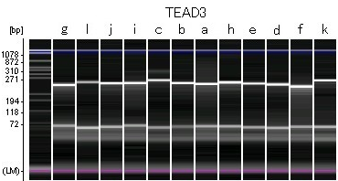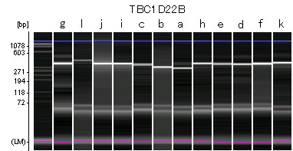

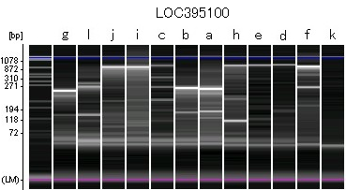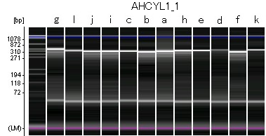

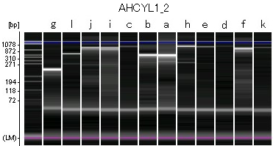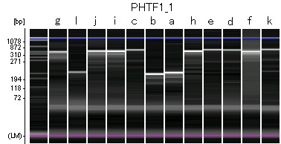

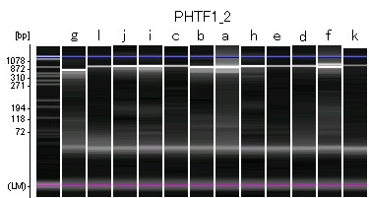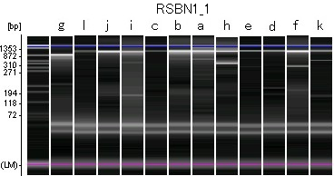

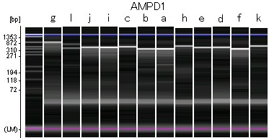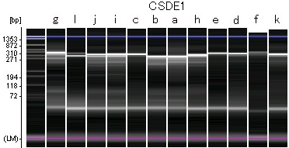

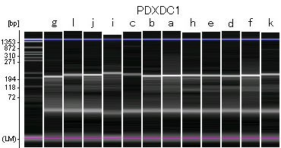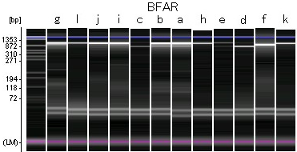

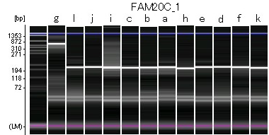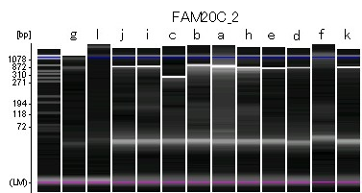

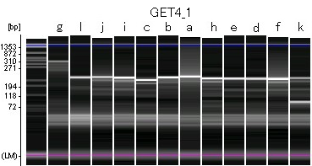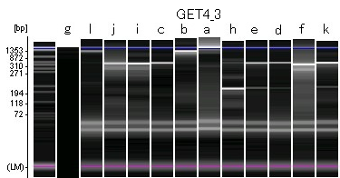
Legend to Fig. S2 MultiNA chip electrophoresis of TBC1D22B-primer amplified PCR. Primers which amplify more than 10 species were selected.
Species are rock dove (a), turtle dove (b), brown-eared bulbul (c), martin (d), swallow (e), starling (f), chicken (g), sparrow (h), carrion crow (i), jungle crow (j), black-backed wagtail (k) and black kite (l). Molecular sized were predicted from internal markers listed in left-side of the graphical view.
Fig. S3 MultiNA chip electrophoresis of PCR product of TBC1D22B gene from feather DNAs.
A.TBC1D22B-primer amplified PCR
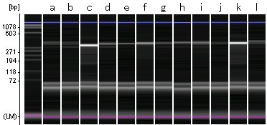

B.TBC1D22B_i-primer amplified PCR
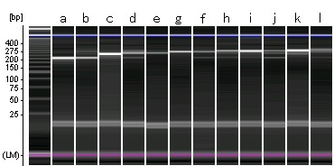

Species are rock dove (a), turtle dove (b), brown-eared bulbul (c), martin (d), swallow (e), starling (f), chicken (g), sparrow (h), carrion crow (i), jungle crow (j), black-backed wagtail (k) and black kite (l).
Molecular sized were predicted from internal markers listed in left-side of the graphical view.

Fig. S4 A phylogenetic trees on species picked up in this study
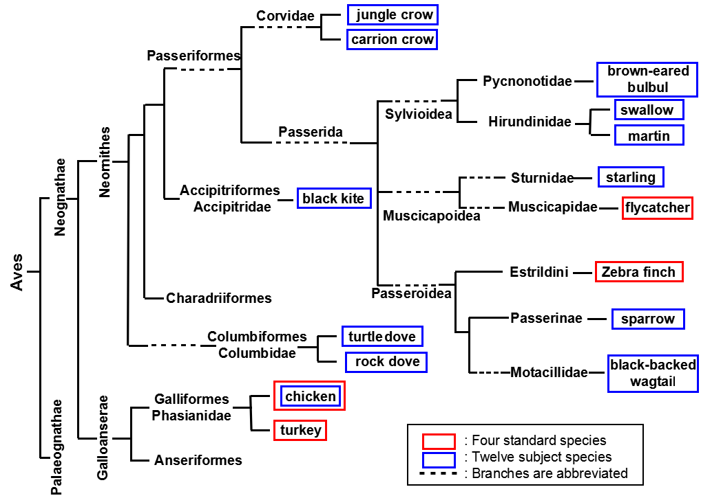
Legened to Fig.S3 Species targeted for species identification in this study are indicated by blue frames and species with standard genome constructed by red frames.

Fig. S5 Sequence alignment of PCR products form each species of birds.

'Motacilla_alba_lugens' ---TTTGCCTTTCGYTGGATGAACAACCTGCTGATGAGGGAGCTGCCCCTGCGCTGCACCATCCGCCTCTGGGACACCTACCAGGTATGCAGGCTCCACTGACCTCCCT-CTTGGCTTGTCACTGTCACTGGTGTCCCTGTCCCCA---C
'Corvus_corone' CAGTTTGCCTTTCGYTGGATGAACAACCTGCTCATGAGGGAGCTGCCCCTCCGCTGCACCATCCGCCTCTGGGACACCTACCAGGTATGCAGGCTCCACTGACC-CCCTGCCTGGCTTGTCACTGTCACTTGTGTCCCTGGCCCCA---A
'Corvus_macrorhynchos' CAGTTTGCCTTTCGYTGGATGAACAACCTGCTCATGAGGGAGCTGCCCCTCCGCTGCACCATCCGCCTCTGGGACACCTACCAGGTATGCAGGCTCCACTGACC-CCCTGCCTGGCTTGTCACTGTCACTTGTGTCCCTGTCCCCA---A
'Passer_montanus' --GTTTGCCTTTCGYTGGATGAACAACCTGCTCATGAGGGAGCTGCCCCTGCGCTGCACCATCCGCCTCTGGGACACCTACCAGGTATGCAG-CTCCACTG-CCTCCCT-CTTGCCTTGTCCCTGGCACCTGTGTCCCTGTCCCCA---C
'Gallus_gallus_domesticus' CAGTTTGCCTTTCGYTGGATGAACAATCTGCTCATGAGGGAGCTGCCTCTCCGCTGCACAATCCGCCTCTGGGACACCTACCAGGTACGTGGACTT-GCTGCCATCCCTCCTTGGCTGCTTGCTGT-----AGGGCCAACTCCCCACGCA
'Sturnus_cineraceus' ---TTTGCCTTTCGYTGGATGAACAACCTGCTCATGAGGGAGCTGCCCCTCCGCTGCACCATCCGCCTCTGGGACACCTACCAGGTATGCAG---------GCTCCACTGGCCTCCCTGTCACTGTCCCTCGTGTCCCTGTCCCCAGTAC
'Hirundo_rustica' CAGTTTGCCTTTCGYTGGATGAACAATCTGCTCATGAGGGAGCTGCCCCTGCGCTGCACCATCCGCCTCTGGGACACCTACCAGGTATGCAC-------TGCCCTCCCTGCTCGGCTTGTCACTGCCACTCGTGTCCCTGTCCCCA---C
'Hypsipetes_amaurotis' --GTTTGCCTTTCGYTGGATGAACAACCTGCTCATGAGGGAGCTGCCCCTGCGCTGCACCATCCGCCTCTGGGACACCTACCAGGTATGCAG-------TGACC-CCCTGCTTGGCTTGTCTCTGTCACCTGTGTCCCTGTCCCCA---C
'Columba_livia' CAGTTTGCCTTTCGYTGGATGAACAATCTGCTGATGAGGGAGCTGCCGCTTCGCTGCACCATCCGCCTCTGGGACACCTACCAGGTA--CAG---------------------GGGCTCCCGCTGCCTTCCCTGCTTTACTGGTCA----
'Streptopelia_orientalis' CAGTTTGCCTTTCGYTGGATGAACAATCTGCTGATGAGGGAGCTGCCGCTTCGCTGCACCATCCGCCTCTGGGACACCTACCAGGTA--CAG---------------------GGGCTCCCGCTGCCTTCCCTGCTTTAATGGTCA----

'Motacilla_alba_lugens' GGGG--ACAGAGGTCTCCTGGCACCAGCCGGGGTGCTGAGGGAAACAAAGCAGTGTGGTCAC-AGGATGTTTACAGCNAGCTG--GGCGATGGGTGGCCCAGTAGGACGCCTGTGTCTGGGG--CTTGTTCTCCAGCTGAGCTGCAGGAG
'Corvus_corone' GGGG--ACAGAGGTTTCCTGGCACCA--------GCTGAGGGGCACAAAGCAGTGTGGCCCC-AGGATGTTTACAGCCACCTG--GGTGATGGGTGACCCAGTGGGACATCTGTGTCTGGGGAAGTTGTTCTCCAGCTGAGCTGCAGGAG
'Corvus_macrorhynchos' GGGG--ACAGAGGTTTCCTGGCACCA--------GCTGAGGGGCACAAAGCAGTGTGGCCCC-AGGATGTTTACAGCCAGCTG--GGTGATGGGTGACCCAGTAGGACATCTGTGTCTGGGGAAGTTGTTCTCCAGCTGAGCTGCAGGAG
'Passer_montanus' GGGG--ACAGAGGGCTCCTGGCACCAGCTGGG-TGCTGAGGGAAACAAAGCAGAGTGGCCCC-AGGATGTTTGCAGCT----G--GGTGATGGGTGGCCCAGTAGGACATCTGTGTCTGGGG-----GTTCTCCAGCTGAGCTGCAGGAG
'Gallus_gallus_domesticus' GGGA--GATGAGGCACCATG----CAGCTGGGGAGATAAGAGGAACAA---AGTGTGGCCTCTGGGGTGTTTATAGACAGATGAAGGTGACACATGG-----------ACATGTGTCTGGGGGAGCTGTGCTCCAGCAGAGCCATAGGAG
'Sturnus_cineraceus' AGACCCACAGAGGTCTCCTGGCACCAGCTGGGGTGCTGAGGGAAACAAAGCAGTGTGGGC-C-AGGATGTTTGCAGGCAGCTG--GGTGGAGGGTGGAC---------ATCTGTGGCTGGGG--GTTGTTCTCCAGCTGAGCTGCAGGAG
'Hirundo_rustica' GGGG--ACAGAGGG-------------------TGCTCAGGGAAGCAAAGCAGTGTGGCCCC-AGGGTGTTCACAGCCAGCTG--GGTGCTGGGTGGCCTCCCAGGACATCTGTGTCTGGGG--GTCGTTCTCCAGCTGTGCTGCAGGAG
'Hypsipetes_amaurotis' GGGG--ACAGAGGA-------------------TGCTGAGGGAAACAAAGCAATGTGGCCCC-AGGATGTTTATAGGCAGCTG--GGTGCTAGGTGGCCCC-------ATCTGTGTCTGGGG--GTTGTTCTCCAGCTGAGCTGCAGGGG
'Columba_livia' -------C----------------------------TGTGGGGA------CAATT---CCAT-AGGACGTTTATAGCCACTTG--GGTGATGGGTGGCCCAGTAGGACGTGGGTTTCTGGGG------AGCTCCAGTGGAGCTGCAGGAG
'Streptopelia_orientalis' -------C----------------------------TGTGGGGA------CAATT---CCAN-AGGACGTTTATAGCCACTTG--GGTGACGGGTGGCCTAGTAGGACATGGGTTTCTGGGG------AGCTCCAGTGGAGCTGCAGGAG

'Motacilla_alba_lugens' TTCACCCAGAGTTTTGCTGTCCACAGTCAGAGCCAGAGGGATTCTCCCACTCCACACCTGTACGTCTGTGCTGCCTTCYTGATCAAGTGGCNRAAGGAGATC
'Corvus_corone' CTCACTCAGAGTTTTGCTGTCCACAGTCAGAGCCAGAAGGATTCTCCCATTTC-CACCTGTACGTCTGCGCTGCCTTCYTGATCAAGTGGCGNAAGGAGATC
'Corvus_macrorhynchos' CTCACTCAGAGTTTTGCTGTCCACAGTCAGAGCCAGAAGGATTCTCCCATTTC-CACCTGTACGTCTGCGCTGCCTTCYTGATCAAGTGGCGRNNGGAGATC
'Passer_montanus' CTCACCCAGANTTTTGCTGCCCACAGTCAGAGCCAGAAGGATTCTCCCATTTC-CACCTGTACGTCTGTGCTGCCTTCYTGATCAAGTGGCGRNAGGAGATC
'Gallus_gallus_domesticus' CTGACTCCGAGTTTTGTTGCTTACAGTCAGAGCCAGAGGGGTTCTCGCACTTC-CACCTCTATGTCTGTGCCGCCTTCYTGATCAAGTGGCGGAAGGAGATC
'Sturnus_cineraceus' CTCACCCAGAGTTTTGCTGTCCACAGTCAGAGCCAGAAGGATTCTCCCATTTC-CACCTGTACGTCTGTGCTGCCTTCYTGATCAAGTGGCGNNNGGAGATC
'Hirundo_rustica' TTCACCCAGAGTTTTGCTGTCCACAGTCAGAGCCGGAAGGATTCTCCCATTTCACACCTGTACGTCTGCGCTGCCTTCYTGATCAAGTGGCGGAAGGAGATC
'Hypsipetes_amaurotis' TTCACCCAGAGTTTC-CTGTCCACAGTCAGAGCCAGAAGGATTCTCCCATTTC-CACCTGTACGTCTGTGCTGCCTTCYTGATCAAGTGGCGGAAGGAGATC
'Columba_livia' CTGATCCAGAGTTTTGCTACTTGCAGTCGGAGCCAGAAGGATTCTCCCATTNC-CACCTGTACGTCTGCGCCGCATTCYTGATCAAGTGGCGGAAGGAGATC
'Streptopelia_orientalis' CTGATCCGGAGTTTTGCTACTTGCAGTCGGAGCCAGAAGGATTCTCCCATTTC-CACCTGTACGTCTGCGCCGCCTTCYTGATCAAGTGGCGGNAGGAGATC

* Sequences of PCR products from black kite (Milvus migrans) and martin (Delichon urbica) could not determined.
Nine sequences were newly identified and registered on DDBJ. Entry IDs on DDBJ: 54079b500fd0bf1a99000211.Motacilla_alba_lugens (black-backed wagtail), 54079b500fd0bf1a99000211.Corvus_corone (carrion crow), 54079b500fd0bf1a99000211.Corvus_macrorhynchos (jungle crow), black kite (Milvus migrans), 54079b500fd0bf1a99000211.Hypsipetes_amaurotis (brown-eared bulbul), 54079b500fd0bf1a99000211.Streptopelia_orientalis (turtle dove), 54079b500fd0bf1a99000211.Columba_livia (rock dove), 54079b500fd0bf1a99000211.Passer_montanus (sparrow), 54079b500fd0bf1a99000211.Hirundo_rustica (swallow), martin (Delichon urbica), 54079b500fd0bf1a99000211.Sturnus_cineraceus (starling)

Fig. S6 Program searching combinations that obtain the greatest results with the smallest number of genes

require 'csv'

def create_wholepair()
whole_pair=Array.new
(0..11).to_a.each{|i1|
(0..11).to_a.each{|i2|
if i1 < i2 then
whole_pair<< [i1,i2]
end
}
}
return whole_pair
end

start_time=Time.now
a_bsps=Array.new
b_electrph=Hash.new
i=0
CSV.foreach("size_divergency_birds.csv") do |row|
if i==0 then
a_bsps=row
else
b_electrph[row[0].sub("*","")]=row[1..-1].map{|x| x.to_i}
end
i+=1
end

wset=create_wholepair
diff_pair=Hash.new
b_electrph.each{|gene,gdata|
diff_pair[gene]=Array.new

gdata.each_with_index{|gs1,idx1|
gdata.each_with_index{|gs2,idx2|
if idx1 < idx2 then
if gs1>0 && gs2>0 && (gs1-gs2).abs > 19 then
diff_pair[gene] << [[idx1,idx2],(gs1-gs2).abs]
wset.delete([idx1,idx2])
end
end
}
}
# p "#{gene} #{undistinguish[gene]}"
}
p "all primers #{wset}"

undistinguish=Hash.new
diff_pair=Hash.new
b_electrph.each{|gene,gdata|
diff_pair[gene]=Array.new
undistinguish[gene]=create_wholepair
# p undistinguish[gene]
gdata.each_with_index{|gs1,idx1|
gdata.each_with_index{|gs2,idx2|
if idx1 < idx2 then
if gs1>0 && gs2>0 && (gs1-gs2).abs > 19 then
diff_pair[gene] << [[idx1,idx2],(gs1-gs2).abs]
undistinguish[gene].delete([idx1,idx2])
end
end
}
}
# p "#{gene} #{undistinguish[gene]}"
}

undist_double=Hash.new
undistinguish.each{|gene1,udpair1|
undistinguish.each{|gene2,udpair2|
if gene1 != gene2 then
undist_double[[gene1,gene2].sort]=udpair1&udpair2
end
}
}

undist_triple=Hash.new
undistinguish.each{|gene1,udpair1|
undistinguish.each{|gene2,udpair2|
undistinguish.each{|gene3,udpair3|
if [gene1,gene2,gene3].uniq.length > 2 then
undist_triple[[gene1,gene2,gene3].sort]=udpair1&udpair2&udpair3
end
}
}
}

CSV.open("undist_double.csv","w") do |csv|
undist_double.sort_by{|k,v| v.length}[0,10].each{|set|
row=[]
row << set[0]
set[1].each{|pair|
row << [pair,""].flatten
}
csv << row.flatten
}
end

CSV.open("undist_triple.csv","w") do |csv|
undist_triple.sort_by{|k,v| v.length}[0,10].each{|set|
row=[]
row << set[0]
set[1].each{|pair|
row << [pair,""].flatten
}
csv << row.flatten
}
end

p "Treatment time #{Time.now - start_time}s"

