Supporting Information
Experimental Design
BP patients and IgG purification
The BP patients fulfilled the following inclusion criteria: (i) clinical blistering or erosion on the skin and (ii) circulating autoantibodies against COL17 as detected by BP180-NC16A ELISA/CLEIA (MBL, Nagoya, Japan), by a recently established full-length COL17 ELISA (1) or by Western blotting using epidermal extract (2). Patients’ serum were obtained before systemic therapy. BP patients were subdivided into two types: NC16A-BP patients, who had autoantibodies against NC16A, and non-NC16A-BP patients, who did not have autoantibodies against NC16A but who did have autoantibodies against parts of COL17 outside the NC16A domain.
For this study, 8 patients with BP (4 with NC16A-BP and 4 with non-NC16A-BP, Supplementary Table 1) and 4 healthy volunteers were investigated. Total IgG was purified using the protein G affinity column according to the manufacturer’s instructions (GE Healthcare, Amersham, UK). In accordance with the Hokkaido University Hospital bylaws and standard operating procedures approved by the Hokkaido University Hospital Review Board, we obtained consent from each participating patient upon his or her first visit to the hospital for experimental procedures to be performed at Hokkaido University Hospital. The studies were conducted according to the Declaration of Helsinki.

Immunofluorescent (IF) microscopy
Indirect IF microscopy was performed to detect IgG and IgG subclasses. Briefly, 5-µm frozen healthy human skin sections were incubated with 100-fold patients’ serum and then stained using 100-fold diluted FITC-conjugated anti-human IgG (Jackson ImmunoResearch Laboratories, West Grove, PA) or FITC-conjugated anti-human IgG subclasses, including IgG1, IgG2, IgG3 and IgG4 (Sigma Aldrich, St. Luis, MO).

Cell culture
NHEKs were cultured first in PCT medium containing 0.03 mM calcium (CELLnTEC, Bern, Switzerland). When used for experiments, they were cultured in Dulbecco's modified Eagle’s medium (DMEM) (Life Technologies, Tokyo, Japan), containing 1.8 mM calcium, for 24 hours. The antibiotic and antimycotic solution (Sigma Aldrich, St. Luis, MO) and 10% fetal calf serum were supplied in the medium.

Epidermal organ culture
Normal human skin obtained from uninvolved skin of surgical specimens were incubated with 1,000 PU/ml dispase in PBS (Wako Pure Chemical Industries, Osaka, Japan) at 4 °C overnight. The epidermis was gently separated from the dermis, and placed onto polycarbonate membrane filter with basal cell side down (Isopore 0.45-μm pore size, Merck Millipore, Darmstadt, Germany). The epidermis with polycarbonate filter was placed on the DMEM medium and cultured with NC16A-BP-IgG and non-NC16A-BP-IgG at 37 °C for 2 hours.

Depletion assay and Western blotting
A depletion assay was performed as reported previously, with minor modifications (3). Briefly, NHEKs were cultured to approximately 40% confluence in 12-well plate. To examine the depletion of COL17 in NHEKs, BP-IgG or normal human IgG were added in culture medium and incubated for 6 hours. Cells were lysed in RIPA buffer (Thermo Fisher Scientific, Rockford, IL) containing protease inhibitor cocktail (Sigma Aldrich, St. Louis, MO) and the lysates were centrifuged at 20,000 g for 20 min. The lysates were mixed with 5x SDS sample buffer (final concentration: 62.5 mM Tris-HCl; pH 6.8; 30% glycerol; 2% mercaptoethanol) and samples were heated at 95°C for 5 min. Each fraction was subjected to SDS–PAGE in 6% polyacrylamide gel. Blotting was performed as described above, using rabbit polyclonal anti-COL17 (4) (1:2,000 dilution), rabbit anti-β-tubulin (Abcam, Tokyo, Japan, 1:10,000 dilution), α6-integrin (Santa Cruz Biotechnology, Santa Cruz, CA, 1:200 dilution), and β4-integrin (Santa Cruz Biotechnology, Santa Cruz, CA, 1:200 dilution) antibodies as the primary antibodies, followed by HRP-conjugated goat anti-rabbit IgG (Life Technologies, Tokyo, Japan, 1:5,000 dilution) or HRP-conjugated goat anti-mouse IgG (Jackson ImmunoResearch Laboratories, West Grove, PA, 1:5,000 dilution). Signals were visualized with Clarity Western ECL Substrate (Bio-Rad Laboratories, Hercules, CA). For semiquantitative analysis of COL17 amount, the density of COL17 and β-tubulin was measured by ImageJ (http://rsbweb.nih.gov/ij/).

Quantitative RT-PCR
COL17A1 expression was measured byRT-PCR. mRNA was extracted from NHEKs and organ cultured skin incubated with NC16A-BP-IgG and non-NC16A-BP-IgG by RNeasy Mini Kit (Qiagen, Valencia, CA). Single-stranded cDNA was synthesized using RT2 First Strand Kit (Qiagen, Valencia, CA). According to the manufacturer's instructions, assays were performed using RT² SYBR GREEN/ROX PCR Master Mix (Qiagen) and Step-OnePlus (Applied Biosystems). Relative expression ratios were normalized to glyceraldehydes 3-phosphate dehydrogenase (GAPDH).

Detachment assay
A detachment assay was performed as reported previously, with minor modifications (3). NHEKs were seeded in 12-well plates and cultured as described above. After 6 hours of stimulation with BP-IgG, the adhesion of the NHEKs to the bottom of the plate was assayed by counting the number of adherent cells after 20-min. vibration with a vortex. Cells retained on the bottom of the culture plate were treated with 0.25% trypsin (Life Technologies, Tokyo, Japan) for 5 min at 37°C and released completely into the medium by pipetting. The released cells were counted using a blood cell counter under a microscope.

Reactive oxygen species (ROS) release assay
ROS release capacities were evaluated using ex vivo assays as reported before, with minor modifications (5). Briefly, 1 μg purified COL17 were coated in a 96-well white plate. BP-IgG or normal human IgG was added at a concentration of 2 mg/mL, and the mixture was incubated at 37°C for 1 hour. After the plates were washed with PBS, freshly isolated human neutrophils (100 µL x 10⁷ cells/mL) with luminol (Sigma Aldrich, St. Louis, MO, 100 μg/mL) were added. The positive control was stimulated with PMA (Wako, Osaka, Japan, 0.1 μg/mL). Neutrophil activation was assayed by digital imager to measure the production of ROS (LAS 4000 mini, Fujifilm). For semiquantitative analysis of ROS production, the plot density was measured by ImageJ (http://rsbweb.nih.gov/ij/).

Statistical analysis
Statistical calculations were performed using SigmaPlot (Version 12.0, Systat Software, Chicago, IL). To compare the parameters, one-way ANOVA was used. A p-value of <0.05 was considered statistically significant. The graphs show median ±standard error mean (SEM).

Results
Reactive oxygen species (ROS) production were comparable in NC16A-BP and non-NC16A-BP
Although there were some differences in ROS production induced by non-NC16A-BP IgG and NC16A-BP IgG, binding IgG to COL17 was also less in NC16A-BP IgG than in non-NC16A-BP IgG (Figure 1a). We think the reason that the low number of patients (4 cases each) did not show any significance. Furthermore, positive control was relatively low density due to a low concentration of PMA (0.1 μg/ml). It is difficult to detect the big differences of chemilumiscence by LAS 4000 mini (Fujifilm), because the device adjusts the density automatically.

Discussion
Autoantibodies of non-NC16A-BP and mucous membrane pemphigoid (MMP) react against parts of COL17 outside the NC16A domain, but previous reports suggest that the precise epitopes might be different. Although the epitope of autoantibodies of non-NC16A-BP were still not fully identified, autoantibodies of non-NC16A-BP mainly target mid-potion of extracellular domain of COL17 (1). In contrast, it is well known that autoantibodies of MMP also frequently target parts of COL17 outside the NC16A domain, mainly recognize with C-terminus of COL17 (6). Furthermore, the clinical features of MMP and non-NC16A-BP are distinct from each other. The non-NC16A-BP shows basically cutaneous lesions but not mucosal involvement. In this study, none of non-NC16A-BP patients showed mucosal involvements.

Acknowledgements
We wish to sincerely thank Ms. Mika Tanabe for her technical assistance. This work was supported in part by a JSPS Grant-in-Aid for Young Scientists (B) (26860861 to HI), and Lydia O'Leary Memorial Foundation.

Authorship contributions
KI, HI, MK and KI performed the experiments. HI, KI, KN, HU, WN and HS designed the experiments. KI and HI wrote the manuscript, and all coauthors had final approval of the submission.
NC16A | age gender | DPP4 | mucosa | NC16AELISA | COL17ELISA* | IIF | IgG1 | IgG2 | IgG3 | IgG4
1 | 74 M | - | - | 131.1 | 67.8 | 160 | + | + | + | +
2 | 61 F | - | + | 87 | 43.8 | 80 | + | + | - | +
3 | 45 F | - | - | 132 | 93.5 | 40 | + | + | - | -
4 | 83 M | - | - | 138.6 | 75.4 | 320 | + | + | - | +
average | 68.25 | 0/4 | 1/4 | 122.175 | 70.125 | 150 | 4/4 | 4/4 | 1/4 | 3/4
non-NC16A | age gender | DPP4 | mucosa | NC16AELISA | COL17ELISA* | IIF | IgG1 | IgG2 | IgG3 | IgG4
1 | 87 M | + | - | 3.2 | 79.8 | 320 | + | + | + | +
2 | 89 F | - | - | -1.5 | 82.3 | 40 | + | - | + | -
3 | 72 M | + | - | 4.2 | 66 | 40 | + | + | + | +
4 | 74 F | - | - | 4 | 76.8 | 80 | + | - | + | +
average | 80.5 | 2/4 | 0/4 | 2.475 | 76.225 | 120 | 4/4 | 2/4 | 4/4 | 3/4

Supplementary Table 1. Characterization of autoantibodies in BP patients
* COL17-ELISA: full-length COL17 ELISA

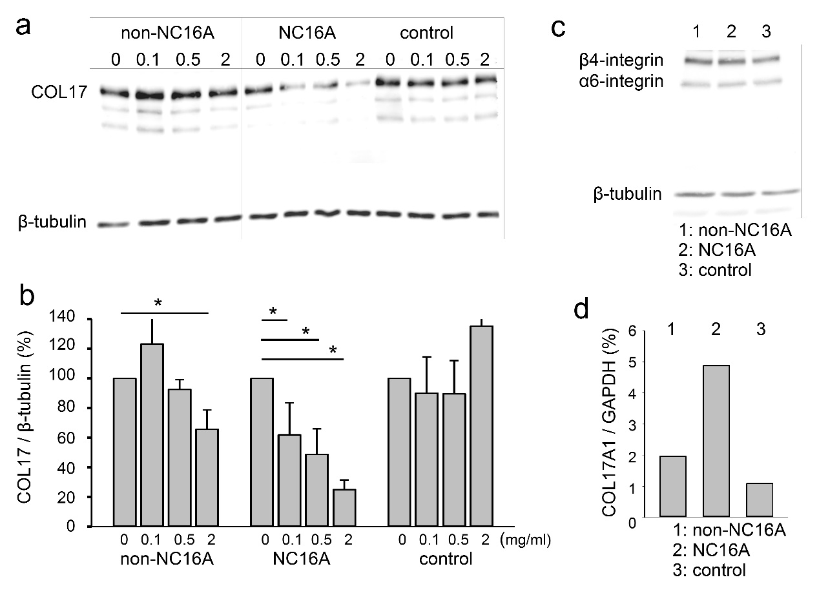
Supplementary Figure 1. NC16A-BP IgG but not non-NC16A-BP IgG depletes COL17 in a dose-dependent manner.

After NHEKs at 40% confluence are treated with 0, 0.1, 0.5 or 2 mg/mL of IgG for 6 hours, COL17 was detected by Western blotting. β-tubulin was the internal control. (a) The figure shows representative Western blotting. (b) The relative COL17 amount was measured compared to β-tubulin (* P<0.05). (c) When cells were stimulated with BP-IgG, the other hemidesmosomal proteins, α6-integrin or β4-integrin, were detected by Western blotting.(d) Quantitative RT-PCR of COL17A1 gene was measured in the organ cultured tissue stimulated by BP-IgG.

1 Izumi K, Nishie W, Mai Y et al. Autoantibody Profile Differentiates between Inflammatory and Noninflammatory Bullous Pemphigoid. J Invest Dermatol 2016: 136: 2201–2210.
2 Dmochowski M, Hashimoto T, Bhogal B S et al. Immunoblotting studies of linear IgA disease. J Dermatol Sci 1993: 6: 194–200.
3 Iwata H, Kamio N, Aoyama Y et al. IgG from patients with bullous pemphigoid depletes cultured keratinocytes of the 180-kDa bullous pemphigoid antigen (type XVII collagen) and weakens cell attachment. J Invest Dermatol 2009: 129: 919–26.
4 Natsuga K, Nishie W, Shinkuma S et al. Antibodies to pathogenic epitopes on type XVII collagen cause skin fragility in a complement-dependent and -independent manner. J Immunol 2012: 188: 5792–9.
5 Yu X, Holdorf K, Kasper B et al. FcγRIIA and FcγRIIIB are required for autoantibody-induced tissue damage in experimental human models of bullous pemphigoid. J Invest Dermatol 2010: 130: 2841–4.
6 Nakatani C, Muramatsu T, Shirai T. Immunoreactivity of bullous pemphigoid (BP) autoantibodies against the NC16A and C-terminal domains of the 180 kDa BP antigen (BP180): immunoblot analysis and enzyme-linked immunosorbent assay using BP180 recombinant proteins. Br J Dermatol 1998: 139: 365–70.

