**Supplementary material for**

**Plasmon Mediated Cathodic Photocurrent Generation in Sol-gel Synthesized Doped SrTiO3 Nanofilms**

Ramu Pasupathi Sugavaneshwar,1,2 Kai Chen,1,2 Gandham Lakshminarayana,1,2 Satoshi Ishii,1,2 Thang Duy Dao,1,2 Naoto Umezawa,2,3 and Tadaaki Nagao*.1,2

*1International Center for Materials Nanoarchitectonics (MANA), National Institute for Materials Science (NIMS), 1-1 Namiki, Tsukuba, Ibaraki 305-0044, Japan*

*2CREST, Japan Science and Technology Agency, 4-1-8 Honcho, Kawaguchi, Saitana, 332-0012, Japan*

*3Catalytic materials group, environmental remediation center* *National Institute for Materials Science (NIMS), 1-1 Namiki, Tsukuba, Ibaraki 305-0044, Japan*



FIG S1 (a) XRD pattern of STO and Rh-STO (b) Extended view of the XRD pattern to illustrate the shift represents from 31-34º.(c) XRD pattern of Au/Rh-STO and Ag/Rh-STO



FIG S2 　(a)Sr 3d, (b)Ti 2p, and (c) O1s high resolution XPS spectra of Rh-STO. (d) Sr 3d, (e)Ti 2p, and (f) O1s high resolution XPS spectra of STO.

Table S1 Binding energy values of XPS spectrum for Rh-STO and STO.

|  |  |  |  |  |  |  |  |
| --- | --- | --- | --- | --- | --- | --- | --- |
|  | Sr 3d  Binding energy  (eV) | | Ti 2p  Binding energy  (eV) | | O1s binding energy (eV) | | |
| Rh-STO | 132.9 | 134.7 | 457.9 | 463.3 | 533.77 | 531.6 | 529.2 |
| STO | 133.1 | 134.8 | 458.4 | 463.9 | 531.8 | 529.8 | 527.3 |



FIG S3 The short circuit photocurrent and transmission spectra of (a) STO (b)Rh-STO (c) Au/Rh-STO and (d) Ag/Rh-STO films. Absolute values of the current density are plotted.



FIG S4 Light intensity plot of the wavelength tunable source

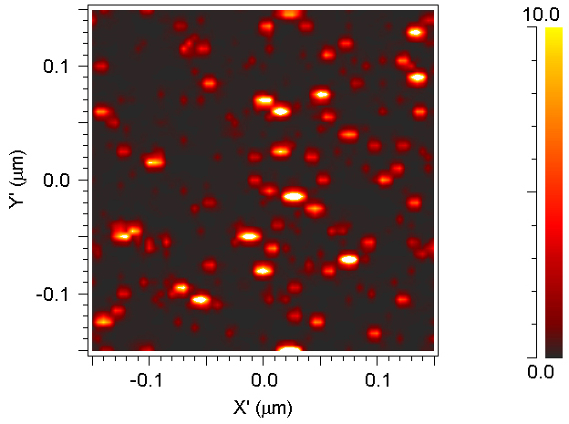

Fig S5 Field amplitude map of Ag on STO