Supplementary Material

Lactobacillus helveticus SBT2171 Induces A20 Expression via Toll-like Receptor 2 Signaling and Inhibits the Lipopolysaccharide-induced Activation of Nuclear Factor-kappa B and Mitogen-activated Protein Kinases in Peritoneal Macrophages
Michio Kawano, Masaya Miyoshi, Tadaaki Miyazaki*
* Correspondence: Tadaaki Miyazaki: miyazaki@pop.med.hokudai.ac.jp

Supplementary Figure
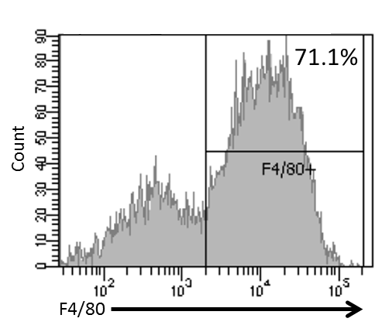
Supplementary Figure 1
The ratio of F4/80 positive cells per the peritoneal exudate adherent cells
The peritoneal exudate cells were seeded on plate and incubated for three hours. The adherent cells were washed once with PBS and detached with trypsin/EDTA. The adherent cells were treated with Zombie Aqua (Biolegend, San Diego, CA, USA) live–dead discriminating dye. These cells were treated with anti-mouse CD16/32 antibody (Biolegend) and then stained with Brilliant Violet 421TM-linked anti-F4/80 antibody (Biolegend) or corresponding isotype control (Biolegend). The stained cells were fixed with paraformaldehyde and analyzed with a flow cytometer (FACS Canto II, BD bioscience, Franklin Lakes, NJ, USA). The ratio of F4/80 positive cells per the live adherent cells was calculated.
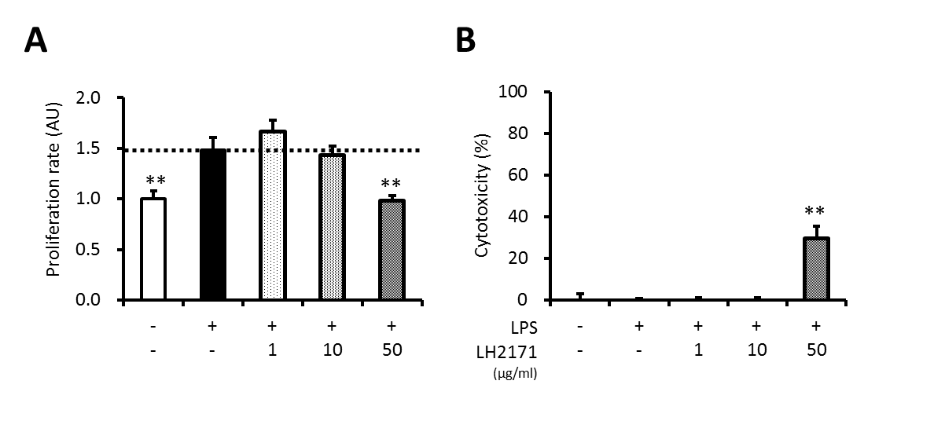
Supplementary Figure 2
LH2171 does not affect cell proliferation or cell death in LPS-stimulated peritoneal macrophages at a concentration of 10 µg/ml or less.
The peritoneal macrophages were pre-incubated with or without LH2171 for 4 hours and stimulated with 1 µg/ml LPS for 16 hours, after which cell proliferation rate (A) and cytotoxicity (B) were determined. The cell proliferation rate was determined relative to the mean value of untreated control (A). The cytotoxicity was determined by calculating the percentage of LDH release relative to the maximum LDH release control (B). Data are shown as mean + SD (n = 3) and analyzed by Dunnett’s test (**P < 0.01), which compared the LPS-treated group with the other groups.
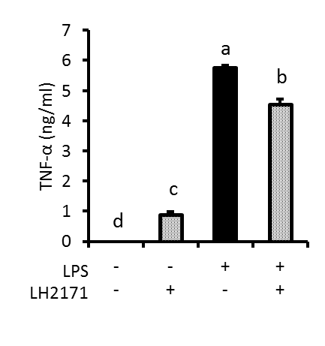
Supplementary Figure 3
LH2171 inhibited secretion of TNF-α from LPS-stimulated peritoneal macrophages.
The peritoneal macrophages were pre-incubated with or without 10 µg/ml LH2171 for 4 hours and stimulated with 1 µg/ml LPS for 16 hours, and subsequently TNF-α amount in the culture supernatant was measured by ELISA kit (Biolegend). Data are shown as mean + SD (n = 3) and analyzed by Tukey-Kramer’s (^{a-d}P < 0.05).

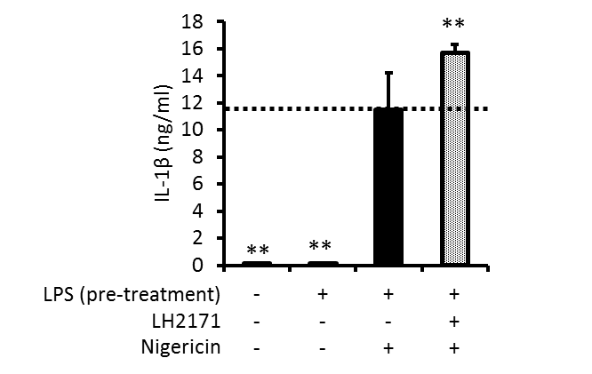
Supplementary Figure 4
LH2171 did not inhibit IL-1β secretion from LPS-pretreated peritoneal macrophages.
The peritoneal macrophages were pre-incubated with 1 µg/ml LPS for 16 hours and then treated with 10 µg/ml LH2171 for 2 hours. Subsequently these macrophages were additionally treated with 5 µM nigericin for 45 min to measure IL-1β amount in the cell culture supernatant. Data are shown as mean + SD (n = 3) and analyzed by Dunnett’s test (**P < 0.01), which compared the LPS+nigericin-treated group with the other groups.
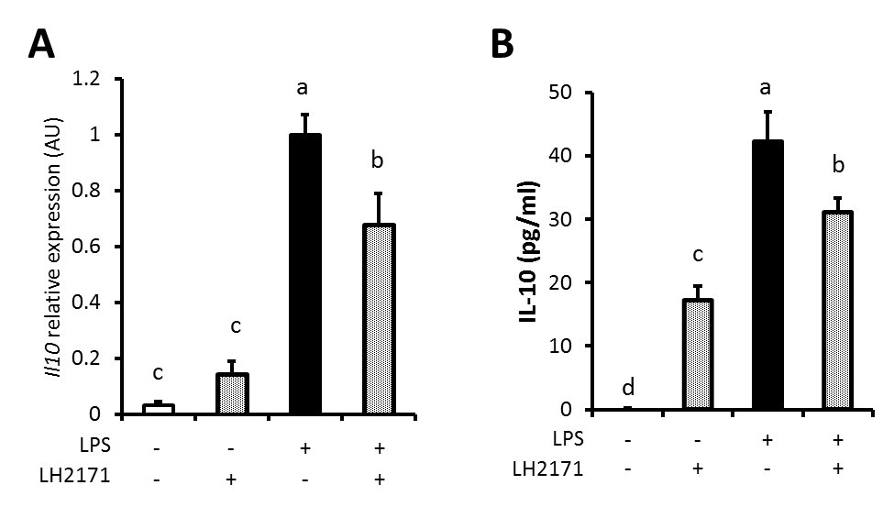
Supplementary Figure 5
LH2171 inhibited Il10 mRNA expression and IL-10 production in LPS-stimulated peritoneal macrophages.
The peritoneal macrophages were pre-incubated with or without 10 µg/ml LH2171 for 4 hours and stimulated with 1 µg/ml LPS for 16 hours, after which Il10 mRNA was quantified by a qPCR assay (A) and IL-10 amount in the cell culture supernatant was measured (B). The Il10 mRNA expression was determined relative to the mean value of LPS-treated control. Data are shown as mean + SD (n = 3) and analyzed by Tukey-Kramer’s (^{a-d}P < 0.05).
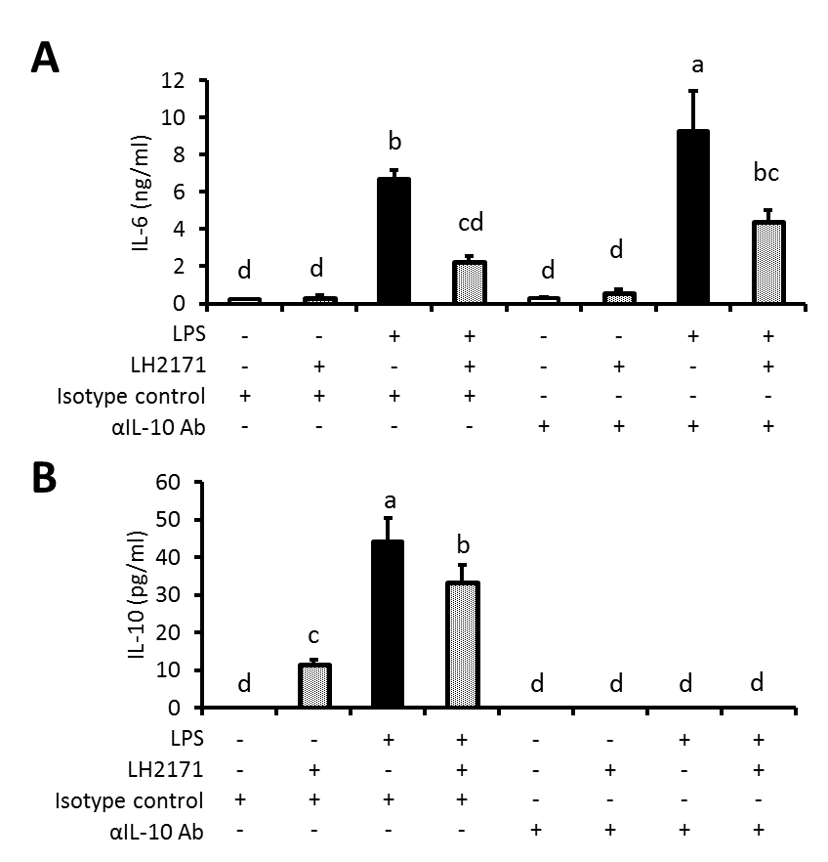
Supplementary Figure 6
The treatment of IL-10 blocking antibody did not affect the inhibitory effect of LH2171 on IL-6 secretion from peritoneal macrophages.
The peritoneal macrophages were pre-incubated with 10 µg/ml anti-IL-10 antibody (Tonbo Biosciences, San Diego, CA, USA) or corresponding isotype control (Biolegend) for 2 hours. These macrophages incubated with or without 10 µg/ml LH2171 for 4 hours and stimulated with 1 µg/ml LPS for 16 hours, after which IL-6 (A) or IL-10 (B) amount in the cell culture supernatant was measured by ELISA kits ((A) Biolegend, (B) R&D systems, Minneapolis, MN, USA). Data are shown as mean + SD (n = 3) and analyzed by Tukey-Kramer’s (^{a-d}P < 0.05).

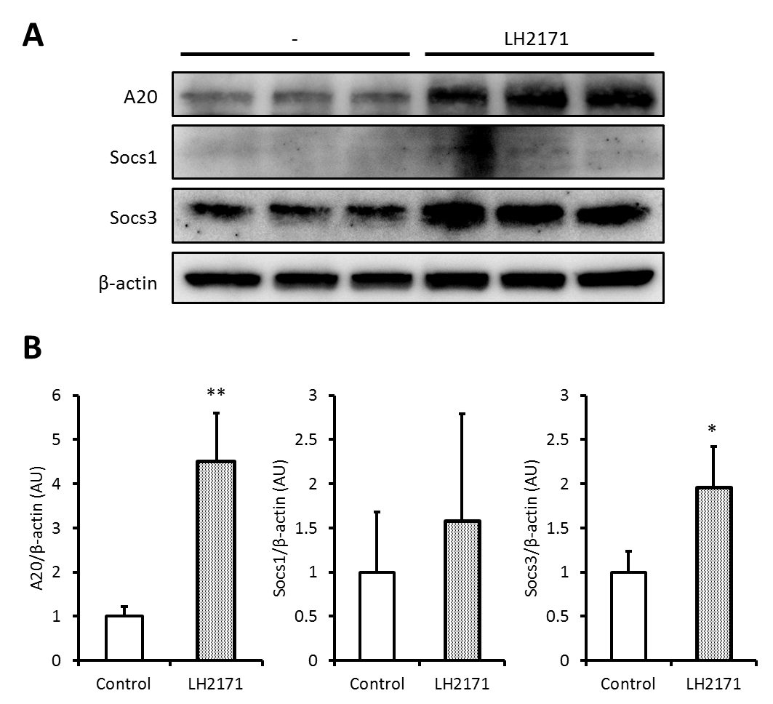
Supplementary Figure 7
LH2171 treatment for 20 hours upregulated the protein level of A20 and Socs3 in peritoneal macrophages
The peritoneal macrophages were incubated with or without 10 µg/ml LH2171 for 20 hours, after which the expression of A20, Socs1, Socs3, and β-tubulin was detected by western blot analysis (A). The ratio of A20/β-tubulin, Socs1/β-tubulin, and Socs3/β-tubulin by the densitometric quantification was shown (B). The quantified values were determined relative to the mean values of untreated control. Data are shown as mean + SD (n = 3) and analyzed by Student’s t-test (*P < 0.05, **P < 0.01).
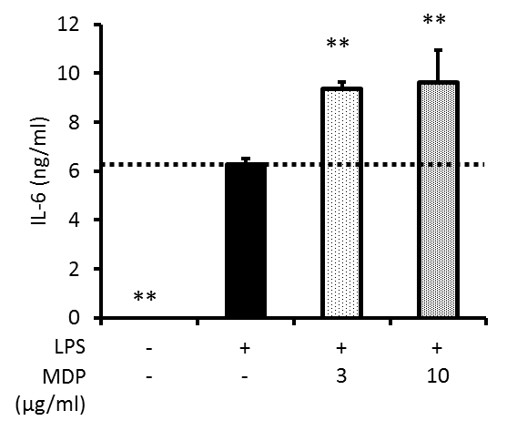
Supplementary Figure 8
Muramyl dipeptide did not inhibit inflammatory cytokine production in LPS-stimulated peritoneal macrophages.
The peritoneal macrophages were pre-incubated with 3 or 10 µg/ml muramyl dipeptide (MDP) for 4 hours and stimulated with 1 µg/ml LPS for 16 hours, after which IL-6 level in the culture supernatant was determined. MDP was purchased from Sigma Aldrich (St. Louis, MO, USA). Data are shown as mean + SD (n = 3) and analyzed by Dunnett’s test (**P < 0.01), which compared the LPS-treated group with the other groups.

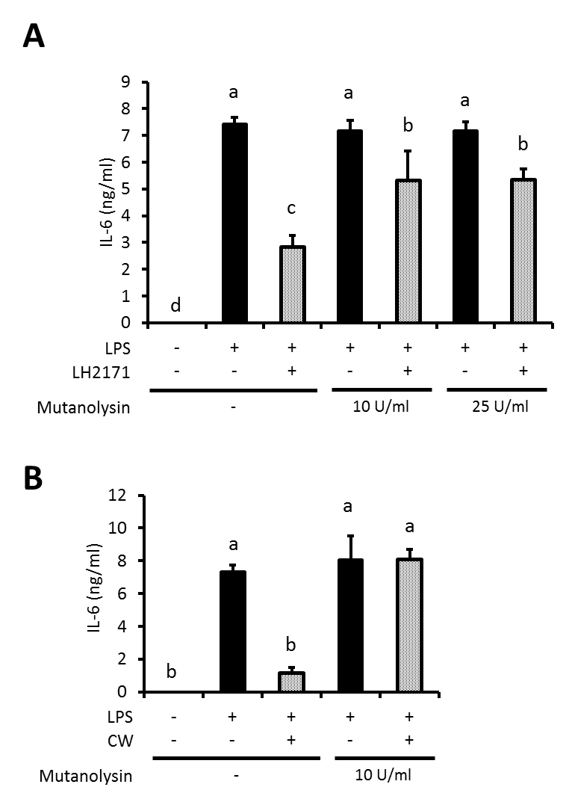
Supplementary Figure 9
Mutanolysin-treatment diminished the inhibitory effect of LH2171 and its cell wall on IL-6 secretion in peritoneal macrophages.
LH2171 cells or cell wall fractions were treated with different concentration of mutanolysin (0, 10 or 25 U/ml) in buffer (49 mM MES, 1 mM MgCl2, 0.66 mM TES and for 22 hours at 37°C, followed by heat inactivation for 30 min at 80°C. The peritoneal macrophages were pre-incubated with mutanolysin-treated or untreated LH2171 (A) or its cell wall (B) at a dose of 10 µg/ml for 4 hours and stimulated with 1 µg/ml LPS for 16 hours, after which IL-6 levels in the culture supernatants were determined. Data are shown as mean + SD (n = 3) and analyzed by Tukey-Kramer’s test (^{a-d}P < 0.05).

Supplementary Table

Supplementary Table 1 Primers for gene expression analysis
Gene name |  |  | Sequence |  | bp
Tnfa | Forward | 5' | AGCCCACGTCGTAGCAAACCAC | 3' | 22
 | Reverse | 5' | CGGGGCAGCCTTGTCCCTTG | 3' | 20
Il6 | Forward | 5' | CGTGGAAATGAGAAAAGAGTTGTGC | 3' | 25
 | Reverse | 5' | TGGTACTCCAGAAGACCAGAGGA | 3' | 23
Il1b | Forward | 5' | CCCTGCAGCTGGAGAGTGTGGA | 3' | 22
 | Reverse | 5' | TGTGCTCTGCTTGTGAGGTGCTG | 3' | 23
Nos2 | Forward | 5' | GTTCTCAGCCCAACAATACAAGA | 3' | 23
 | Reverse | 5' | GTGGACGGGTCGATGTCAC | 3' | 19
Nlrp3 | Forward | 5' | GACCAGCCAGAGTGGAATGAC | 3' | 21
 | Reverse | 5' | AACCTGCTTCTCACATGTCGT | 3' | 21
Ccl2 | Forward | 5' | CCAGCACCAGCACCAGCCAA | 3' | 20
 | Reverse | 5' | TGGGGCGTTAACTGCATCTGGC | 3' | 22
Il10 | Forward | 5' | GCCCCAGGCAGAGAAGCATGG | 3' | 21
 | Reverse | 5' | GGGGAGAAATCGATGACAGCGCC | 3' | 23
Socs1 | Forward | 5' | TCCGATTACCGGCGCATCACG | 3' | 21
 | Reverse | 5' | CTCCAGCAGCTCGAAAAGGCA | 3' | 21
Tollip | Forward | 5' | ATTATGGCATGACTCGTATGGAC | 3' | 23
 | Reverse | 5' | CTATACCACTCGTCCTCCACTTG | 3' | 23
Irakm | Forward | 5' | TTCCTGGCACGTTCGAATCA | 3' | 20
 | Reverse | 5' | CGCTGCAGCAAAATCCGTTA | 3' | 20
A20 | Forward | 5' | AAACCAATGGTGATGGAAACTG | 3' | 22
 | Reverse | 5' | GTTGTCCCATTCGTCATTCC | 3' | 20
Socs3 | Forward | 5' | GGAGATTTCGCTTCGGGACT | 3' | 20
 | Reverse | 5' | CGCTCCAGTAGAATCCGCTC | 3' | 20
Tlr2 | Forward | 5' | AAGATGTCGTTCAAGGAGGTGCG | 3' | 23
 | Reverse | 5' | ATCCTCTGAGATTTGACGCTTTG | 3' | 23
Tlr4 | Forward | 5' | CCTGATGACATTCCTTCT | 3' | 18
 | Reverse | 5' | AGCCACCAGATTCTCTAA | 3' | 18
Rpl19 | Forward | 5' | ATGAGTATGCTCAGGCTACAGA | 3' | 22
 | Reverse | 5' | GCATTGGCGATTTCATTGGTC | 3' | 21

Supplementary Table 2 Antibodies for western blot analysis and fluorescent immunostaining
Antibodies |  |  |  | Source |  |  | Identifier
Rabbit anti-NF-κB p65 |  |  |  | Cell Signaling Technologies |  |  | Cat#8242
Rabbit anti-Phospho-NF-κB p65 (Ser536) |  |  |  | Cell Signaling Technologies |  |  | Cat#3033
Mouse anti-IκBα |  |  |  | Cell Signaling Technologies |  |  | Cat#4814
Rabbit anti-Phospho-JNK (T183/Y185) |  |  |  | R&D systems |  |  | Cat#AF1205
Rabbit anti-JNK |  |  |  | Cell Signaling Technologies |  |  | Cat#9252
Rabbit anti-Phospho-p38 MAPK (Thr180/Tyr182) |  |  |  | Cell Signaling Technologies |  |  | Cat#9211
Rabbit anti-p38 MAPK |  |  |  | Cell Signaling Technologies |  |  | Cat#9212
Rabbit anti-Erk1/2 |  |  |  | Cell Signaling Technologies |  |  | Cat#9102
Rabbit anti-Phospho-Erk1/2 (Thr202/Tyr204) |  |  |  | Cell Signaling Technologies |  |  | Cat#9101
Rabbit anti-A20 |  |  |  | Cell Signaling Technologies |  |  | Cat#5630
Rabbit anti-Socs1 |  |  |  | Cell Signaling Technologies |  |  | Cat#3950
Rabbit anti-Socs3 |  |  |  | Cell Signaling Technologies |  |  | Cat#2932
Rabbit anti-β-actin |  |  |  | Cell Signaling Technologies |  |  | Cat#4970
Horse anti-mouse IgG HRP-linked |  |  |  | Cell Signaling Technologies |  |  | Cat#7076
Goat anti-rabbit IgG HRP-linked |  |  |  | Cell Signaling Technologies |  |  | Cat#7074
Goat anti-rabbit IgG Alexa Fluor® 488-linked |  |  |  | Abcam |  |  | Cat#ab150077

