Electronic Supplementary Material
Author: Akira Terui, Junjiro N Negishi, Nozomi Watanabe, Futoshi Nakamura
Title: Stream resource gradients drive consumption rates of supplemental prey in the adjacent riparian zone
Journal: Ecosystems

ESM 1: Carnivorous arthropods attracted by supplemental larvae In order to investigate carnivorous animals attracted by supplemental prey (beetle larvae), we carried out an additional experiment in the field (July 2016). As with the main experiment, we placed six plastic cups containing 10 beetle larvae at one site in each of Satsunai and Tottabetsu Rivers. However, we installed sticky traps (5-cm wide, 9.5-cm long) at the entrance of plastic cups to capture carnivorous arthropods attracted by supplemental prey. We kept those traps in place over one night.
In total, 60 individuals of carnivorous arthropods were captured. Carabid beetles accounted for 93% of the carnivorous arthropods (L. noguchii, 78%; A. grandis, 15%), followed by earwigs (Dermaptera; 5%) and staphylinind beetles (2%).

ESM 2: Species-specific response to emergence flux To examine how Carabid species’ responses to emergence flux are different among species (Lithochlaenius noguchii, Apristus grandis, Brachinus stenoderus, and Bembidion spp.), we compared performance of random intercept and random slope models using generalized mixed effect models (GLMMs). We assumed that the number of ground beetles captured by pit fall traps for species s follows a negative binomial distribution (function glmer.nb in the R package lme4), and the expected mean μ_{ij.s} (site i in survey j) was related to liner predictors with a log-link function:

log(μ_{ij,s}) = α_{s} + β1×log(EF_{i}) + β2×Year_{ij} + δ_{k} for a random intercept model
log(μ_{ij,s}) = α_{s} + β1_{s} × log(EF_{i}) + β2×Year_{ij} + δ_{k} for a random slope model

where EF_{i} is the emergence flux, Year_{ij} is the sampling year, and δ_{k} is the random effect of river identity. In the random intercept model, the intercept term α_{s} varies by species but the effect of emergence flux β1 does not. In the random slope model, both the intercept α_{s} and effect of emergence flux β1_{s} vary by species.
We did not find strong support for the random slope model (AIC = 1007 for the random intercept model; AIC = 1008 for the random slope model). This result suggests limited variation in species’ responses to spatial subsidies.

ESM 3: Species-specific effect on consumption rate of supplemental prey We estimated species-specific contributions of the dominant Carabid beetle species (L. noguchii, A. grandis, B. stenoderus, and Bembidion spp.) to the consumption rate of supplemental prey (i.e., beetle larvae). As with the main Bayesian analysis, the consumption rate CR_{ijt} was drawn from an overdispersed Poisson distribution:

CR_{ijt} ~ Poisson(cr_{ijt})
log(cr_{ijt}) = β_{0,cr} + β_{1,cr} × w.gb_{it} + β_{2,cr} × TEMP_{cr,ijt} + log(TIME_{ijt}) + δ_{it} + ε_{ijt}

where TEMP_{cr,ijt} is the average air temperature during the experiment, TIME_{ijt} is the time elapsed during the experiment (1.7–2.3 days; an offset term), δ_{it} is the site-specific year effect, and ε_{ijt} is the data-level error that accounts for overdispersion. The random effects (δ_{it} and ε_{ijt}) were drawn from normal distributions with a mean of 0 and variance of σ_{R}² (subscript R corresponds to each random effect name). The variable w.gb_{it} is the weighted mean of species-specific Carabid beetle density:

w.gb_{it} = $\sum{{(w}_{s}×{GB}_{it,s})}$
$\sum{w_{s}}$ = 1

w_{s} is the weight parameter for species s and GB_{it,s} is the beetle density at site i and year t for species s (individual CPUE⁻¹). The parameter w_{s} represents the relative importance of species s for the consumption rate of supplemental prey (i.e., relative per-capita performance). We employed a censoring function as in the main analysis: when all beetle larvae were removed or consumed during the experiment, the observations were treated initially as “NA”, and the values of >C_{ijt} beetle larvae were randomly generated along the parameter inference of Markov Chain Monte Carlo (MCMC) simulations.
Vague priors were assigned to the parameters: normal distributions (mean = 0, variance = 10³) for regression coefficients β, truncated normal distributions (mean = 0, variance = 10³, range: 0–30) for standard deviations of random effects (σ_{δ} and σ_{ε}), and a Dirichlet distribution for w_{s} [w_{s} ~ Dirichlet(1,1,1,1)]. The model was fitted to the data using JAGS (ver. 4.1.0) and the package “runjags” in R 3.2.3. Three MCMC chains were run with 22,500 iterations (7,500 burn-in), and 500 samples per chain were used to calculate posterior probabilities. Convergence was assessed by examining whether the R-hat indicator of each parameter approached a value of 1.
The estimated species-specific contributions w_{s} were largely overlapped (Table S2). This result suggests that little variation exists in per-capita consumption performance among the dominant Carabid beetle species.

ESM 4: Longitudinal gradients in the Tokachi River basin We explored longitudinal gradients of biological properties in the study region to support our interpretation of the Bayesian path model. Specifically, we investigated whether unknown longitudinal gradients, rather than algal biomass, have the potential to control a suite of variables (algal biomass [log transformed AFDM], emergence flux [log transformed], beetle density, and consumtion rate). Our basic model structure was described as follows:

link(θ_{i}) = α + β1×watershed_area_{i} + β2×river_ID_{i} + β3×river_ID_{i} ×watershed_area_{i} + γX,

where θ_{i} is the parameter specified in models with a normal (mean; log-transformed algal biomass and emergence flux), a negative binomial (mean; beetle density), or a binomial (proportion; consumption rate) error distribution. The parameter α is the intercept, and β1–3 are regression coefficients for watershed area (a proxy for longitudinal position; standardized using a mean of 0 and variance of 1), river identity (Satsunai, Bisei, and Tottabetsu), and their interaction term, respectively. The parameter γ is a vector of regression coefficients associated with the matrix of confounding factors X. Algal biomass and emergence flux were modeled without the term γX, but some control variables were included in the models for beetle density (air temperature, bar area, sampling year and offset term) and consumption rate (air temperature and sampling year). The function link() denotes a link function for each of the specified models (identity for normal models, log for a negative binomial model, and logit for a binomial model). Continuous explanatory variables were standardized before the analysis.
For all the response variables, we found significant interactive effects of watershed area and river identity (Table S3). Specifically, strong positive effects of watershed area were found only in the Satsunai River (Fig. S2). This result suggests that without the excessive increase in algal biomass observed in the Satsunai River (Fig. S2a), any longitudinal gradients have little influence on the response variables. These facts strongly suggest that algal biomass is the primary factor controlling consumption rates of supplemental prey via trophic interactions.

Table S1 Inventory of Carabid beetle species captured by pit fall traps. Species were shown in order of relative dominance. Abundance represents the total number of individuals across sampling sites.
Species | Proportion | Abundance
Lithochlaenius noguchii | 0.542 | 2437
Apristus grandis | 0.191 | 871
Bembidion spp. | 0.127 | 579
Brachinus stenoderus | 0.126 | 574
Pterostichus leptis | 0.005 | 22
Tachyura exarata | 0.004 | 18
Chlaenius pallipes | 0.002 | 10
Agonum impressum | 0.002 | 9
Pterostichus planicollis | 0.001 | 3
Pterostichus fortipes | 0.001 | 3
Elaphrus japonicas | < 0.0005 | 2
Amara macra | < 0.0005 | 1
Total | 1.00 | 4565

Table S2 Specifies-specific effects on consumption rate of supplemental prey
Parameter | Note | Estimate | 95% CI
β_{0,cr} | Intercept | 3.01 | 2.69 to 3.28
β_{1,cr} | Effect of beetle density* | 0.16 | 0.04 to 0.35
β_{2,cr} | Effect of air temperature | 0.28 | 0.16 to 0.42
w_{s} | Weight parameter for L. noguchii | 0.20 | 0.02 to 0.60
 | for A. grandis | 0.18 | 0.01 to 0.53
 | for Bembidion spp. | 0.31 | 0.03 to 0.63
 | for B. stenoderus | 0.23 | 0.01 to 0.66
* The regression coefficient was not standardized

Table S3 Parameter estimates of GLMs used to examine the potential effects of watershed area.
Significant variables are shown in bold.
Response | Effect | Estimate | SE | Wald p-value
Algal biomass | Intercept | 7.00 | 0.18
 | Watershed area | 0.01 | 0.13 | 0.46
 | Bisei (vs. Tottabetsu) | 0.10 | 0.61 | 0.88
 | Satsunai (vs. Tottabetsu) | 1.26 | 0.25 | < 0.01
 | Watershed × Bisei | 0.04 | 0.65 | 0.95
 | Watershed × Satsunai | 1.89 | 0.48 | < 0.01
Emergence flux | Intercept | 4.12 | 0.18
 | Watershed area | 0.16 | 0.13 | 0.24
 | Bisei (vs. Tottabetsu) | −0.16 | 0.62 | 0.80
 | Satsunai (vs. Tottabetsu) | 0.26 | 0.26 | 0.33
 | Watershed × Bisei | −1.12 | 0.67 | 0.13
 | Watershed × Satsunai | 1.76 | 0.49 | < 0.01
Beetle density | Intercept | 2.23 | 0.30
 | Watershed area | 0.37 | 0.21 | 0.08
 | Bisei (vs. Tottabetsu) | −0.86 | 0.83 | 0.30
 | Satsunai (vs. Tottabetsu) | 0.25 | 0.39 | 0.53
 | Watershed × Bisei | −1.21 | 0.83 | 0.15
 | Watershed × Satsunai | 1.91 | 0.69 | < 0.01
 | Air temperature | −0.04 | 0.21 | 0.86
 | Bar area | −0.10 | 0.14 | 0.48
 | Year 2016 (vs. 2015) | −0.17 | 0.25 | 0.49
Consumption rate | Intercept | 1.59 | 0.13
 | Watershed area | 0.38 | 0.09 | < 0.01
 | Bisei (vs. Tottabetsu) | 0.53 | 0.33 | 0.11
 | Satsunai (vs. Tottabetsu) | −0.08 | 0.16 | 0.62
 | Watershed × Bisei | 0.09 | 0.36 | 0.81
 | Watershed × Satsunai | 0.66 | 0.26 | 0.01
 | Air temperature | 0.80 | 0.07 | < 0.01
 | Year 2016 (vs. 2015) | 0.32 | 0.13 | 0.01

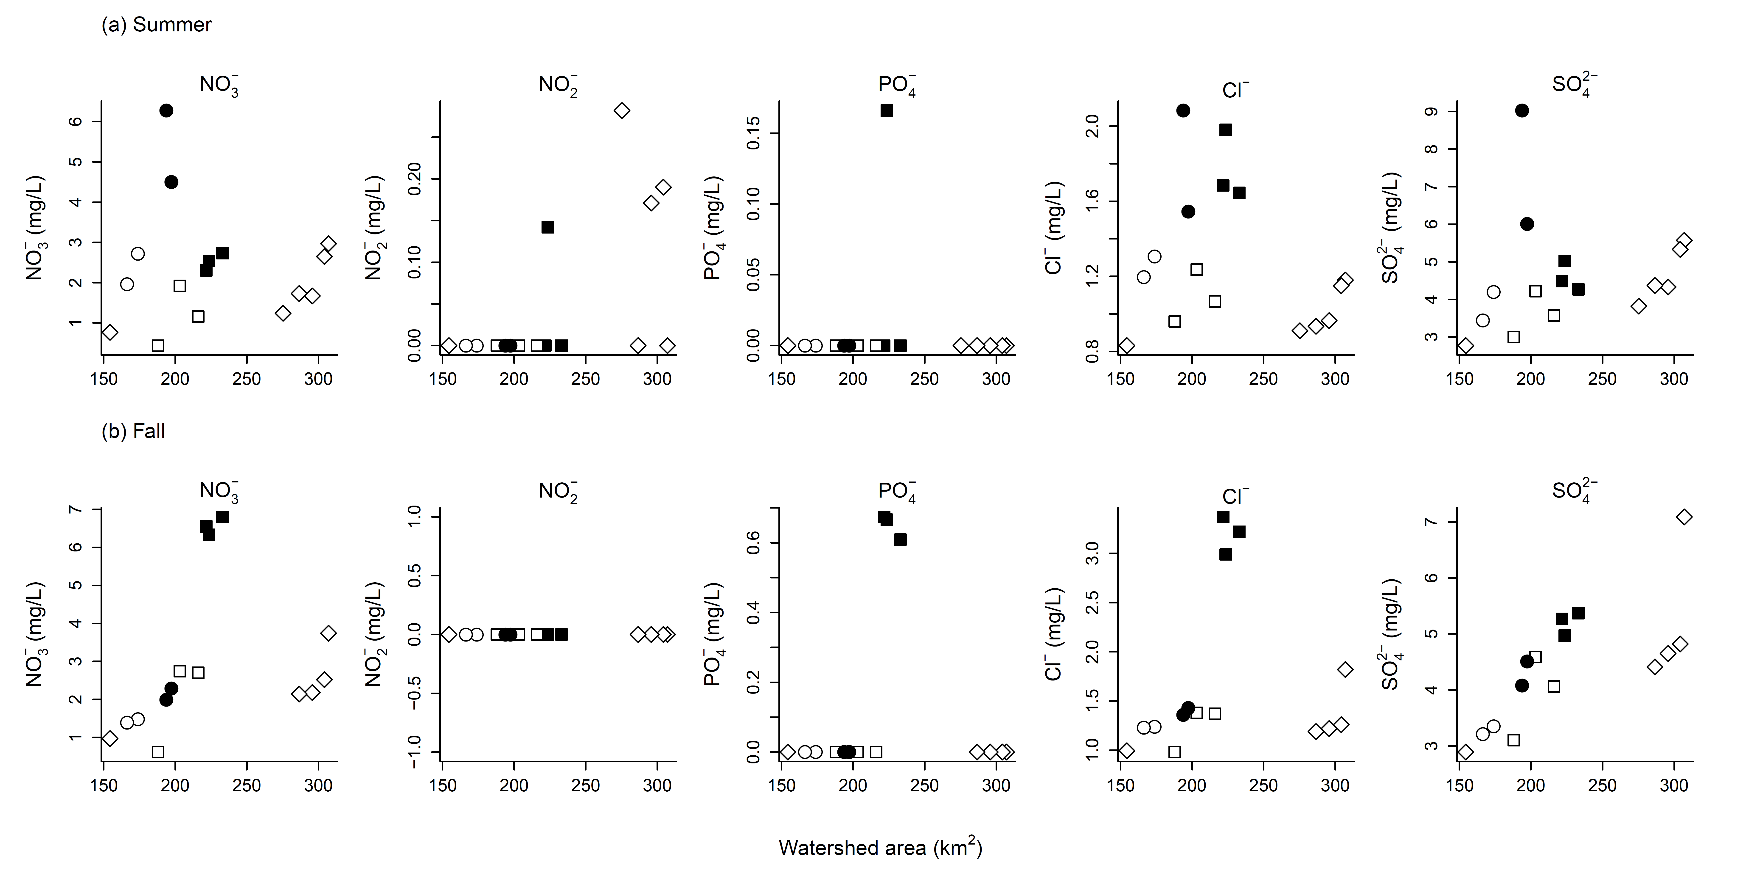Figure S1 Nutritional conditions of river water along a gradient of watershed area. Different symbols denote different rivers (square, Satsunai; circle, Bisei; diamond, Tottabetsu). Filled points indicate sites eutrophicated due to sewage water inputs. Water samples (500 mL) were collected at each site during the summer (top: July) and fall (bottom: September) of 2015. Collected samples were filtered through GF/F filters and analyzed using an ion spectrometer (IA-300, TOA-DKK, Tokyo, Japan)
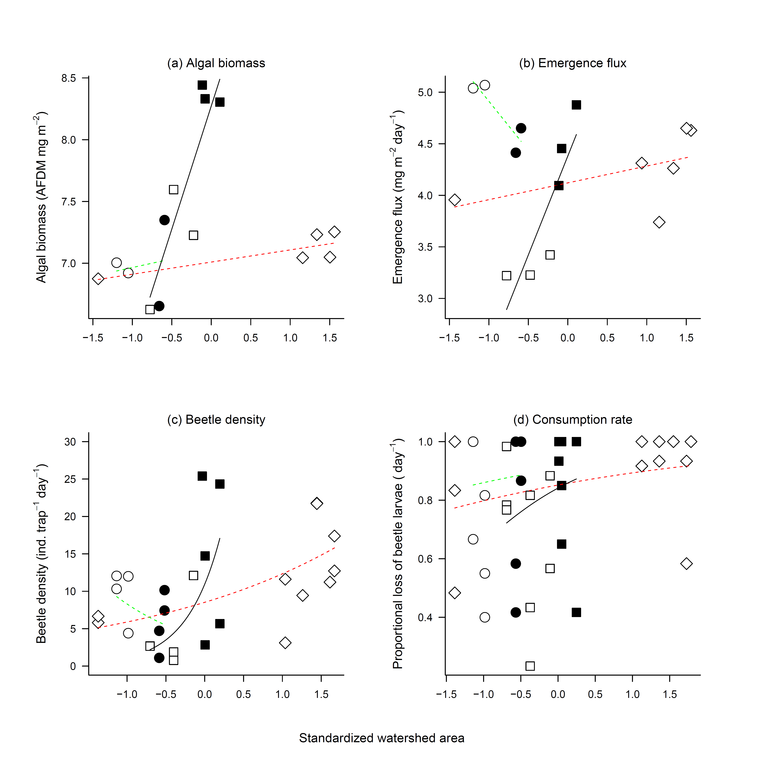Figure S2 River-specific effects of watershed area on algal biomass (a), emergence flux (b), beetle density (c), and consumption rate (d). Different symbols denote different rivers (square, Satsunai; circle, Bisei; diamond, Tottabetsu). Filled symbols indicate sites eutrophied due to sewage water inputs. Lines are values fitted by generalized linear models (black, Satsunai; green, Bisei; red, Tottabetsu).

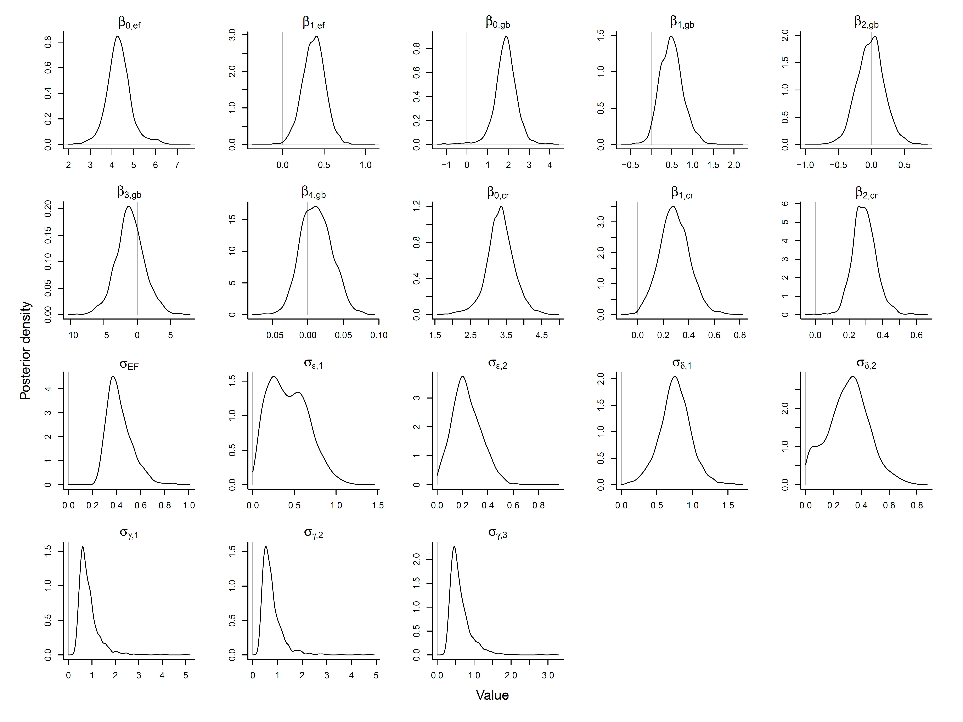Figure S3 Posterior distribution of parameters estimated in the Bayesian path model. See Table 2 for parameter descriptions.

