Table S1 Association of maternal PFASs levels with cord blood adipokines and birth size stratified by child sex and interaction between PFASs and child sex.
PFOS | Boys | Girls
 | β (95% CI) | β (95% CI) | p_{interaction}
Total adiponectin | 0.13 (0.00, 0.26) | 0.11 (-0.06, 0.27) | 0.563
HMW adiponectin | 0.13 (-0.04, 0.30) | 0.12 (-0.08, 0.33) | 0.598
Leptin | 0.01 (-0.28, 0.30) | -0.14 (-0.49, 0.21) | 0.008
Birth weight (g) | 190 (-162, 543) | -251 (-645, 143) | 0.201
Ponderal index (kg/m³) | -2.46 (-4.74, -0.18) | -2.11 (-4.86, 0.64) | 0.658
PFOA
Total adiponectin | 0.06 (-0.13, 0.13) | 0.05 (-0.05, 0.16) | 0.811
HMW adiponectin | -0.01 (-0.19, 0.16) | 0.05 (-0.09, 0.18) | 0.885
Leptin | -0.14 (-0.42, 0.15) | 0.08 (-0.15, 0.31) | 0.591
Birth weight (g) | -276 (-619, 67) | -169 (-419, 81) | 0.160
Ponderal index (kg/m³) | -1.02 (-3.33, 1.29) | -1.39 (-3.13, 0.36) | 0.376
Adjusted for maternal BMI, parity, smoking during pregnancy, blood sampling period and gestational age.
P_{interaction} for PFOS or PFOA and child sex interaction.

Table S2 Adjusted least square means (LSM) for cord blood adipokines by tertiles of PFASs.
PFOS | Total  adiponectin |  |  | HMW adiponectin |  |  | Leptin
 | LSM | LCI | UCI | LSM | LCI | UCI | LSM | LCI | UCI
T1 | 17.02 | 15.41 | 18.63 | 11.23 | 9.81 | 12.65 | 7.44 | 5.58 | 9.31
T2 | 19.36 | 17.77 | 20.94 | 12.97 | 11.58 | 14.36 | 8.11 | 6.28 | 9.95
T3 | 19.93 | 18.34 | 21.53 | 13.22 | 11.81 | 14.62 | 7.09 | 5.22 | 8.97
P_{trend} | 0.095 |  |  | 0.072 |  |  | 0.906
PFOA
T1 | 17.78 | 16.19 | 19.37 | 11.72 | 10.34 | 13.09 | 7.45 | 5.78 | 9.13
T2 | 21.24 | 19.60 | 22.89 | 14.67 | 13.24 | 16.09 | 7.89 | 6.15 | 9.63
T3 | 19.86 | 18.08 | 21.65 | 13.14 | 11.59 | 14.69 | 7.23 | 5.35 | 9.11
P_{trend} | 0.644 |  |  | 0.796 |  |  | 0.789
PFOS; T1:1.5-4.0 ng/mL, T2: 4.1-6.2 ng/mL, T3: 6.3-14.7 ng/mL.
PFOA; T1:<LOD-1.10 ng/mL, T2: 1.20-1.80 bg/mL, T3: 1.90-5.30 ng/mL.
Adjusted for maternal BMI, parity, smoking during pregnancy, blood sampling period, gestational age and infant sex.
LSM: least square mean, LCI: lower 95% confidence interval, UCI: upper 95% confidence interval, T: tertile, LOD: limit of detection.

Table S3 Adjusted least square means (LSM) for birth size by tertiles of PFASs.
PFOS | Birth weight |  |  | Ponderal index
 | LSM | LCI | UCI | LSM | LCI | UCI
T1 | 3196 | 3095 | 3298 | 28.39 | 27.71 | 29.06
T2 | 3076 | 2976 | 3176 | 26.68 | 26.02 | 27.34
T3 | 3158 | 3057 | 3258 | 27.23 | 26.57 | 27.90
P_{trend} | 0.424 |  |  | 0.003
PFOA
T1 | 3197 | 3095 | 3300 | 27.78 | 27.08 | 28.48
T2 | 3092 | 2986 | 3199 | 27.61 | 26.89 | 28.34
T3 | 3087 | 2972 | 3203 | 26.58 | 25.79 | 27.37
P_{trend} | 0.021 |  |  | 0.002
PFOS; T1:1.5-4.0 ng/mL, T2: 4.1-6.2 ng/mL, T3: 6.3-14.7 ng/mL.
PFOA; T1:<LOD-1.10 ng/mL, T2: 1.20-1.80 bg/mL, T3: 1.90-5.30 ng/mL.
Adjusted for maternal BMI, parity, smoking during pregnancy, blood sampling period, gestational age and infant sex.
LOD: limit of detection.

Table S4 Comparison of basic characteristics between whole population (n=469) and participants included in this study (n=168).
Characteristics |  | Whole population  (n=469) | Participants included in this study  (n=168)
Mother |  | % or mean (SD)
Age at delivery (years) |  | 30.7 (4.9) | 30.0 (4.6)
Pre-pregnancy BMI (kg/m²) |  | 21.1 (3.1) | 21.2 (3.3)
Parity | 0 | 48.0% | 53.6%
 | ≧ 1 | 51.8% | 46.4%
Smoking during pregnancy | No | 83.3% | 81.5%
 | Yes | 16.6% | 18.5%
Alcohol intake during pregnancy | No | 68.0% | 66.7%
 | Yes | 32.0% | 33.3%
Education (years) | ≦ 12 | 45.0% | 45.2%
 | ≧ 13 | 55.0% | 54.8%
Family income (yen) | < 5M | 68.9% | 72.0%
 | ≧ 5M | 31.1% | 28.0%
Infant
Sex | Boy | 46.9% | 46.4%
 | Girl | 53.1% | 53.6%
Gestational age (days) |  | 276.7 ± 7.8 | 279.0 ± 6.6
Birth weight (g) |  | 3091 ± 347 | 3150 ± 330
Birth length (cm) |  | 48.2 ± 1.7 | 48.6 ± 1.6
Ponderal Index (kg/m³) |  | 27.5 ± 2.3 | 27.5 ± 2.2

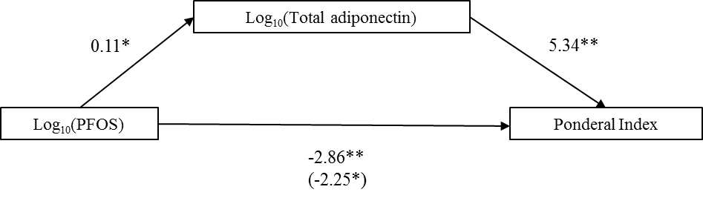
Figure S1. Mediation analysis of the association between PFOS and total adiponectin and between PFOS and PI. Regression coefficients of each path are described alongside with arrows. The total effect of PFOS on PI is described in the parentheses. A significant indirect effect of PFOS on PI through total adiponectin was observed (indirect effect=0.61; bias-corrected and accelerated confidence interval: 0.04, 1.50). The total adiponectin as a mediator can account for roughly 30% of total effect (percent mediation=0.27). Adjusted for maternal BMI, parity, smoking during pregnancy, blood sampling period, gestational age and infant sex. *p<0.05 and **P<0.01.

