Appendix A.
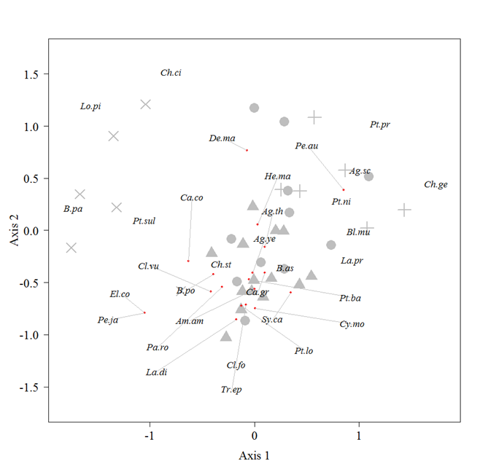
Fig. A1. Non-metric multidimensional scaling (NMDS) ordination of wetland ground beetle species
Symbols indicate study sites in grassland (x symbols), newly abandoned farmland (triangles), previously abandoned farmland (circles), and remnant wetland (crosses). Red dots with gray lines denote species positions. Please refer to Table A1 for the species names indicated by the abbreviations.

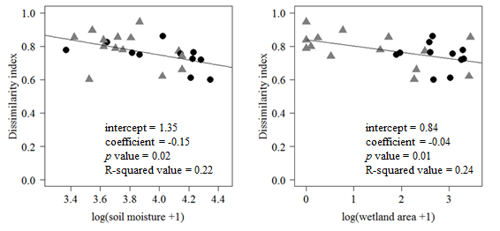Fig. A2. Relationships between the dissimilarity index and two variables (soil moisture and wetland area)
Each point indicates an abandoned farmland site, and the dissimilarity index indicates the difference in species composition for wetland ground beetles between abandoned farmland and wetland. The regression lines are based on linear regression analysis using the dissimilarity index and log-transformed soil moisture or the wetland area. Symbols indicate abandonment age: newly abandoned sites (gray triangles) and previously abandoned sites (black circles).

Table A1 List of ground beetle species (Coleoptera: Carabidae) found in this study, the number of sites sampled and the total number of individuals
Species |  | Sites | Total | Abbr.
Wetland species
Brachypterous | Bembidion assimile | 10 | 46 | B.as
 | Carabus conciliator hokkaidensis | 5 | 55 | Ca.co
 | Carabus granulatus yezoensis | 26 | 350 | Ca.gr
 | Cychrus morawitzi | 2 | 8 | Cy.mo
 | Demetrias marginicollis | 2 | 2 | De.ma
 | Hemicarabus maeander paludis | 16 | 55 | He.ma
 | Pterostichus bandotaro | 30 | 426 | Pt.ba
 | Pterostichus prolongatus | 8 | 48 | Pt.pr
 | Pterostichus sulcitarsis | 9 | 40 | Pt.sul
Macropterous | Agonum sculptipes | 19 | 492 | Ag.sc
 | Agonum thoreyi nipponicum | 31 | 692 | Ag.th
 | Agonum yezoanum | 21 | 277 | Ag.ye
 | Amara ampliata | 8 | 50 | Am.am
 | Bembidion paediscum | 2 | 3 | B.pa
 | Bembidion poppii captivorum | 3 | 5 | B.po
 | Blethisa multipunctata aurata | 1 | 1 | Bl.mu
 | Chlaenius circumductus | 2 | 2 | Ch.ci
 | Chlaenius gebleri | 3 | 23 | Ch.ge
 | Chlaenius stschukini | 5 | 6 | Ch.st
 | Clivina fossor sachalinica | 1 | 1 | Cl.fo
 | Clivina vulgivaga | 18 | 129 | Cl.vu
 | Elaphrus comatus | 1 | 1 | El.co
 | Lachnocrepis prolixa | 16 | 155 | La.pr
 | Lasiotrechus discus | 14 | 458 | La.di
 | Loricera pilicornis | 6 | 56 | Lo.pi
 | Panagaeus robustus | 6 | 12 | Pa.ro
 | Perileptus japonicus | 1 | 1 | Pe.ja
 | Peronomerus auripilis | 9 | 31 | Pe.au
 | Pterostichus longinquus | 6 | 40 | Pt.lo
 | Pterostichus nigrita | 25 | 214 | Pt.ni
 | Synuchus callitheres | 1 | 1 | Sy.ca
 | Trechus ephippiatus | 26 | 1396 | Tr.ep
Open-land species
Brachypterous | Acupalpus hilaris | 7 | 14
 | Pterostichus microcephalus | 5 | 10
Macropterous | Amara chalcites | 7 | 70
 | Amara communis | 13 | 81
 | Amara plebeja | 2 | 2
 | Anisodactylus signatus | 5 | 26
 | Chlaenius pallipes | 15 | 87
 | Dolichus halensis | 7 | 25
 | Harpalus calceatus | 1 | 1
 | Harpalus capito | 4 | 6
 | Harpalus jureceki | 7 | 24
 | Harpalus sinicus | 5 | 21
 | Harpalus vicarious | 24 | 8859
 | Pterostichus haptoderoides japanensis | 8 | 64
 | Pterostichus planicollis | 14 | 165
 | Pterostichus samurai | 1 | 1
 | Stenolophus iridicolor | 1 | 1
 | Stenolophus propinquus | 10 | 17
 | Trichotichnus longitarsis | 5 | 7
Other habitat species
Brachypterous | Damaster blaptoides rugipennis | 3 | 4
 | Leptocarabus arboreus arboreus | 3 | 7
 | Leptocarabus opaculus opaculus | 9 | 104
 | Pterostichus orientalis jessoensis | 1 | 1
Macropterous | Agonum impressum | 13 | 71
 | Anisodactylus tricuspidatus | 2 | 7
 | Campalita chinense | 4 | 6
 | Colpodes lampros | 1 | 1
 | Pterostichus subovatus | 1 | 1
 | Pterostichus neglectus | 9 | 57
 | Synuchus melantho | 22 | 590
 | Synuchus nitidus | 3 | 3
The number of sites at which each species was collected (Site), total number of individuals (Total), and the abbreviations of the species names (Abbr.).
Listed species were grouped by their wing forms; brachypterous (species with rudimentary or short hind wings) and macropterous (species with long hind wings).
Table A2 Pairwise ANOSIM between land uses
(a) Wetland and open-land ground beetle species
 | Statistic | Newly abandoned | Previously abandoned | Wetland
Grassland | R | 0.90 | 0.78 | 1.00
 | p | p < 0.01 | p < 0.01 | 0.02
Newly abandoned | R |  | 0.15 | 0.78
 | p |  | 0.12 | p < 0.01
Previously abandoned | R |  |  | 0.17
 | p |  |  | 0.47
b) Wetland ground beetle species
 | Statistic | Newly abandoned | Previously abandoned | Wetland
Grassland | R | 0.84 | 0.80 | 0.95
 | p | p < 0.01 | p < 0.01 | p < 0.01
Newly abandoned | R |  | 0.16 | 0.71
 | p |  | 0.08 | p < 0.01
Previously abandoned | R |  |  | 0.17
 | p |  |  | 0.46
R values (R) and Bonferroni-correlated p values (p) are shown.

Table A3 Range of variables in SEM
Variables | Land uses | Mean | SD | Max | Min
Vegetation density | Grassland | 1.00 | 0.00 | 1.00 | 1.00
 | Newly abandoned | 2.62 | 0.30 | 3.41 | 2.25
 | Previously abandoned | 2.88 | 0.44 | 3.59 | 2.09
 | Remnant wetland | 3.04 | 0.67 | 3.84 | 2.16
Soil moisture (%) | Grassland | 39.32 | 3.71 | 45.16 | 35.22
 | Newly abandoned | 44.50 | 11.46 | 62.72 | 29.72
 | Previously abandoned | 56.70 | 15.53 | 76.19 | 28.09
 | Remnant wetland | 78.71 | 2.13 | 80.63 | 74.94
Patch area (ha) | Newly abandoned | 7.35 | 13.98 | 55.45 | 1.25
 | Previously abandoned | 22.32 | 20.71 | 62.99 | 4.77
Wetland area within 500 m buffer (ha) | Newly abandoned | 7.11 | 10.45 | 30.50 | 0.00
 | Previously abandoned | 16.54 | 7.55 | 26.47 | 5.68
Distance between abandoned farmland and wetland area (m) | Newly abandoned | 409.57 | 418.82 | 1572.22 | 26.87
 | Previously abandoned | 83.77 | 51.77 | 178.91 | 18.60
Mean values (Mean), standard deviations (SD), maximum values (Max), and minimum values (Min) are shown.

