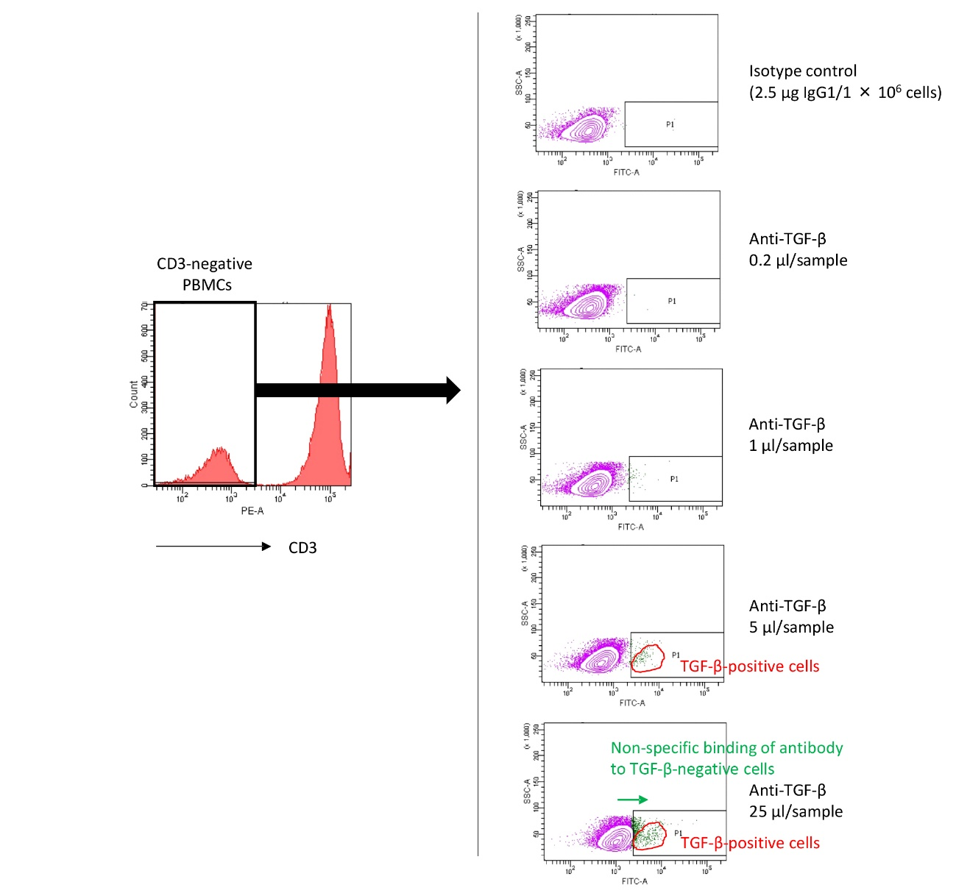
Figure S2. Titration of the anti-TGF-β antibody
We at first sought which population in PBMCs could be applied for the titration of the anti-TGF-β antibody. As Dedobbellee et al. have demonstrated the presence of cells that constitutively express TGF-β in the peripheral blood B cells (Dedobbellee O, et al. J Immunol 2017; 199: 391-396), we focused on the CD3-negative population in PBMCs in our experiments. The fluorescence labeling of CD3-negative PBMCs was examined using FITC-conjugated isotype control IgG1 (2.5 µg/1 × 10⁶ cells, an excessive dose) and FITC-conjugated anti-TGF-β antibody in diverse doses (0.2, 1, 5, and 25 μl/sample). Results demonstrated that TGF-β-expressing cells could be detected in cases where >5 μl/sample of the anti-TGF-β antibody was applied. However, a non-specific binding of the antibody to TGF-β-negative cells occurred when 25 μl/sample of the anti-TGF-β antibody was used; therefore, this dose seemed too much for this purpose. In contrast, when 5 μl/sample of the anti-TGF-β antibody was employed, TGF-β-positive and TGF-β-negative cells were clearly separated. These findings support the validity of our data obtained using 5 μl/sample of the anti-TGF-β antibody.

