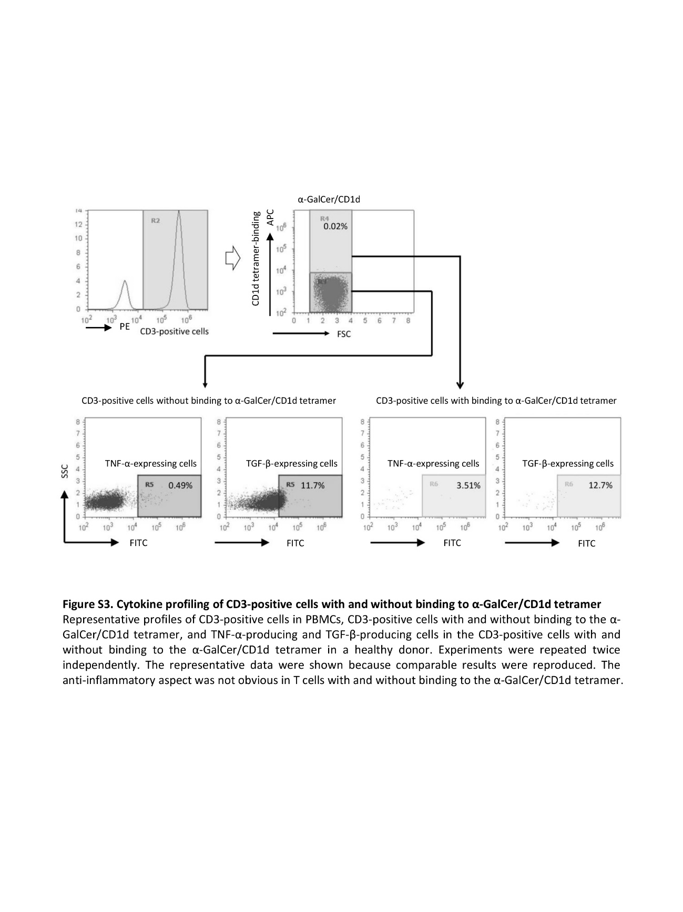

**Figure S4. Cytokine profiling of CD3-positive cells with and without binding to α-GalCer/CD1d tetramer**

Representative profiles of CD3-positive cells in PBMCs, CD3-positive cells with and without binding to the α-GalCer/CD1d tetramer, and TNF-α-producing and TGF-β-producing cells in the CD3-positive cells with and without binding to the α-GalCer/CD1d tetramer in a healthy donor. Experiments were repeated twice independently. The representative data were shown because comparable results were reproduced. The anti-inflammatory aspect was not obvious in T cells with and without binding to the α-GalCer/CD1d tetramer.