Supplementary data

Determination of risk factors

Hypertension was defined as the use of any antihypertensive medication or blood pressure higher than 140/90 mmHg on more than two occasions during the follow-up period. Diabetes mellitus was defined as the use of any antidiabetic medication or haemoglobin A1c (NGSP) > 6.5%. Dyslipidaemia was defined as the use of any lipid-lowering agents or an elevated serum low-density lipoprotein concentration > 140 mg/dl. Glucocorticosteroid treatment was defined as the use of any oral or intravenous corticosteroid therapy for more than three consecutive months at any time of the follow-up. Current cigarette smoking was defined as any cigarette or cigar during the follow-up period.

Determination of antiphospholipid antibodies and the antiphospholipid score (aPL-S)
For lupus anticoagulant (LA), mixing tests of three clotting assays were performed using a semiautomated hemostasis analyzer (STart 4; Diagnostica Stago) according to the guidelines recommended by the Subcommittee on Lupus Anticoagulant/Antiphospholipid Antibody of the Scientific and Standardization Committee of the International Society on Thrombosis and Haemostasis [1]. For measurement of the activated Partial Thromboplastin Time (APTT), PTT-LA test (Diagnostica Stago) was used for screening and confirmed with mixing test using Staclot LA kit (Diagnostica Stago). The Dilute Russell's viper venom time (dRVVT) was screened and confirmed by the Gradipore LA test (Sydney New South Wales, Australia) and the kaolin clotting time (KCT) using a kaolin solution (Dade Behring, Liederbach, Germany).
Anticardiolipin antibodies (aCL) immunoglobulins (Ig) G and M, anti-beta2 glycoprotein I antibodies (aβ2GPI) IgG and IgM, and phosphatidylserine-dependent antiprothrombin antibodies (aPS/PT) IgG and IgM were assayed by enzyme-linked immunosorbent assay (ELISA) as described previously [2-4].

References

1. Brandt JT, Triplett DA, Alving B, Scharrer I. Criteria for the diagnosis of lupus anticoagulants: an update. On behalf of the Subcommittee on Lupus Anticoagulant/Antiphospholipid Antibody of the Scientific and Standardisation Committee of the ISTH. Thromb Haemost. 1995;74(4):1185-90.
2. Amengual O, Atsumi T, Khamashta MA, Koike T, Hughes GR. Specificity of ELISA for antibody to beta 2-glycoprotein I in patients with antiphospholipid syndrome. Br J Rheumatol. 1996;35(12):1239-43.
3. Atsumi T, Ieko M, Bertolaccini ML, Ichikawa K, Tsutsumi A, Matsuura E, et al. Association of autoantibodies against the phosphatidylserine-prothrombin complex with manifestations of the antiphospholipid syndrome and with the presence of lupus anticoagulant. Arthritis Rheum. 2000;43(9):1982-93.
4. Harris EN, Gharavi AE, Patel SP, Hughes GR. Evaluation of the anti-cardiolipin antibody test: report of an international workshop held 4 April 1986. Clin Exp Immunol. 1987;68(1):215-22.

Table S1. Antiplatelet agents
Antiplatelet agents | Total (N=90) | Wf (N=13) | AP (N=41) | Wf + AP (N=21) | DAPT (N=15)
Aspirin (maximum dose 100mg/day ) | 64 (71.1%) | - | 34 (83.9%) | 18 (85.7%) | 12 (80.0%)
Ticlopidin (200 - 300mg/day) or Clopidogrel (50 - 75mg/day) | 12 (13.3%) | - | 2 (4.9%) | 0 (0%)) | 10 (66.7%)
Cilostazol (100 - 200mg/day) | 10 (11.1%) | - | 4 (9.8%) | 1 (4.8%) | 5 (33.3%)
Other antiplatelet agents* | 6 (6.7%) | - | 1 (2.4%) | 2 (9.5%) | 3 (20.0%)
*Other antiplatelet agents included dipyridamole (maximum dose 400mg/day), beraprost sodium (maximum dose 120μg/day), sarpogrelate hydrochloride (maximum dose 300mg/day) or dilazep dihydrochloride (maximum dose 150mg/day).
Results are presented as number of patients and percentage in each group. N: number of patients, Wf: warfarin monotherapy, AP: antiplatelet monotherapy, Wf + AP: warfarin and antiplatelet combination therapy, DAPT: dual antiplatelet therapy.

Table S2. Antiphospholipid score and antiphospholipid antibody profiles
 |  | Total (N=90) | Wf (N=13) | AP (N=41) | Wf + AP (N=21) | DAPT (N=15) | P-value
aPL-S |  | 31 [14-50.5] | 33 [13.0-71.0] | 26 [13.0-42.0] | 35 [15.0-54.5] | 33 [20.0-41.0] | 0.434
aPL-S ≥ 30 |  | 47 (54.4%) | 8 (61.5%) | 18 (43.9%) | 13 (61.9%) | 8 (53.3%) | 0.493
Lupus anticoagulant |  | 74 (82.2%) | 9 (69.2%) | 32 (78.1%) | 19 (90.5%) | 14 (93.3%) | 0.214
 | PTT-LA | 62 (68.9%) | 5 (38.5%) | 27 (65.9%) | 17 (81.0%) | 13 (86.7%) | 0.024＊
 | KCT | 63 (70.0%) | 7 (53.9%) | 23 (56.1%) | 19 (90.5%) | 14 (93.3%) | 0.002＊
 | dRVVT | 48 (53.3%) | 7 (53.9%) | 23 (56.1%) | 12 (57.1%) | 6 (40.0%) | 0.724
aCL (IgG or IgM) |  | 43 (47.8%) | 8 (61.5%) | 18 (43.9%) | 12 (57.1%) | 5 (33.3%) | 0.353
 | IgG | 24 (26.7%) | 5 (38.5%) | 9 (22.0%) | 7 (33.3%) | 3 (20.0%) | 0.540
 | IgM | 6 (6.7%) | 1 (7.7%) | 2 (4.9%) | 2 (9.5%) | 1 (6.7%) | 0.920
 | IgG and IgM | 13 (14.4%) | 2 (15.4%) | 7 (17.1%) | 3 (14.3%) | 1 (6.7%) | 0.773
antiβ2GPI (IgG or IgM) |  | 49 (54.4%) | 11 (84.6%) | 21 (51.2%) | 8 (38.1%) | 9 (60%) | 0.047＊
 | IgG | 35 (38.9%) | 8 (61.5%) | 12 (29.3%) | 7 (33.3%) | 8 (53.3%) | 0.115
 | IgM | 7 (7.8%) | 1 (7.7%) | 5 (12.2%) | 0 | 1 (6.7%) | 0.222
 | IgG and IgM | 7 (7.8%) | 2 (15.4%) | 4 (9.8%) | 1 (4.8%) | 0 | 0.287
aPS/PT (IgG or IgM) |  | 62 (68.9%) | 8 (61.5%) | 30 (73.2%) | 13 (61.9%) | 11 (73.3%) | 0.734
 | IgG | 38 (42.2%) | 5 (38.5%) | 18 (43.9%) | 7 (33.3%) | 8 (53.3%) | 0.667
 | IgM | 7 (7.8%) | 0 | 4 (9.8%) | 3 (14.3%) | 0 | 0.124
 | IgG and IgM | 17 (18.9%) | 3 (23.1%) | 8 (19.5%) | 3 (14.3%) | 3 (20.0%) | 0.924
Results of antibody test are presented as number of antibody positive patients and percentage in each group.＊P-values <0.05. P-values are multiple comparison between 4 groups and were estimated using Kruskal-Wallis test. aPL-S: Antiphospholipid score aPL-S are presented as the median (IQR: Interquartile range 25th -75th). aPL: antiphospholipid antibodies, PTT-LA: Activated Partial Thromboplastin Time, KCT: Kaolin Clotting Time, dRVVT: Diluted Russell Viper Venom time, aCL: anticardiolipin antibodies, antiβ2GPI: anti-β2Glycoprotein I antibodies, aPS/PT: Phosphatidylserine-dependent antiprothrombin antibody, N: number of patients, Wf: warfarin monotherapy, AP: antiplatelet monotherapy, Wf + AP: warfarin and antiplatelet combination therapy, DAPT: dual antiplatelet therapy.
Table S3. Recurrent thrombosis, severe bleeding and death
 |  | Total (N=90) | Wf (N=13) | AP (N=41) | Wf + AP (N=21) | DAPT (N=15) | P-value
Arterial thrombosis
 | Cerebral infarction | 29 (32.2%) | 9 (69.2%) | 13 (31.7%) | 6 (28.6%) | 1 (6.7%) | 0.004＊
 | Coronary heart disease | 3 (3.3%) | 0 | 3 (7.3%) | 0 | 0 | 0.184
 | Arterial ischemia in legs | 1 (1.1%) | 1 (7.7%) | 0 | 0 | 0 | 0.268
 | Central retinal artery occlusion | 2 (2.2%) | 0 | 0 | 1 (4.8%) | 1 (6.7%) | 0.285
Venous thrombosis
 | Deep vein thrombosis | 3 (3.3%) | 1 (7.7%) | 2 (4.9%) | 0 | 0 | 0.352
 | Branch retinal vein occlusion | 1 (1.1%) | 0 | 0 | 0 | 1 (6.7%) | 0.303
 | Superficial thrombophlebitis | 1 (1.1%) | 0 | 0 | 1 (4.8%) | 0 | 0.345
Severe bleeding |  | 9 (10.0%) | 0 | 5 (12.2%) | 2 (9.5%) | 2 (13.3%) | 0.373
 | Cerebral haemorrhage | 4 (4.4%) | 0 | 2 (4.9%) | 1 (4.8%) | 1 (6.7%)
 | Cardiovascular system haemorrhage | 2 (2.2%) | 0 | 1 (2.4%) | 0 | 1 (6.7%)
 | Alveolar haemorrhage | 1 (1.1%) | 0 | 0 | 1 (4.8%) | 0
 | Gastrointestinal haemorrhage | 1 (1.1%) | 0 | 1 (2.4%) | 0 | 0
 | Multiple subcutaneous haemorrhage | 1 (1.1%) | 0 | 1 (2.4%) | 0 | 0
Mortality |  | 14 (15.6%) | 1 (7.7%) | 5 (12.2%) | 4 (19.1%) | 4 (26.7%) | 0.476
 | Related to bleeding | 3 (3.3%) | 0 | 1 (2.4%) | 1 (4.8%) | 1 (6.7%)
 | Related to thrombosis recurrence | 2 (2.2%) | 1 (7.7%) | 0 | 1 (4.8%) | 0
＊P-values <0.05. P-values are multiple comparison between 4 groups and were estimated using Kruskal-Wallis test. Severe bleeding event was defined as the events that required hospitalization and/or blood transfusion. N: number of patients, Wf: warfarin monotherapy, AP: antiplatelet monotherapy, Wf + AP: warfarin and antiplatelet combination therapy, DAPT: dual antiplatelet therapy
Table S4. Risk factors for recurrent thrombosis
 |  | Univariate analysis |  |  | Multivariate analysis
 |  | Unadjusted Hazard Ratio | (95％ CI) | P value | Adjusted Hazard Ratio | (95％ CI) | P value
Warfarin monotherapy |  | 2.93 | ( 1.394 - 5.731) | 0.007* | 4.23 | ( 1.686 – 10.378) | 0.003*
Male |  | 1.50 | ( 0.672 - 3.046 ) | 0.302 | 1.05 | ( 0.442 - 2.296 ) | 0.909
Age > 50 |  | 1.16 | ( 0.618 - 2.218 ) | 0.654 | 1.46 | ( 0.727 – 3.077 ) | 0.295
Steroid |  | 1.09 | ( 0.554 - 2.253 ) | 0.813 | 1.01 | ( 0.492 - 2.175 ) | 0.984
Smoking |  | 1.43 | ( 0.722 - 2.714 ) | 0.295 | 1.63 | ( 0.782 - 3.271 ) | 0.188
Hypertension |  | 1.34 | ( 0.715 - 2.608 ) | 0.364 | 1.18 | ( 0.602 - 2.382 ) | 0.637
Dyslipidemia |  | 1.06 | ( 0.559 - 1.980 ) | 0.859 | 1.49 | ( 0.692 – 3.317 ) | 0.314
Diabetes Mellitus |  | 1.41 | ( 0.565 - 3.045 ) | 0.436 | 1.76 | ( 0.683 – 4.036 ) | 0.225
aPL-S ≥ 30 |  | 1.04 | ( 0.559 - 1.985 ) | 0.895 | 1.01 | ( 0.484 - 2.063 ) | 0.990
＊P-values <0.05. P-values were estimated using Cox Regression Analysis. aPL-S: the antiphospholipid score, CI: Confidence Interval

Figure legend
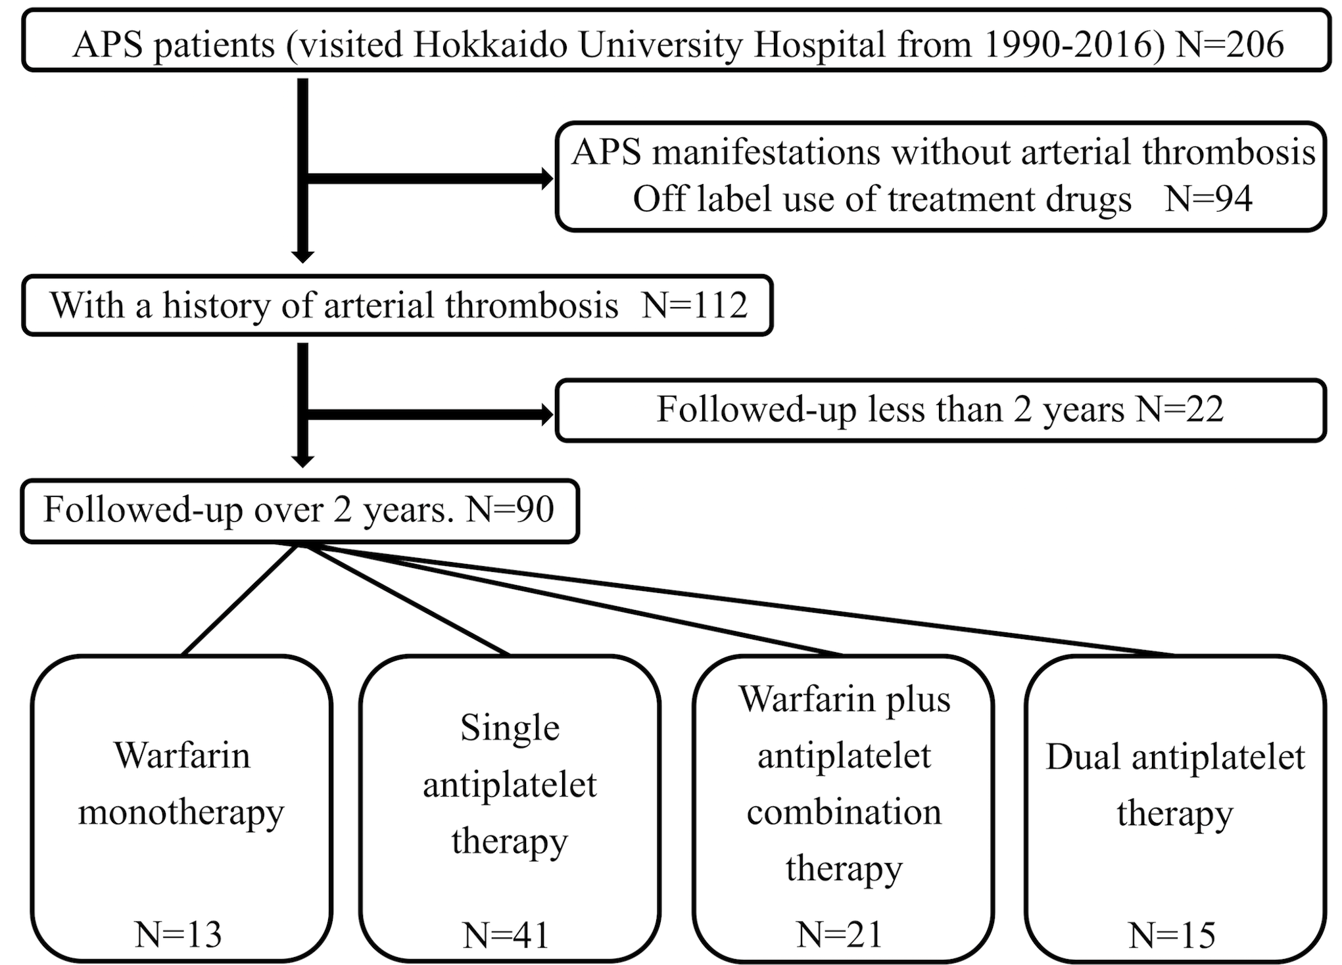
Figure S1. Flow chart of the study design
Patients were categorized into four groups according to the therapy used for secondary prevention of thrombosis. APS: antiphospholipid syndrome, N: number of patients.

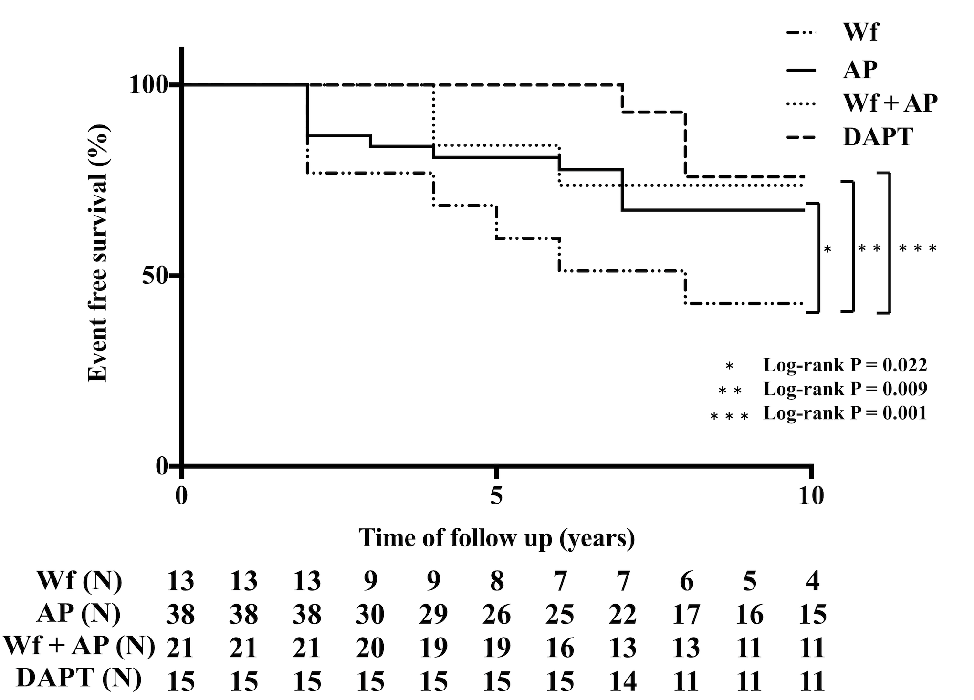
Figure S2. Ten-years thrombosis-free survival (sub-analysis)
Data were estimated using the Kaplan-Meier curves. P-values <0.05. The sub-analysis excluding patients with recurrence of cardiac events were performed. Warfarin (Wf) was less effective for prevention of thrombosis than other treatment options.
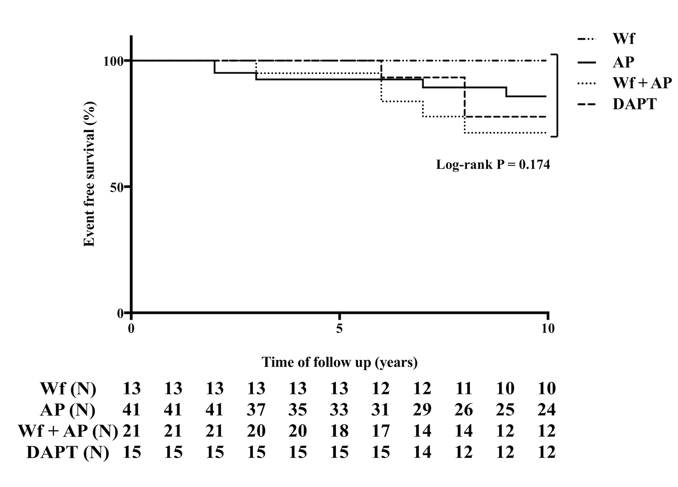
Figure S3. Ten-years adverse events-free survival
Data were estimated using the Kaplan-Meier curves. P-values <0.05. Adverse events-free survival curves. Adverse events were defined as severe bleeding and death. No statistically significant difference in frequency of adverse events was observed between the 4 groups (Log-rank p = 0.174). The case of mortality in Wf monotherapy died 15 years later from the start of the observation. N: number of patients, Wf: warfarin monotherapy, AP: antiplatelet monotherapy, Wf + AP: warfarin and antiplatelet combination therapy, DAPT: dual antiplatelet therapy.

