Supplementary information
The SS-GMPE was constructed based on the equation (1) of Boore et al. (2014) (equation S1) as well as Eq. 2. We performed linear regression analysis using the least-squares method for the pseudo-spectral acceleration of events 2 through 7 (Table 1) with different M_{w} (equation S2).
ln Y = F_{E} (M, mech) + F_{P} (R_{JB}, M, region) + F_{S} (V_{S30}, R_{JB}, M, z₁) (S1)
where F_{E}, F_{P,} and F_{S} represent functions for source, path, and site effects, respectively. The predictor variables are M, mech, R_{JB} (in km), V_{S30} (in m/s), and z₁ (in km). Y is the predicted 5% damped pseudo-spectral acceleration (Y in cm/s²).
a M_{w} + c_{i} = In Obs_{i} - F_{P} (R_{JB}, M_{w}, region) (S2)
where Obs_{i}, R_{JB} are the same parameters as in equation (1), and i indicates the number of observation sites (1 to 8). We thus obtain regression coefficients a for the source term and c_{i} for each site condition term. F_{P} is the same as the equation (3), (4) of Boore et al. (2014). The regional coefficient Δc is used the default value of 0.0.
Fig. S1 shows obtained regression coefficients a for the source term and c_{i} for each site condition term. Additionally, we performed linear regression analysis using the least-squares method for the coefficient c of each site with the bedrock depth at each site in shown as equation (S3).
c = pD₃₂₀₀ + q (T = 1 – 10 seconds) (S3)
where p and q are the regression coefficient, c is the coefficient of a GMPE applicable to the whole Kathmandu Valley, and D₃₂₀₀ is the top of the bedrock depth at each site (D₃₂₀₀ in m). Fig. S2 shows the comparison of the proposed GMPEs.

Supplementary file
Data 1 D3200.dat
Top of the bedrock data (Vs = 3200 m/s) in the Kathmandu Valley by Bijukchhen (2018)
Data 2 Model1_SSGMPE_coeffs.dat (Table 2, Fig. 6)
Coefficients a and c_{i} of SS-GMPE (Model 1) based on Morikawa and Fujiwara (2013)
Data 3 Model1_c_coeffs.dat (Table 3, Fig. 7)
Coefficients c for model 1
Data 4 SSGMPE_model2_coeffs.dat (Fig. S1)
Coefficients a and c_{i} of SS-GMPE (Model 2) based on Boore et al. (2014)
Data 5 Model1_c_coeffs.dat
Coefficients c for model 2
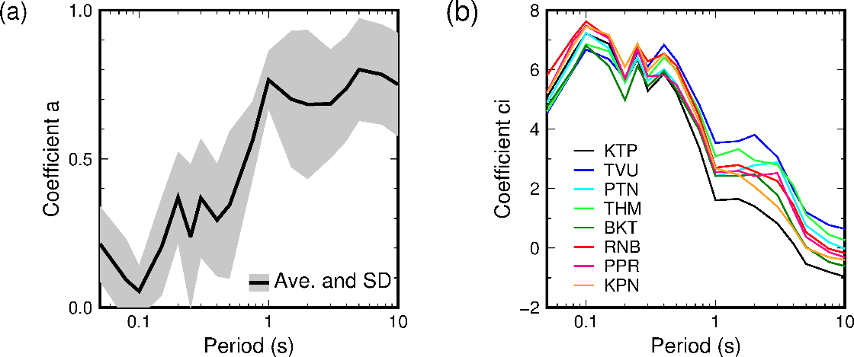
Fig. S1 (a) Average values of the regression coefficient a. Error bars indicate standard deviations. (b) Constructed coefficient c_{i} at each site.

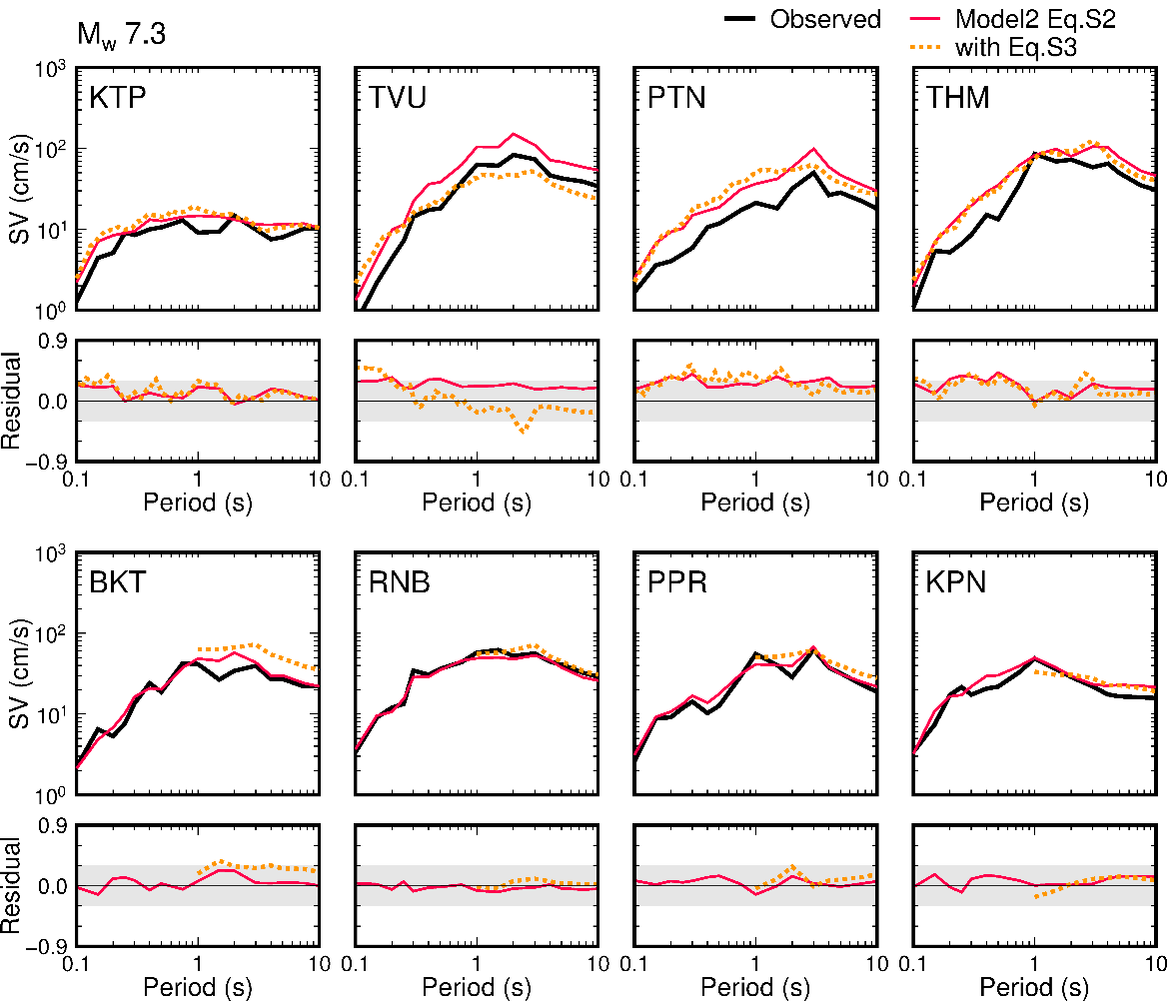
Fig. S2 Observed velocity response spectra for Mw 7.3 event and predicted values calculated on equation S2, S3 (Model 2) as well as the residuals (log [pre/obs]).

