**Supporting Information for**

**Quantifying Protein-Specific N-glycome Profiles by Focused Protein- and Immunoprecipitation-Glycomics**

Takashi Kobayashi,†,# Koji Ogawa,‡,# Jun-ichi Furukawa,§,#,* Hisatoshi Hanamatsu,‡ Megumi Hato,† Tomoyo Yoshinaga,† Kenichi Morikawa,‡ Goki Suda,‡ Takuya Sho,‡ Masato Nakai,‡ Kenichi Higashino,† Yoshito Numata,† Yasuro Shinohara,§ and Naoya Sakamoto‡,*

† Shionogi Innovation Center for Drug Discovery, Shionogi & Co., Ltd., Sapporo, Japan

‡ Department of Gastroenterology and Hepatology, Graduate School of Medicine, Hokkaido University, Sapporo, Japan

§ Laboratory of Medical and Functional Glycomics, Graduate School of Advanced Life Science, Hokkaido University, Sapporo, Japan

**Table of Contents**

Supplementary Figures and Tables:

Table S1: Clinical characteristics of NAFL and NASH patients

Table S2: N-glycans derived from human serum proteins analyzed in this study

Figure S1: Representative MS/MS spectra of N-glycans measured in this study

Figure S2: Entire gel images of SDS-PAGE analysis of human serum proteins shown in Figure 2

Figure S3: N-glycan amounts of AAT measured by the FPG method or after direct tryptic digestion

Figure S4: Representative MALDI-TOF MS spectra of tryptic peptides of AAT

Figure S5: SDS-PAGE analysis of AAT and CP immunoprecipitated from NAFLD patient sera

Figure S6: MALDI-TOF MS spectra of SALSA-derivatized N-glycans released from AAT of pooled human serum samples

Figure S7: Representative MALDI-TOF MS spectra of N-glycans released from AAT after exoglycosidase digestion

Figure S8: MS/MS spectra of AAT-A3F after sialidase digestion

Figure S9: Serum concentrations of IPG target proteins

Supplementary Methods:

Protein identification

N-glycomic analysis by MALDI-TOF MS after glycoblotting

Fucosidase digestion of AAT-derived N-glycans

**Table S1**

Clinical characteristics of NAFL and NASH patients.

Values are represented as mean ± SD unless specified otherwise.

|  |  |  |
| --- | --- | --- |
|  | NAFL (N=5) | NASH (N=6) |
| Age | 50.2 ± 16.8 | 53.8 ± 21.4 |
| Body height (cm) | 167 ± 13.4 | 159 ± 9 |
| Body weight (kg) | 88.8 ± 21 | 78.2 ± 23.1 |
| Body mass index (BMI) | 31.4 ± 2.7 | 31 ± 9.8 |
| ALT (IU/L) | 57 ± 25.3 | 98.7 ± 91.1 |
| AST (IU/L) | 37 ± 10.8 | 60.8 ± 46.9 |
| Fasting blood sugar (mg/dL) | 153.6 ± 68.4 | 128.5 ± 54.8 |
| Insulin (units) | 20.4 ± 11.9 | 30.3 ± 19.2 |
| Homa | 9.7 ± 9.7 | 10.4 ± 7.8 |
| HbA1c (%) | 6.5 ± 0.9 | 5.8 ± 1.3 |
| Fasting Serum Cholesterol | 199.8 ± 42.5 | 203.5 ± 8.6 |
| Fasting Serum Triglyceride | 208.8 ± 112.3 | 162.5 ± 97.3 |
| NAS Steatosis (0/1/2/3) | 0/2/1/2 | 0/3/2/1 |
| NAS Lobular Inflammation (0/1/2/3) | 1/3/1/0 | 0/3/3/0 |
| NAS Ballooning (0/1/2) | 4/1/0 | 0/4/2 |
| NAS total | 3.2 ± 0.8 | 4.5 ± 1 |
| Brunt Stage (0/1/2/3/4) | 2/2/0/0/1 | 0/5/1/0/0 |
| Female (%) | 20 | 67 |
| Diabetes (%) | 60 | 33 |
| Hyperlipidemia (%) | 60 | 0 |

**Table S2**

N-glycans derived from human serum proteins analyzed in this study.

Peak 15 is an internal standard (A2GN1) spiked for quantification.

Hex; hexose, HexNAc; N-acetylhexosamine, Fuc; Fucose, NeuAc; N-acetylneuraminic acid

|  |  |  |  |
| --- | --- | --- | --- |
| Peak No. | m/z | Composition | Abbreviation |
| 1 | 1649.654 | (Hex)2 + (Man)3(GlcNAc)2 | H2 + core |
| 2 | 1811.707 | (Hex)3 + (Man)3(GlcNAc)2 | H3 + core |
| 3 | 1877.765 | (HexNAc)2 (Fuc)1 + (Man)3(GlcNAc)2 | N2 F1 + core |
| 4 | 1893.760 | (Hex)1 (HexNAc)2 + (Man)3(GlcNAc)2 | H1 N2 + core |
| 5 | 2039.818 | (Hex)1 (HexNAc)2 (Fuc)1 + (Man)3(GlcNAc)2 | H1 N2 F1 + core |
| 6 | 2055.813 | (Hex)2 (HexNAc)2 + (Man)3(GlcNAc)2 | H2 N2 + core |
| 7 | 2080.845 | (HexNAc)3 (Fuc)1 + (Man)3(GlcNAc)2 | N3 F1 + core |
| 8 | 2160.844 | (Hex)3 (HexNAc)1 (Fuc)1 + (Man)3(GlcNAc)2 | H3 N1 S1 + core |
| 9 | 2198.875 | (Hex)1 (HexNAc)2 (NeuAc)1 + (Man)3(GlcNAc)2 | H1 N2 S1 + core |
| 10 | 2242.897 | (Hex)1 (HexNAc)3 (Fuc)1 + (Man)3(GlcNAc)2 | H1 N3 F1 + core |
| 11 | 2201.871 | (Hex)2 (HexNAc)2 (Fuc)1 + (Man)3(GlcNAc)2 | H2 N2 F1 + core |
| 12 | 2344.933 | (Hex)1 (HexNAc)2 (Fuc)1 (NeuAc)1 + (Man)3(GlcNAc)2 | H1 N2 F1 S1 + core |
| 13 | 2360.928 | (Hex)2 (HexNAc)2 (NeuAc)1 + (Man)3(GlcNAc)2 | H2 N2 S1 + core (A1) |
| 14 | 2404.950 | (Hex)2 (HexNAc)3 (Fuc)1 + (Man)3(GlcNAc)2 | H2 N3 F1 + core |
| 15 | 2462.964 | (Hex)2 (HexNAc)2 (NeuAc)2 + (Man)3(GlcNAc)1 | A2GN1 (Internal Standard) |
| 16 | 2506.986 | (Hex)2 (HexNAc)2 (Fuc)1 (NeuAc)1 + (Man)3(GlcNAc)2 | H2 N2 F1 S1 + core |
| 17 | 2666.043 | (Hex)2 (HexNAc)2 (NeuAc)2 + (Man)3(GlcNAc)2 | H2 N2 S2 + core (A2) |
| 18 | 2710.065 | (Hex)2 (HexNAc)3 (Fuc)1 (NeuAc)1 + (Man)3(GlcNAc)2 | H2 N3 F1 S1 + core |
| 19 | 2812.101 | (Hex)2 (HexNAc)2 (Fuc)1 (NeuAc)2 + (Man)3(GlcNAc)2 | H2 N2 F1 S2 + core |
| 20 | 3031.175 | (Hex)3 (HexNAc)3 (NeuAc)2 + (Man)3(GlcNAc)2 | H3 N3 S2 + core |
| 21 | 3336.291 | (Hex)3 (HexNAc)3 (NeuAc)3 + (Man)3(GlcNAc)2 | H3 N3 S3 + core (A3) |
| 22 | 3482.349 | (Hex)3 (HexNAc)3 (Fuc)1 (NeuAc)3 + (Man)3(GlcNAc)2 | H3 N3 F1 S3 + core (A3F) |

**Figure S1**

Representative MS/MS spectra of N-glycans measured in this study. Green circle, Man; yellow circle, Gal; blue square, GlcNAc; red triangle, Fuc; purple diamond, Neu5Ac.

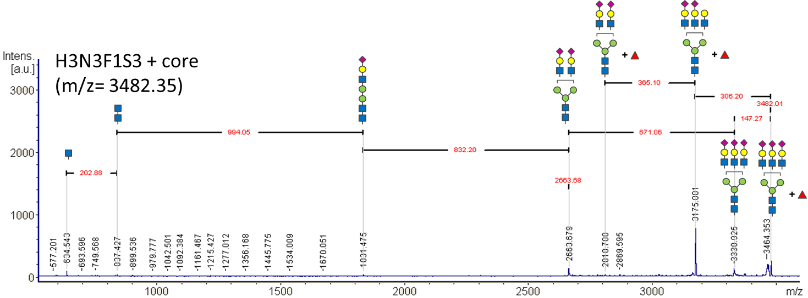

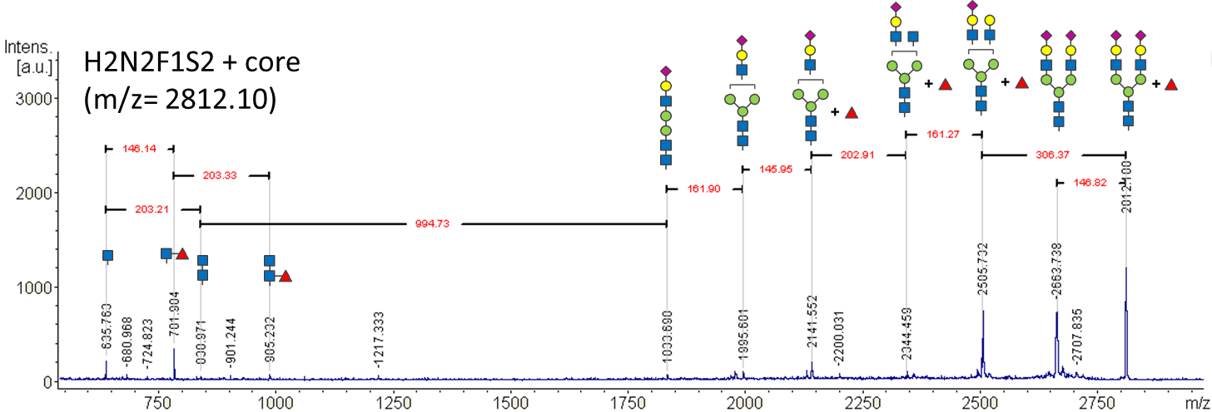

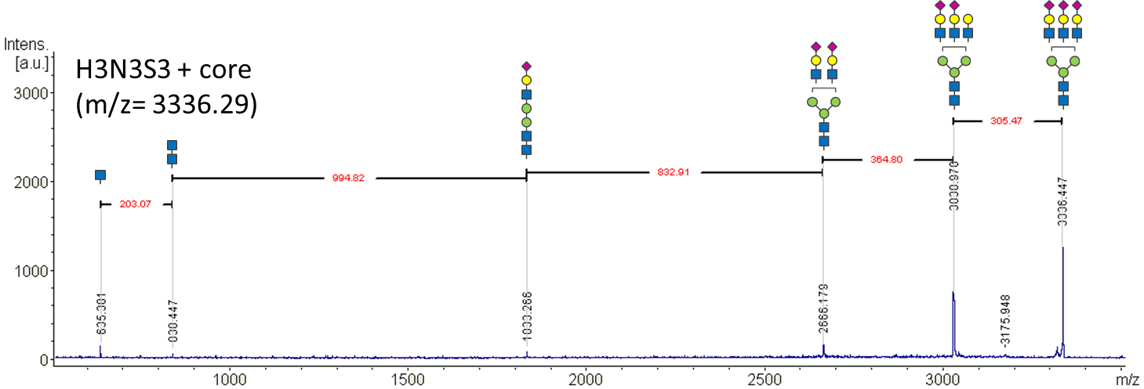

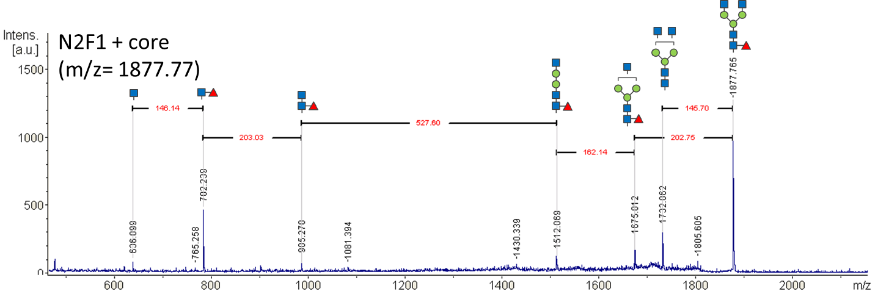

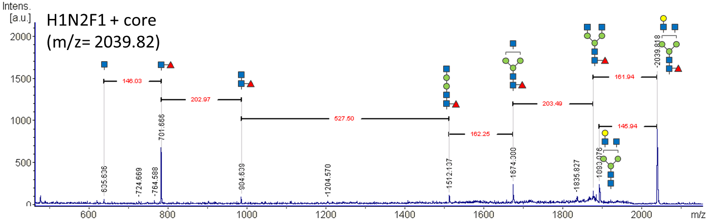

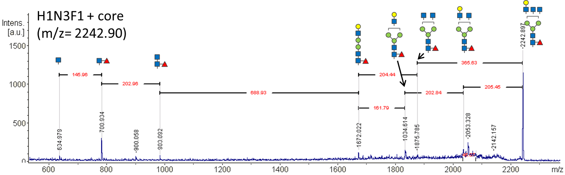

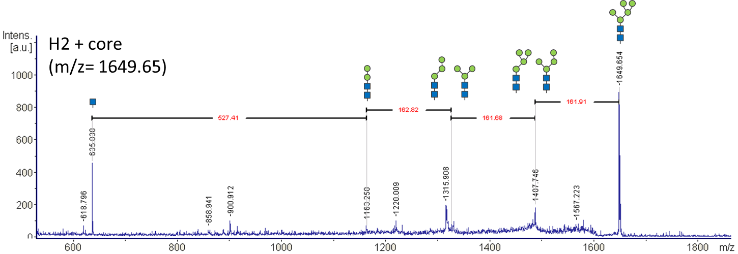

**Figure S2**

Entire gel images of SDS-PAGE analysis of human serum proteins shown in Figure 2.

**Figure S3**

N-glycan amounts of AAT measured by the FPG method or after direct tryptic digestion. A, N-glycan of 1 - 5 μg AAT were directly prepared with reduction/alkylation, trypsinization and PNGase F digestion (direct digestion); B, N-Glycan of 1 - 5 μg AAT were measured after gel extraction in the same manner as in FPG method; C, the results of Figure S2A and S2B were compared to each other. Each data was obtained from triplicate (duplicate for 5 μg point) glycomic analyses of human AAT purchased from Sigma (#A9024).







**Figure S4**

Representative MALDI-TOF MS spectra of tryptic peptides of AAT. A, standard AAT (Sigma, #A9024) processed with FPG procedure; B, AAT purified from serum by FPG procedure; C, standard AAT processed with IPG procedure; D, AAT purified from serum by IPG procedure.

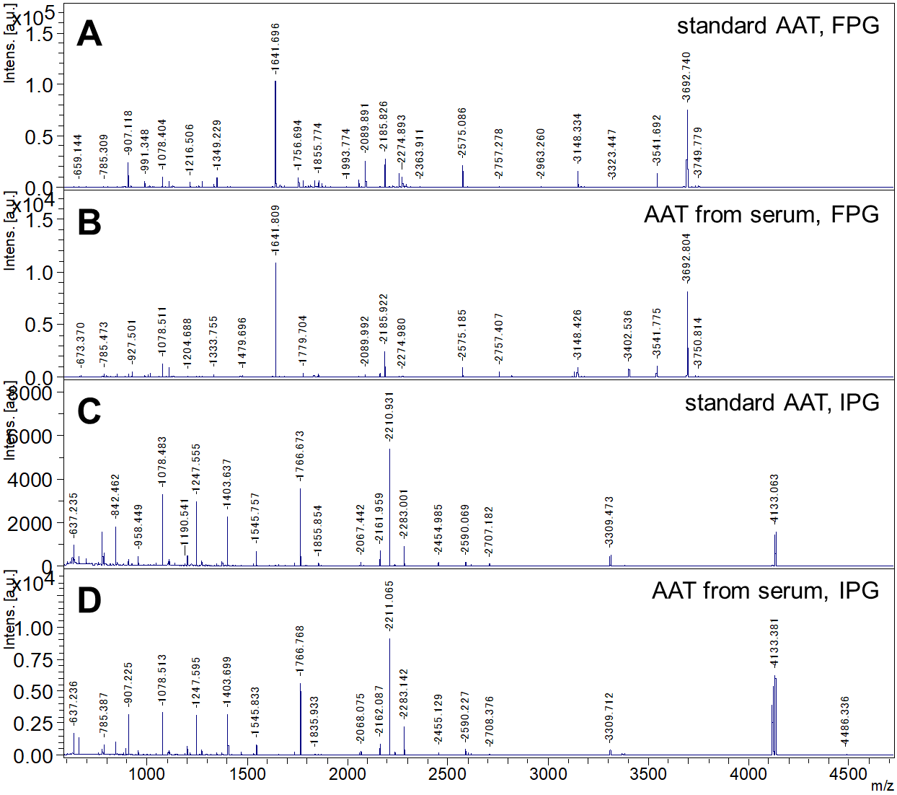

**Figure S5**

SDS-PAGE analysis of AAT (A) and CP (B) immunoprecipitated from NAFLD patient sera. (C) The amounts of AAT before and after immunoprecipitation. Commercially available AAT (Sigma, #A9024) or CP (Athens Research, # 16-16-030518) was loaded onto the rightmost lane.



**C**

**Figure S6**

MALDI-TOF MS spectra of SALSA-derivatized N-glycans released from AAT of pooled human serum samples.

A and C, NAFL; B and D, NASH. Spectra A and B were obtained by conventional glycoblotting analysis, while spectra C and D were from SALSA analysis.

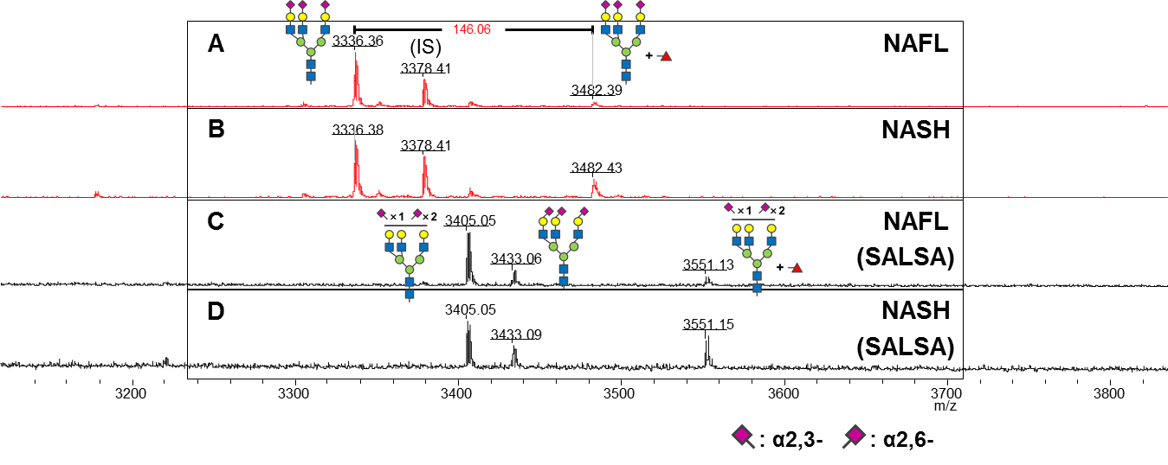

**Figure S7**

Representative MALDI-TOF MS spectra of N-glycans released from AAT after exoglycosidase digestion. Fucose residues of AAT-A3F were almost totally digested by α1,3/4-fucosidase.

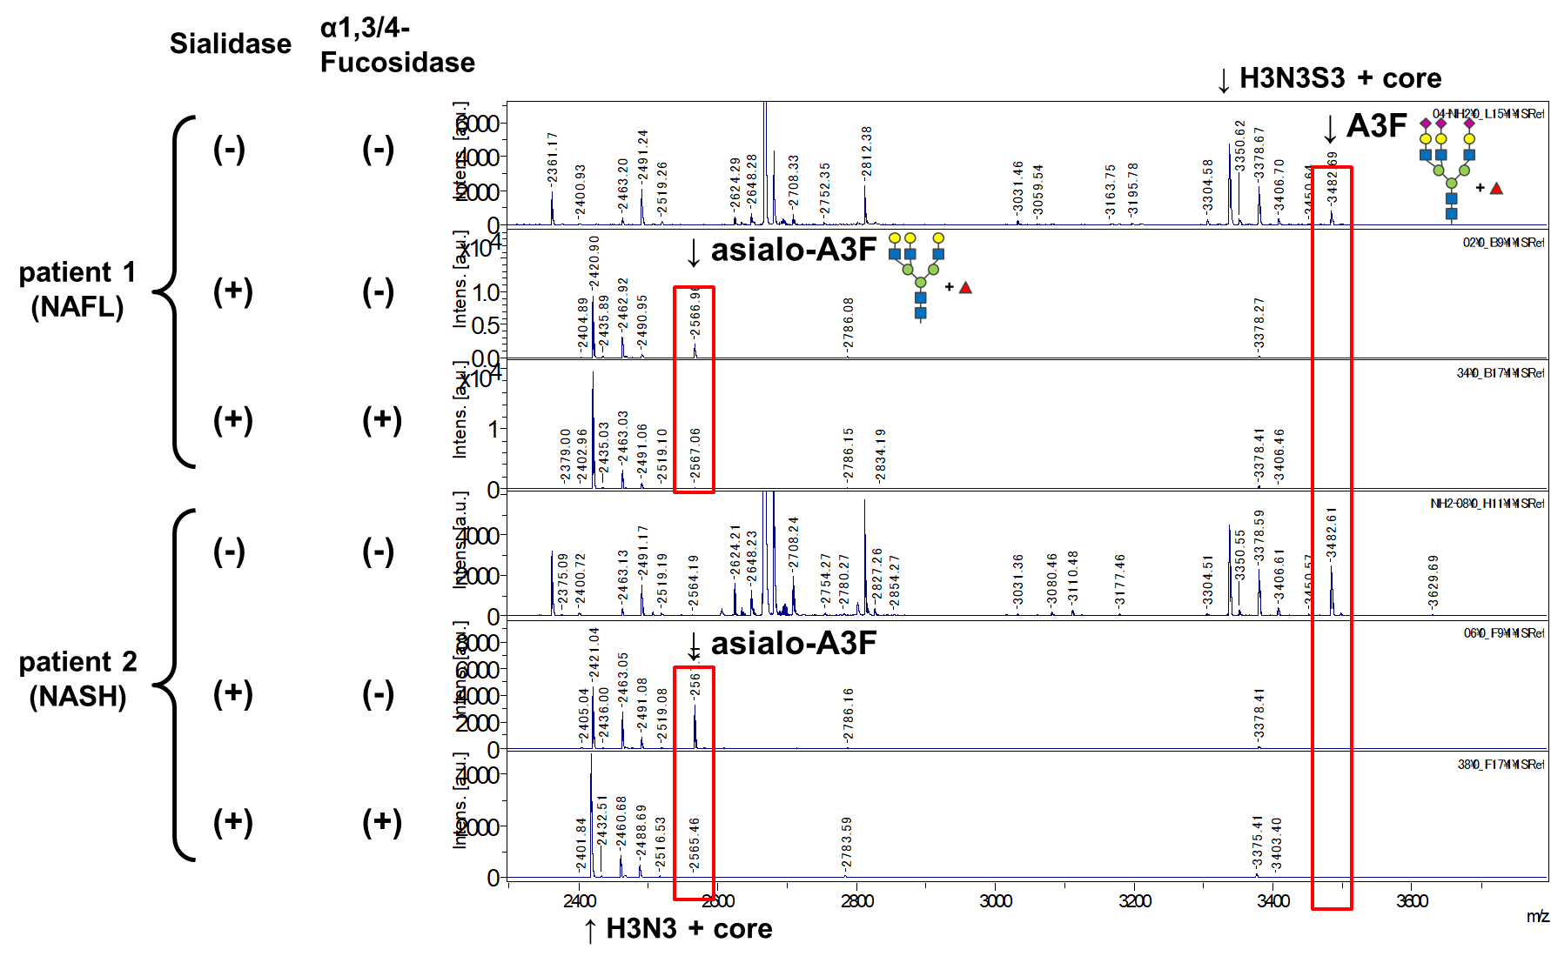

**Figure S8**

MS/MS spectra of AAT-A3F after sialidase digestion. The peak of A3F (m/z = 3482) was shifted to m/z = 2726 after sialidase digestion. MS/MS analysis of this glycan indicated that this structure was (Hex)3 (HexNAc)3 (Fuc)1 + core.

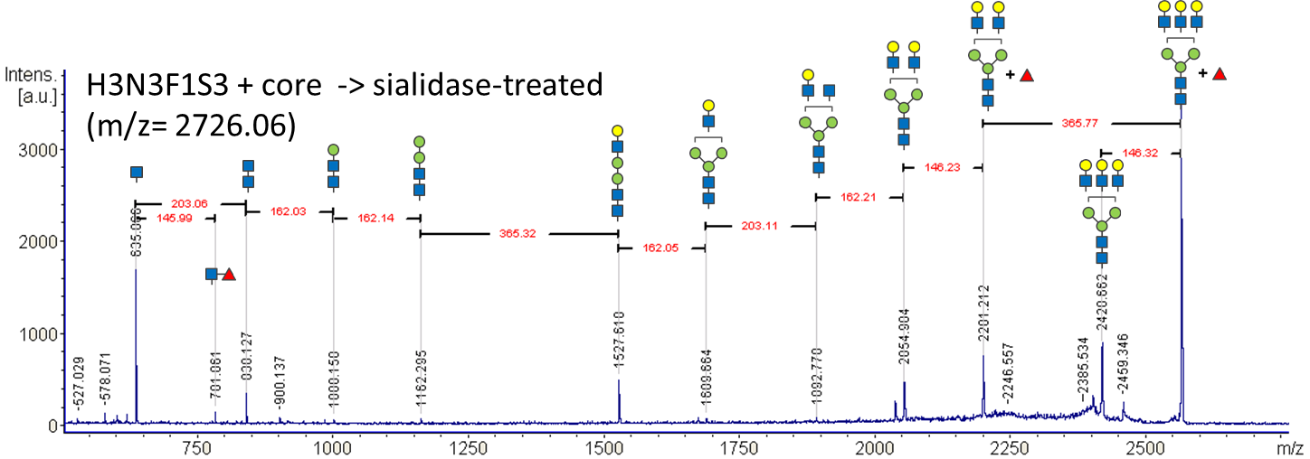 **Figure S9**

Serum concentrations of IPG target proteins.

A, alpha-1 antitrypsin (AAT); B, Ceruloplasmin (CP).

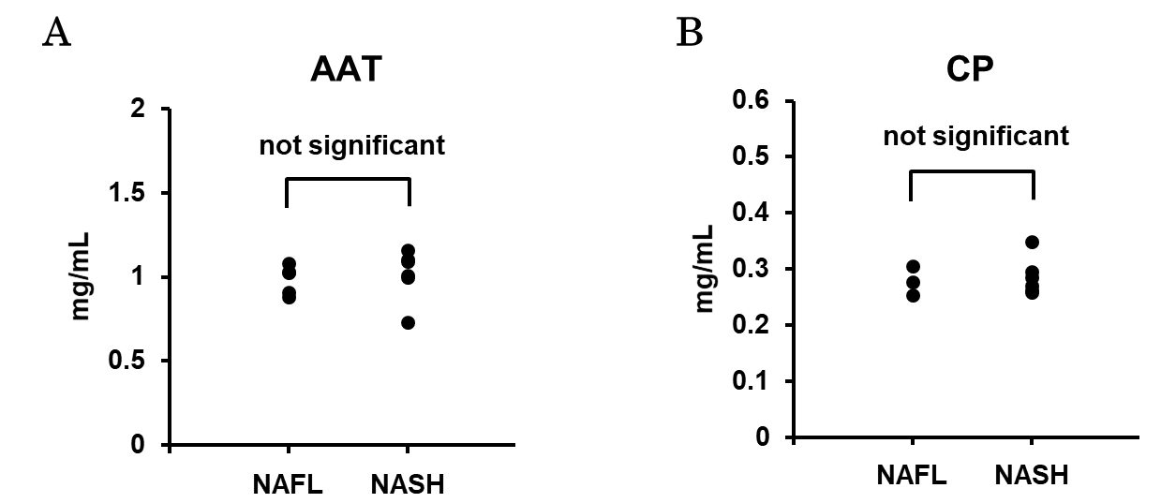

**Supplementary Methods**

**Protein identification**

For protein identification, extracted peptides from the gels were purified on Zip TipC18 columns (Millipore, Bedford, MA) and analyzed by MALDI-TOF and TOF/TOF MS. Signals with an S/N ratio >6 were used to build peak lists with the SNAP algorithm (FlexAnalysis 3.0 software package, BrukerDaltonics GmbsH, Bremen, Germany). Resulting peak lists were used to search against the UniProtKB/SwissProt database (UniProt release 2018_11, https://www.uniprot.org). Identification by peptide mass fingerprinting was performed using Mascot software (Matrix Science, Inc., Boston, MA). The following search parameters were used: one tryptic missed cleavage allowed; peptide mass tolerance in the searches was 0.2 Da for MS spectra and 0.6 Da for MS/MS spectra; fixed modification: carbamidomethyl (cysteine). After the initial peptide scanning, at least three peptides were subjected to MS/MS analysis followed by search with the fragmentation spectra in the SwissProt database using Mascot software.

**N-glycomic analysis by MALDI-TOF MS after glycoblotting**

N-glycosidase F-treated samples were dropped onto BlotGlyco beads (5 mg) on a filter plate (MultiScreen Solvinert 0.45 μm Low-Binding Hydrophilic PTFE; Millipore), followed by addition of 2% (v ⁄ v) acetic acid ⁄ acetonitrile. In this step, a synthesized glycan, NeuAc2Gal2GlcNAc2 + Man3GlcNAc1 (A2GN1), was added as the internal standard for the quantification of each glycan. After incubation at 80°C for 45 min to covalently ligate glycans onto the beads via hydrazone bonds, the beads were sequentially washed with 2 M guanidine hydrochloride, distilled water and 1% (v ⁄ v) tri-ethylamine ⁄ methanol to remove nonspecifically bound impurities. The beads were incubated with 10% (v ⁄ v) acetic anhydride ⁄ methanol at ambient temperature for 30 min to cap the unreacted hydrazide groups on the beads, and sequentially washed with 10 mM HCl, methanol, and dioxane. The beads were then incubated with 100 mM of 1-methyl-3-p-tolyltriazene in dioxane at 60°C for 1 h to convert the carboxylic acid of sialic acid to methyl ester, and this was followed by sequential washing with dioxane, methanol, and distilled water. The trapped glycans were finally released as aoWR derivatives via transamination by adding 20 mM aoWR in 2% (v ⁄ v) acetic acid ⁄ acetonitrile, followed by incubation at 80°C for 45 min. The resulting aoWR-labeled glycans were recovered by washing the beads with 10 mM HCl (100 μL), and the collected solution was further purified with a HILIC purification plate (MassPrep HILIC μElution plate; Waters, Milford, MA, USA) to remove the excess reagents.

aoWR-labeled N-glycans were mixed with 2,5-dihydrobenzoic acid solution (10 mg/mL in 30% acetonitrile) and subsequently subjected to MALDI-TOF MS analysis as previously described, 23 with minor modifications. Briefly, all measurements were performed by using an Ultraflex II TOF/TOF mass spectrometer equipped with a reflector and controlled by the FlexControl 3.0 software package (Bruker Daltonics GmbsH, Bremen, Germany) according to protocols. All spectra were obtained in the reflectron mode with an acceleration voltage of 25 kV, a reflector voltage of 26.3 kV, and a pulsed ion extraction of 70 ns in the positive ion mode. Masses were annotated by using the FlexAnalysis 3.0 software package (BrukerDaltonics GmbsH, Bremen, Germany). Quantification was performed by comparative analyses between the areas of the MS signals derived from each glycan (Supplementary table 2) and the internal standard glycan, A2GN1. In TOF/TOF mode measurements for fragment ion analysis, precursor ions were accelerated to 8 kV and selected in a timed ion gate. Fragment ions generated by laser-induced decomposition of the precursor were further accelerated by 19 kV in the LIFT cell. Fragment masses were analyzed after passing through the ion reflector.

**Fucosidase digestion of AAT-derived N-glycans**

N-glycans derived from 1 μg AAT were dissolved in 100 mM Ammonium acetate (pH 5.5). 0.5 U α2,3-Sialidase (TAKARA BIO, Shiga, Japan), 0.25 U α(2-3,6,8,9) Neuraminidase from *Arthrobacter ureafaciens* (Sigma, St. Louis, MO) and 0.2 μU α-1,3/4-L-Fucosidase (TAKARA BIO) were added and incubated overnight at 37°C. Samples were heated at 90°C for 10 min and analysed by MALDI-TOF MS after glycoblotting.