SUPPLEMENTARY METHODS

Cells

FS-L3 cells were grown in Eagle’s Minimum Essential Medium (EMEM; Nissui Pharmaceutical) supplemented with NaHCO₃ and 1% anti-BVDV-antibody free foetal bovine serum (Japan Bio Serum). SK-L cells were propagated in EMEM supplemented with 0.295% TPB, 10 mM BES, and 10% horse serum. SK-6 cells were propagated in EMEM supplemented with 0.295% TPB and 7% horse serum.

Western blotting analysis
After treatment with Immobilon Western Detection Reagents (Merck), protein signals were detected by WSE-6100H LuminoGraph I (ATTO) and analysed using the CS Analyzer 4 (ATTO) or ImageJ software (National Institutes of Health).

RNA extraction and reverse transcriptase quantitative polymerase chain reaction (RT-qPCR)
RNA was extracted from infected cells with TRIzol Reagent (Thermo Fisher Scientific) and chloroform at various times after infection. Extracted RNA was reverse-transcribed with random and Oligo-dT primers by using M-MLV reverse transcriptase (Thermo Fisher Scientific). Then, two microliters of cDNA were subjected to PCR with gene-specific primers (Supplemental Table 1) using KAPA SYBR FAST qPCR Master Mix (2X) Kit (Roche) and Light Cycler 480 II instrument (Roche). To show the relative mRNA amounts, crossing point (Cp) values were normalized to mock-infected cells.

Flow cytometry
Three color flow-cytometric analyses were performed on BD FACSCantoTM Flow Cytometer (Becton, Dickinson and Company). Cell monolayer was suspended by PBS and stained with AnnexinV/PI kit (Medical & Biological Laboratories) following the manufacturer’s procedure. Then, cells were permeabilized by 0.1% trinton-100 in PBS for 10 min and incubated with anti-NS3 antibody (46/1; [33]) for 1h at room temperature. After washing step with PBS, cells were treated with APC-conjugated anti-mouse IgG antibody for 1h at room temperature and washed again with PBS. Finally, cells suspended in binding buffer (Medical & Biological Laboratories) were utilized for flow cytometry. Data was analyzed by FlowJoTM (Becton, Dickinson and Company). Annexin V positive means cells with phosphatidylserine and PI positive means cells with disruption of cell membrane.

SUPPLEMENTARY TABLE & FIGURES

Table S1. Primers used for RT-qPCR.
Gene | Primer sequences (5’→3’) | GenBank accession #
β-actin | F: CAA GGA CCT CTA CGC CAA CAC  R: TGG AGG CGC GAT GAT CTT | DQ845171
Caspase-3 | F: AGT GGG ACT GAA GAT GAC ATG G  R: TTT CAG CGC TGC ACA AAG TG | NM_214131
Caspase-8 | F: AAA TCA ACA AGG CCC TGC TG  R: ATC CGA AGC ACT TTC AAG GC | NM_001031779
MLKL | F: TTT CAA GGG CCA CAG GAA TG  R: TGG TAT TGC TTT GGC TGT GG | MG543991
RIPK1 | F: ACC TTT TCG GCA GCC GCA TG  R: TGC TGT GCA AAA GGG TCA TG | MG586799

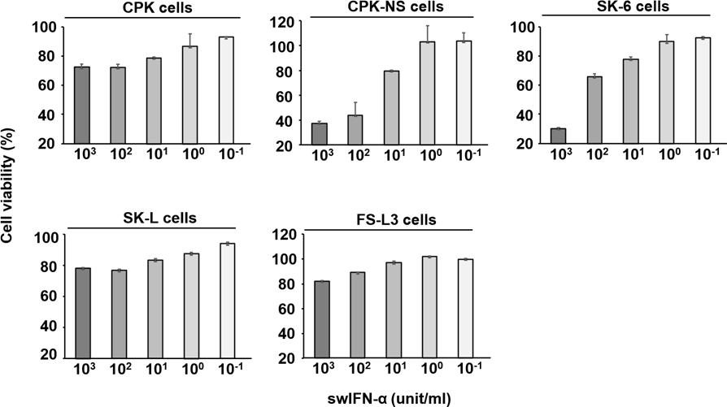
Fig. S1. Cell viability of various cell lines treated with swIFN-α. Cells were treated with swIFN-α at the indicated concentrations. Cell viability was measured with the CCK-8 assay 96 h after the treatment with swIFN-α. The OD₄₅₀ values in medium-treated cells were considered as 100% viability. The results are indicated as the mean values of three independent experiments with error bars representing the standard error of the mean.
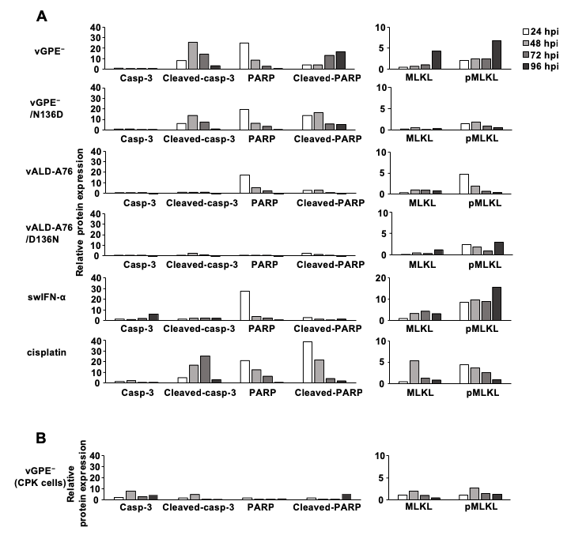
Fig. S2. Relative expression of cell-death-related proteins in CPK-NS and CPK cells. Expression signals were quantified by using ImageJ (National Institutes of Health) and described as the relative expression level of target protein/GAPDH ratio. The ratio for mock-infected or mock-treated cells was set to a value of 1. (A) CPK-NS cells. (B) CPK cells.
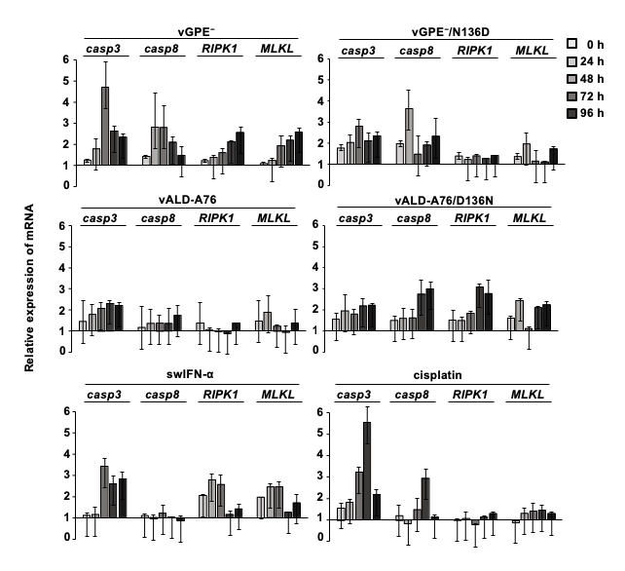
Fig. S3. mRNA expression of cell-death-related proteins in CPK-NS cells. CPK-NS cells were inoculated with the indicated CSFV clones at MOI=1.0 TCID50/cell or treated with 2×10⁵ unit/cell of swIFN-α or 50 µM of cisplatin. RNA was extracted at the indicated time points and assessed by RT-qPCR. Target gene/β-actin ratio for untreated cells was set to a value of 1. The results are mean values of three independent experiments with error bars representing the standard error of the mean.
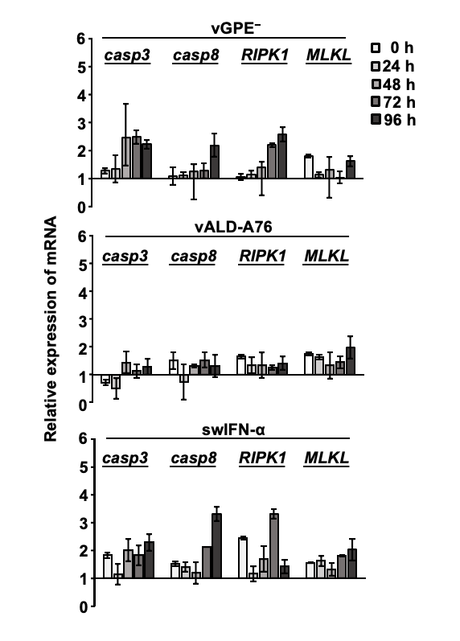

Fig. S4. mRNA expression of cell-death-related proteins in CPK cells. CPK cells were inoculated with indicated CSFVs at MOI=1.0 TCID50/cell or treated with 2×10⁵ unit/cell of swIFN-α. RNA was extracted at the indicated time points and assessed by RT-qPCR. Target gene/β-actin ratio for untreated cells was set to a value of 1. The results are mean values of three independent experiments with error bars representing the standard error of the mean.
Fig. S5. Analysis of relationship between CSFV infection and cell death. CPK-NS cells were inoculated with CSFV clones at MOI=1.0 TCID₅₀/cell. Cells were fixed with 10% formaldehyde and then stained with annexin V, PI and anti-NS3 antibody followed by APC-conjugated secondary antibody. The 10⁴ cells were counted by BD FACSCanto Flow Cytometer and data was analyzed by FlowJo. All cells were plotted by (A) Annexin V (Y-axis), NS3 (X-axis), (B) PI (Y-axis), NS3 (X-axis), and (C) Annexin V (Y-axis), PI (X-axis). Fig. S5A and S5B are shown as bar graphs in Fig.S5D. Although Annexin V was barely detected, it was as least confirmed that both infected and non-infected cells were going through cell death with membrane disruption (PI+) since 48 hpi, and that apoptosis is triggered in infected cells at early stage of infection (PI-/Annexin+) at 24 hpi. Combining with the cell-death inhibition test and Western blotting analysis, this experiment yields that infected cells underwent apoptosis and non-infected cells followed the fate to necroptosis.

