Supporting information
Marimo Bead-Supported Core-Shell Nanocomposites of Titanium Nitride and Chromium-Doped Titanium Dioxide as Highly Efficient Water Floatable Green Photocatalyst
Manpreet Kaur^{1,4,†}, Satish Laxman Shinde^{1*,†}, Satoshi Ishii^{1,2*}, Min-Wen Yu^{1,3}, Wipakorn Jevasuwan¹, Naoki Fukata^{1,2}, Yunxiang Li¹, Jinhua Ye¹, and Tadaaki Nagao^{1,4*}
¹International Center for Materials Nanoarchitectonics (WPI-MANA), National Institute for Materials Science (NIMS), Tsukuba, Ibaraki, 305-0044, Japan
²Faculty of Pure and Applied Sciences, University of Tsukuba, Tsukuba, Ibaraki 305-8577, Japan
³Institute of Lighting and Energy Photonics, College of Photonics, National Chiao Tung University, Tainan 71150, Taiwan
⁴Department of Condensed Matter Physics, Hokkaido University, Sapporo, Hokkaido, 060-0810, Japan

Table of contents: (Total pages. 13; 19 figures and 2 tables)
- Optical pictures of different fabricated samples.
- Schematic representation of synthesis steps of SiO₂ layer onto TiN NPs.
- SEM images of (a) TiO₂ (b) Cr-TiO₂ (c) TSCT (d) TiN. The scale bar represents 200 nm.
- XRD plot of B-Cr-TiO₂ NPs. Here “A” and “R” stands for Anatase and Rutile, respectively.
- XRD pattern of TiN NPs (TiN: JCPDS, No. 06-4909) and TSCT with varying SiO₂/TiN wt%.
- Raman spectra of TiN and B-Cr-TiO₂. Here “A” and “R” for Anatase and Rutile.
- Nitrogen adsorption desorption Isotherm of TSCT, TiN, TiO₂, Cr-TiO₂ and B-Cr-TiO₂.
- Cr-TiO₂ (a) TEM, inset: electron diffraction pattern (b) HRTEM image (c), (d) enlarged marked Lattice spacing.
- B-Cr-TiO₂ (a) TEM image, inset: electron diffraction pattern (b) HRTEM image of B-Cr-TiO₂ (c), (d) enlarged marked Lattice spacing.
- TEM image and particle size distribution of (a) TiO₂ (b) Cr-TiO₂ (c) TiN (d) TSCT, and (e) isolated TSCT nanoparticle.
- XPS high resolution spectra of (a) Ti 2p (b) O 1s (c) Cr 2p (d) Si 2p of TSCT.
- EPR spectrum of TiN NPs at room temperature.
- MB dye degradation rate of TSCT with (a) different ratio of TiN NPs in TSCT hybrid structure (b) as a function of catalyst loading and (c) under the illumination of UV component, visible light component, and full spectrum of the simulated solar light.
- Pictures of synthesized P-Marimos (a) without any NPs loading,(b) with TiO₂, (c) with Cr-TiO₂ and (d) with TSCT.
- MB dye degradation performance of P-Marimo. The absorbance spectra of MB for (a) TSCT (b) Cr-TiO₂ (c) TiO₂. Note: pink and grey region in absorbance spectra represents the absorbance region for MB and leuco methylene blue respectively.
- MB degradation performance pre-illuminated for 2 minute and after being stored in the dark environment for 1 day and next day, sample heated at 50 °C for 15 min before measuring its absorption spectra. (b) MB degradation performance pre-illuminated for 2 minute and after being stored in the dark environment for 1 year (c) optical images of samples with MB 1. TSCT 2. Cr-TiO₂, and 3. MB without any catalysts.
- MO dye degradation by TSCT (a) Under light (b) Pre- illumination and then 1 hour in the dark environment.
- Photoactivity comparison of typical IPA oxidation by TSCT, Cr-TiO₂ and TiO₂.
- Energy level diagram of TSCT (before contact) and standard redox potential of different oxidative species with respect to vacuum energy levels and NHE.
- Degradation efficiency of MB (10 µM) by P-Marimo’s of TSCT in successive cycles of uses.
- Crystallite size and BET surface area TiO₂, Cr -TiO₂, B-Cr-TiO₂, TiN and TSCT samples.
- Comparison of photocatalytic degradation of MB dyes by various nanomaterials reported in the literatures. Here efficiency represents the dye degradation efficiency.

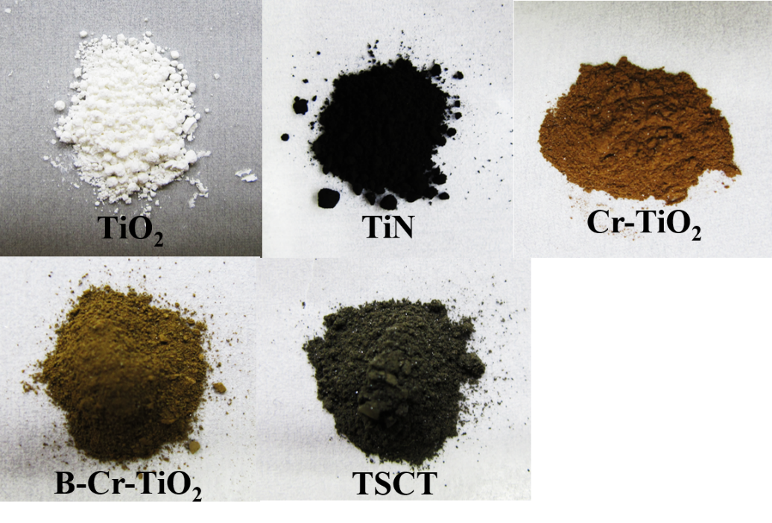
Figure S1. Optical images of the fabricated samples.

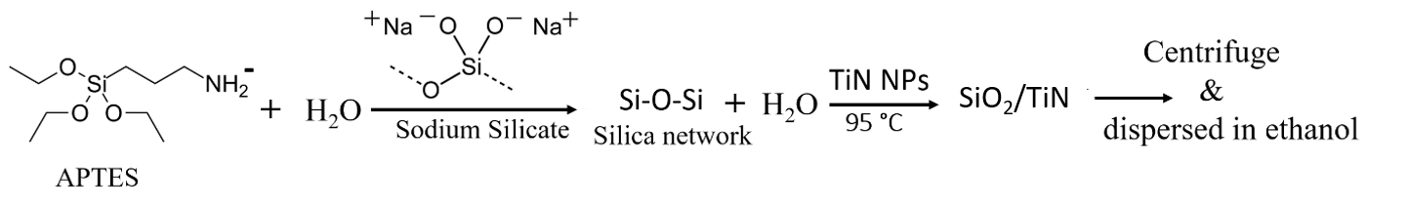
Figure S2. Schematic representation of the synthesis steps of SiO₂ layer onto TiN NPs.
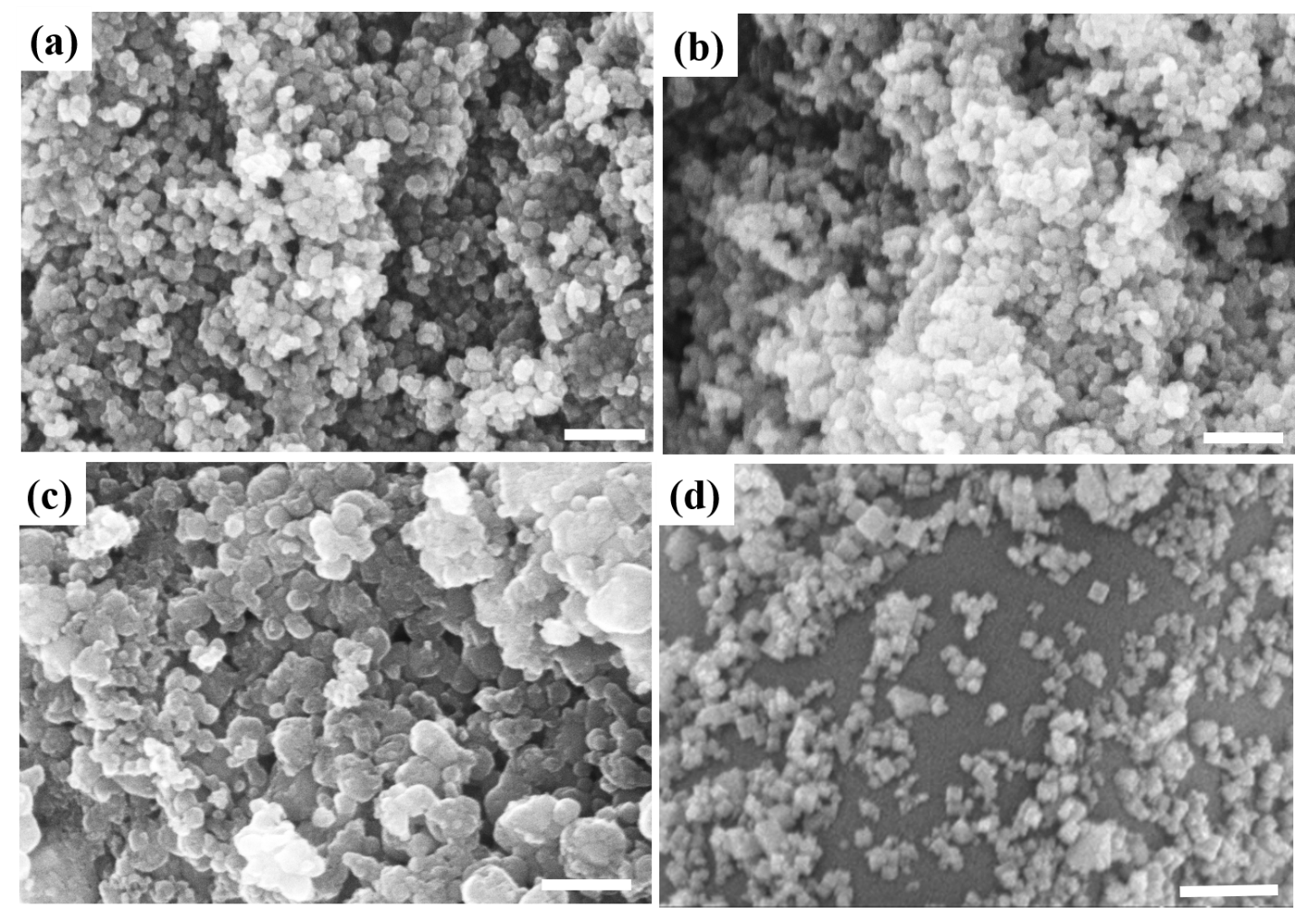
Figure S3. SEM images of (a) TiO₂ (b) Cr-TiO₂ (c) TSCT, and (d) TiN. Each scale bar represents 200 nm.
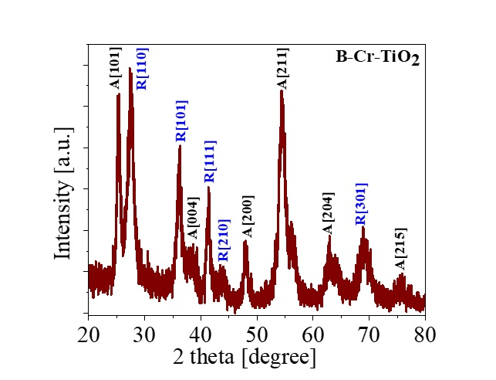
Figure S4. XRD plot of B-Cr-TiO₂ NPs. “A” and “R” stands for anatase and rutile, respectively.
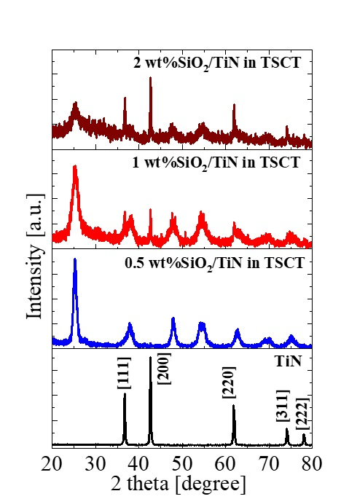
Figure S5. XRD pattern of TiN NPs (TiN: JCPDS, No. 06-4909) and TSCT with varying SiO₂/TiN wt%.
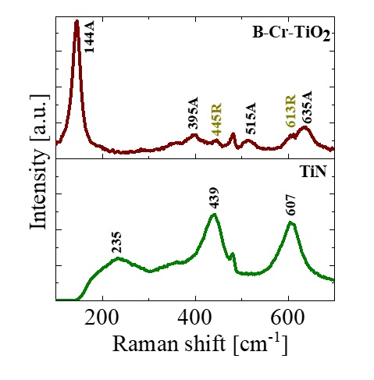
Figure S6. Raman spectra of TiN and B-Cr-TiO_{2.} “A” and “R” stand for anatase and rutile, respectively.

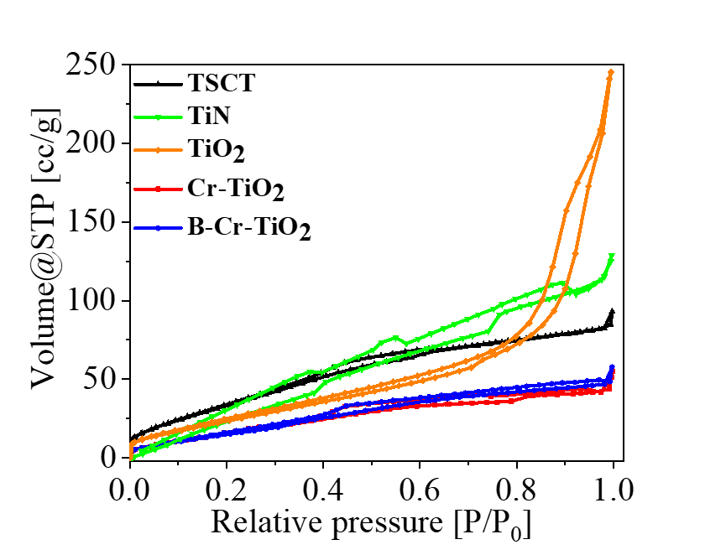
Figure S7. Nitrogen adsorption desorption isotherm of TSCT, TiN, TiO₂, Cr-TiO₂, and B-Cr-TiO₂.

Table S1. Crystallite size and BET surface area of TiO₂, Cr-TiO_{2,} B-Cr-TiO₂, TiN, and TSCT samples.
Sample | Particle size (nm) | S_{BET} (m²/g)
TiO₂ | 7.81 | 104.778
Cr-TiO₂ | 9.14 | 70.624
B-Cr-TiO₂ | 10.43 | 75.829
TiN | 30.88 | 206.89
TSCT | 75 | 149.3

Note S1. The average crystallite size (D_{XRD}) was calculated using the Debye– Scherrer formula¹;
D_{XRD} = 0.9 λ/ (βcosθ),
where Scherrer constant is taken as 0.9, λ is the wavelength of incident X-ray, β is the full width at half height of the diffraction peak and θ is the diffraction angle.

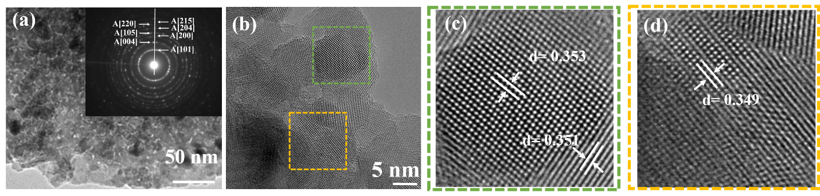
Figure S8. (a) TEM image of Cr-TiO₂ and electron diffraction pattern in the inset. (b) HRTEM image of Cr-TiO₂, and (c), (d) enlarged images of the marked areas in image (b).

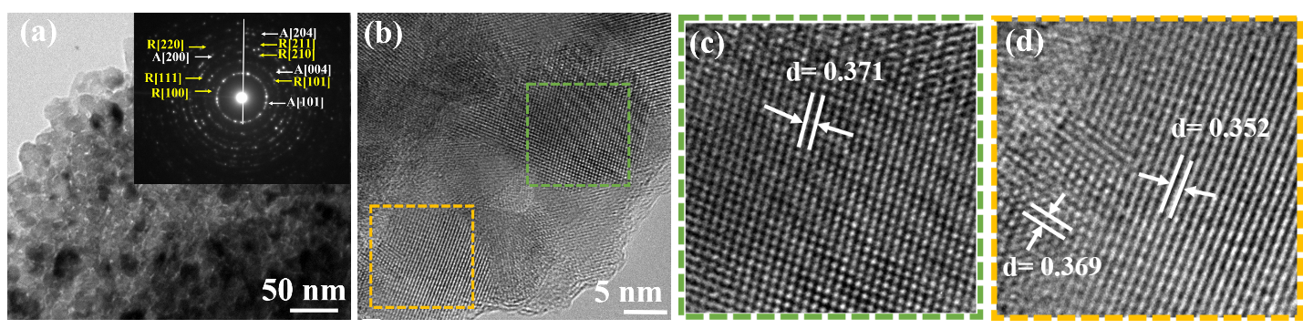
Figure S9. TEM image of B-TiO₂ and electron diffraction pattern in the inset. (b) HRTEM image of B-TiO₂, and (c), (d) enlarged images of the marked areas in image (b).

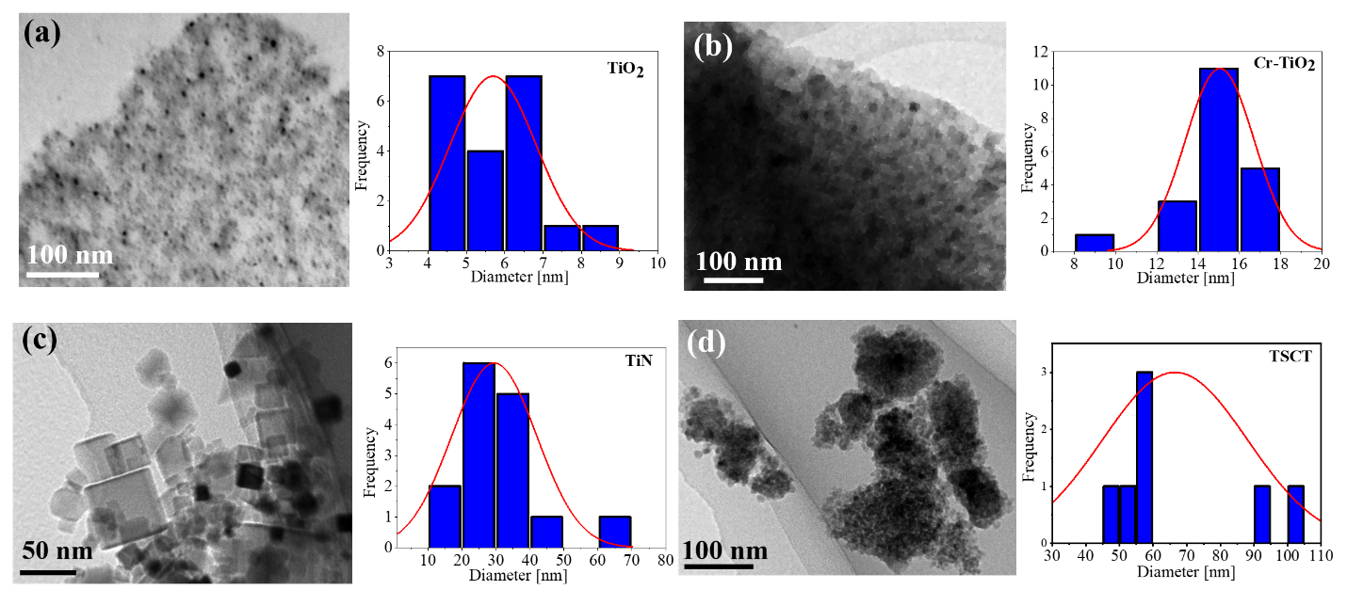
Figure S10. TEM images and particle size distributions of (a) TiO₂ (b) Cr-TiO₂ (c) TiN, and (d) TSCT.
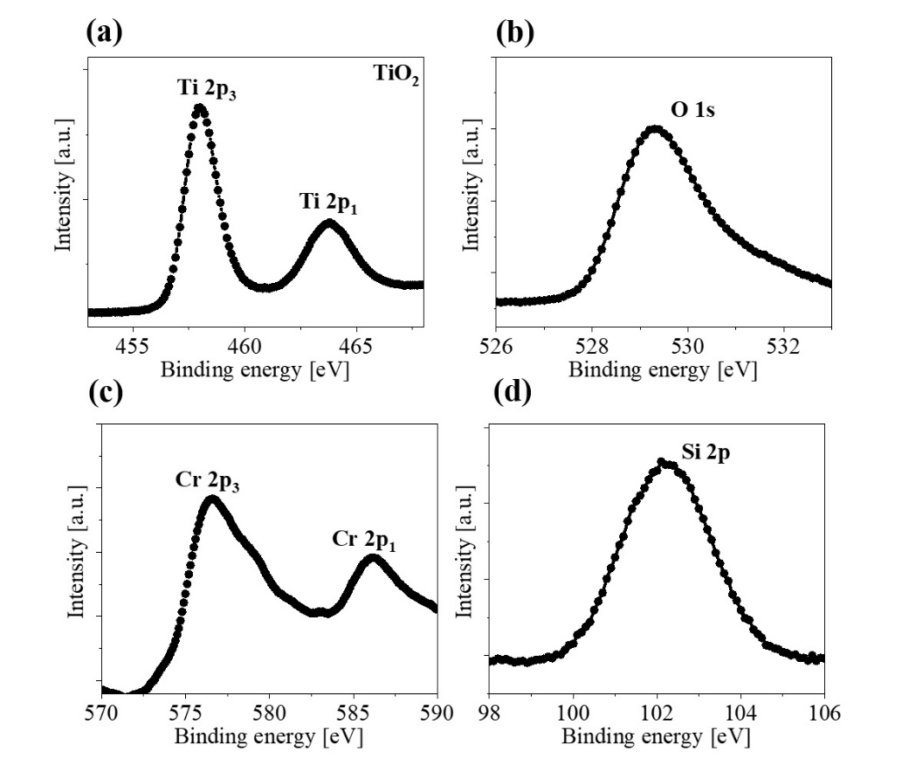
Figure S11. High resolution XPS spectra of (a) Ti 2p (b) O 1s (c) Cr 2p, and (d) Si 2p of TSCT.
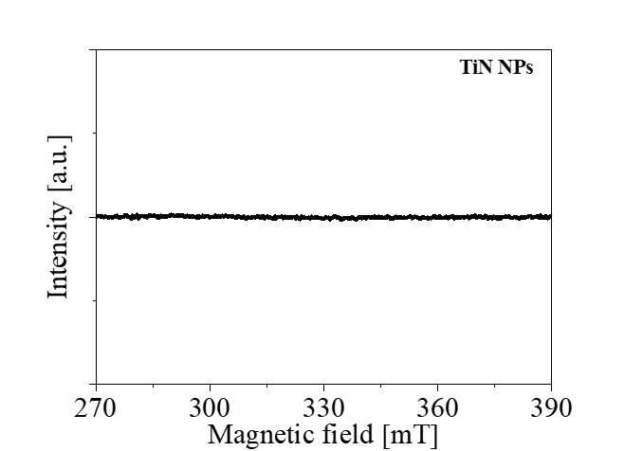
Figure S12. EPR spectrum of TiN NPs at room temperature.

Table S2. Comparison of photocatalytic degradation of MB dyes by various nanomaterials reported in the literatures. Here efficiency represents the dye degradation efficiency.

Photocatalyst | Conc | photocatalytic  conditions | Dye Conc. | Efficiency | Period  (min) | Rate  constant  (min⁻¹) | Ref.
TSCT | 2 mg mL⁻¹ | 100 mW/cm⁻² | 1 ×10⁻⁵ M  or 3 mgL⁻¹ | 99% | 10 | 0.23 | Our work
Cu_{0.26}Zn_{0.05}Fe_{0.26}S_{0.43} NCs | 0.4 mg mL⁻¹ | day light | 10mgL⁻¹ | >95% | 30 | 0.108 | ²
CdS/MoS₂  heterostructure | 0.6 mg mL⁻¹ | illuminated by 300 W Xe arc lamp, > 420 nm | 2 ×10⁻⁵ M | >80% | 50 | 0.0058 | ³
N-TiO₂/g-C₃N₄  composites | 0.4 mg mL⁻¹ | illuminated by 300 W xenon arc lamp | 10mgL⁻¹ | 69 % | 60 | 0.070 | ⁴
Ag₂CO₃ rods | 1 mg mL⁻¹ | illuminated by a 300 W Xe arc lamp | 10mgL⁻¹ | 95% | 40 | NA | ⁵
Au/TiO₂  superstructure | 1 g L⁻¹ | illuminated by a 500 mW  cm⁻² Xe lamp,460 nm- 700 nm | 1.0 × 10⁻⁵ M | NA | NA | 0.25 | ⁶
Graphene oxide  modified Ag₂O  nanocomposites | 0.5 mg mL⁻¹ | irradiated under 500 W tungsten lamp | 10mgL⁻¹ | 95% | 100 | 0.035 | ⁷
Zinc sulfide–  graphene  nanocomposites | 0.12 mg mL⁻¹ | irradiated under 4 W UV lamps with wavelength 254 nm | 10ppm | 96.7% | 80 | NA | ⁸
AgCl:Ag  Plasmonic NCs | NA | irradiated under 150 W quartz halogen lamp | 20mgL⁻¹ | >90% | 60 | 0.07 | ⁹
Cu₂S-Pd₄S  Hybrid nanoplates | 25 ppm | irradiated under 100 W halogen lamp | 100mM | over  80% | 30 | NA | ¹⁰

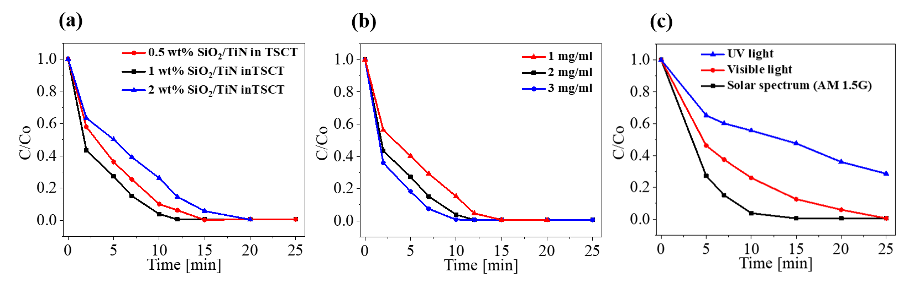
Figure S13. MB dye degradation rate of TSCT with (a) different ratio of TiN NPs in TSCT, (b) as a function of catalyst loading, and (c) under the illumination of UV component, visible light component, and full spectrum of the simulated solar light.

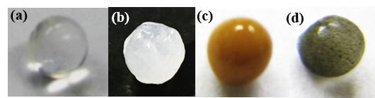
Figure S14. Pictures of synthesized P-Marimos (a) without NPs loading, (b) loaded with TiO₂, (c) with Cr-TiO₂ and (d) with TSCT.

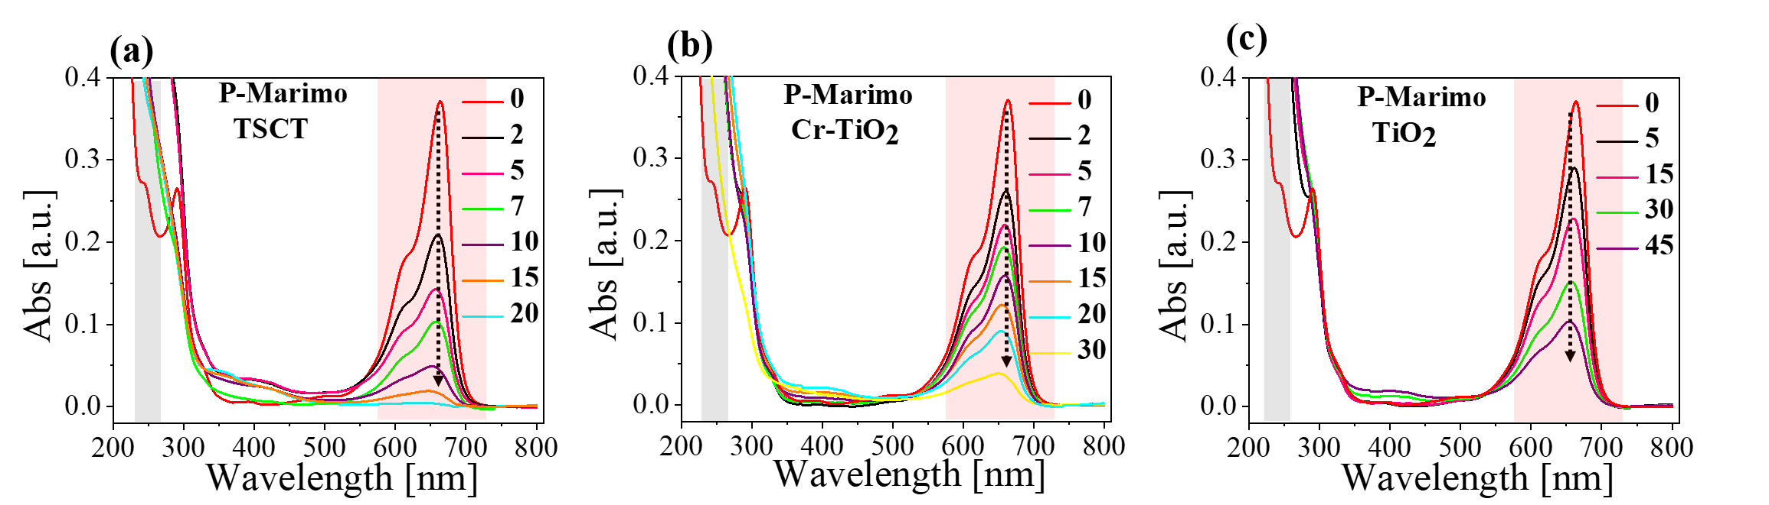
Figure S15. Absorbance spectra of MB dye degradation for (a) TSCT (b) Cr-TiO₂, and (c) TiO₂. Note that the pink and grey regions in the absorbance spectra represent the absorbance regions of MB and leuco methylene blue, respectively.

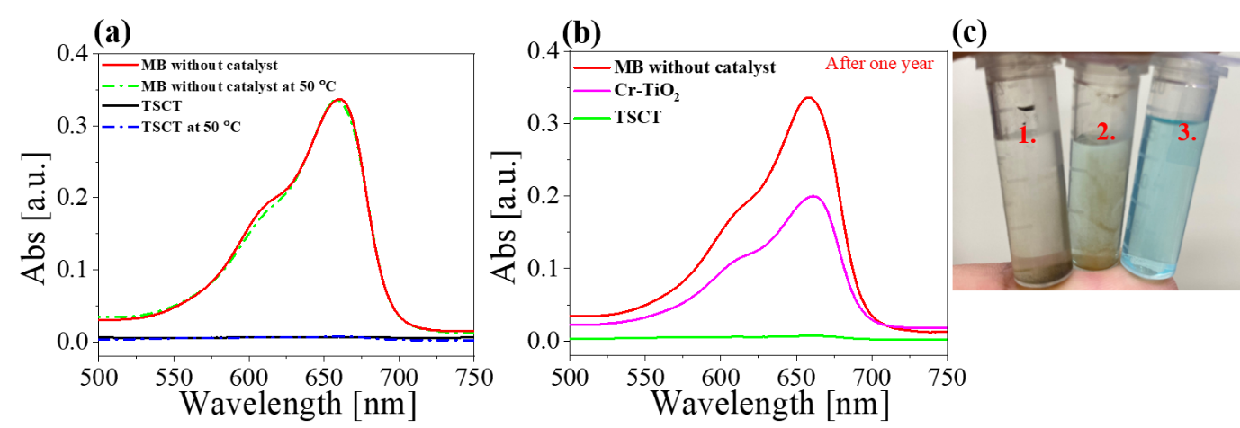
Figure S16. (a) MB degradation performance of TSCT. The MB with TSCT was pre-illuminated for 2 minute and kept in the dark for 1 day and heated at 50 °C for 15 min. Absorbance spectra of MB with TSCT before heating, MB without TSCT, and MB without TSCT and heated at 50 °C were also plotted. (b) Absorbance spectra of MB with TSCT and Cr-TiO₂ that were pre-illuminated for 2 minute and stored in the dark environment for 1 year. Absorbance spectrum of MB is also shown. (c) Optical images of; 1. MB with TSCT 2. MB with Cr-TiO₂, and 3. MB without any catalysts.

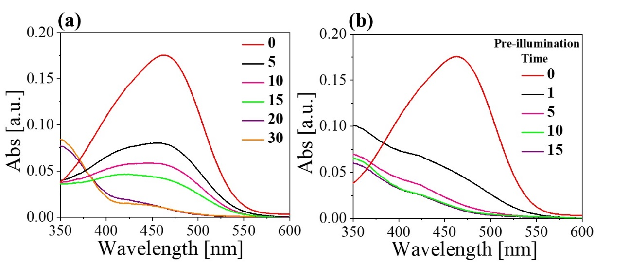
Figure S17. MO dye degradation by TSCT. (a) Absorbance spectra of the samples under solar light by varying the illumination time. (b) Absorbance spectra of the samples which were pre-illuminated and kept in the dark environment for one hour where the pre-illumination time was varied.

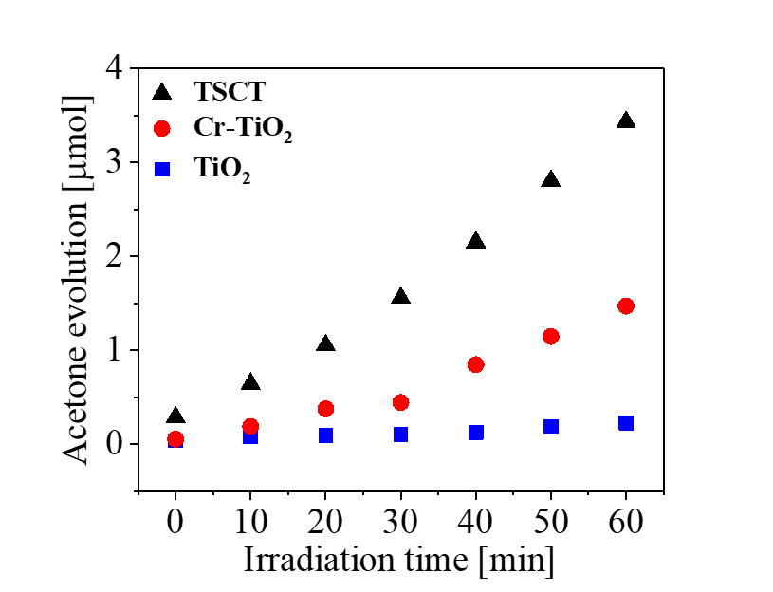
Figure S18. Photocatalytic activity comparison of typical IPA oxidation by TSCT, Cr-TiO₂ and TiO₂.

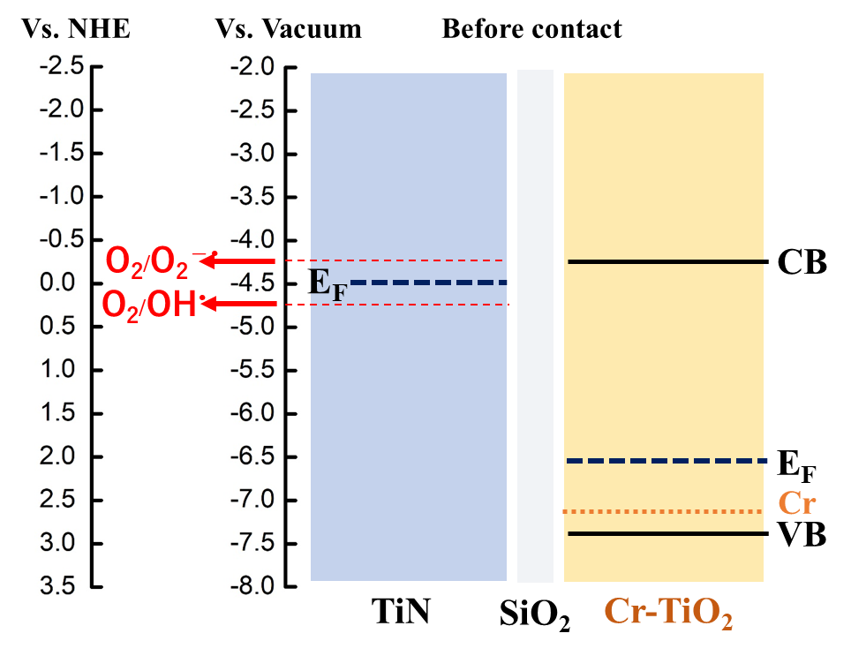

Figure S19. (a) Another possible example of an energy level diagram of TSCT (before charge transfer) and standard redox potential of different oxidative species with respect to vacuum energy levels and NHE.
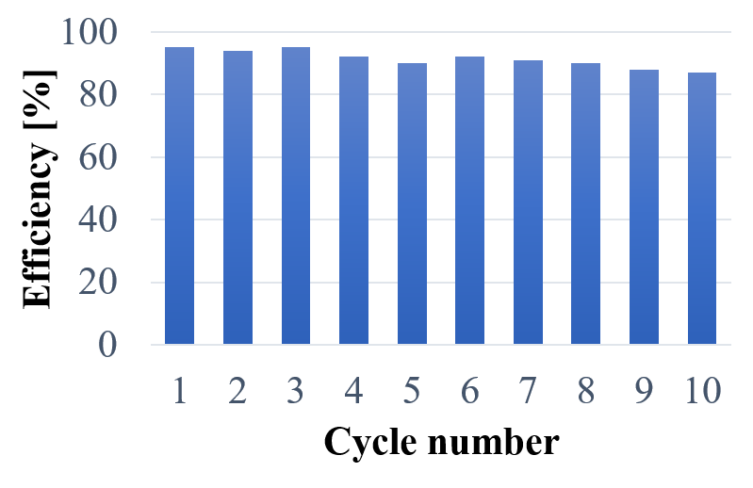
Figure S20. Degradation efficiency of MB (10 µM) by P-Marimo TSCT in successive cycles of uses.

Reference:
1. Ghosh, S.; Divya, D.; Remani, K. C.; Sreeremya, T. S., Growth of monodisperse nanocrystals of cerium oxide during synthesis and annealing. J. Nanopart. Res. 2010, 12 (5), 1905-1911.
2. Dalui, A.; Thupakula, U.; Khan, A. H.; Ghosh, T.; Satpati, B.; Acharya, S., Mechanism of versatile catalytic activities of quaternary CuZnFeS nanocrystals designed by a rapid synthesis route. Small 2015, 11 (15), 1829-1839.
3. Liu, E.; Kang, L.; Yang, Y.; Sun, T.; Hu, X.; Zhu, C.; Liu, H.; Wang, Q.; Li, X.; Fan, J., Plasmonic Ag deposited TiO₂ nano-sheet film for enhanced photocatalytic hydrogen production by water splitting. Nanotechnology 2014, 25 (16), 165401.
4. Wang, X. J.; Yang, W. Y.; Li, F. T.; Xue, Y. B.; Liu, R. H.; Hao, Y. J., In situ microwave-assisted synthesis of porous N-TiO₂/g-C₃N₄ heterojunctions with enhanced visible-light photocatalytic properties. Ind. Eng. Chem. Res. 2013, 52 (48), 17140-17150.
5. Xu, C.; Liu, Y.; Huang, B.; Li, H.; Qin, X.; Zhang, X.; Dai, Y., Preparation, characterization, and photocatalytic properties of silver carbonate. Appl Surf. Sci. 2011, 257 (20), 8732-8736.
6. Bian, Z.; Tachikawa, T.; Zhang, P.; Fujitsuka, M.; Majima, T., Au/TiO₂ superstructure-based plasmonic photocatalysts exhibiting efficient charge separation and unprecedented activity. J. Am. Chem. Soc. 2013, 136 (1), 458-465.
7. Ji, Z.; Shen, X.; Yang, J.; Xu, Y.; Zhu, G.; Chen, K., Graphene Oxide Modified Ag₂O Nanocomposites with Enhanced Photocatalytic Activity under Visible Light Irradiation. Eur. J. Inorg. Chem. 2013, 2013 (36), 6119-6125.
8. Yu, L.; Ruan, H.; Zheng, Y.; Li, D., A facile solvothermal method to produce ZnS quantum dots-decorated graphene nanosheets with superior photoactivity. Nanotechnology 2013, 24 (37), 375601.
9. An, C.; Peng, S.; Sun, Y., Facile synthesis of sunlight driven AgCl: Ag plasmonic nanophotocatalyst. Adv. Mater. 2010, 22 (23), 2570-2574.
10. Park, K. H.; Lee, Y. W.; Kim, D.; Lee, K.; Lee, S. B.; Han, S. W., Synthesis and photocatalytic properties of Cu₂S–Pd₄S hybrid nanoplates. Chem–A Eur. J. 2012, 18 (19), 5874-5878.

