Supplementary Material 3

Table S3.1 Evaluation of OPLS-DA model for each tissue/serum

Tissue/serum | Aª | N^{b} | R²X(cum)^{c} | R²Y(cum)^{c} | Q²(cum)^{d}
Liver | 1+0+0 | 10 | 0.439 | 0.933 | 0.862
Brain^{e} | 0+0+0 | 10 | - | - | -
Ventricle | 1+4+0 | 10 | 0.907 | 0.999 | 0.930
Atrium | 1+3+0 | 10 | 0.740 | 0.998 | 0.944
Renal Medulla | 1+3+0 | 10 | 0.698 | 0.984 | 0.832
Renal Cortex | 1+4+0 | 10 | 0.914 | 0.995 | 0.823
Spleen | 1+0+0 | 10 | 0.370 | 0.608 | 0.417
Serum | 1+5+0 | 10 | 0.949 | 1.000 | 0.818
ª the number of components.
^{b} the number of samples that the model is based on.
^{c} the ‘‘goodness of fit’’ parameter that shows how well the model describes the variation in the data. R2X, R2Y are the cumulative variations explained in the metabolite and class-variable data, respectively.
^{d} the cross-validated prediction estimates of class separation that shows how well samples are predicted by the model.
^{e} there was no validated model established for brain samples.

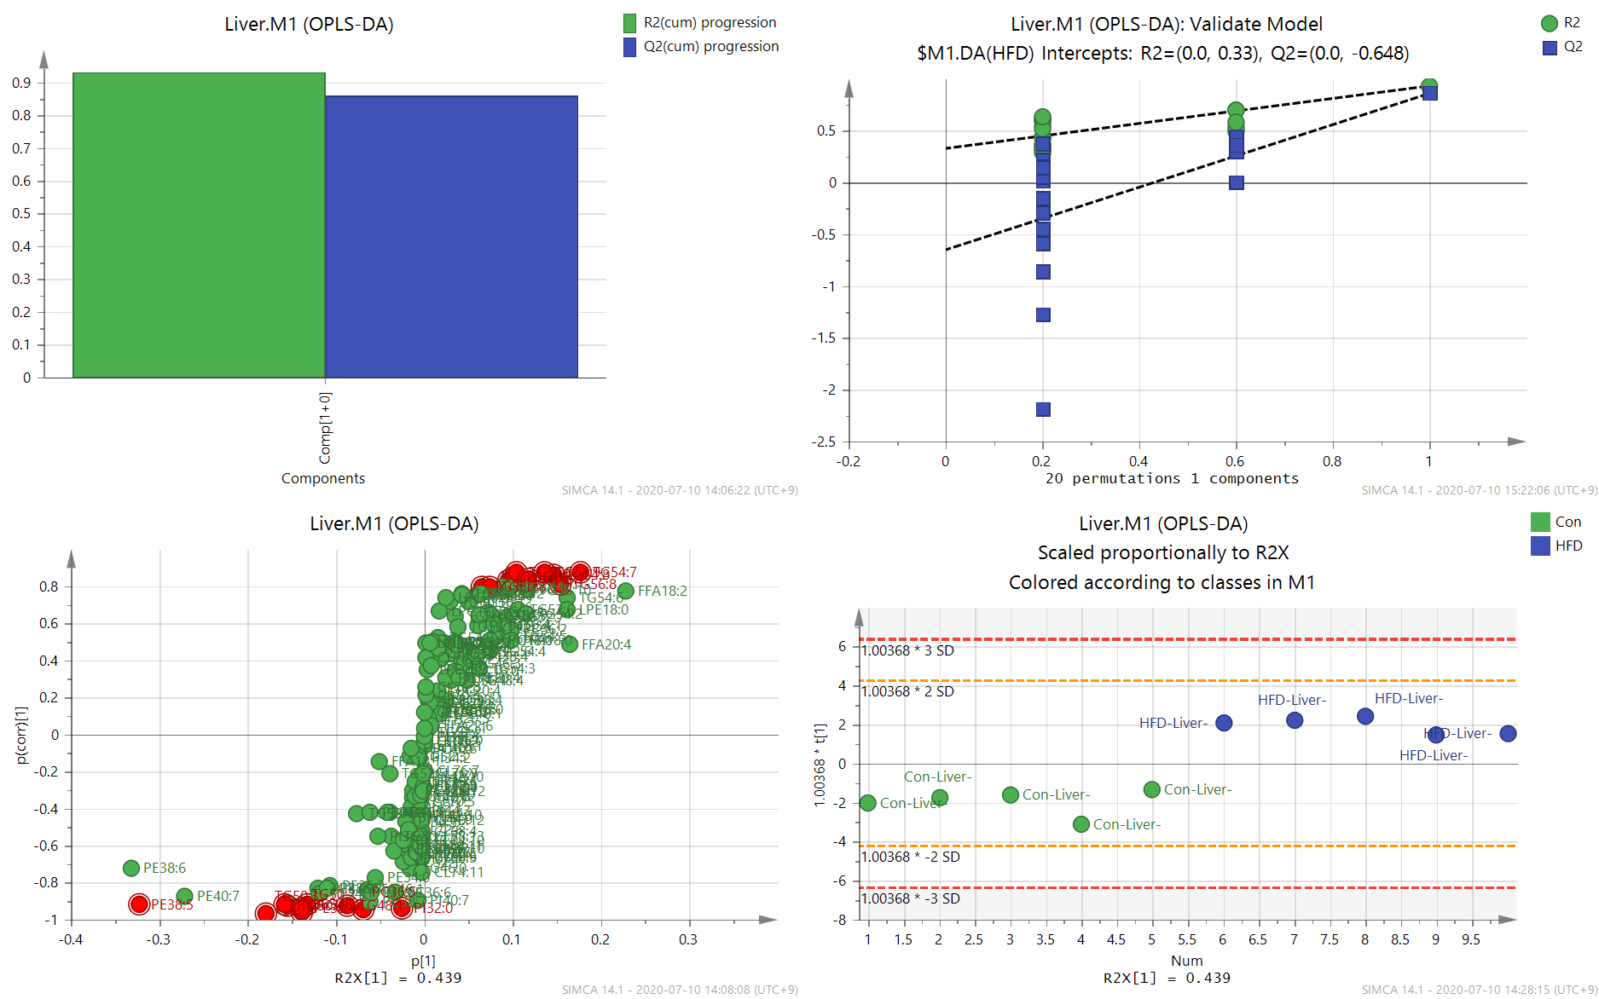
Figure S3.1 OPLS-DA for liver samples, including summary of fit, permutation, S-plot, and score plot.

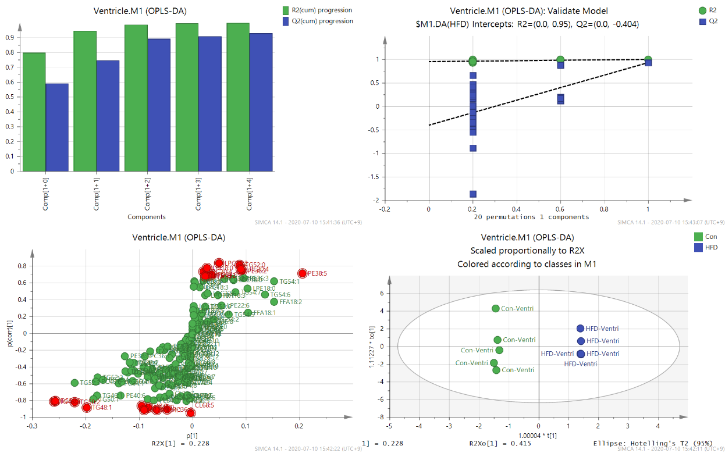
Figure S3.2 OPLS-DA for ventricle samples, including summary of fit, permutation, S-plot, and score plot.

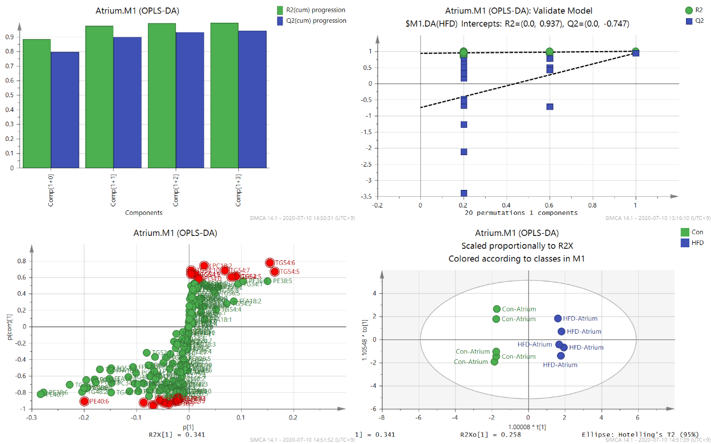
Figure S3.3 OPLS-DA for atrium samples, including summary of fit, permutation, S-plot, and score plot.

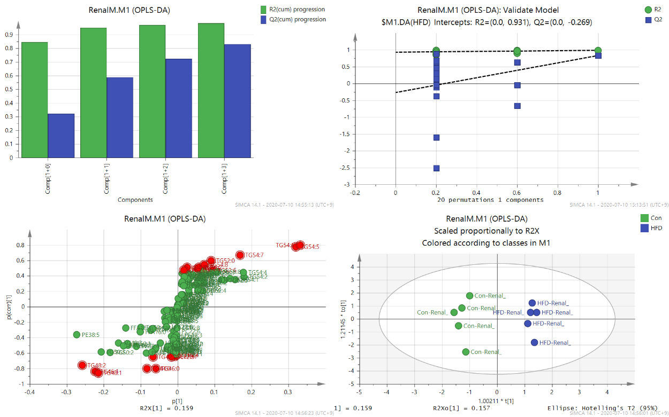
Figure S3.4 OPLS-DA for renal medulla samples, including summary of fit, permutation, S-plot, and score plot.

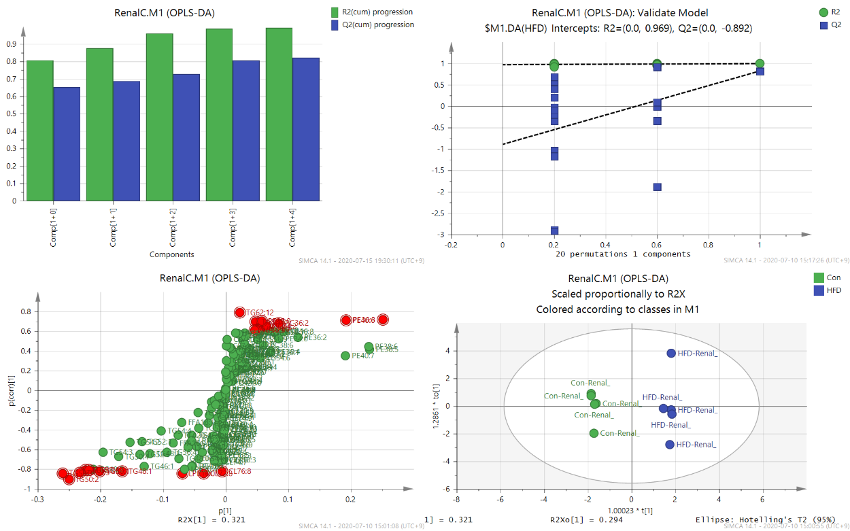
Figure S3.5 OPLS-DA for renal cortex samples, including summary of fit, permutation, S-plot, and score plot.

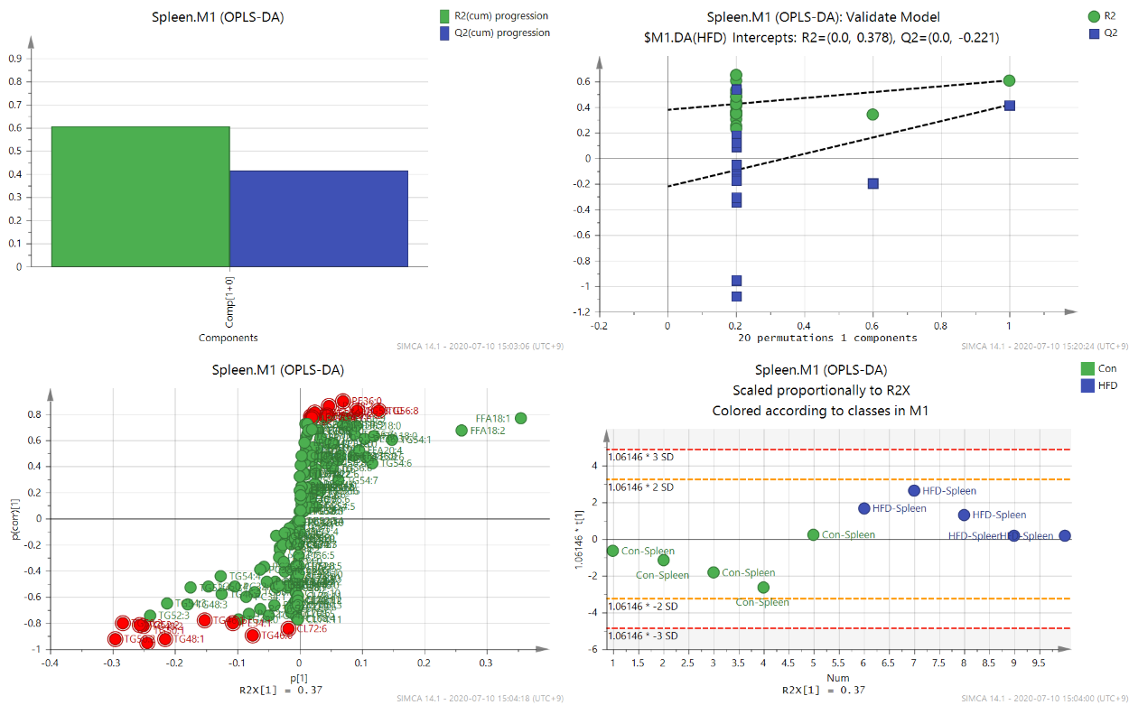
Figure S3.6 OPLS-DA for spleen samples, including summary of fit, permutation, S-plot, and score plot.

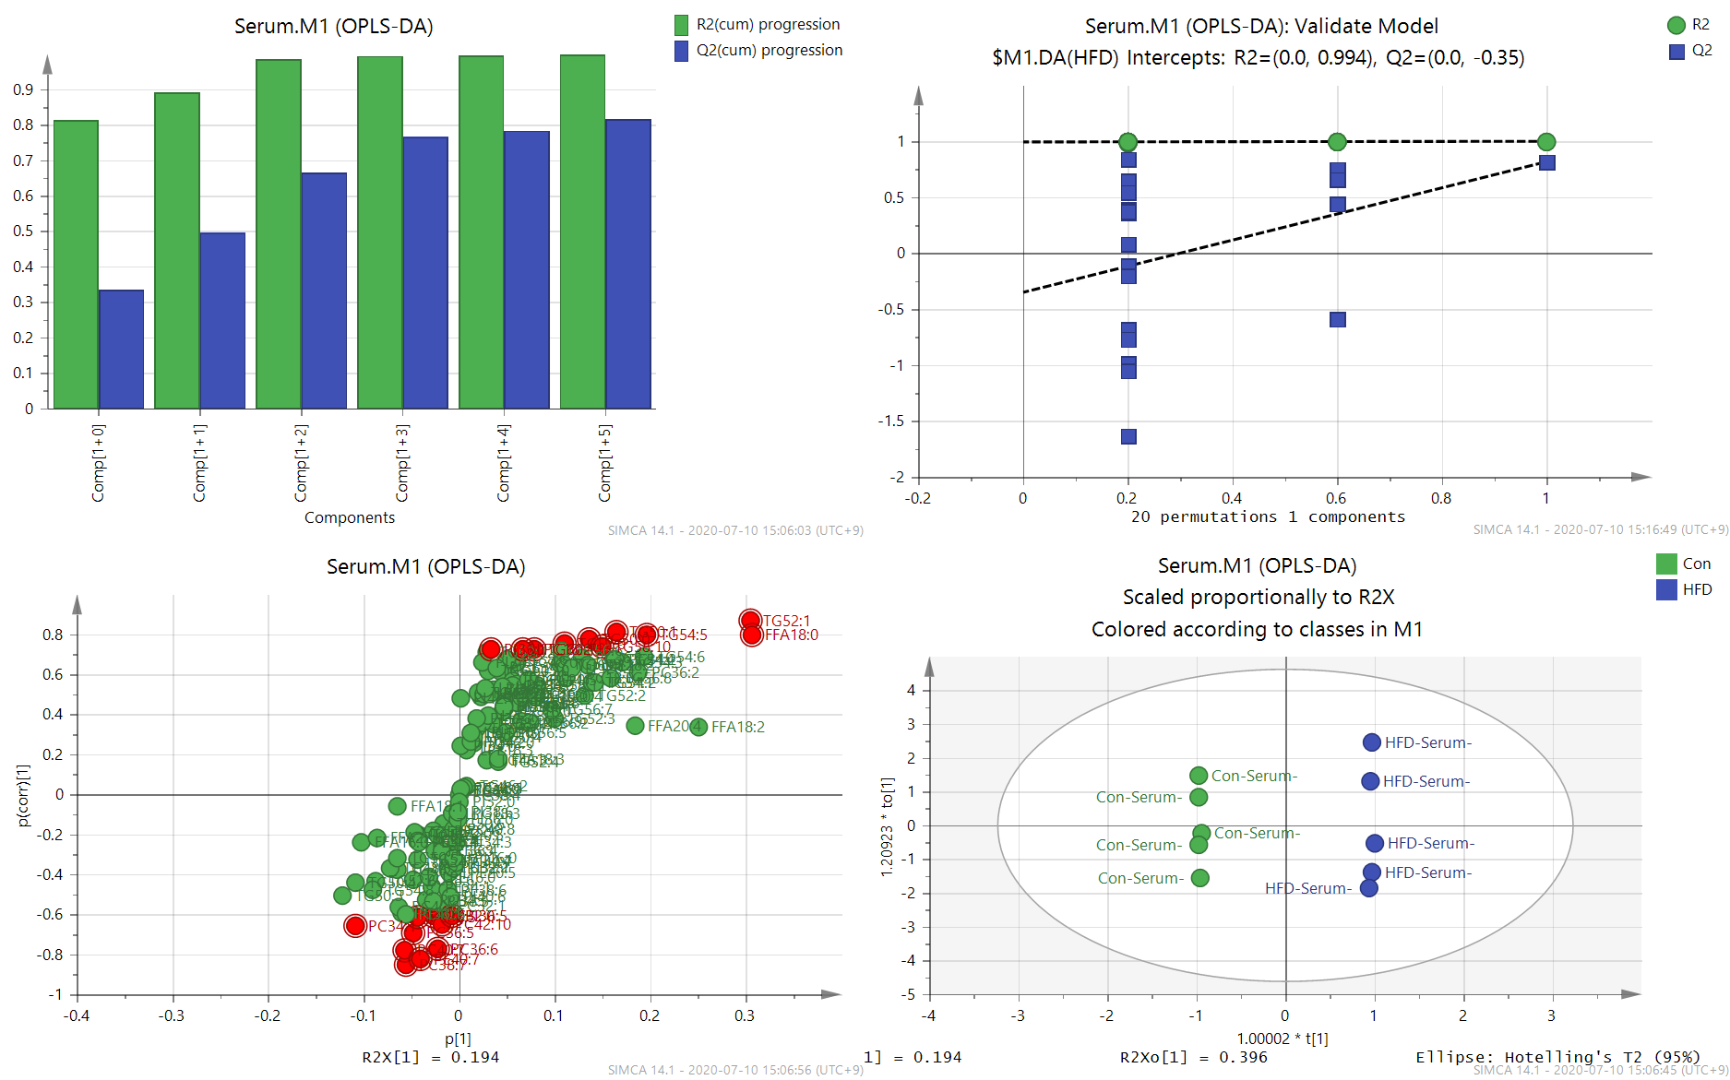
Figure S3.7 OPLS-DA for serum samples, including summary of fit, permutation, S-plot, and score plot.

Table S3.2 Differences of the top variant lipid species, and their covariance (p[1]) and correlation (p(corr)[1]) values in multiple tissues and serum from control and HFD-STZ groups

Lipid species |  | Amount (nmol/g tissue, or nmol/mL serum)ª |  | Fold of  change | P value^{b} | Q value^{c} | Covariance  p[1]^{d} | Correlation  p(corr)[1]^{d}
 |  | Con | HFD
Liver
Increased in HFD | TG56:9 | 13.986±9.722 | 41.366±12.102 | 2.96 | 0.016 | 0.028 | 0.1353 | 0.8798
 | TG54:7 | 44.783±19.914 | 91.747±18.007 | 2.05 | 0.016 | 0.028 | 0.1773 | 0.8795
 | TG56:6 | 4.523±3.195 | 21.184±8.468 | 4.68 | 0.008 | 0.021 | 0.1044 | 0.8763
 | TG54:8 | 16.062±9.736 | 48.760±16.643 | 3.04 | 0.008 | 0.021 | 0.1463 | 0.8649
 | TG56:5 | 11.165±5.831 | 26.571±7.778 | 2.38 | 0.016 | 0.028 | 0.0998 | 0.8486
 | TG56:7 | 15.053±11.798 | 36.214±9.339 | 2.41 | 0.056 | 0.065 | 0.1185 | 0.8390
 | TG56:10 | 3.594±2.480 | 17.996±8.915 | 5.01 | 0.016 | 0.028 | 0.0947 | 0.8296
 | TG56:8 | 29.417±22.671 | 67.000±15.923 | 2.28 | 0.032 | 0.044 | 0.1541 | 0.8118
 | TG58:7 | 2.150±1.450 | 8.948±4.762 | 4.16 | 0.008 | 0.021 | 0.0643 | 0.7973
 | TG58:8 | 2.992±3.066 | 12.020±5.807 | 4.02 | 0.016 | 0.028 | 0.0739 | 0.7964
Decreased in HFD | PE38:5 | 343.088±69.620 | 192.559±26.733 | 0.56 | 0.008 | 0.021 | -0.3232 | -0.9156
 | TG48:2 | 35.634±11.394 | 9.621±3.807 | 0.27 | 0.008 | 0.021 | -0.1334 | -0.9178
 | PE36:1 | 100.929±10.431 | 62.229±9.268 | 0.62 | 0.008 | 0.021 | -0.1586 | -0.9184
 | TG48:1 | 15.890±4.552 | 4.250±0.964 | 0.27 | 0.008 | 0.021 | -0.0881 | -0.9213
 | TG50:4 | 89.737±6.861 | 51.288±6.414 | 0.57 | 0.008 | 0.021 | -0.1549 | -0.9220
 | PE38:4 | 68.391±7.507 | 39.454±6.870 | 0.58 | 0.008 | 0.021 | -0.1393 | -0.9348
 | PI32:0 | 2.093±0.241 | 1.081±0.102 | 0.52 | 0.008 | 0.021 | -0.0256 | -0.9353
 | PC36:5 | 16.190±1.428 | 8.846±0.707 | 0.55 | 0.008 | 0.021 | -0.0690 | -0.9445
 | TG50:2 | 60.678±4.153 | 31.823±2.965 | 0.52 | 0.008 | 0.021 | -0.1381 | -0.9592
 | TG50:3 | 84.518±7.473 | 36.522±5.101 | 0.43 | 0.008 | 0.021 | -0.1802 | -0.9685
Ventricle
Increased in HFD | LPC18:2 | 1.849±0.391 | 3.999±1.074 | 2.16 | 0.008 | 0.021 | 0.0502 | 0.8296
 | TG52:0 | 8.463±1.209 | 15.195±3.702 | 1.80 | 0.016 | 0.028 | 0.0879 | 0.8101
 | LPI18:0 | 0.594±0.248 | 1.283±0.365 | 2.16 | 0.032 | 0.044 | 0.0274 | 0.7741
 | LPE20:4 | 5.094±1.088 | 12.824±5.069 | 2.52 | 0.008 | 0.021 | 0.0912 | 0.7623
 | PE36:2 | 20.821±2.590 | 29.247±5.420 | 1.40 | 0.056 | 0.065 | 0.0933 | 0.7378
 | LPC20:4 | 0.659±0.086 | 1.052±0.278 | 1.60 | 0.016 | 0.028 | 0.0202 | 0.7327
 | PE38:5 | 92.083±15.861 | 134.686±29.163 | 1.46 | 0.056 | 0.065 | 0.2057 | 0.7079
 | TG54:0 | 1.328±0.109 | 2.703±1.127 | 2.03 | 0.008 | 0.021 | 0.0367 | 0.6932
 | LPE18:2 | 0.996±0.247 | 1.881±0.707 | 1.89 | 0.032 | 0.044 | 0.0292 | 0.6818
 | LPI20:4 | 0.364±0.082 | 0.935±0.481 | 2.57 | 0.016 | 0.028 | 0.0233 | 0.6775
Decreased in HFD | TG50:3 | 126.982±17.998 | 68.969±27.852 | 0.54 | 0.032 | 0.044 | -0.2568 | -0.8081
 | TG48:2 | 92.216±28.085 | 33.269±16.665 | 0.36 | 0.016 | 0.028 | -0.2591 | -0.8130
 | TG50:2 | 99.040±10.972 | 57.325±19.850 | 0.58 | 0.032 | 0.044 | -0.2205 | -0.8249
 | TG48:0 | 14.715±1.880 | 7.342±2.751 | 0.50 | 0.008 | 0.021 | -0.0948 | -0.8661
 | TG48:1 | 45.425±10.791 | 14.048±6.965 | 0.31 | 0.008 | 0.021 | -0.1978 | -0.8858
 | TG46:0 | 6.871±1.972 | 1.469±0.890 | 0.21 | 0.008 | 0.021 | -0.0821 | -0.8881
 | PC36:6 | 2.503±0.600 | 0.783±0.244 | 0.31 | 0.008 | 0.021 | -0.0472 | -0.9102
 | PE34:1 | 5.921±0.931 | 2.477±0.762 | 0.42 | 0.008 | 0.021 | -0.0669 | -0.9173
 | CL72:8 | 8.856±2.028 | 2.574±0.457 | 0.29 | 0.008 | 0.021 | -0.0901 | -0.9189
 | CL68:5 | 0.013±0.001 | 0.004±0.002 | 0.29 | 0.008 | 0.021 | -0.0035 | -0.9530
Atrium
Increased in HFD | TG54:6 | 17.464±12.080 | 52.076±18.256 | 2.98 | 0.032 | 0.044 | 0.1555 | 0.7790
 | LPC18:2 | 2.234±0.668 | 3.472±0.641 | 1.55 | 0.056 | 0.065 | 0.0290 | 0.7413
 | TG54:10 | 0.013±0.015 | 0.054±0.033 | 4.20 | 0.056 | 0.065 | 0.0051 | 0.6795
 | TG54:7 | 6.843±4.150 | 14.515±5.201 | 2.12 | 0.056 | 0.065 | 0.0687 | 0.6784
 | TG54:5 | 42.633±23.620 | 87.992±31.670 | 2.06 | 0.032 | 0.044 | 0.1637 | 0.6644
 | TG56:11 | 0.014±0.016 | 0.059±0.042 | 4.17 | 0.056 | 0.065 | 0.0051 | 0.6378
 | TG54:9 | 0.153±0.130 | 0.429±0.242 | 2.80 | 0.151 | 0.157 | 0.0127 | 0.6333
 | TG52:5 | 27.565±7.728 | 42.708±13.459 | 1.55 | 0.095 | 0.102 | 0.0908 | 0.6080
 | TG56:4 | 19.494±6.224 | 32.053±11.094 | 1.64 | 0.056 | 0.065 | 0.0815 | 0.6017
 | PI34:0 | 1.445±0.688 | 2.205±0.419 | 1.53 | 0.056 | 0.065 | 0.0197 | 0.5831
Decreased in HFD | CL78:12 | 0.774±0.234 | 0.160±0.152 | 0.21 | 0.008 | 0.021 | -0.0219 | -0.8696
 | CL78:11 | 0.552±0.181 | 0.097±0.090 | 0.18 | 0.008 | 0.021 | -0.0189 | -0.8727
 | CL76:11 | 4.547±1.382 | 0.683±0.597 | 0.15 | 0.008 | 0.021 | -0.0558 | -0.8970
 | CL78:13 | 0.639±0.177 | 0.103±0.103 | 0.16 | 0.008 | 0.021 | -0.0209 | -0.9027
 | PE40:6 | 86.389±14.125 | 37.978±11.853 | 0.44 | 0.008 | 0.021 | -0.1994 | -0.9072
 | PC32:2 | 1.626±0.254 | 0.777±0.193 | 0.48 | 0.008 | 0.021 | -0.0264 | -0.9090
 | CL76:10 | 2.998±0.840 | 0.322±0.249 | 0.11 | 0.008 | 0.021 | -0.0471 | -0.9238
 | PE34:1 | 13.808±2.603 | 5.027±1.350 | 0.36 | 0.008 | 0.021 | -0.0858 | -0.9268
 | PC36:5 | 4.195±0.296 | 2.506±0.417 | 0.60 | 0.008 | 0.021 | -0.0379 | -0.9395
 | PC38:7 | 7.866±1.084 | 2.462±0.825 | 0.31 | 0.008 | 0.021 | -0.0683 | -0.9562
Renal medulla
Increased in HFD | TG54:6 | 51.790±18.633 | 135.797±44.360 | 2.62 | 0.008 | 0.021 | 0.3328 | 0.7969
 | TG54:5 | 92.054±28.774 | 172.060±40.192 | 1.87 | 0.016 | 0.028 | 0.3205 | 0.7756
 | TG54:7 | 19.455±8.162 | 45.501±20.057 | 2.34 | 0.032 | 0.044 | 0.1689 | 0.6699
 | TG52:0 | 5.183±3.831 | 13.408±8.007 | 2.59 | 0.056 | 0.065 | 0.0914 | 0.5973
 | TG54:8 | 2.695±1.710 | 8.389±6.684 | 3.11 | 0.032 | 0.044 | 0.0723 | 0.5459
 | LPC18:2 | 2.295±0.513 | 3.135±0.871 | 1.37 | 0.151 | 0.157 | 0.0258 | 0.5086
 | TG52:7 | 2.860±1.437 | 6.740±5.126 | 2.36 | 0.310 | 0.312 | 0.0579 | 0.5062
 | TG50:6 | 3.225±1.375 | 6.655±4.827 | 2.06 | 0.421 | 0.421 | 0.0535 | 0.4859
 | TG52:6 | 17.080±7.097 | 28.758±14.832 | 1.68 | 0.310 | 0.312 | 0.0953 | 0.4757
 | LPC20:5 | 0.935±0.304 | 1.308±0.385 | 1.40 | 0.095 | 0.102 | 0.0166 | 0.4750
Decreased in HFD | CL68:4 | 0.030±0.023 | 0.010±0.005 | 0.32 | 0.056 | 0.065 | -0.0048 | -0.6258
 | CL70:6 | 0.182±0.165 | 0.040±0.015 | 0.22 | 0.016 | 0.028 | -0.0129 | -0.6282
 | CL70:7 | 0.064±0.053 | 0.015±0.009 | 0.24 | 0.016 | 0.028 | -0.0077 | -0.6448
 | CL72:5 | 0.318±0.251 | 0.080±0.041 | 0.25 | 0.056 | 0.065 | -0.0168 | -0.6486
 | TG42:0 | 5.254±3.780 | 1.598±1.186 | 0.30 | 0.151 | 0.157 | -0.0663 | -0.6493
 | TG48:2 | 107.367±29.051 | 57.865±23.244 | 0.54 | 0.032 | 0.044 | -0.2576 | -0.7600
 | TG44:0 | 7.733±3.147 | 3.001±1.256 | 0.39 | 0.016 | 0.028 | -0.0827 | -0.7980
 | TG46:0 | 5.006±1.374 | 2.542±0.713 | 0.51 | 0.008 | 0.021 | -0.0582 | -0.8006
 | TG46:1 | 49.186±18.954 | 15.265±7.220 | 0.31 | 0.016 | 0.028 | -0.2231 | -0.8344
 | TG48:1 | 53.459±15.295 | 22.769±4.848 | 0.43 | 0.008 | 0.021 | -0.2138 | -0.8596
Renal cortex
Increased in HFD | TG62:12 | 0.409±0.316 | 1.120±0.279 | 2.74 | 0.016 | 0.028 | 0.0225 | 0.7905
 | PE36:3 | 101.079±23.062 | 196.351±71.149 | 1.94 | 0.032 | 0.044 | 0.2513 | 0.7192
 | PE40:6 | 85.662±24.852 | 141.886±37.506 | 1.66 | 0.016 | 0.028 | 0.1919 | 0.7117
 | PE36:0 | 8.640±1.750 | 13.921±3.782 | 1.61 | 0.056 | 0.065 | 0.0581 | 0.7055
 | TG58:7 | 3.002±1.900 | 6.664±2.118 | 2.22 | 0.032 | 0.044 | 0.0475 | 0.6946
 | PC36:2 | 28.130±8.321 | 39.734±5.732 | 1.41 | 0.056 | 0.065 | 0.0851 | 0.6792
 | PC34:2 | 16.518±5.427 | 23.531±3.994 | 1.42 | 0.095 | 0.102 | 0.0656 | 0.6546
 | TG58:8 | 5.199±4.200 | 11.088±3.021 | 2.13 | 0.056 | 0.065 | 0.0574 | 0.6412
 | PC34:0 | 12.785±2.596 | 17.910±4.408 | 1.40 | 0.056 | 0.065 | 0.0541 | 0.6242
 | PC36:3 | 9.605±3.152 | 13.523±2.463 | 1.41 | 0.095 | 0.102 | 0.0468 | 0.6135
Decreased in HFD | TG52:4 | 150.697±34.207 | 85.041±14.719 | 0.56 | 0.008 | 0.021 | -0.2187 | -0.8068
 | TG52:2 | 195.054±27.437 | 127.644±28.411 | 0.65 | 0.016 | 0.028 | -0.2236 | -0.8096
 | TG48:1 | 49.988±19.709 | 13.339±2.275 | 0.27 | 0.008 | 0.021 | -0.1648 | -0.8202
 | CL76:8 | 0.070±0.022 | 0.027±0.011 | 0.39 | 0.008 | 0.021 | -0.0057 | -0.8247
 | TG50:1 | 109.948±27.018 | 56.408±12.338 | 0.51 | 0.008 | 0.021 | -0.2013 | -0.8253
 | TG52:3 | 192.550±24.425 | 121.618±28.136 | 0.63 | 0.008 | 0.021 | -0.2334 | -0.8387
 | LPE16:0 | 19.065±2.510 | 13.116±2.189 | 0.69 | 0.016 | 0.028 | -0.0686 | -0.8426
 | CL72:8 | 3.002±0.689 | 1.458±0.438 | 0.49 | 0.008 | 0.021 | -0.0347 | -0.8434
 | TG50:3 | 134.590±42.173 | 45.382±10.244 | 0.34 | 0.008 | 0.021 | -0.2604 | -0.8440
 | TG50:2 | 136.866±25.993 | 60.353±12.817 | 0.44 | 0.008 | 0.021 | -0.2502 | -0.9008
Spleen
Increased in HFD | PE36:0 | 7.057±1.171 | 11.267±0.993 | 1.60 | 0.008 | 0.021 | 0.0700 | 0.8982
 | LPC18:2 | 1.455±0.346 | 3.228±1.047 | 2.22 | 0.008 | 0.021 | 0.0468 | 0.8617
 | TG56:8 | 8.357±6.242 | 18.380±9.974 | 2.20 | 0.095 | 0.102 | 0.1269 | 0.8281
 | TG58:10 | 3.194±2.428 | 9.111±5.245 | 2.85 | 0.056 | 0.065 | 0.0917 | 0.8260
 | TG62:14 | 0.163±0.151 | 0.633±0.391 | 3.88 | 0.032 | 0.044 | 0.0247 | 0.8123
 | TG60:12 | 0.857±0.769 | 2.406±1.238 | 2.81 | 0.095 | 0.102 | 0.0451 | 0.8028
 | LPC20:5 | 0.501±0.276 | 1.958±1.487 | 3.91 | 0.016 | 0.028 | 0.0442 | 0.7877
 | TG60:13 | 0.062±0.058 | 0.308±0.271 | 5.00 | 0.032 | 0.044 | 0.0186 | 0.7849
 | TG58:11 | 0.437±0.213 | 1.548±1.274 | 3.54 | 0.016 | 0.028 | 0.0396 | 0.7791
 | LPC20:4 | 0.783±0.098 | 1.154±0.273 | 1.47 | 0.032 | 0.044 | 0.0203 | 0.7767
Decreased in HFD | TG46:1 | 26.399±17.687 | 8.542±2.930 | 0.32 | 0.151 | 0.157 | -0.1519 | -0.7814
 | PE34:1 | 32.716±4.344 | 20.326±1.867 | 0.62 | 0.008 | 0.021 | -0.1075 | -0.8009
 | TG50:3 | 109.465±61.574 | 57.392±14.862 | 0.52 | 0.222 | 0.227 | -0.2843 | -0.8038
 | TG52:2 | 143.678±48.399 | 103.920±17.400 | 0.72 | 0.222 | 0.227 | -0.2571 | -0.8138
 | TG48:2 | 70.272±43.366 | 26.847±8.632 | 0.38 | 0.151 | 0.157 | -0.2505 | -0.8226
 | CL72:6 | 0.499±0.073 | 0.172±0.060 | 0.34 | 0.008 | 0.021 | -0.0180 | -0.8410
 | TG46:0 | 5.447±2.962 | 1.732±0.834 | 0.32 | 0.016 | 0.028 | -0.0750 | -0.8942
 | TG50:2 | 104.999±43.606 | 54.112±17.437 | 0.52 | 0.095 | 0.102 | -0.2952 | -0.9224
 | TG48:1 | 43.732±22.543 | 14.481±5.178 | 0.33 | 0.056 | 0.065 | -0.2154 | -0.9258
 | TG50:1 | 79.786±24.626 | 43.056±10.721 | 0.54 | 0.032 | 0.044 | -0.2441 | -0.9539
Serum
Increased in HFD | TG52:1 | 24.913±8.356 | 54.252±10.172 | 2.18 | 0.008 | 0.021 | 0.3047 | 0.8721
 | TG50:1 | 17.460±3.791 | 26.611±3.602 | 1.52 | 0.016 | 0.028 | 0.1644 | 0.8133
 | FFA18:0 | 74.178±9.565 | 106.755±17.254 | 1.44 | 0.016 | 0.028 | 0.3070 | 0.7967
 | TG54:5 | 41.149±4.373 | 54.573±6.790 | 1.33 | 0.008 | 0.021 | 0.1963 | 0.7948
 | TG50:0 | 5.929±2.565 | 12.499±3.354 | 2.11 | 0.032 | 0.044 | 0.1358 | 0.7758
 | TG52:0 | 1.553±1.007 | 6.017±2.885 | 3.87 | 0.032 | 0.044 | 0.1097 | 0.7507
 | TG58:10 | 10.795±4.408 | 19.128±3.958 | 1.77 | 0.016 | 0.028 | 0.1495 | 0.7426
 | LPC18:2 | 1.239±0.203 | 2.914±1.234 | 2.35 | 0.008 | 0.021 | 0.0665 | 0.7279
 | TG60:11 | 1.146±0.928 | 3.512±1.520 | 3.06 | 0.032 | 0.044 | 0.0789 | 0.7259
 | PI36:1 | 0.175±0.057 | 0.583±0.303 | 3.34 | 0.008 | 0.021 | 0.0326 | 0.7221
Decreased in HFD | PC32:0 | 1.825±0.234 | 1.488±0.260 | 0.82 | 0.095 | 0.102 | -0.0271 | -0.6044
 | PI36:5 | 0.046±0.026 | 0.019±0.009 | 0.42 | 0.032 | 0.044 | -0.0077 | -0.6100
 | PE38:5 | 1.789±0.717 | 0.952±0.481 | 0.53 | 0.095 | 0.102 | -0.0434 | -0.6148
 | PC42:10 | 0.511±0.096 | 0.378±0.079 | 0.74 | 0.095 | 0.102 | -0.0177 | -0.6475
 | PC34:1 | 14.002±2.684 | 9.082±3.623 | 0.65 | 0.056 | 0.065 | -0.1080 | -0.6542
 | PC36:5 | 2.566±0.640 | 1.636±0.400 | 0.64 | 0.032 | 0.044 | -0.0483 | -0.6958
 | PC36:6 | 0.298±0.095 | 0.127±0.057 | 0.43 | 0.016 | 0.028 | -0.0218 | -0.7726
 | PC40:7 | 1.997±0.685 | 0.845±0.280 | 0.42 | 0.016 | 0.028 | -0.0570 | -0.7774
 | PE40:7 | 0.802±0.290 | 0.256±0.083 | 0.32 | 0.008 | 0.021 | -0.0405 | -0.8251
 | PC38:7 | 1.788±0.470 | 0.768±0.134 | 0.43 | 0.008 | 0.021 | -0.0561 | -0.8534
ª Data were expressed as means ± standard deviations. Con, control group; HFD, high fat diet-STZ group.
^{b} P value was calculated using Mann-Whitney U-test.
^{c} Q value was calculated by Benjamini-Hochberg false discovery rate (FDR) correction (FDR rate was set at 0.1) within all the selected lipid variables.
^{d} p[1] and p(corr)[1] were calculated by SIMCA-P based on the individual model of each tissue/serum.
Abbreviations of lipid classes: TG, triacylglycerol; FFA, free fatty acid; PC, phosphatidylcholine; LPC, lysophosphatidylcholine; PE, phosphatidylethanolamine; LPE, lysophosphatidylethanolamine; PI, phosphatidylinositol; LPI, lysophosphatidylinositol; CL, cardiolipin.

