Supplementary Material 5

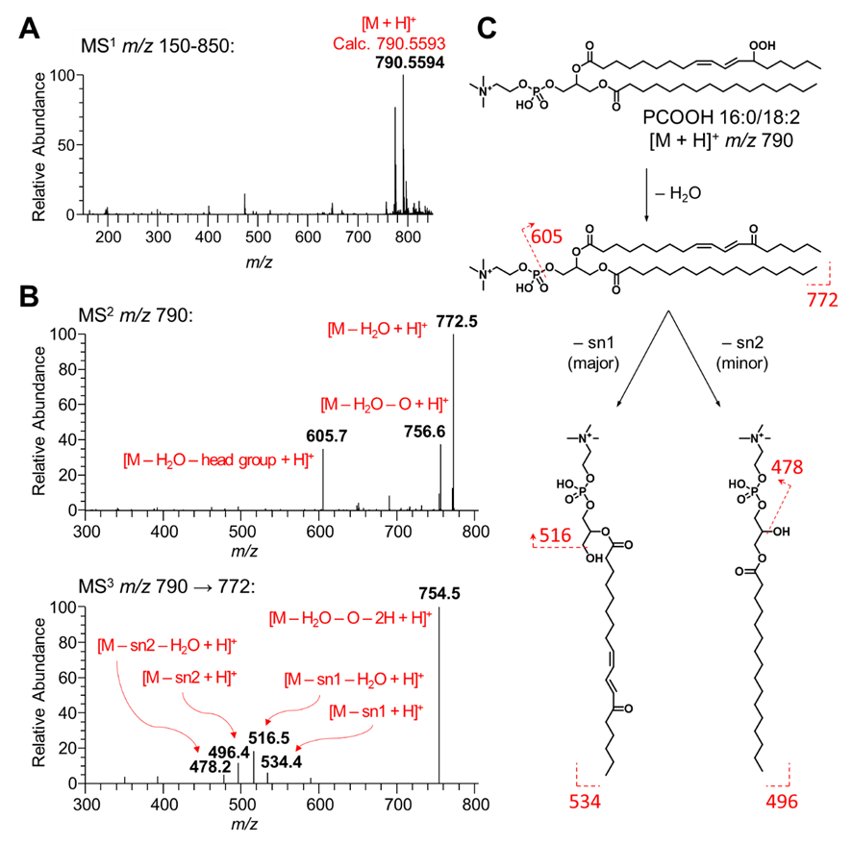
Fig. S5.1 Identification of fatty acyl composition in the lipid hydroperoxide PCOOH 16:0/18:2. (A) The HRMS¹ spectrum showed an identical signal at m/z 790.5594 as [M + H]⁺; (B) in MS² spectrum, the signals of m/z 772 and m/z 756 indicated the existence of the hydroperoxyl group, while m/z 605 was assigned as the [M – H₂O – headgroup + H]⁺; (C) the MS³ spectrum not only gave the signal of hydroperoxyl group cleavage as [M – H₂O – O – 2H + H]⁺) at m/z 754, but also showed two pairs of signals, m/z 534, 516, and m/z 496, 478, which were assigned as [M – FA16:0 + H]⁺ and [M – FA18:2OOH + H]⁺, respectively.

Table S5.1 LC/MS data of the identified lipid hydroperoxides
Lipid species | Formula | Diagnostic ion | RT | Calc. m/z | Exp. m/z | Δppm
TGOOH52:2 | C₅₅H₁₀₂O₈ | [M + NH₄]⁺ | 12.58 | 908.7913 | 908.7939 | 2.86
TGOOH52:3 | C₅₅H₁₀₀O₈ | [M + NH₄]⁺ | 12.32 | 906.7756 | 906.7769 | 1.43
TGOOH52:4 | C₅₅H₉₈O₈ | [M + NH₄]⁺ | 12.12 | 904.7600 | 904.7610 | 1.11
TGOOH54:3 | C₅₇H₁₀₄O₈ | [M + NH₄]⁺ | 12.69 | 934.8069 | 934.8064 | −0.53
TGOOH54:4 | C₅₇H₁₀₂O₈ | [M + NH₄]⁺ | 12.42 | 932.7913 | 932.7908 | −0.54
TGOOH54:5 | C₅₇H₁₀₀O₈ | [M + NH₄]⁺ | 12.16 | 930.7756 | 930.7763 | 0.75
TGOOH56:6 | C₅₉H₁₀₂O₈ | [M + NH₄]⁺ | 12.78 | 956.7913 | 956.7936 | 2.40
TGOOH56:7 | C₅₉H₁₀₀O₈ | [M + NH₄]⁺ | 12.48 | 954.7756 | 954.7762 | 0.63
PCOOH34:2 | C₄₂H₈₀O₁₀NP | [M + H]⁺ | 6.25 | 790.5593 | 790.5597 | 0.51
PCOOH34:3 | C₄₂H₇₈O₁₀NP | [M + H]⁺ | 5.66 | 788.5436 | 788.5432 | −0.51
PCOOH34:4 | C₄₂H₇₆O₁₀NP | [M + H]⁺ | 3.94 | 786.5280 | 786.5281 | 0.13
PCOOH34:5 | C₄₂H₇₄O₁₀NP | [M + H]⁺ | 3.20 | 784.5123 | 784.5119 | −0.51
PCOOH36:2 | C₄₄H₈₄O₁₀NP | [M + H]⁺ | 6.86 | 818.5906 | 818.5898 | −0.98
PCOOH36:3 | C₄₄H₈₂O₁₀NP | [M + H]⁺ | 6.49 | 816.5749 | 816.5745 | −0.49
PCOOH36:4 | C₄₄H₈₀O₁₀NP | [M + H]⁺ | 6.01 | 814.5593 | 814.5582 | −1.35
PCOOH36:5 | C₄₄H₇₈O₁₀NP | [M + H]⁺ | 5.66 | 812.5436 | 812.5432 | −0.49
PCOOH36:6 | C₄₄H₇₆O₁₀NP | [M + H]⁺ | 4.25 | 810.5280 | 810.5275 | −0.62
PCOOH38:4 | C₄₆H₈₄O₁₀NP | [M + H]⁺ | 6.68 | 842.5906 | 842.5911 | 0.59
PCOOH38:5 | C₄₆H₈₂O₁₀NP | [M + H]⁺ | 6.27 | 840.5749 | 840.5743 | −0.71
PCOOH38:6 | C₄₆H₈₀O₁₀NP | [M + H]⁺ | 5.88 | 838.5593 | 838.5584 | −1.07
PCOOH38:7 | C₄₆H₇₈O₁₀NP | [M + H]⁺ | 5.06 | 836.5436 | 836.5425 | −1.31
PCOOH38:8 | C₄₆H₇₆O₁₀NP | [M + H]⁺ | 4.52 | 834.5280 | 834.5273 | −0.84
PCOOH40:6 | C₄₈H₈₄O₁₀NP | [M + H]⁺ | 6.57 | 866.5906 | 866.5900 | −0.69
PEOOH36:2 | C₄₁H₇₈O₁₀NP | [M − H]⁻ | 13.64 | 774.5291 | 774.5256 | −4.52
PEOOH36:3 | C₄₁H₇₆O₁₀NP | [M − H]⁻ | 13.17 | 772.5134 | 772.5112 | −2.85
PEOOH36:4 | C₄₁H₇₄O₁₀NP | [M − H]⁻ | 12.84 | 770.4978 | 770.4949 | −3.76
PEOOH38:4 | C₄₃H₇₈O₁₀NP | [M − H]⁻ | 13.67 | 798.5291 | 798.5259 | −4.01
PEOOH38:5 | C₄₃H₇₆O₁₀NP | [M − H]⁻ | 13.10 | 796.5134 | 796.5142 | 1.00
PEOOH38:6 | C₄₃H₇₄O₁₀NP | [M − H]⁻ | 12.84 | 794.4978 | 794.4955 | −2.89
PEOOH40:6 | C₄₅H₇₈O₁₀NP | [M − H]⁻ | 13.57 | 822.5291 | 822.5255 | −4.38
PEOOH40:7 | C₄₅H₇₆O₁₀NP | [M − H]⁻ | 13.22 | 820.5134 | 820.5107 | −3.29
PEOOH40:8 | C₄₅H₇₄O₁₀NP | [M − H]⁻ | 12.86 | 818.4978 | 818.4938 | −4.89
PIOOH34:1 | C₄₃H₈₁O₁₅P | [M − H]⁻ | 14.44 | 867.5240 | 867.5263 | 2.65
PIOOH34:2 | C₄₃H₇₉O₁₅P | [M − H]⁻ | 13.92 | 865.5084 | 865.5052 | −3.70
PIOOH34:3 | C₄₃H₇₇O₁₅P | [M − H]⁻ | 13.79 | 863.4927 | 863.4957 | 3.47
PIOOH34:4 | C₄₃H₇₅O₁₅P | [M − H]⁻ | 13.62 | 861.4771 | 861.4801 | 3.48
PIOOH38:4 | C₄₇H₈₃O₁₅P | [M − H]⁻ | 12.70 | 917.5397 | 917.5370 | −2.94

