Supplementary information
Complete, rapid and reversible regulation of the motility
of a nano-biomolecular machine using an osmolyte trimethylamine-N-oxide
Tasrina Munmun,^{1,#} Arif Md. Rashedul Kabir,^{2,#} Kazuki Sada,^{1,2} and Akira Kakugo^{1,2,*}

¹Graduate School of Chemical science and Engineering, Hokkaido University, Sapporo 060-0810, Japan.
²Faculty of Science, Hokkaido University, Sapporo 060-0810, Japan.

*Corresponding author
E-mail: kakugo@sci.hokudai.ac.jp
#These authors contributed equally to this work.

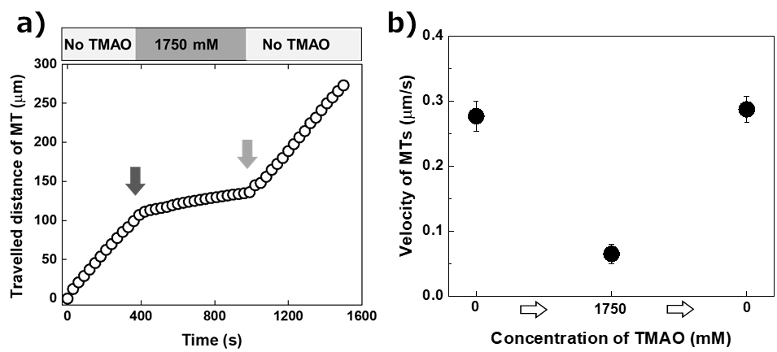

Supplementary Figure 1: Restoration of the motility of kinesin-driven MTs in an in vitro motility assay upon decreasing the concentration of TMAO. (a) Motility behavior of a single MT upon changing the concentration of TMAO in the motility assay. Plotted is the travelled distance of one MT as a function of time. The arrowheads indicate starting point where motility behavior of the MT was changed due to the change in concentration of TMAO in the motility assay buffer. The upper panel shows corresponding concentration of TMAO in the motility assay. (b) Change in average velocity of MTs upon changing the concentration of TMAO in the motility assay buffer. The velocity of MTs decreased in the presence of 1750 mM TMAO, which was recovered after elimination of the TMAO. Error bars: standard deviation.

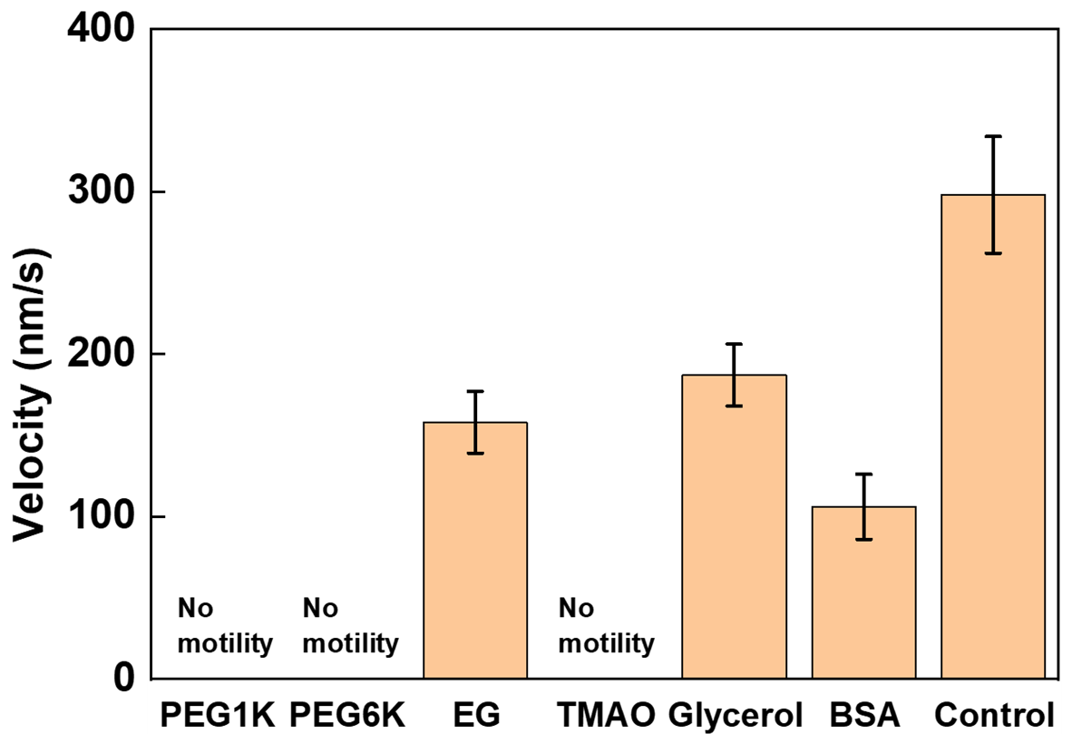
Supplementary Figure 2: Effect of various osmolyte solutions (25% w/v) on the motility behavior of MTs in the in vitro motility assay. Error bars: standard deviation.

Supplementary Table 1: Physicochemical properties of osmolyte solutions (25% w/v) and their effect on the motility of kinesin-driven MTs in an in vitro motility assay at 20 °C. ‘No motility’ indicates motility of MTs was completely terminated and ‘slow’ means velocity of MTs was slower compared to that in the absence of any osmolyte (313±36 nm/s).
Osmolyte | MW  (Da) | Concentration (M) | Viscosity  (mPa.s) | Osmotic pressure (MPa) | Motility of MTs | Velocity  (nm/s)
PEG | 1000 | 0.25 | 4.8 | 1.8 | No motility | NA
PEG | 6000 | 0.042 | 20.9 | 1.0 | No motility | NA
EG | 62.07 | 4.03 | 2.0 | 9.8 | Slow | 158±19
TMAO | 75.11 | 3.33 | 2.4 | >5 | No motility | NA
Glycerol | 92.09 | 2.71 | 2.1 | 6.6 | Slow | 187±19
BSA | 66500 | 0.004 | 5.9 | 0.07 | Slow | 106±20

Supplementary movie 1: Suppression of motility of kinesin-driven MTs in an in vitro motility assay using TMAO. MTs became slower upon increasing the concentration of TMAO gradually. The movie is 100 times faster than the actual speed.
Supplementary movie 2: Acceleration of motility of kinesin-driven MTs in an in vitro motility assay upon decreasing the concentration of TMAO. MTs became faster upon decreasing the concentration of TMAO gradually. The movie is 100 times faster than the actual speed.
Supplementary movie 3: Complete on/off switching of the motility of MTs using 3000 mM TMAO. The movie is 100 times faster than the actual speed.

