Supplementary Materials
Non-Linear Rheological Study of Hydrogel Sliding Friction in Water and Concentrated Hyaluronan Solution
Satoshi Hirayamaª, Takayuki Kurokawa^{b,c,*} and Jian Ping Gong^{b,c,d}
ª Graduate School of Life Science, Hokkaido University, N21W11, Kita-ku, Sapporo, 001-0021, Japan
^{b} Faculty of Advanced Life Science, Hokkaido University, N21W11, Kita-ku, Sapporo, 001-0021, Japan
^{c} Global Station for Soft Matter, Global Institution for Collaborative Research and Education (GI-CoRE), Hokkaido University, Sapporo, Japan
^{d} Institute for Chemical Reaction Design and Discovery (WPI-ICReDD), Hokkaido University, Sapporo, Japan
kurokawa@sci.hokudai.ac.jp

In situ observation system for frictional interface
We introduce the in situ observation system for frictional interface we have developed [1]. This system utilizes the principle of the critical refraction between different materials. The difference in the critical angle of refraction between water and glass and between gel and glass can distinguish where the gel is in contact with glass from where it is not (see Fig. S1[a][b]). Figure. S2 shows a schematic illustration of the in situ observation system using a rheometer (ARES-G2, TA Instruments). A trapezoidal prism was attached to the upper plate of the rheometer. A hydrophobically-treated cover glass was fixed to the bottom of the trapezoidal prism. Disk-shaped poly (vinyl alcohol) (PVA) gels, which were 15 mm in diameter and 2.4 mm in thickness, were fixed onto the lower plate of the rheometer. The separate gel-glass interface was immersed in hyaluronan (HA) solution. The upper plate with prism and cover glass was allowed to approach the PVA gel surface slowly until the initial normal pressure.
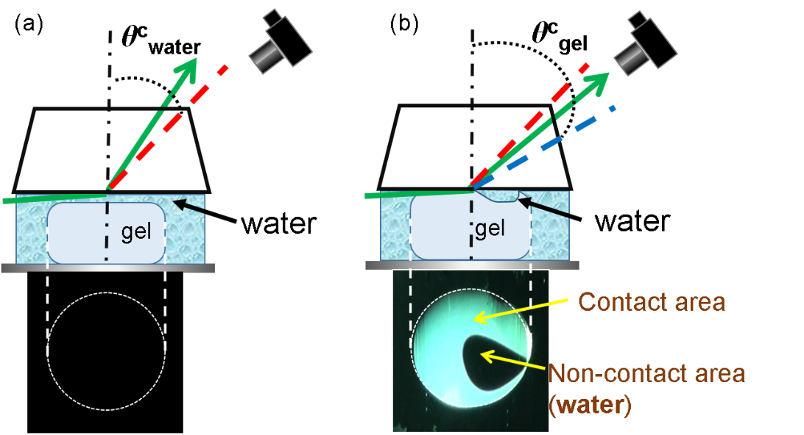
Figure S1: Schematic illustration of the observation of gel-glass contact based on the principle of critical refraction using a trapezoidal prism. In (a), where a water film exists at the gel-glass interface, the light coming from the water film refracts at the angle less than θ^{c}_{water}. On the other hand, in (b) where the gel contacts with the glass prism, the light comes from the gel refracts at the angle less than θ^{c}_{gel}. Here, θ^{c}_{water} and θ^{c}_{gel} are critical refraction angles of the water and water, respectively, and θ^{c}_{water} < θ^{c}_{gel}. So, when we set a camera at an angle θ_{r} (θ^{c}_{water} < θ_{r} < θ^{c}_{gel}), a black image is observed in (a), and a bright image of the gel is observed in (b).
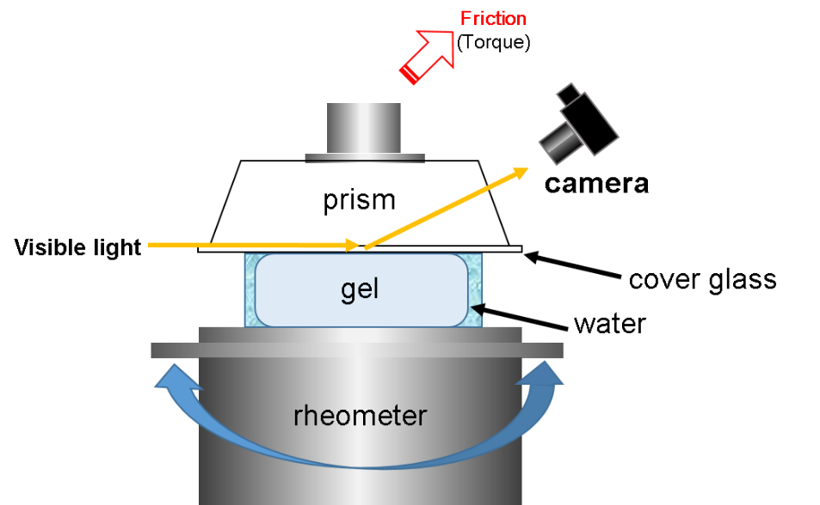
Figure S2: Schematic illustration of the set up for the in situ observation system for gel frictional interface against glass.

Video S1: In situ image of oscillatory frictional test with strain amplitude 0.3 for a poly (vinyl alcohol) hydrogel against a hydrophobically treated glass in water.

Video S2: In situ image of oscillatory frictional test with strain amplitude 1.0 for a poly (vinyl alcohol) hydrogel against a hydrophobically treated glass in water.

Video S3: In situ image of oscillatory frictional test with strain amplitude 3.8 for a poly (vinyl alcohol) hydrogel against a hydrophobically treated glass in water.

References for the Supplementary Materials
[1] Yamamoto T, Kurokawa T, Ahmed J, Kamita G, Yahsima S, Furukawa Y, Ota Y, Furukawa H, Gong JP, In situ observation of a hydrogel-glass interface during sliding friction. Soft Matter 2014;10:5589-5596

