Supplementary Data 2

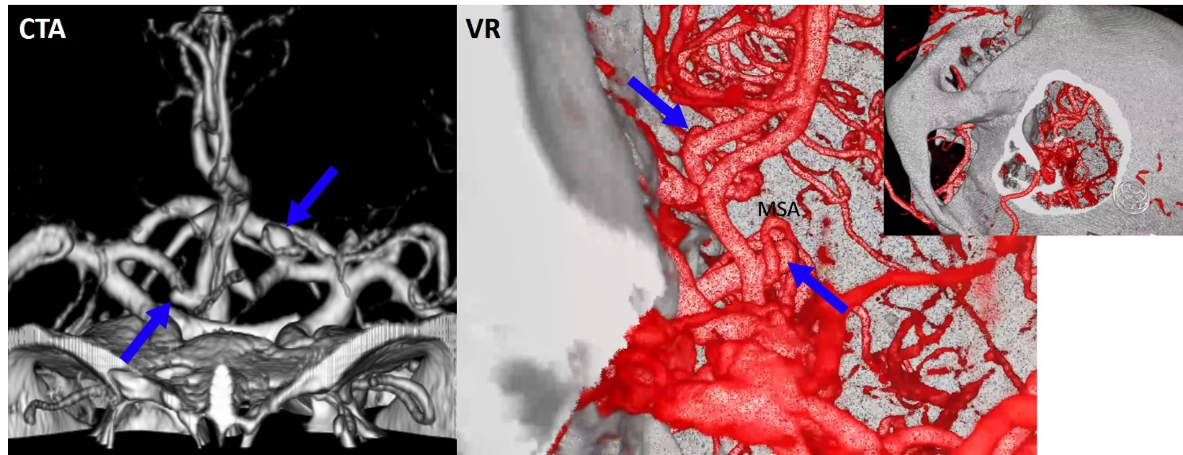

This patient was a 38-year-old man with hypertension. He was diagnosed with the left proximal anterior cerebral artery (ACA)-medial lenticulostriate artery (MLA) aneurysm (supero-posterior projection) and right ACA aneurysm (right side projection). The position of the left ACA aneurysm was also relatively high.
Both aneurysms seemed to be able to be clipped through the left pterional approach. However, it was clarified through virtual reality (VR) session that MSA was located completely in front of the aneurysm from the surgical view and twined around the aneurysm. The right ACA aneurysm was also projected to a dead angle from the surgical view. Therefore, a surgical risk was estimated higher after VR session than before VR session. After the explanation of surgical risk, the final decision to decline surgery was made by the patient himself.

