**Supporting Information**

**Molecular motion of halogenated ethylammonium / [18]crown-6 supramolecular ions in nickel dithiolate magnetic crystals**

Naohiro Hasuo, Kiyonori Takahashi, Kenta Kokado, Ichiro Hisaki, and Takayoshi Nakamura

**Table of Contents**

**§1. Crystal data, data collection and reduction parameter.**

**§2. Crystallographically independent molecules with atom numbering**

**§3. Packing structures of crystals 2-4.**

**§4. Detailed analysis of structures of crystals 1-4.**

**§5. Temperature- and frequency-dependent dielectric constants for crystals 1-4**

**§6. Transfer integrals between [Ni(dmit)2]– molecules in crystals 1-4.**

**§1. Crystal data, crystal data, data collection, and reduction parameter.**

**Table S1.** Crystal data, data collection, and reduction parameter for crystals **1**, **2**, **3** and **4** at the lowest temperatures.

|  |  |  |  |  |
| --- | --- | --- | --- | --- |
|  | **1@113K** | **2@93K** | **3@93K** | **4@106K** |
| *Temperature* / K | 113 | 93 | 93 | 106 |
| *Crystal Dimensions* / mm3 | 0.724×0.378×0.207 | 0.507×0.211×0.090 | 0.69×0.60×0.18 | 0.40×0.11×0.07 |
| *Chemical formula* | C20H32NNiO6S10 | C20H31FNNiO6S10 | C20H31ClNNiO6S10 | C20H31BrNNiO6S10 |
| *Formula weight* | 761.77 | 779.77 | 796.22 | 840.73 |
| *Crystal System* | Triclinic | Triclinic | Triclinic | Triclinic |
| *Space group* | *P*-1 | *P*-1 | *P*-1 | *P*-1 |
| *a /* Å | 11.1765(4) | 10.3645(3) | 11.2107(3) | 10.9869(3) |
| *b /* Å | 12.2812(3) | 12.6254(5) | 12.3150(2) | 12.0485(4) |
| *c /* Å | 12.6527(4) | 12.9123(4) | 12.7451(3) | 13.7559(5) |
| *α /* deg | 87.364(2) | 69.835(3) | 92.2792(18) | 115.833(4) |
| *β /* deg | 68.465(3) | 79.972(3) | 112.126(2) | 91.587(3) |
| *γ /* deg | 80.094(2) | 79.948(3) | 96.0601(18) | 100.906(3) |
| *V /* Å3 | 1591.12(9) | 1549.82(10) | 1614.83(7) | 1596.83(10) |
| *Z* | 2 | 2 | 2 | 2 |
| *Dcalc /* g∙cm-3 | 1.590 | 1.671 | 1.638 | 1.748 |
| *μ*(Mo Kα) */* cm-1 | 1.302 | 1.343 | 1.366 | 2.549 |
| 2*θ*max */* deg | 61.784 | 61.986 | 61.838 | 61.140 |
| *Reflections measured* | 22773 | 18605 | 45358 | 19669 |
| *Independent reflections* | 7934 | 7679 | 8651 | 7891 |
| *Reflections used* | 7934 | 7679 | 8651 | 7891 |
| *R*1 *a* | 0.0357 | 0.0324 | 0.0495 | 0.0356 |
| *R*w(*F*2)*b* | 0.0980 | 0.0792 | 0.1395 | 0.0703 |
| *GOF* | 1.051 | 1.070 | 1.098 | 0.995 |
| *CCDC number* | 2053279 | 2053282 | 2053390 | 2053298 |

*a* *R*1 = ∑||*F*o| - |*F*c|| / ∑|*F*o| and *b* *R*w = (∑ω(|*F*o| - |*F*c|)2 / ∑ω*F*o2)1/2.

**Table S2.** Crystal data, data collection, and reduction parameter for crystal **1**.

|  |  |
| --- | --- |
|  |  |
| *Temperature* / K | 293 |
| *Crystal Dimensions* / mm3 | 0.724×0.378×0.207 |
| *Chemical formula* | C20H32NNiO6S10 |
| *Formula weight* | 761.77 |
| *Crystal System* | Triclinic |
| *Space group* | *P*-1 |
| *a /* Å | 11.2486(6) |
| *b /* Å | 12.3540(8) |
| *c /* Å | 12.7375(8) |
| *α /* deg | 87.498(5) |
| *β /* deg | 69.343(6) |
| *γ /* deg | 80.758(5) |
| *V /* Å3 | 1634.62(18) |
| *Z* | 2 |
| *Dcalc /* g∙cm-3 | 1.548 |
| *μ*(Mo Kα) */* cm-1 | 1.267 |
| 2*θ*max */* deg | 62.114 |
| *Reflections measured* | 20189 |
| *Independent reflections* | 8034 |
| *Reflections used* | 8034 |
| *R*1 *a* | 0.0365 |
| *R*w(*F*2)*b* | 0.0945 |
| *GOF* | 1.051 |
| *CCDC number* | 2053280 |

*a* *R*1 = ∑||*F*o| - |*F*c|| / ∑|*F*o| and *b* *R*w = (∑ω(|*F*o| - |*F*c|)2 / ∑ω*F*o2)1/2.

**Table S3.** Crystal data, data collection, and reduction parameter for crystal **2** at different temperatures.

|  |  |  |  |  |
| --- | --- | --- | --- | --- |
|  | **2** |  |  |  |
| *Temperature* / K | 113 | 133 | 153 | 173 |
| *Crystal Dimensions* / mm3 | 0.507×0.211×0.090 | 0.507×0.211×0.090 | 0.507×0.211×0.090 | 0.507×0.211×0.090 |
| *Chemical formula* | C20H31FNNiO6S10 | C20H31FNNiO6S10 | C20H31FNNiO6S10 | C20H31FNNiO6S10 |
| *Formula weight* | 779.77 | 779.77 | 779.77 | 779.77 |
| *Crystal System* | Triclinic | Triclinic | Triclinic | Triclinic |
| *Space group* | *P*-1 | *P*-1 | *P*-1 | *P*-1 |
| *a /* Å | 10.3864(2) | 10.3884(3) | 10.3994(3) | 10.4067(3) |
| *b /* Å | 12.6343(5) | 12.6271(4) | 12.6286(5) | 12.6314(5) |
| *c /* Å | 12.9338(5) | 12.9344(4) | 12.9431(4) | 12.9479(4) |
| *α /* deg | 69.944(3) | 70.113(3) | 70.317(3) | 70.517(3) |
| *β /* deg | 79.973(3) | 79.966(2) | 79.956(2) | 79.892(2) |
| *γ /* deg | 79.970(3) | 80.068(2) | 80.078(3) | 80.138(3) |
| *V /* Å3 | 1557.90(10) | 1559.30(9) | 1564.10(9) | 1567.96(9) |
| *Z* | 2 | 2 | 2 | 2 |
| *Dcalc /* g∙cm-3 | 1.662 | 1.661 | 1.656 | 1.650 |
| *μ*(Mo Kα) */* cm-1 | 1.336 | 1.335 | 1.331 | 1.327 |
| 2*θ*max */* deg | 62.114 | 61.916 | 61.652 | 61.248 |
| *Reflections measured* | 19702 | 19502 | 19288 | 19026 |
| *Independent reflections* | 7645 | 7689 | 7694 | 7718 |
| *Reflections used* | 7645 | 7689 | 7694 | 7718 |
| *R*1 *a* | 0.0329 | 0.0386 | 0.0340 | 0.0366 |
| *R*w(*F*2)*b* | 0.0806 | 0.0941 | 0.0865 | 0.0925 |
| *GOF* | 1.054 | 0.990 | 1.075 | 1.075 |
| *CCDC number* | 2053283 | 2053284 | 2053285 | 2053286 |

*a* *R*1 = ∑||*F*o| - |*F*c|| / ∑|*F*o| and *b* *R*w = (∑ω(|*F*o| - |*F*c|)2 / ∑ω*F*o2)1/2.

|  |  |  |  |  |
| --- | --- | --- | --- | --- |
|  | **2** |  |  |  |
| *Temperature* / K | 193 | 213 | 233 | 253 |
| *Crystal Dimensions* / mm3 | 0.507×0.211×0.090 | 0.507×0.211×0.090 | 0.507×0.211×0.090 | 0.507×0.211×0.090 |
| *Chemical formula* | C20H31FNNiO6S10 | C20H31FNNiO6S10 | C20H31FNNiO6S10 | C20H31FNNiO6S10 |
| *Formula weight* | 779.77 | 779.77 | 779.77 | 779.77 |
| *Crystal System* | Triclinic | Triclinic | Triclinic | Triclinic |
| *Space group* | *P*-1 | *P*-1 | *P*-1 | *P*-1 |
| *a /* Å | 10.4204(3) | 10.4363(3) | 10.4520(3) | 10.4754(3) |
| *b /* Å | 12.6319(4) | 12.6370(4) | 12.6374(4) | 12.6503(4) |
| *c /* Å | 12.9511(4) | 12.9511(4) | 12.9527(4) | 12.9637(4) |
| *α /* deg | 70.735(3) | 70.974(3) | 71.178(3) | 71.385(3) |
| *β /* deg | 79.898(2) | 79.852(2) | 79.806(2) | 79.802(2) |
| *γ /* deg | 80.250(2) | 80.316(2) | 80.408(2) | 80.550(2) |
| *V /* Å3 | 1572.90(9) | 1578.17(8) | 1582.77(9) | 1591.61(9) |
| *Z* | 2 | 2 | 2 | 2 |
| *Dcalc /* g∙cm-3 | 1.646 | 1.641 | 1.636 | 1.627 |
| *μ*(Mo Kα) */* cm-1 | 1.323 | 1.319 | 1.315 | 1.308 |
| 2*θ*max */* deg | 61.70 | 61.50 | 62.07 | 61.34 |
| *Reflections measured* | 19734 | 19305 | 19876 | 19688 |
| *Independent reflections* | 7797 | 7814 | 7847 | 7844 |
| *Reflections used* | 7797 | 7814 | 7847 | 7844 |
| *R*1 *a* | 0.0414 | 0.0336 | 0.0335 | 0.0343 |
| *R*w(*F*2)*b* | 0.1011 | 0.0838 | 0.0864 | 0.0810 |
| *GOF* | 1.016 | 1.050 | 1.044 | 1.047 |
| *CCDC number* | 2053287 | 2053288 | 2053289 | 2053290 |

*a* *R*1 = ∑||*F*o| - |*F*c|| / ∑|*F*o| and *b* *R*w = (∑ω(|*F*o| - |*F*c|)2 / ∑ω*F*o2)1/2.

|  |  |  |  |  |
| --- | --- | --- | --- | --- |
|  | **2** |  |  |  |
| *Temperature* / K | 273 | 293 | 313 | 333 |
| *Crystal Dimensions* / mm3 | 0.507×0.211×0.090 | 0.507×0.211×0.090 | 0.507×0.211×0.090 | 0.507×0.211×0.090 |
| *Chemical formula* | C20H31FNNiO6S10 | C20H31FNNiO6S10 | C20H31FNNiO6S10 | C20H31FNNiO6S10 |
| *Formula weight* | 779.77 | 779.77 | 779.77 | 779.77 |
| *Crystal System* | Triclinic | Triclinic | Triclinic | Triclinic |
| *Space group* | *P*-1 | *P*-1 | *P*-1 | *P*-1 |
| *a /* Å | 10.4883(2) | 10.5115(3) | 10.5377(3) | 10.5475(3) |
| *b /* Å | 12.6467(3) | 12.6531(4) | 12.6697(3) | 12.6632(3) |
| *c /* Å | 12.9675(3) | 12.9821(3) | 13.0079(4) | 13.0124(4) |
| *α /* deg | 71.543(2) | 71.701(2) | 71.903(2) | 72.091(3) |
| *β /* deg | 79.792(2) | 79.787(2) | 79.822(2) | 79.842(3) |
| *γ /* deg | 80.656(2) | 80.782(2) | 80.956(2) | 81.154(2) |
| *V /* Å3 | 1595.30(6) | 1603.24(8) | 1615.05(8) | 1618.65(8) |
| *Z* | 2 | 2 | 2 | 2 |
| *Dcalc /* g∙cm-3 | 1.623 | 1.615 | 1.603 | 1.600 |
| *μ*(Mo Kα) */* cm-1 | 1.305 | 1.298 | 1.289 | 1.286 |
| 2*θ*max */* deg | 61.89 | 61.438 | 58.006 | 57.812 |
| *Reflections measured* | 39570 | 20112 | 17913 | 19117 |
| *Independent reflections* | 8451 | 7909 | 7336 | 7320 |
| *Reflections used* | 8451 | 7909 | 7336 | 7320 |
| *R*1 *a* | 0.0357 | 0.0336 | 0.0354 | 0.0383 |
| *R*w(*F*2)*b* | 0.1327 | 0.0801 | 0.0855 | 0.0986 |
| *GOF* | 0.870 | 1.055 | 1.042 | 1.077 |
| *CCDC number* | 2053291 | 2053292 | 2053293 | 2053294 |

*a* *R*1 = ∑||*F*o| - |*F*c|| / ∑|*F*o| and *b* *R*w = (∑ω(|*F*o| - |*F*c|)2 / ∑ω*F*o2)1/2.

|  |  |  |
| --- | --- | --- |
|  | **2** |  |
| *Temperature* / K | 353 | 373 |
| *Crystal Dimensions* / mm3 | 0.507×0.211×0.090 | 0.507×0.211×0.090 |
| *Chemical formula* | C20H31FNNiO6S10 | C20H31FNNiO6S10 |
| *Formula weight* | 779.77 | 779.77 |
| *Crystal System* | Triclinic | Triclinic |
| *Space group* | *P*-1 | *P*-1 |
| *a /* Å | 10.5673(4) | 10.5742(7) |
| *b /* Å | 12.6724(4) | 12.6426(7) |
| *c /* Å | 13.0358(6) | 13.0305(11) |
| *α /* deg | 72.219(4) | 72.446(6) |
| *β /* deg | 79.801(4) | 79.808(6) |
| *γ /* deg | 81.293(3) | 81.420(5) |
| *V /* Å3 | 1627.17(12) | 1626.1(2) |
| *Z* | 2 | 2 |
| *Dcalc /* g∙cm-3 | 1.592 | 1.593 |
| *μ*(Mo Kα) */* cm-1 | 1.279 | 1.280 |
| 2*θ*max */* deg | 58.162 | 58.054 |
| *Reflections measured* | 18534 | 18911 |
| *Independent reflections* | 7331 | 7413 |
| *Reflections used* | 7331 | 7413 |
| *R*1 *a* | 0.0459 | 0.0514 |
| *R*w(*F*2)*b* | 0.1373 | 0.1505 |
| *GOF* | 0.911 | 0.911 |
| *CCDC number* | 2053295 | 2053296 |

*a* *R*1 = ∑||*F*o| - |*F*c|| / ∑|*F*o| and *b* *R*w = (∑ω(|*F*o| - |*F*c|)2 / ∑ω*F*o2)1/2.

**Table S4.** Crystal data, data collection, and reduction parameter for crystal **3** at different temperatures.

|  |  |  |  |  |
| --- | --- | --- | --- | --- |
|  | **3** |  |  |  |
| *Temperature* / K | 113 | 133 | 153 | 173 |
| *Crystal Dimensions* / mm3 | 0.69×0.60×0.18 | 0.69×0.60×0.18 | 0.69×0.60×0.18 | 0.290×0.249×0.157 |
| *Chemical formula* | C20H31ClNNiO6S10 | C20H31ClNNiO6S10 | C20H31ClNNiO6S10 | C20H31ClNNiO6S10 |
| *Formula weight* | 796.22 | 796.22 | 796.22 | 796.22 |
| *Crystal System* | Triclinic | Triclinic | Triclinic | Triclinic |
| *Space group* | *P*-1 | *P*-1 | *P*-1 | *P*-1 |
| *a /* Å | 11.2193(3) | 11.2216(3) | 11.2185(3) | 11.2452(2) |
| *b /* Å | 12.3191(2) | 12.3162(3) | 12.3084(3) | 12.3442(2) |
| *c /* Å | 12.7473(3) | 12.7541(3) | 12.7536(3) | 12.8113(2) |
| *α /* deg | 92.239(2) | 92.155(2) | 92.083(2) | 91.8320(10) |
| *β /* deg | 111.956(2) | 111.864(2) | 111.733(2) | 111.4310(10) |
| *γ /* deg | 96.066(2) | 96.100(2) | 96.128(2) | 96.2430(10) |
| *V /* Å3 | 1618.98(7) | 1620.96(7) | 1621.02(7) | 1640.65(5) |
| *Z* | 2 | 2 | 2 | 2 |
| *Dcalc /* g∙cm-3 | 1.633 | 1.631 | 1.631 | 1.612 |
| *μ*(Mo Kα) */* cm-1 | 1.363 | 1.361 | 1.361 | 7.865 |
| 2*θ*max */* deg | 52.742 | 52.744 | 61.84 | 144.97 |
| *Reflections measured* | 37298 | 35045 | 41879 | 39675 |
| *Independent reflections* | 6613 | 6623 | 8598 | 6266 |
| *Reflections used* | 6613 | 6623 | 8598 | 6266 |
| *R*1 *a* | 0.0446 | 0.0419 | 0.0438 | 0.0385 |
| *R*w(*F*2)*b* | 0.1268 | 0.1168 | 0.1217 | 0.1156 |
| *GOF* | 1.077 | 1.056 | 1.068 | 1.020 |
| *CCDC number* | 2053392 | 2053393 | 2053394 | 2053395 |

*a* *R*1 = ∑||*F*o| - |*F*c|| / ∑|*F*o| and *b* *R*w = (∑ω(|*F*o| - |*F*c|)2 / ∑ω*F*o2)1/2.

|  |  |  |  |  |
| --- | --- | --- | --- | --- |
|  | **3** |  |  |  |
| *Temperature* / K | 193 | 213 | 233 | 253 |
| *Crystal Dimensions* / mm3 | 0.371×0.624×0.961 | 0.290×0.249×0.157 | 0.290×0.249×0.157 | 0.290×0.249×0.157 |
| *Chemical formula* | C20H31ClNNiO6S10 | C20H31ClNNiO6S10 | C20H31ClNNiO6S10 | C20H31ClNNiO6S10 |
| *Formula weight* | 796.22 | 796.22 | 796.22 | 796.22 |
| *Crystal System* | Triclinic | Triclinic | Triclinic | Triclinic |
| *Space group* | *P*-1 | *P*-1 | *P*-1 | *P*-1 |
| *a /* Å | 11.25474(18) | 11.2637(2) | 11.27140(10) | 11.27840(10) |
| *b /* Å | 12.34881(18) | 12.34200(10) | 12.34060(10) | 12.34600(10) |
| *c /* Å | 12.82304(17) | 12.8337(2) | 12.84520(10) | 12.86190(10) |
| *α /* deg | 91.7415(11) | 91.3720(10) | 91.2410(10) | 91.1450(10) |
| *β /* deg | 111.2915(14) | 110.9960(10) | 110.8230(10) | 110.6780(10) |
| *γ /* deg | 96.3016(12) | 96.4500(10) | 96.4520(10) | 96.4220(10) |
| *V /* Å3 | 1645.75(4) | 1651.13(4) | 1655.78(3) | 1661.63(3) |
| *Z* | 2 | 2 | 2 | 2 |
| *Dcalc /* g∙cm-3 | 1.607 | 1.602 | 1.597 | 1.591 |
| *μ*(Mo Kα) */* cm-1 | 1.341 | 7.815 | 7.793 | 7.765 |
| 2*θ*max */* deg | 58.252 | 145.476 | 146.17 | 144.498 |
| *Reflections measured* | 33190 | 42270 | 41408 | 41385 |
| *Independent reflections* | 7803 | 6349 | 6351 | 6340 |
| *Reflections used* | 7803 | 6349 | 6351 | 6340 |
| *R*1 *a* | 0.0347 | 0.0310 | 0.0321 | 0.0271 |
| *R*w(*F*2)*b* | 0.0910 | 0.0815 | 0.0845 | 0.0763 |
| *GOF* | 1.084 | 1.034 | 1.052 | 1.053 |
| *CCDC number* | 2053396 | 2053397 | 2053398 | 2053399 |

*a* *R*1 = ∑||*F*o| - |*F*c|| / ∑|*F*o| and *b* *R*w = (∑ω(|*F*o| - |*F*c|)2 / ∑ω*F*o2)1/2.

|  |  |  |  |  |
| --- | --- | --- | --- | --- |
|  | **3** |  |  |  |
| *Temperature* / K | 273 | 293 | 313 | 333 |
| *Crystal Dimensions* / mm3 | 0.69×0.60×0.18 | 0.371×0.624×0.961 | 0.371×0.624×0.961 | 0.69×0.60×0.18 |
| *Chemical formula* | C20H31ClNNiO6S10 | C20H31ClNNiO6S10 | C20H31ClNNiO6S10 | C20H31ClNNiO6S10 |
| *Formula weight* | 796.22 | 796.22 | 796.22 | 796.22 |
| *Crystal System* | Triclinic | Triclinic | Triclinic | Triclinic |
| *Space group* | *P*-1 | *P*-1 | *P*-1 | *P*-1 |
| *a /* Å | 11.2803(3) | 11.2892(3) | 11.3149(3) | 11.3046(5) |
| *b /* Å | 12.3375(2) | 12.3438(3) | 12.3589(3) | 12.3319(4) |
| *c /* Å | 12.8611(3) | 12.8805(3) | 12.9090(3) | 12.9008(6) |
| *α /* deg | 91.103(2) | 91.047(2) | 90.9686(19) | 90.991(3) |
| *β /* deg | 110.634(2) | 110.467(2) | 110.340(2) | 110.208(4) |
| *γ /* deg | 96.375(2) | 96.326(2) | 96.269(2) | 96.173(3) |
| *V /* Å3 | 1661.43(7) | 1668.26(7) | 1679.59(8) | 1675.11(13) |
| *Z* | 2 | 2 | 2 | 2 |
| *Dcalc /* g∙cm-3 | 1.592 | 1.583 | 1.574 | 1.579 |
| *μ*(Mo Kα) */* cm-1 | 1.328 | 1.322 | 1.314 | 1.317 |
| 2*θ*max */* deg | 62.142 | 58.016 | 58.032 | 52.744 |
| *Reflections measured* | 49247 | 32304 | 32926 | 27105 |
| *Independent reflections* | 8848 | 7906 | 7989 | 6845 |
| *Reflections used* | 8848 | 7906 | 7989 | 6845 |
| *R*1 *a* | 0.0389 | 0.0366 | 0.0389 | 0.0516 |
| *R*w(*F*2)*b* | 0.1292 | 0.1064 | 0.1150 | 0.1420 |
| *GOF* | 1.015 | 1.015 | 0.996 | 0.986 |
| *CCDC number* | 2053391 | 2053400 | 2053401 | 2053402 |

*a* *R*1 = ∑||*F*o| - |*F*c|| / ∑|*F*o| and *b* *R*w = (∑ω(|*F*o| - |*F*c|)2 / ∑ω*F*o2)1/2.

|  |  |  |
| --- | --- | --- |
|  | **3** |  |
| *Temperature* / K | 353 | 373 |
| *Crystal Dimensions* / mm3 | 0.69×0.60×0.18 | 0.371×0.624×0.961 |
| *Chemical formula* | C20H31ClNNiO6S10 | C20H31ClNNiO6S10 |
| *Formula weight* | 796.22 | 796.22 |
| *Crystal System* | Triclinic | Triclinic |
| *Space group* | *P*-1 | *P*-1 |
| *a /* Å | 11.3244(5) | 11.3571(2) |
| *b /* Å | 12.3495(4) | 12.3603(2) |
| *c /* Å | 12.9385(6) | 12.9511(3) |
| *α /* deg | 90.918(3) | 90.864(2) |
| *β /* deg | 110.128(4) | 109.988(2) |
| *γ /* deg | 96.018(3) | 95.958(2) |
| *V /* Å3 | 1686.95(13) | 1696.81(6) |
| *Z* | 2 | 2 |
| *Dcalc /* g∙cm-3 | 1.568 | 1.558 |
| *μ*(Mo Kα) */* cm-1 | 1.308 | 1.300 |
| 2*θ*max */* deg | 58.424 | 58.26 |
| *Reflections measured* | 30129 | 33505 |
| *Independent reflections* | 8054 | 8059 |
| *Reflections used* | 8054 | 8059 |
| *R*1 *a* | 0.0559 | 0.0396 |
| *R*w(*F*2)*b* | 0.1553 | 0.1222 |
| *GOF* | 0.916 | 0.968 |
| *CCDC number* | 2053403 | 2053404 |

*a* *R*1 = ∑||*F*o| - |*F*c|| / ∑|*F*o| and *b* *R*w = (∑ω(|*F*o| - |*F*c|)2 / ∑ω*F*o2)1/2.

**Table S5.** Crystal data, data collection, and reduction parameter for crystal **4** at different temperatures.

|  |  |  |  |  |
| --- | --- | --- | --- | --- |
|  | **4** |  |  |  |
| *Temperature* / K | 113 | 133 | 153 | 173 |
| *Crystal Dimensions* / mm3 | 0.40×0.11×0.07 | 0.40×0.11×0.07 | 0.40×0.11×0.07 | 0.40×0.11×0.07 |
| *Chemical formula* | C20H31BrNNiO6S10 | C20H31BrNNiO6S10 | C20H31BrNNiO6S10 | C20H31BrNNiO6S10 |
| *Formula weight* | 840.68 | 840.68 | 840.68 | 840.68 |
| *Crystal System* | Triclinic | Triclinic | Triclinic | Triclinic |
| *Space group* | *P*-1 | *P*-1 | *P*-1 | *P*-1 |
| *a /* Å | 10.9810(3) | 11.0117(3) | 11.0165(3) | 11.0374(3) |
| *b /* Å | 12.0448(3) | 12.0652(3) | 12.0569(4) | 12.0627(3) |
| *c /* Å | 13.7409(4) | 13.7791(4) | 13.7786(4) | 13.7656(4) |
| *α /* deg | 115.825(3) | 115.895(3) | 64.116(3) | 64.349(3) |
| *β /* deg | 91.535(2) | 91.351(2) | 79.239(3) | 79.574(2) |
| *γ /* deg | 100.927(2) | 101.004(2) | 78.965(2) | 78.920(2) |
| *V /* Å3 | 1593.91(8) | 1604.68(8) | 1605.03(9) | 1611.42(9) |
| *Z* | 2 | 2 | 2 | 2 |
| *Dcalc /* g∙cm-3 | 1.747 | 1.740 | 1.739 | 1.733 |
| *μ*(Mo Kα) */* cm-1 | 2.554 | 2.537 | 2.536 | 2.526 |
| 2*θ*max */* deg | 62.086 | 61.834 | 62.064 | 62.062 |
| *Reflections measured* | 38281 | 38326 | 39974 | 40700 |
| *Independent reflections* | 8378 | 8423 | 8484 | 8560 |
| *Reflections used* | 8378 | 8423 | 8484 | 8560 |
| *R*1 *a* | 0.0315 | 0.0325 | 0.0337 | 0.0333 |
| *R*w(*F*2)*b* | 0.0677 | 0.0677 | 0.0706 | 0.0690 |
| *GOF* | 1.016 | 1.026 | 1.032 | 1.039 |
| *CCDC number* | 2053299 | 2053300 | 2053301 | 2053302 |

*a* *R*1 = ∑||*F*o| - |*F*c|| / ∑|*F*o| and *b* *R*w = (∑ω(|*F*o| - |*F*c|)2 / ∑ω*F*o2)1/2.

|  |  |  |  |  |
| --- | --- | --- | --- | --- |
|  | **4** |  |  |  |
| *Temperature* / K | 193 | 213 | 233 | 253 |
| *Crystal Dimensions* / mm3 | 0.40×0.11×0.07 | 0.40×0.11×0.07 | 0.40×0.11×0.07 | 0.40×0.11×0.07 |
| *Chemical formula* | C20H31BrNNiO6S10 | C20H31BrNNiO6S10 | C20H31BrNNiO6S10 | C20H31BrNNiO6S10 |
| *Formula weight* | 840.68 | 840.68 | 840.68 | 840.68 |
| *Crystal System* | Triclinic | Triclinic | Triclinic | Triclinic |
| *Space group* | *P*-1 | *P*-1 | *P*-1 | *P*-1 |
| *a /* Å | 11.0467(3) | 11.0537(3) | 11.0760(3) | 11.0864(3) |
| *b /* Å | 12.0603(3) | 12.0557(3) | 12.0662(3) | 12.0734(3) |
| *c /* Å | 13.7505(4) | 13.7262(4) | 13.7164(5) | 13.7103(4) |
| *α /* deg | 64.635(3) | 64.890(3) | 65.106(3) | 65.253(3) |
| *β /* deg | 79.967(2) | 80.331(2) | 80.573(3) | 80.773(3) |
| *γ /* deg | 78.865(2) | 78.815(2) | 78.719(2) | 78.660(2) |
| *V /* Å3 | 1615.49(8) | 1617.26(9) | 1623.84(9) | 1627.77(9) |
| *Z* | 2 | 2 | 2 | 2 |
| *Dcalc /* g∙cm-3 | 1.728 | 1.726 | 1.719 | 1.715 |
| *μ*(Mo Kα) */* cm-1 | 2.520 | 2.517 | 2.507 | 2.501 |
| 2*θ*max */* deg | 62.048 | 62.122 | 62.116 | 62.16 |
| *Reflections measured* | 40000 | 40716 | 40270 | 42066 |
| *Independent reflections* | 8603 | 8593 | 8614 | 8660 |
| *Reflections used* | 8603 | 8593 | 8614 | 8660 |
| *R*1 *a* | 0.0375 | 0.0391 | 0.0405 | 0.0377 |
| *R*w(*F*2)*b* | 0.0851 | 0.0818 | 0.0923 | 0.0875 |
| *GOF* | 1.073 | 1.039 | 1.019 | 1.039 |
| *CCDC number* | 2053303 | 2053304 | 2053305 | 2053306 |

*a* *R*1 = ∑||*F*o| - |*F*c|| / ∑|*F*o| and *b* *R*w = (∑ω(|*F*o| - |*F*c|)2 / ∑ω*F*o2)1/2.

|  |  |  |  |  |
| --- | --- | --- | --- | --- |
|  | **4** |  |  |  |
| *Temperature* / K | 273 | 293 | 313 | 333 |
| *Crystal Dimensions* / mm3 | 0.40×0.11×0.07 | 0.40×0.11×0.07 | 0.40×0.11×0.07 | 0.40×0.11×0.07 |
| *Chemical formula* | C20H31BrNNiO6S10 | C20H31BrNNiO6S10 | C20H31BrNNiO6S10 | C20H31BrNNiO6S10 |
| *Formula weight* | 840.68 | 840.68 | 840.68 | 840.68 |
| *Crystal System* | Triclinic | Triclinic | Triclinic | Triclinic |
| *Space group* | *P*-1 | *P*-1 | *P*-1 | *P*-1 |
| *a /* Å | 11.1022(4) | 11.1201(5) | 11.1694(4) | 11.1865(5) |
| *b /* Å | 12.0838(4) | 12.1021(5) | 12.1413(4) | 12.1459(5) |
| *c /* Å | 13.7055(5) | 13.7058(7) | 13.7408(6) | 13.7395(6) |
| *α /* deg | 65.348(3) | 65.393(5) | 65.543(4) | 65.630(4) |
| *β /* deg | 80.897(3) | 80.958(4) | 81.123(3) | 81.204(4) |
| *γ /* deg | 78.557(3) | 78.454(4) | 78.362(3) | 78.269(4) |
| *V /* Å3 | 1632.00(11) | 1637.40(15) | 1656.09(12) | 1659.95(14) |
| *Z* | 2 | 2 | 2 | 2 |
| *Dcalc /* g∙cm-3 | 1.709 | 1.705 | 1.686 | 1.682 |
| *μ*(Mo Kα) */* cm-1 | 2.494 | 2.486 | 2.458 | 2.452 |
| 2*θ*max */* deg | 62.156 | 62.106 | 58.064 | 58.072 |
| *Reflections measured* | 41574 | 42141 | 33146 | 34340 |
| *Independent reflections* | 8724 | 8744 | 7890 | 7868 |
| *Reflections used* | 8724 | 8744 | 7890 | 7868 |
| *R*1 *a* | 0.0413 | 0.0431 | 0.0416 | 0.0879 |
| *R*w(*F*2)*b* | 0.0922 | 0.0958 | 0.0958 | 0.1086 |
| *GOF* | 1.020 | 1.031 | 1.049 | 1.027 |
| *CCDC number* | 2053307 | 2053308 | 2053309 | 2053310 |

*a* *R*1 = ∑||*F*o| - |*F*c|| / ∑|*F*o| and *b* *R*w = (∑ω(|*F*o| - |*F*c|)2 / ∑ω*F*o2)1/2.

.

|  |  |  |
| --- | --- | --- |
|  | **4** |  |
| *Temperature* / K | 353 | 373 |
| *Crystal Dimensions* / mm3 | 0.40×0.11×0.07 | 0.40×0.11×0.07 |
| *Chemical formula* | C20H31BrNNiO6S10 | C20H31BrNNiO6S10 |
| *Formula weight* | 840.68 | 840.68 |
| *Crystal System* | Triclinic | Triclinic |
| *Space group* | *P*-1 | *P*-1 |
| *a /* Å | 11.2110(4) | 11.2167(4) |
| *b /* Å | 12.1703(4) | 12.1808(4) |
| *c /* Å | 13.7456(5) | 13.7373(5) |
| *α /* deg | 65.635(3) | 65.696(3) |
| *β /* deg | 81.252(3) | 81.308(3) |
| *γ /* deg | 78.145(3) | 78.012(3) |
| *V /* Å3 | 1667.21(10) | 1668.72(11) |
| *Z* | 2 | 2 |
| *Dcalc /* g∙cm-3 | 1.675 | 1.673 |
| *μ*(Mo Kα) */* cm-1 | 2.442 | 2.439 |
| 2*θ*max */* deg | 58.086 | 58.11 |
| *Reflections measured* | 34600 | 35265 |
| *Independent reflections* | 7944 | 7932 |
| *Reflections used* | 7944 | 7932 |
| *R*1 *a* | 0.0522 | 0.0470 |
| *R*w(*F*2)*b* | 0.1284 | 0.1118 |
| *GOF* | 1.016 | 1.008 |
| *CCDC number* | 2053311 | 2053312 |

*a* *R*1 = ∑||*F*o| - |*F*c|| / ∑|*F*o| and *b* *R*w = (∑ω(|*F*o| - |*F*c|)2 / ∑ω*F*o2)1/2.

**§2. Crystallographically independent molecules with atom numbering**

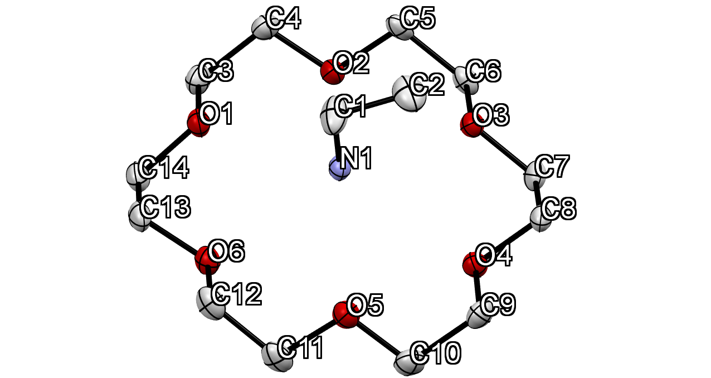

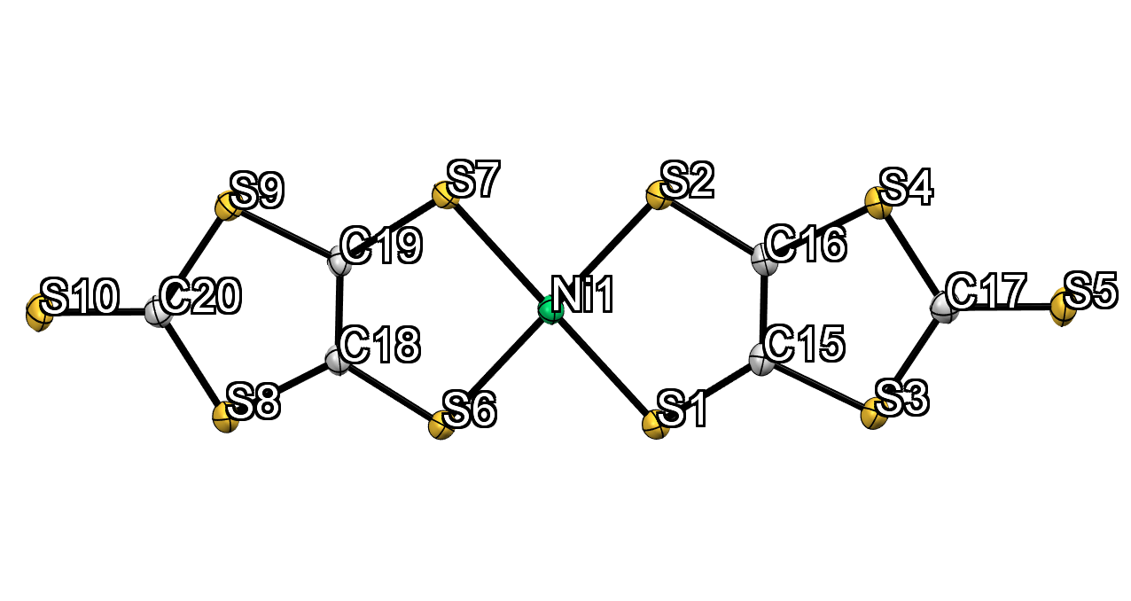**Figure S1.** Crystallographically independent molecules in the crystal **1** at 113 K with atomic numbers. Crystallographically independent molecular structure is depicted as ORTEP with 50% thermal ellipsoids probability level. Hydrogen atoms are omitted for clarity.

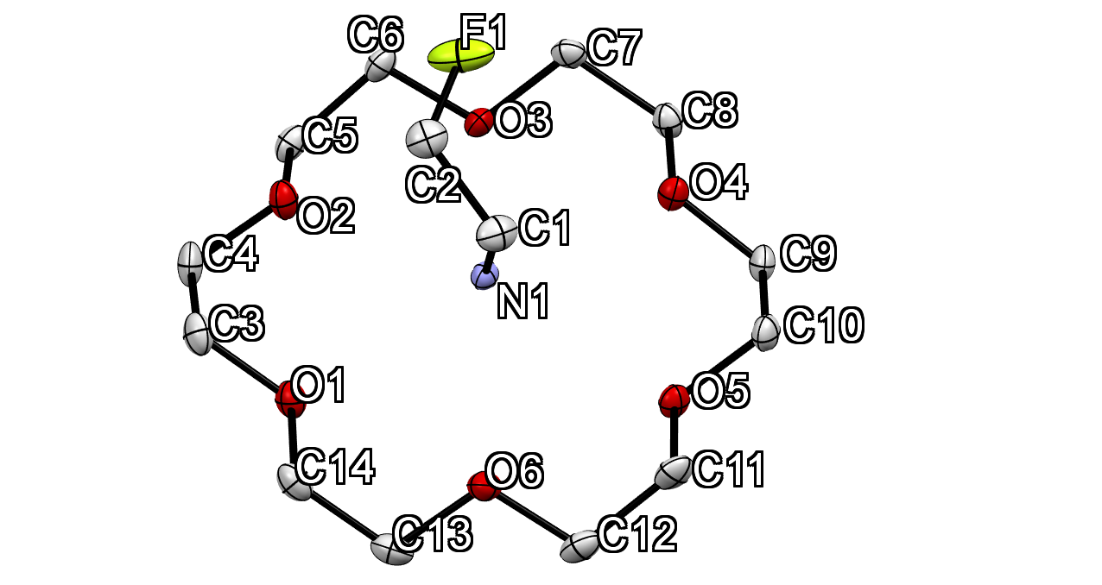

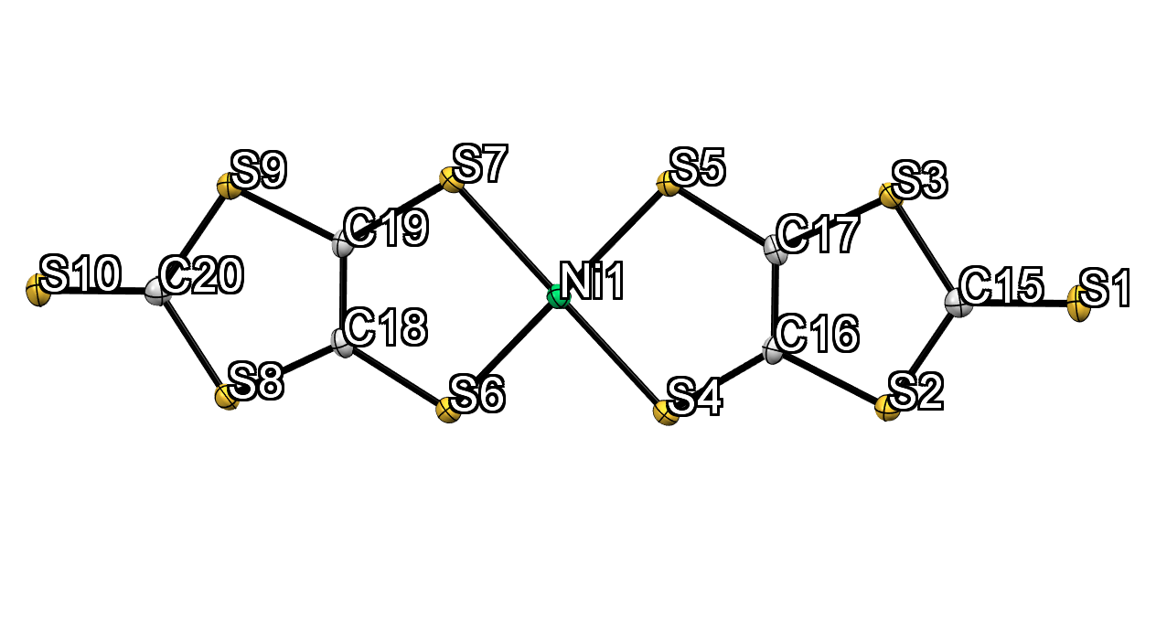

**Figure S2.** Crystallographically independent molecules in the crystal **2** at 93 K with atomic numbers. The structure is depicted as ORTEP with 50% probability. Hydrogen atoms are omitted for clarity.

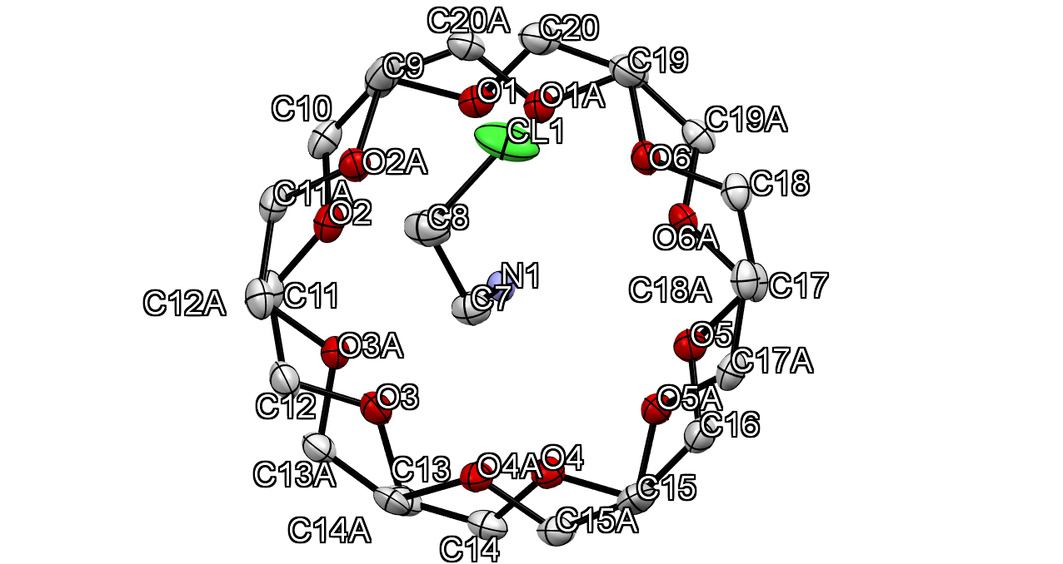

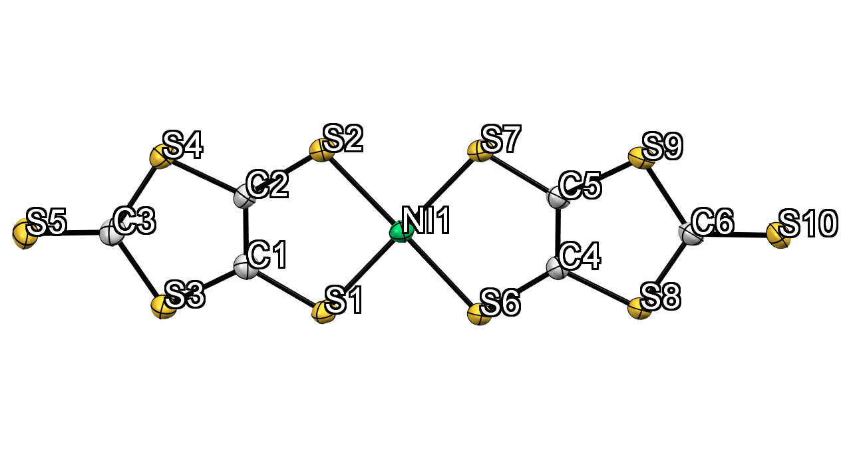

**Figure S3.** Crystallographically independent molecules in the crystal **3** at 93 K with atomic numbers. The structure is depicted as ORTEP with 50% probability. Hydrogen atoms are omitted for clarity.

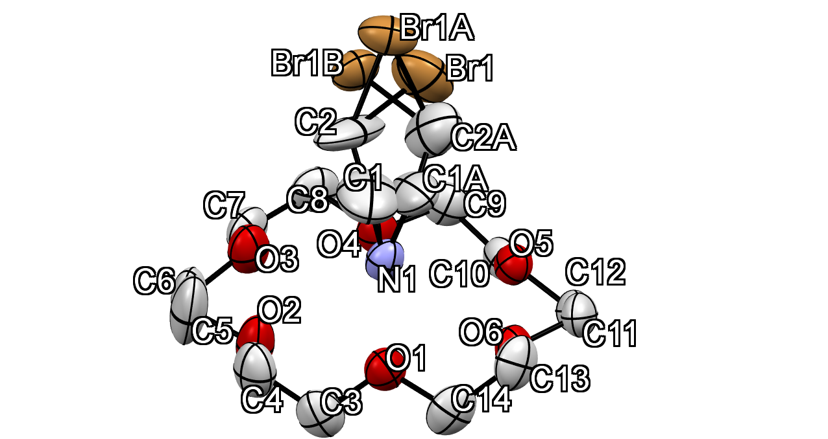

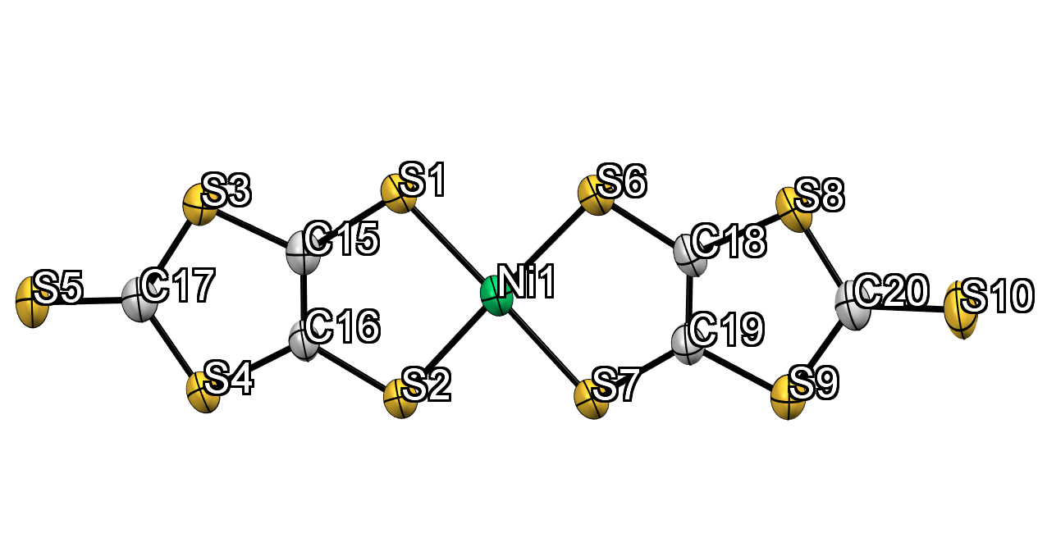

**Figure S4.** Crystallographically independent molecules in the crystal **4** at 293 K with atomic numbers. The structure is depicted as ORTEP with 50% probability. Hydrogen atoms are omitted for clarity.

**§3. Packing structures of crystals 2-4.**

E:\Dropbox\driveE_20191029\STAFF\AssistProf3\学生\蓮尾\dropbox共有201110\report-18C6\原稿\Figs\図S1.tif

**Figure S5.** Packing structures of crystals **2**, **3** and **4** viewed along the (a) *c*, (c) c and (e) *b* axis, respectively. 2D arrangement of supramolecular cations for crystals **2**, **3** and **4** viewed along the (b) *b*, (d) b and (f) *c* axis, respectively. Dotted square encircles the 1D arrangement of supramolecular cations. Hydrogen atoms are omitted for clarity except the atoms connected to nitrogen atom. Sulfur, carbon, and nickel atoms in [Ni(dmit)2] colored as yellow, grey, and green, respectively. Yellow X-C2-NH3 and blue [18]crown-6, and red X-C2-NH3 and green [18]crown-6 is supramolecular cation unit and the two unit form supramolecular cation pair.

**§4. Detailed analysis of structures of crystal 1-4.**

**Table S6.** Intermolecular interaction between supramolecular cations and density of the crystals at the lowest temperatures.

|  |  |  |  |  |
| --- | --- | --- | --- | --- |
| Crystals | *a*Interaction | Å | *bd*c•••c / Å | *D*calc / g cm3 |
| **1** | C-H•••O | 3.595(2) | 3.726 | 1.590 |
| **2** | C-H•••O | 3.633(2) | 3.745 | 1.671 |
| **3** |  |  | 3.782 | 1.638 |
| **4** | C-H•••O | 3.468(3), 3.477(4) | 3.635 | 1.748 |

*a* Intermolecular interaction between the neighboring supramolecular cations. Instead of H•••O distance, distance of C•••O was used for C-H•••O interaction. Distance of weak hydrogen bonding is in the range of 3.2-4.0 Å between hydrogen-bonded donor•••acceptor atoms.

*b* Distance between two plane of neighboring [18]crown-6. The plane of [18]crown-6 used by six oxygen atom in [18]crown-6.

**§5. Temperature- and frequency-dependent dielectric constants for crystals 1-4**



**Figure S6.** Temperature- and frequency-dependent real part of dielectric constant (*ε*1) and tangent delta for crystal **1**.



**Figure S7.** Temperature- and frequency-dependent real part of dielectric constant (*ε*1) and tangent delta for crystal **2**.



**Figure S8.** Temperature- and frequency-dependent real part of dielectric constant (*ε*1) and tangent delta for crystal **3**.

**§6. Transfer integrals between [Ni(dmit)2]– molecules in crystals 1-4.**



**Figure S9.** Transfer integral between [Ni(dmit)2]– anions in crystals (a) **1**, (b) **2**, (c) **3**, and (d) **4**. *t*1 corresponds to the transfer integrals between the intradimer [Ni(dmit)2]– anions, whereas *t*2 and *t*3 are transfer integrals between interdimer [Ni(dmit)2] anions.