**Supporting Information**

**The role of cobalt oxide or magnesium oxide in ozonation of ammonia nitrogen in water**

Philip Anggo Krisbiantoroa, Tomokazu Togawaa, Lina Mahardianib, Haruka Aiharaa, Ryoichi Otomoc,Yuichi Kamiyac,*

a *Graduate School of Environmental Science, Hokkaido University, Nishi 5, Kita 10, Kita-ku Sapporo 060-0810, Japan*

b *Department of Chemistry Education, Faculty of Teacher Training and Education, Sebelas Maret University, Jl. Ir. Sutami 36A Surakarta, Central Java 57126, Indonesia*

c *Faculty of Environmental Earth Science, Hokkaido University, Nishi 5, Kita 10, Kita-ku Sapporo 060-0810, Japan*

*Corresponding author: Prof. Yuichi Kamiya

Email: kamiya@ees.hokudai.ac.jp

TEL: +81 11 706 2217



**Fig. S1.** Time course in the concentrations of (□) NH4+ and (●) Cl– in the reaction solution for ozonation of ammonia nitrogen in **Sol**(Cl) over Co3O4. Reaction conditions: Co3O4, 0.1 g; 10 mmol L–1 NH4Cl, 100 mL; O3/O2 flow rate, 100 mL min–1; concentration of O3, 0.7 vol%; reaction temperature, 333 K.



**Fig. S2.** Changes in the concentration of ClO– in the reaction solution for the reaction of Cl– with O3 (○) in the presence and (●) absence of Co3O4. Reaction conditions: Co3O4, 0.1 g; 10 mmol L–1 NaCl, 100 mL; O3/O2 flow rate, 100 mL min–1; concentration of O3, 0.7 vol%; reaction temperature, 333 K.

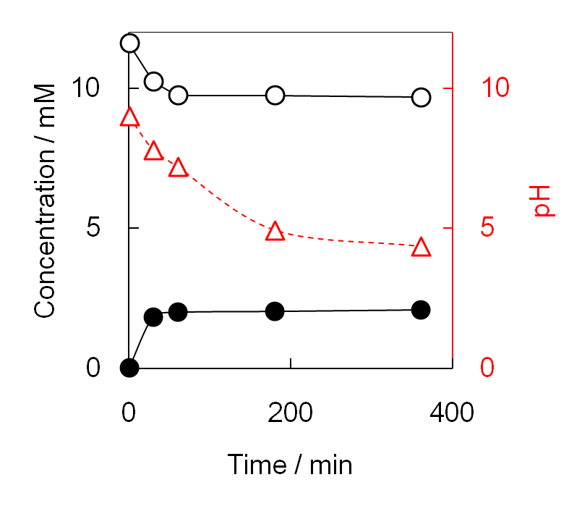

**Fig. S3.** Ozonation of ammonia nitrogen in **Sol**(SO4) in the absence of MgO without pH restoration during the reaction. Concentrations of (○) ammonia nitrogen and (●) NO3–, and (△) pH of the reaction solution. Reaction conditions: 10 mmol L–1 NH4+, 100 mL; initial pH of the reaction solution, 9.0; O3/O2 flow rate, 100 mL min–1; concentration of O3, 0.7 vol%; reaction temperature, 333 K.

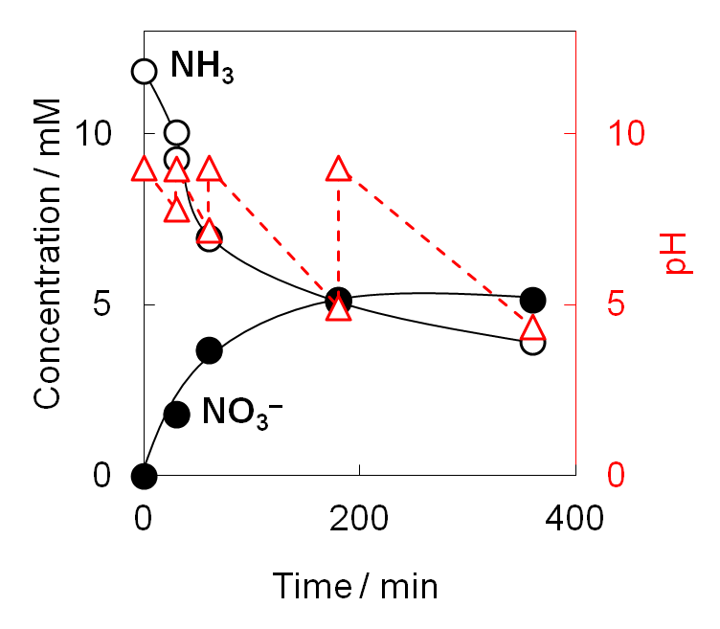

**Fig. S4.** Ozonation of ammonia nitrogen in **Sol**(SO4) in the absence of MgO with pH restoration during the reaction. The pH of the reaction solution was repeatedly restored to 9.0 by the addition of aqueous KOH solution at each sampling time. Concentrations of (○) ammonia nitrogen and (●) NO3–, and (△) pH of the reaction solution. Reaction conditions: 10 mmol L–1 NH4+, 100 mL; initial pH of the reaction solution, 9.0; O3/O2 flow rate, 100 mL min–1; concentration of O3, 0.7 vol%; reaction temperature, 333 K.