Supplementary information
- Materials and methods
  - Standards and reagents
We targeted 10 phthalate metabolites: mono-n-butyl phthalate (MnBP), mono-isobutyl phthalate (MiBP), mono-benzyl phthalate (MBzP), the DEHP metabolites mono (2-ethylhexyl) phthalate (MEHP), mono (2-ethyl-5-hydroxyhexyl) phthalate (MEHHP), mono (2-ethyl-5-oxohexyl) phthalate (MEOHP), mono (2-ethyl-5-carboxypentyl) phthalate (MECPP), the DINP metabolites mono-isononyl phthalate (MiNP), mono-hydroxy-isononyl phthalate (OH-MiNP), and mono-carboxy-isononyl phthalate (cx-MiNP). The selection was based on a literature survey of major presences in the environment and health risks of their parent compounds. Individual native phthalate metabolites MiBP, MnBP, MBzP, MEHP, MEHHP, MEOHP, MECPP, and MiNP and their isotopically labeled standards D₄-MiBP, ¹³C₄-MnBP, ¹³C₄-MBzP, ¹³C₄-MEHP, ¹³C₄-MEHHP, ¹³C₄-MEOHP, ¹³C₄-MECPP, and ¹³C₄-MiNP with purity > 99.9% were purchased from Cambridge Isotope Laboratories, Inc. (Andover, MA, USA). Native standard mono-(4-methyl-7-hydroxyoctyl) phthalate (7OH-MMeOP) and mono-(4-methyl-7-carboxyheptyl) phthalate (7cx-MMeHP) and their isotope-labeled internal standards D₄-7OH-MMeOP and D₄-7cx-MMeHP, respectively, were purchased from Institut für Dünnschichttechnologie und Mikrosensorik e.V. (Teltow, Germany) (Supplemental Table 1). LCMS-grade ultra-pure water, methanol, ammonium bicarbonate, acetic acid, and formic acid were purchased from Wako Pure Chemical Industries, Ltd. (Osaka, Japan). Nitric acid was obtained from Kanto Chemicals, Co., Inc. (Tokyo, Japan). Ammonium acetate was purchased from Sigma-Aldrich Co., Ltd. (St. Louis, MO, USA). β-Glucuronidase (Escherichia coli-K12) was purchased from Roche Diagnostics GmbH (Mannheim, Germany). Solid phase extraction (SPE) Oasis Max 96-well plate (30 mg of polymer, 30 µm particles) was purchased from Waters Corporation (Milford, MA, USA).
  - Urine sample collection and preparation
Parents of children were asked to collect the first morning void urine samples of their children in a polypropylene tube and sent to Hokkaido University, Center for Environmental and Health Sciences using a cool delivery service. When the shipped urine samples arrived at our center creatinine content was measured using an enzyme-linked immunosorbent assay at SRL, Inc. (Tokyo, Japan). On the same day urine samples were transferred to stoppered glass tubes cleaned with acetone, sealed with fluoric tape, wrapped with aluminum foil, and kept at –30 °C until the day of analysis. On the day of analysis urine samples were thawed, and 500-μL urine samples were buffered with 100-mM ammonium acetate (pH 6.5) and spiked with 20 μL of internal standard (D₄-7cx-MMeHP: 500 ng/mL; ¹³C₄-MBzP, ¹³C₄-MEHP, ¹³C₄-MEHHP, ¹³C₄-MEOHP, ¹³C₄-MECPP, ¹³C₄-MiNP, D₄-7OH-MMeOP: 1000 ng/mL; D₄-MiBP, ¹³C₄-MnBP: 2000 ng/mL) solution. Then, 50 μL of β-glucuronidase was added to the samples and incubated for 90 min at 37 °C. After incubation, 0.5 % ammonia water was added to each sample. After this, samples extraction was performed using solid phase extraction (SPE) that was previously conditioned to activate the stationary phase with 1 mL of 0.05 % nitric acid in 90 % methanol, 1 mL of methanol, and then with 1 mL of 0.5 % ammonia water. Then samples were loaded onto conditioned SPE cartridge and sequentially washed with 0.5 mL ultrapure water, 0.5 mL methanol, 0.5 mL ultrapure water, and 0.5 mL of 40 % methanol containing 0.2 % formic acid. The target phthalate metabolites on the cartridge were extracted using 90 % methanol containing 0.2% formic acid. The extracted mixture of 250 μL was transferred to a vial and diluted with 750 μL of ultrapure water. Finally, 40 μL of sample from the vial was injected onto UPLC-MS/MS (ACQUITY UPLC H-class equipped with Xevo TQ-S micro mass spectrometer from Waters Corporation, Milford, MA, USA) to quantify phthalate metabolites.
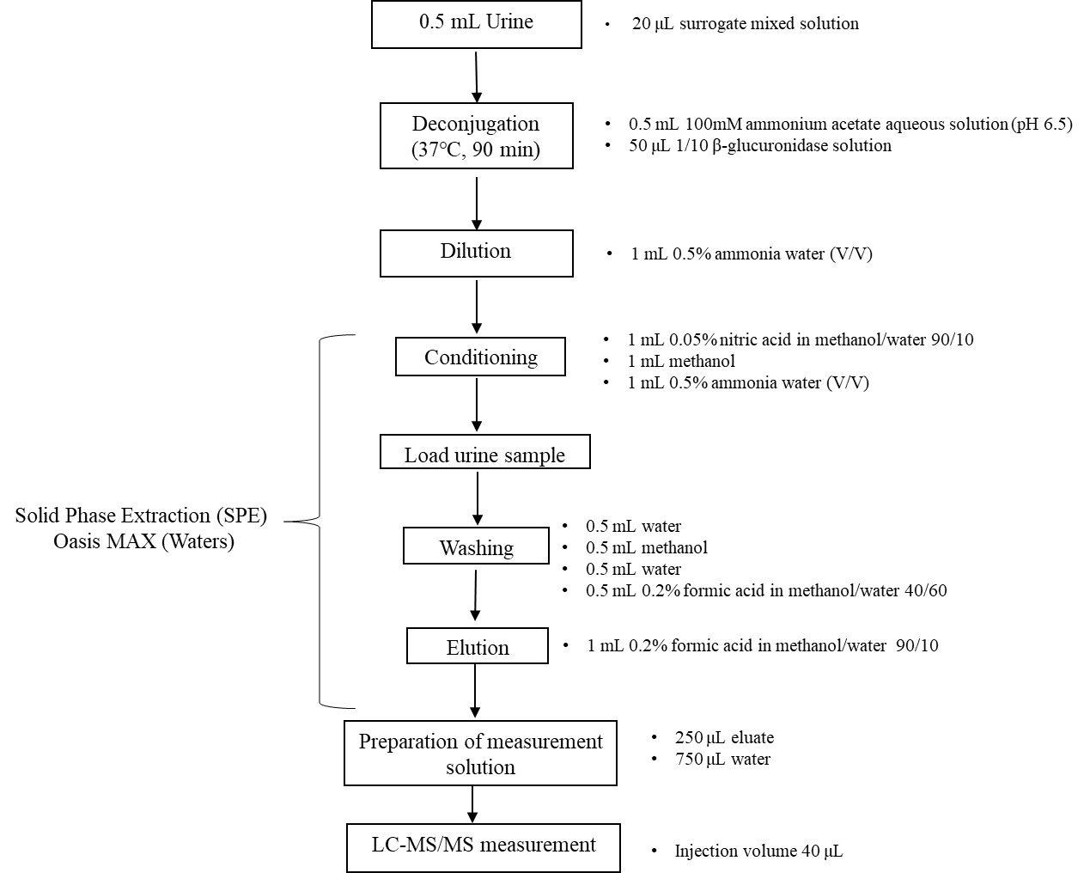
Supplemental Figure 1: Sample preparation procedure for urinary phthalate metabolites

  - Instrumental analysis
The phthalate metabolites were quantified using Waters ACQUITY UPLC H-class equipped with Xevo TQ-S micro mass spectrometer (Waters Corporation, Milford, MA, USA). Chromatographic separation was achieved using an Acquity UPLC charged surface hybrid (CSH) Phenyl-Hexyl column (Waters; 1.7 µm, 2.1 mm × 100 mm). The mobile phase was constituted of 5 mM ammonium bicarbonate in Milli-Q water (A) and 5 mM ammonium bicarbonate in 95% methanol (B). The ultra-performance liquid chromatography tandem mass spectrometry (UPLC-MS/MS) analysis was performed in a negative ion electrospray ionization mode, and target compounds were determined by multiple-reaction monitoring (MRM). Detailed information including instruments, chromatographic conditions, and mass spectrometric conditions can be found in the Supporting Information (Supplemental Table 2 and 3).
  - Quality assurance
For each batch, two procedural blanks were analyzed to control the background contamination. For all target analytes, 12 calibration points ranging 0–20 ng/mL were used to construct calibration curves. A satisfactory correlation coefficient of calibration curves ≥ 0.998 was obtained for all measured metabolites. Additionally, external quality assurance of the German external quality assessment scheme (G-EQUAS) confirmed the proficiency of the method within the range for MiBP, MnBP, MBzP, MEHP, MECPP, MEOHP, and MEHHP (Supplemental Table 5). In each batch of 20 samples, replicated analysis of the calibration standard at a concentration of 5 ng/mL and reference value 63 G-EQUAS samples with known concentrations were conducted to determine both inter- and intra-day precision and were within acceptable limits with a coefficient of variation < 10%. The limits of detection (LOD) and limits of quantification (LOQ) of individual phthalate metabolites were determined based on the standard deviation (SD) of repeated analysis (n=7) of the spiked ultra-pure water with 0.16 ng/mL for MEOHP, 7OH-MMeOP, and 7cx-MMeHP; 0.32 ng/mL for MEHP, MiNP, MEHHP, and MECPP; 0.8 ng/mL for MBzP; and 1.6 ng/mL for MiBP and MnBP, according to the following formula: LOD = 2 × t (n-1, 0.05) × standard deviation (SD) and LOQ = 10 × SD. The LOD and LOQ of metabolites ranged 0.05–0.95 ng/mL and 0.13–2.5 ng/mL, respectively (Table 2). The recovery percentage of ¹³C₄- and D₄-labeled internal standards spiked on pooled urine samples ranged 81–120%. The detailed quality assurance (QA)/quality control (QC) results are shown in Supplemental Table 4.

Supplemental Table 1. Parent phthalates with native and internal isotope labeled standards for metabolites

Parent phthalates | Abbr | Native standards | Abbr | Internal standard | M. Wt (g/mol)
Di-butyl phthalate | DBP | Mono-isobutyl phthalate | MiBP | ¹³C₄-MiBP | 222.24
 |  | Mono-n-butyl phthalate | MnBP | ¹³C₄-MnBP | 222.24
Butyl benzyl phthalate | BBzP | Mono-benzyl phthalate | MBzP | ¹³C₄-MBzP | 256.25
Di(2-ethylhexyl) phthalate | DEHP | Mono(2-ethylhexyl) phthalate | MEHP | ¹³C₄-MEHP | 278.34
 |  | Mono(2-ethyl-5-oxohexyl) phthalate | MEOHP | ¹³C₄-MEOHP | 292.33
 |  | Mono(2-ethyl-5-hydroxyhexyl) phthalate | MEHHP | ¹³C₄-MEHHP | 294.34
 |  | Mono(2-ethyl-5-carboxypentyl) phthalate | MECPP | ¹³C₄-MECPP | 308.33
Di-isononyl phthalate | DINP | Mono-isononyl phthalate | MiNP | D₄-MiNP | 292.40
 |  | Mono-(4-methyl-7-hydroxyoctyl) phthalate | 7OH-MMeOP | D₄-7OH-MMeOP | 308.37
 |  | Mono-(4-methyl-7-carboxyheptyl) phthalate | 7cx-MMeHP | D₄-7cx-MMeHP | 322.35
Abbr: Abbreviation; M. Wt: Molecular weight

Supplemental Table 2. Parameters of analysis condition of LC-MS/MS for determination of phthalate metabolites.
Parameters |  |  |  | Conditions
LC |  |  |  | ACQUITY UPLC H-class
Analytical column |  |  |  | CSH Phenyl Hexyl column (Waters, 2.1 x 100mm, 1.7 µm)
Guard column |  |  |  | CSH Phenyl Hexyl (Waters, 2.1 x 5 mm,1.7µm)
Retention gap column |  |  |  | Atlantis T3 (Waters, 2.1 x 50 mm, 3µm)
Column temperature |  |  |  | 40 ^{º}C
MS/MS |  |  |  | Xevo TQ-S micro tandem quadrupole:
MS mode |  |  |  | Multiple Reactions Monitoring (MRM)
Ionization mode |  |  |  | Electrospray in negative mode (ESI - Negative)
Mobile phase A |  |  |  | 5 mM Ammonium bicarbonate in water
Mobile phase B |  |  |  | 5 mM Ammonium bicarbonate in 95 % Methanol
Mobile phase C |  |  |  | Methanol
Flow rate |  |  |  | 0.25 mL/min
Injection volume |  |  |  | 40 µL
Total run time |  |  |  | 30 minutes
Gradient | Time (min) | 0 | 0.5 |  | 1 | 10 | 11 | 15 | 15.1 | 23 | 23.1 | 30
 | A (%) | 90 | 90 |  | 70 | 65 | 55 | 52.5 | 35 | 25 | 90 | 90
 | B (%) | 10 | 10 |  | 30 | 35 | 45 | 47.5 | 65 | 72.5 | 10 | 10
 | C (%) | 0 | 0 |  | 0 | 0 | 0 | 0 | 0 | 2.5 | 0 | 0
LC: Liquid chromatography; UPLC: Ultra-performance liquid chromatography MS: Mass spectrometry;
QSM: Quaternary Solvent Manager; CSH: Charged Surface Hybrid

Supplemental Table 3. MRM parameters of ten phthalate metabolites and their isotopically labeled internal standards with instrument conditions.
Native Compounds | Quantification Ion | Confirmation Ion 1 | Confirmation Ion 2 | Quantification Ion |  | Confirmation Ion
 | Precursor/Product | Precursor/Product | Precursor/Product | Cone (V) | Collision (eV) | Cone (V) | Collision (eV)
MiBP | 220.82 > 76.93 | 220.82 > 133.98 |  | 15 | 19 | 15 | 12
MnBP | 220.82 > 76.93 | 220.82 > 76.93 |  | 10 | 17 | 10 | 14
MBzP | 254.79 > 76.86 | 254.79 > 104.42 |  | 10 | 21 | 10 | 15
MEHP | 277.05 > 133.91 | 277.05 > 126.95 |  | 9 | 14 | 9 | 18
MEOHP | 290.98 > 143.03 | 290.98 > 120.89 |  | 18 | 12 | 18 | 16
MEHHP | 292.93 > 145.03 | 292.93 > 120.88 |  | 10 | 13 | 10 | 18
MECPP | 306.98 > 158.98 | 306.98 > 112.87 |  | 9 | 11 | 9 | 29
MiNP | 291.15 > 141.07 | 291.15 > 76.99 |  | 18 | 17 | 18 | 25
7OH-MMeOP | 307.27 > 120.95 | 307.27 > 159.10 | 307.27 > 76.99 | 18 | 18 | 18 | 16
7cx-MMeHP | 321.00 > 173.04 | 321.00 > 120.95 | 321.00 > 76.93 | 15 | 16 | 15 | 25
Labeled internal standards
MiBP-d₄ | 224.82 > 80.96 | 224.82 > 138.00 |  | 15 | 19 | 15 | 12
MnBP-¹³C₄ | 224.76 > 71.00 | 224.76 > 78.95 |  | 10 | 17 | 10 | 14
MBzP-¹³ C₄ | 258.84 > 106.95 | 258.41 > 76.41 |  | 10 | 21 | 10 | 15
MEHP-¹³C₄ | 281.09 > 136.91 | 281.09 > 127.20 |  | 9 | 14 | 9 | 15
MEOHP-¹³C₄ | 294.84 > 143.02 | 294.84 > 123.88 |  | 18 | 12 | 18 | 16
MEHHP-¹³C₄ | 296.73 > 123.88 | 296.73 > 145.04 |  | 10 | 13 | 10 | 18
MECPP-¹³C₄ | 310.97 > 159.04 | 310.97 > 113.01 |  | 9 | 11 | 9 | 29
MiNP-¹³C₄ | 294.70 > 141.13 | 294.70 > 78.95 |  | 18 | 17 | 18 | 25
D4-7OH-MMeOP | 311.21 > 124.98 | 311.21 > 159.09 |  | 18 | 18 | 18 | 16
D4-7cx-MMeHP | 325.06 > 173.09 | 325.06 > 124.98 |  | 15 | 16 | 15 | 25
Due to multiple presence of DiNP isomers and their oxidized metabolites, we assumed other oxidized isomers of 7OH-MMeOP and 7cx-MMeHP based on mass fragments, which have been reported that same fragments have shown in oxidized isomers of DiNP (Koch et al., 2007). Metabolite concentrations in the following are depicted as cx-MiNP (based on 7cx-MMeHP) and OH-MiNP (based on 7OH-MMeOP).
Supplemental Table 4: Summary of method validation and quality control results
Metabolites | Retention window (min) | R² | IDL (ng/mL) | IS  recovery % | CV  % | Native recovery % | CV% | LOD (ng/mL) | LOQ (ng/mL) | Inter-day mean (ng/mL) | CV % | Intra-day mean (ng/mL) | CV %
MiBP | 7:0 - 8:2 | 0.998 | 0.03 | 99 | 4.5 | 92 | 8.0 | 0.95 | 2.5 | 5.2 | 5.7 | 5.1 | 2.7
MnBP | 7:5 - 8:5 | 0.999 | 0.04 | 100 | 5.5 | 91 | 8.6 | 0.78 | 2.02 | 5.0 | 5.1 | 5.0 | 1.7
MBzP | 10:0 - 10:4 | 0.999 | 0.02 | 89 | 2.7 | 100 | 6.1 | 0.1 | 0.26 | 4.9 | 5.8 | 5.0 | 3.1
MEHP | 21:0 - 21:3 | 0.999 | 0.01 | 86 | 3.6 | 96 | 4.8 | 0.15 | 0.39 | 4.9 | 5.3 | 4.9 | 0.9
MEOHP | 10:3 - 11:0 | 0.999 | 0.01 | 93 | 3.8 | 97 | 5.9 | 0.05 | 0.15 | 5.0 | 6.7 | 5.1 | 2.2
MEHHP | 11:3 - 12:1 | 0.999 | 0.02 | 86 | 5.7 | 96 | 7.5 | 0.15 | 0.25 | 5.0 | 5.6 | 5.0 | 1.1
MECPP | 4:0 - 5:0 | 0.999 | 0.01 | 113 | 2.4 | 97 | 8.2 | 0.12 | 0.38 | 4.9 | 5.4 | 5.0 | 1.7
MiNP | 21:1 - 22:0 | 0.999 | 0.01 | 83 | 3.9 | 95 | 4.9 | 0.09 | 0.31 | 5.0 | 5.6 | 5.0 | 1.7
OH-MiNP | 15:1 - 16:3 | 0.999 | 0.01 | 86 | 6.6 | 108 | 6.1 | 0.05 | 0.13 | 5.3 | 4.9 | 5.3 | 1.3
cx-MiNP | 7:3 - 10:0 | 0.999 | 0.01 | 94 | 6.0 | 91 | 5.5 | 0.11 | 0.33 | 4.8 | 7.4 | 4.8 | 1.6
R² : Correlation Coefficient; IDL: Instrument detection limit; ng/mL: nanogram per milliliter; IS (Internal standard) mean recovery % based on 10 repeats of standard spiked in pooled children urine; native mean recovery % based on 10 repeats of individual native metabolites spiked in pooled children urine; CV: coefficient of variation; LOD: Limit of detection; LOQ: Limit of quantification; Inter-/ Intra-day precision were based on 4 replicates of the standard at a concentration of 5 ng/mL.

Supplemental Table 5: Sensitivity analysis of this study popula9tion demographic and building characteristics with sub-cohort participants
 |  | Total (N= 386) | Sub-cohort (N=243)
Gender | Boys | 203 (52.6) | 115 (47.3)
 | Girls | 183 (47.4) | 128 (52.7)
Height | cm | 119.8 (102.0-150.0) | 119.2 (115.8 - 121.7)
Weight | Kg | 22.0 (14.8-42.3) | 21.7 (20.0 - 24.0)
Urine sample collection year | 2012 | 62 (16.1) | 39 (16.0)
 | 2013 | 65 (16.8) | 43 (17.7)
 | 2014 | 54 (14.0) | 34 (13.9)
 | 2015 | 74 (19.1) | 48 (19.7)
 | 2016 | 86 (22.2) | 47 (19.3)
 | 2017 | 45 (11.6) | 32 (13.1)
Annual household income (JPY) | < 3 Million | 48 (12.4) | 28 (12.2)
 | ≥ 3 Million | 321 (83.2) | 201 (87.8)
Number of residents | ≤4 | 251 (65.0) | 153 (63.0)
 | ≥5 | 135 (35.0) | 90 (37.0)
Home type | Detached | 269 (70.0) | 170 (69.9)
 | Apartment | 116 (30.0) | 73 (30.1)
House structure | Wooden | 269 (69.5) | 169 (70.0)
 | Concrete | 114 (29.5) | 72 (30.0)
Renovation within the past 1 year | Yes | 22 (5.7) | 13 (5.3)
 | No | 364 (94.3) | 230 (94.7)
Mechanical ventilation system in living and/or child room | Yes | 229 (59.3) | 149 (61.3)
 | No | 157 (40.7) | 94 (38.7)
Use of insecticide | Yes | 125 (32.4) | 80 (32.9)
 | No | 261 (67.6) | 163 (67.1)
PVC flooring | Yes | 65 (16.9) | 45 (18.5)
 | No | 321 (831) | 198 (81.5)
PVC wall material | Yes | 310 (80.3) | 198 81.4)
 | No | 76 (19.7) | 45 (18.6)
Vacuum cleaning/week | ≤3 times | 199 (54.8) | 114 (50.8)
 | 4-7 times | 164 (45.2) | 10 (49.2)
Duration of window opening/day | <1 hour | 247 (64.0) | 158 (65.0)
 | ≥1 hour | 139 (36.0) | 85 (35.0)
Main road | < 50 meters | 75 (19.5) | 40 (16.5)
 | No or ≥ 50 meters | 310 (80.5) | 202 (83.5)
Building age (years) | Continuous | 13 (<1- 50) | 12 (7 - 22)
Dampness index (0-5) | Continuous | 2 (1 - 5) | 2 (1 - 2)

Supplemental Table 6: Sensitivity analysis of distribution of urinary phthalate metabolite concentrations in 7 years old children with sub-cohort participants
Metabolites (ng/mL) | Total (N= 386) | Sub-cohort (N=243)
MiBP | 12.1 (7.1- 27.4) | 11.8 (7.2 - 25.2)
MnBP | 35.1 (20.7 - 58.8) | 33.6 (20.5 - 56.0)
MBzP | 1.5 (0.7 - 3.5) | 1.4 (0.7 - 3.2)
MEHP | 4.1 (2.7 - 7.0) | 3.9 (2.3 - 7.2)
MEOHP | 20.5 (12.3 -33.2) | 20.4 (11.4 - 32.8)
MEHHP | 26.7 (16.4 - 43.8) | 26.1 (15.6 - 43.5)
MECPP | 38.4 (23.3 - 67.1) | 37.2 (20.2 - 64.7)
MiNP | 0.6 (0.4 -1.2) | 0.6 (0.3 - 1.1)
OH-MiNP | 4.1 (2.2 - 7.5) | 3.8 (2.1 - 7.2)
cx-MiNP | 2.4 (1.3 - 4.6) | 2.3 (1.3 - 4.6)
∑DEHP ª (µmol/L) | 0.29 (0.18 - 0.49) | 0.29 (0.17 - 0.49)
∑DINP ^{b} (µmol/L) | 0.02 (0.01 – 0.05) | 0.02 (0.0.01 - 0.04)
Creatinine corrected (µg/g Cr)
MiBP | 13.3 (8.4 - 25.0) | 13.0 (8.3 - 23.9)
MnBP | 39.1 (26.3 - 59.2) | 36.1 (26.3 - 58.2)
MBzP | 1.7 (0.7 - 3.9) | 1.4 (0.7 - 3.4)
MEHP | 4.5 (2.9 - 7.4) | 4.4 (2.9 - 7.6)
MEOHP | 22.4 (14.9 - 32.5) | 21.3 (13.9 - 31.2)
MEHHP | 28.7 (19.3 - 43.7) | 27.8 (19.2 - 42.2)
MECPP | 42.8 (27.0 - 68.5) | 42.0 (26.8 - 62.7)
MiNP | 0.7 (0.4 - 1.3) | 0.7 (0.4 - 1.2)
OH-MiNP | 4.5 (2.8 - 7.4) | 4.3 (2.7 - 7.2)
cx-MiNP | 2.7 (1.6 - 4.9) | 2.7 (1.5 - 4.8)
∑DEHP ª (µmol/L Cr) | 0.34 (0.22 - 0.51) | 0.32 (0.21 – 0.48)
∑DINP ^{b} (µmol/L Cr) | 0.02 (0.01 - 0.03) | 0.02 (0.01 – 0.04)
Data are expressed as median and interquartile range (IQR).
ª ΣDEHP: sum of molar concentrations metabolites [MEHP + MEOHP + MEHHP + MECPP]
^{b} ΣDINP: sum of molar concentrations metabolites [MiNP + OH-MiNP + cx-MiNP]
Abbreviations; LOD: Limit of detection; Max: maximum; Min: minimum; P: percentiles; n.a: not applicable; MiBP: mono-isobutyl phthalate, MnBP: mono-n-buty phthalate, MBzP: mono-benzyl phthalate, MEHP: mono (2-ethylhexyl) phthalate, MEOHP: mono (2-ethyl-5-oxohexyl) phthalate, MEHHP: mono (2-ethyl-5-hydroxyhexyl) phthalate, MECPP: mono (2-ethyl-5-carboxypentyl) phthalate, MiNP: mono-isononyl phthalate, OH-MiNP: mono-hydroxy-isononyl phthalate, cx-MiNP: mono(carboxy-isononyl phthalate).

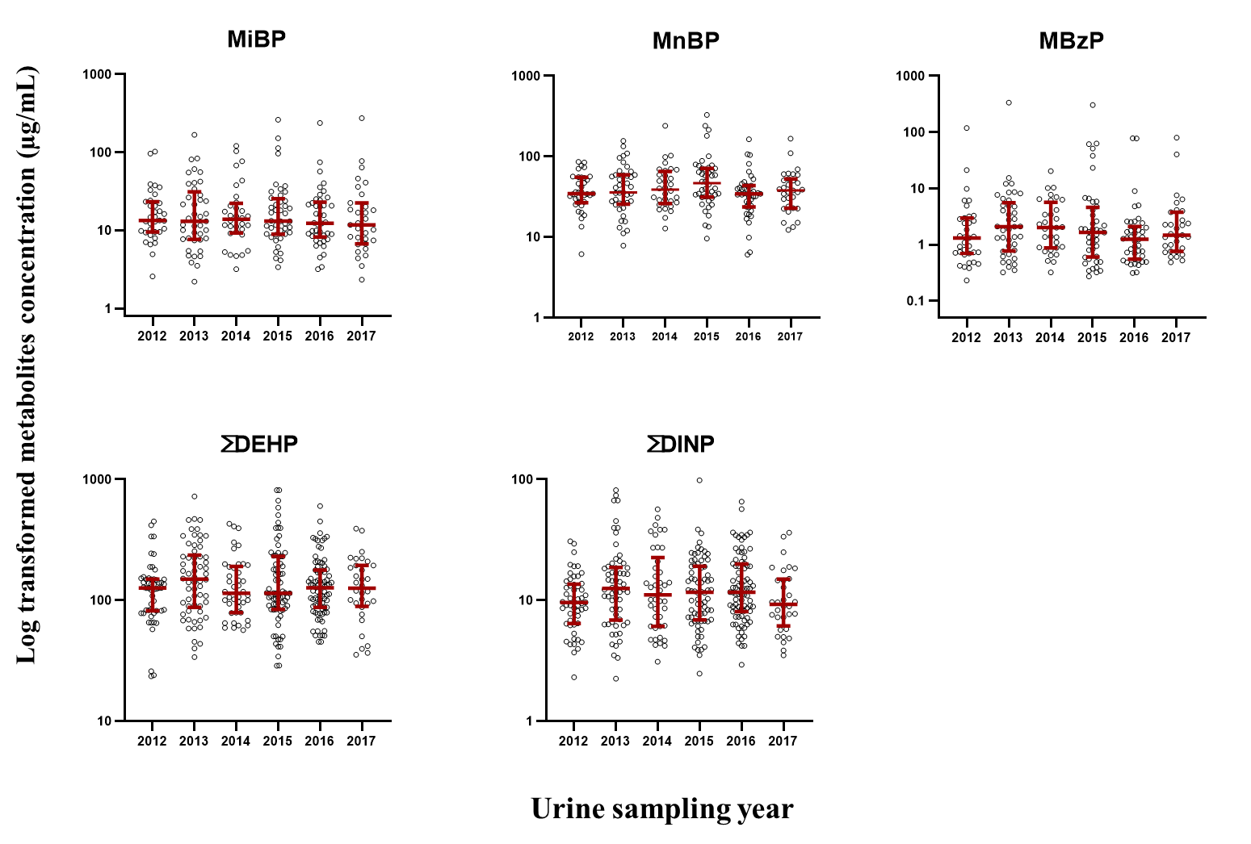

Supplemental figure 2: Sensitivity analysis of sub-cohort participants natural log transformed creatinine corrected concentration level of urinary phthalate metabolites. Bars represent interquartile ranges and median.

Supplemental Table 7: Spearman’s correlations of ten phthalate metabolites analyses (μg/g creatinine).
 | MiBP | MnBP | MBzP | MEHP | MEOHP | MEHHP | MECPP | MiNP | OH-MiNP | cx-MiNP
MiBP | 1 | 0.079*** | 0.015*** | 0.140*** | 0.250*** | 0.233*** | 0.235*** | 0.077*** | 0.133*** | 0.057***
MnBP |  | 1.000 | 0.061*** | 0.122*** | 0.155*** | 0.147*** | 0.135*** | 0.035*** | 0.039*** | 0.044***
MBzP |  |  | 1.000 | 0.091*** | 0.135*** | 0.112*** | 0.093*** | 0.319*** | 0.276*** | 0.220***
MEHP |  |  |  | 1.000 | 0.703*** | 0.710*** | 0.686*** | 0.540*** | 0.369*** | 0.306***
MEOHP |  |  |  |  | 1.000 | 0.966*** | 0.936*** | 0.464*** | 0.534*** | 0.477***
MEHHP |  |  |  |  |  | 1.000 | 0.949*** | 0.502*** | 0.582*** | 0.509***
MECPP |  |  |  |  |  |  | 1.000 | 0.454*** | 0.557*** | 0.548***
MiNP |  |  |  |  |  |  |  | 1.000 | 0.827*** | 0.693***
OH-MiNP |  |  |  |  |  |  |  |  | 1.000 | 0.863***
Statistical significance *** p value of <0.001

Supplemental Table 8: Seasonal variation of phthalate metabolites level in children
 | Season | 25% | Median | 75% | p value
MiBP | Winter | 7.55 | 13.07 | 21.97 | 0.115
 | Spring | 9.43 | 15.86 | 38.90
 | Summer | 9.61 | 15.86 | 26.38
 | Autumn | 6.64 | 11.59 | 23.56
MnBP | Winter | 24.58 | 40.17 | 59.14 | 0.121
 | Spring | 30.09 | 45.67 | 68.10
 | Summer | 27.99 | 38.81 | 60.28
 | Autumn | 22.54 | 34.21 | 56.76
MBzP | Winter | 0.72 | 1.71 | 4.02 | 0.555
 | Spring | 0.87 | 1.68 | 5.74
 | Summer | 0.73 | 1.73 | 3.38
 | Autumn | 0.71 | 1.39 | 3.72
MEHP | Winter | 2.91 | 4.39 | 7.37 | 0.598
 | Spring | 3.33 | 5.19 | 7.55
 | Summer | 3.07 | 4.38 | 6.87
 | Autumn | 2.85 | 3.93 | 8.31
MEOHP | Winter | 14.63 | 22.38 | 31.06 | 0.613
 | Spring | 17.19 | 24.05 | 34.98
 | Summer | 14.98 | 21.92 | 33.69
 | Autumn | 14.71 | 21.09 | 32.18
MEHHP | Winter | 19.03 | 29.32 | 42.73 | 0.690
 | Spring | 23.09 | 31.76 | 45.89
 | Summer | 19.90 | 28.05 | 42.93
 | Autumn | 18.72 | 26.38 | 45.32
MECPP | Winter | 26.57 | 42.26 | 64.73 | 0.955
 | Spring | 30.40 | 45.00 | 71.72
 | Summer | 27.92 | 39.79 | 73.39
 | Autumn | 26.98 | 44.62 | 67.92
∑DEHP | Winter | 0.21 | 0.34 | 0.51 | 0.822
 | Spring | 0.25 | 0.36 | 0.56
 | Summer | 0.22 | 0.32 | 0.52
 | Autumn | 0.21 | 0.34 | 0.50
MiNP | Winter | 0.50 | 0.76 | 1.40 | 0.880
 | Spring | 0.45 | 0.69 | 1.39
 | Summer | 0.41 | 0.66 | 1.34
 | Autumn | 0.47 | 0.81 | 1.24
OH-MiNP | Winter | 2.96 | 4.50 | 7.29 | 0.931
 | Spring | 2.58 | 3.67 | 7.26
 | Summer | 2.78 | 4.49 | 8.21
 | Autumn | 2.72 | 4.58 | 6.70
cx-MiNP | Winter | 1.68 | 2.83 | 4.81 | 0.200
 | Spring | 1.42 | 2.19 | 3.82
 | Summer | 1.71 | 3.03 | 5.63
 | Autumn | 1.50 | 2.63 | 4.32
∑DINP | Winter | 0.02 | 0.03 | 0.04 | 0.809
 | Spring | 0.01 | 0.02 | 0.04
 | Summer | 0.02 | 0.03 | 0.05
 | Autumn | 0.02 | 0.02 | 0.03
Seasons were categorized as follows: Winter (December - February); spring (March - May); summer (June - August); autumn (September - November). Abbreviations; MiBP: mono-isobutyl phthalate, MnBP: mono-n-buty phthalate, MBzP: mono-benzyl phthalate, MEHP: mono (2-ethylhexyl) phthalate, MEOHP: mono (2-ethyl-5-oxohexyl) phthalate, MEHHP: mono (2-ethyl-5-hydroxyhexyl) phthalate, MECPP: mono (2-ethyl-5-carboxypentyl) phthalate, MiNP: mono-isononyl phthalate, OH-MiNP: mono-hydroxy-isononyl phthalate, cx-MiNP: mono(carboxy-isononyl phthalate).

Supplemental Table 9: Comparison of the published urinary phthalate metabolites median level with the current study (ng/mL)

Country | Urine collection year | Age | N | MiBP | MnBP | MBzP | MEHP | MEOHP | MEHHP | MECPP | MiNP | OH-MiNP | cx-MiNP | References
Japan | 2012-2017 | 7 | 386 | 12.1 | 35.1 | 1.5 | 4.1 | 20.5 | 26.7 | 38.4 | 0.6 | 4.1 | 2.4 | Current study
Japan | 2009-2010 | 7 - 12 | 178 | 47 | <LOD | 16.3 | 19.7 | 51.5 |  | 34.9 |  |  |  | Ait Bamai et al., 2015
Germany | 2014-2017 | 6 - 10 | 736 | 28.8 | 22.4 | 3.2 | 1.5 | 9 | 12.9 | 13.8 |  | 7.9 | 6 | Schwedler et al., 2020
Germany | 2003-2006 | 3 - 14 | 599 | 88.1 | 93.4 | 18.1 | 6.7 | 36.3 | 46 | 61.4 |  | 11 | 12.7 | Becker et al., 2009
USA | 1999-2016 | 6 - 11 | 415 | 11.6 | 15.4 | 10.9 | 1.3 | 6.1 | 9 | 14.9 | <LOD |  |  | CDC, 2019
China | 2012 | 8 - 11 | 782 | 38.5 | 47.1 | 0.3 | 5.9 | 17.6 | 11.8 | 20.7 |  |  |  | Wang et al., 2015
China | 2013-2014 | 5 - 10 | 434 | 46.2 | 58.1 | 0.2 | 4.5 | 14.5 | 24.7 | 39 |  |  |  | Liao et al., 2018
Taiwan | 2013-2014 | 9 - 11 | 204 | 15.4 | 15.6 | <LOD | 4.44 | 11.1 | 17.2 |  | <LOD |  |  | Weng et al., 2017
South Korea | 2011 | 1 - 6 | 392 |  |  |  | 14.9 | 83.3 | 80.3 |  |  |  |  | Song et al., 2013
Australia | 2010-2012 | 6 - 15 | 220 | 35 | 12 | 2.6 |  | 8.7 | 34 | 23 | <LOD |  |  | Hartmann et al, 2015

Abbreviation N: Number of studies participants; LOD: Limit of detection.

Supplemental Table 10: Mean concentration (ng/mL) of phthalate metabolites in urine samples analytical method validation result from reference values G-EQUAS 63
 | Control material 63-9A |  | Control material 63-9B
Metabolites | This study measured value | Reference value (tolerance range) | This study measured value | Reference value (tolerance range)
MiBP | 8.6 | 8.6 (6.2 - 11.0) | 81.8 | 75.9 (60.3 - 91.5)
MnBP | 9.4 | 14.1 (9.3 - 18.9) | 28.3 | 42.2 (29.3 - 55.1)
MBzP | 1.0 | 1.3 (0.7 - 1.9) | 3.4 | 3.6 (2.7 - 4.5)
MEHP | 2.8 | 3.4 (2.3 - 4.5) | 9.2 | 11.8 (8.7 - 17.9)
MEOHP | 13.0 | 11.8 (9.3 - 14.5) | 32.3 | 29.4 (23.4 - 35.3)
MEHHP | 18.9 | 17.5 (12.5 - 22.6) | 43.4 | 39.8 (30.0 - 49.6)
MECPP | 20.8 | 16.0 (10.7 - 21.3) | 48.7 | 37.5 (26.5 - 48.6)
G-EQUAS: German external quality assessment scheme (http://www.g-equas.de/)

