**Supplementary Materials**

**Geology-dependent impacts of forest conversion on stream fish diversity**

**# Analyses of total nitrogen and total phosphorus**

Surface water samples were collected from the streamflow in each studied river and were immediately filtered through precombusted glass-microfiber filters (Whatman GF/F, GE Healthcare UK Ltd., Buckinghamshire, England) using syringes. The filtered water samples were quickly taken back to the laboratory in a cooler box with ice packs and were stored in a freezer at –15 degrees Celsius until analyses. The concentrations of total N and total P of each sample were analyzed by the colorimetric method using a continuous flow injection analyzer (AACS-4, BL-Tech Co. Ltd., Osaka, Japan) after NaOH-K2S2O8 digestion.

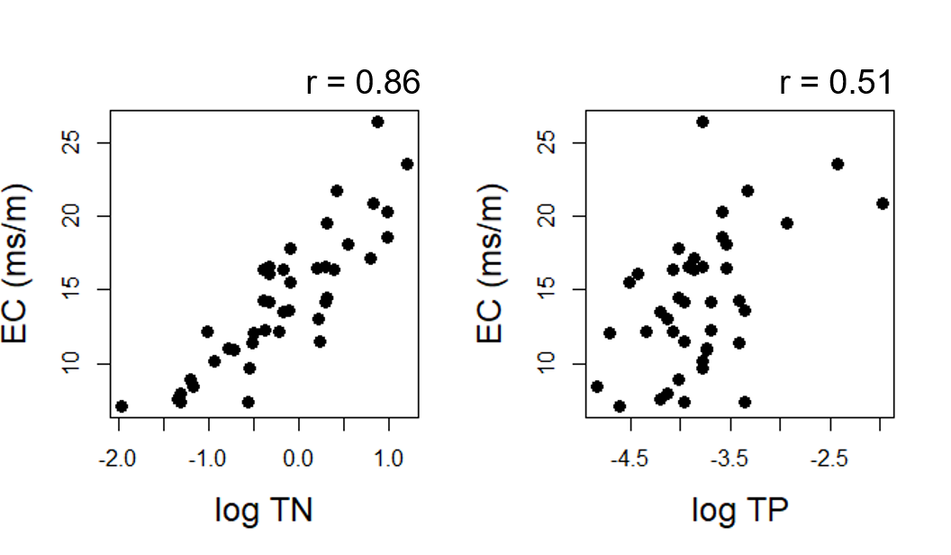

**Fig. S1** Relationships of electrical conductivity (EC, ms/m) with total nitrogen (TN, mg/L) and total phosphorus (TP, mg/L). EC was highly and positively correlated with the water quality indices, suggesting that EC is a good proxy for nutrient enrichment in the study region. Both TN and TP were log-transformed.

**# Analysis of the habitat complexity index**

We employed principal component analysis (PCA) to integrate the three CVs of stream environments into one habitat complexity index. PCA showed that the variations in CVs were well explained by PC1; the proportion of the variance that was explained by PC1 was 0.64. All CVs were log-transformed before analysis. Data were analyzed using the ‘psych’ package in R (version 3.3.2).

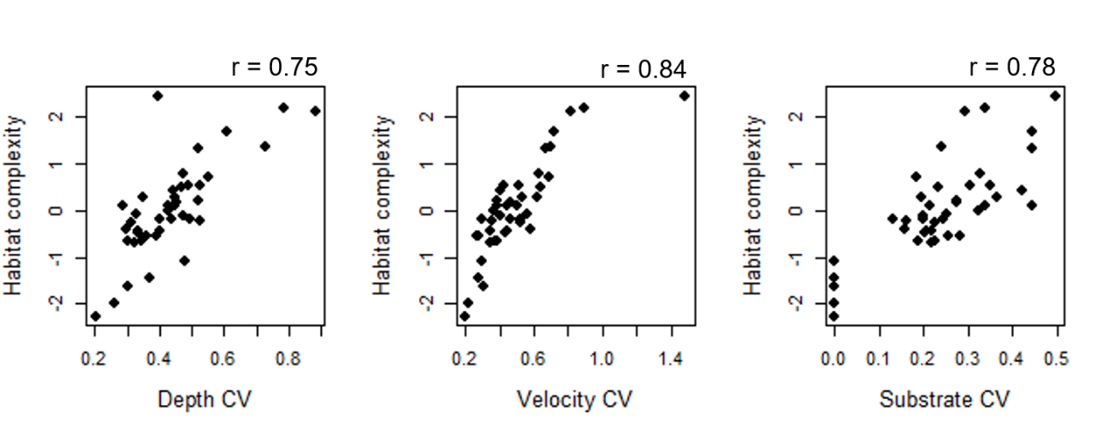

**Fig. S2** Relationships of the habitat complexity index (PC1) with the CVs of water depth, current velocity and substrate coarseness. The index calculated by PCA was highly and positively correlated with the CVs, suggesting that the index well represented the reach-scale habitat complexity in the study region.

**# Relationships of fish diversity with abiotic factors**

**- Fine sediments**

In each study reach, a typical glide reach was chosen, and surface sediment samples (samples typically were 300–500 g dry mass) were collected in the reach using a trowel, one at mid-channel and one on each side near the bank. These samples were placed into individual bags and taken back to the laboratory. The samples were stored at -10 degrees Celsius until analyses. We later thawed the sediment samples and sieved them using 20 mm, 250 μm and 40 µm mesh sieves. The samples retained on the 20 mm sieve were discarded. Each remaining sample (i.e., 40–250 μm and <40 μm sediments) was dried for at least 48 h at 60 degrees Celsius to obtain the dry mass of each size fraction. We weighed the dry samples and calculated the percentage of the dry mass of <40 μm sediments relative to the total weight of the sediment, which was obtained by combining the dry masses of the two size fractions. The mean percentage of the three sampling points in each study river was finally calculated.

**- Woody cover**

In each study reach, we measured large pieces of wood (> 10 cm in diameter) and calculated the percentage of woody cover (100*total cover area/study reach area) following the methods of Kawai et al. (2014).

**- Water temperature**

In the 15 study reaches, we measured the summer mean water temperature. The water temperature was measured hourly using loggers (Onset, Hobo pendant temperature logger UA-002064) from 20th June to 31st August. With the logged data, we calculated the summer mean water temperature.

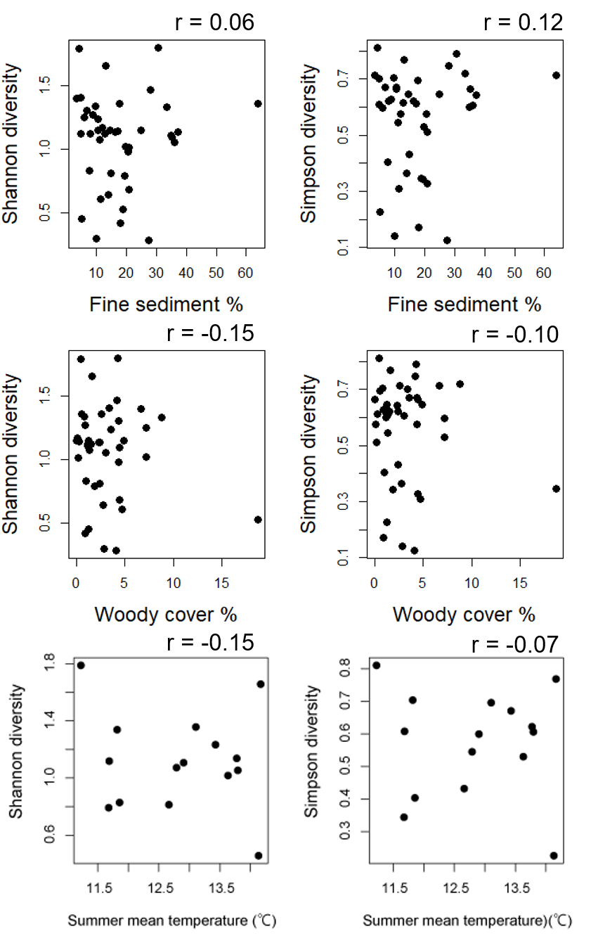

**Fig. S3** Relationships of fish diversity with the percentage of fine sediment, percentage of woody cover and summer mean water temperature.

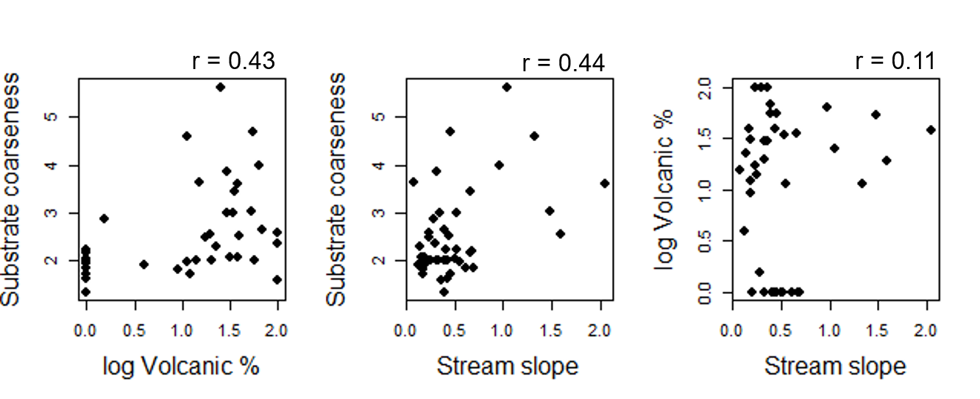

**Fig. S4** Relationships between underlying geology (proportion of volcanic rocks within a 1 km buffer), stream slope and substrate coarseness. The proportion of volcanic materials was log-transformed to ensure multivariate normality for SEM.

**# Relationship of benthic macroinvertebrate abundance with nutrient enrichment**

**- Sampling**

In March 2011, twelve invertebrate samples were collected from 27 sites in the Kitamihorobetsu River, Hokkaido. Agricultural land cover in each catchment area ranged from 0-17.9 % (see details in Sueyoshi et al. 2016; 2017). Invertebrate samples were preserved in 70% EtOH and sorted and counted in the laboratory. EC was measured on the same sampling occasion using a WM 22-EP pH meter (DKK-TOA, Hyogo, Japan).

**- Data analysis**

We used generalized linear models (GLMs) with a Poisson error distribution to test for relationships between invertebrate abundances and nutrient enrichment. The response variable was the total abundance of all invertebrates, Chironomidae and other taxa in each site, and the explanatory variable was EC. Coefficients of electric conductivity were tested for significance by Wald tests. We also tested for a relationship between agricultural land cover in each study catchment (Agriculture %) and nutrient enrichment using GLMs with Gaussian error distribution.

**Fig. S5** Relationship between benthic macroinvertebrate abundance and nutrient enrichment in northern Hokkaido. We found significant relationships in all models. Solid lines show estimated insect abundances and EC based on the results of GLMs. All models show a significant relationship (*p*<0.05) between the response and explanatory variables.

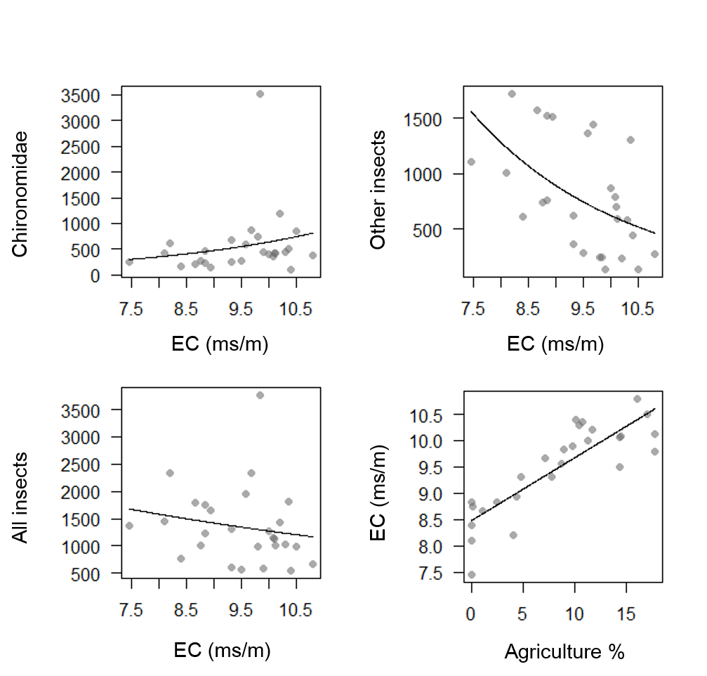

**# Selection of spatial scales for calculations of land use and underlying geology**

**- Data analysis**

We used GLMs with Gaussian error distributions to test for relationships of land use and geology with local habitat quality at both scales (reach, catchment). The response variables were EC, substrate coarseness and habitat complexity, and the explanatory variables were the percentage of agricultural land use and volcanic geology. Coefficients of the explanatory variable were tested for significance by Wald tests. The method used to measure each factor is provided in the Methods section.

**- Selection of spatial scales**

Table S1 shows that 1) EC is more related to catchment-scale land use and 2) substrate coarseness is more related to reach-scale geology. Based on the analyses, we applied catchment-scale land use and reach-scale geology in the present study.

**Table S1** Relationships of land use and geology with local habitat quality at both spatial scales



* Significant relationships (p < 0.05) are shown in boldface.

**Table S2** Observed and estimated species richness in each study reach.

*Estimation of species richness (rarefaction-extrapolation analysis) was performed using the iNEXT package (Hsieh et al. 2016).

**Table S3** Water chemical variables of the study reaches.

**Table S4** Abiotic and biotic data for the statistical analyses.



Table S4 (Continued)



**References**

Kawai, H., Nagayama, S., Urabe, H., Akasaka, T., & Nakamura, F. (2014). Combining energetic profitability and cover effects to evaluate salmonid habitat quality. Environmental biology of fishes, 97(5), 575-586.

Hsieh, T. C., Ma, K. H., & Chao, A. (2016). iNEXT: an R package for rarefaction and extrapolation of species diversity (H ill numbers). Methods in Ecology and Evolution, 7(12), 1451-1456.