FIGURE S1 Progression-free and overall survival in all patients
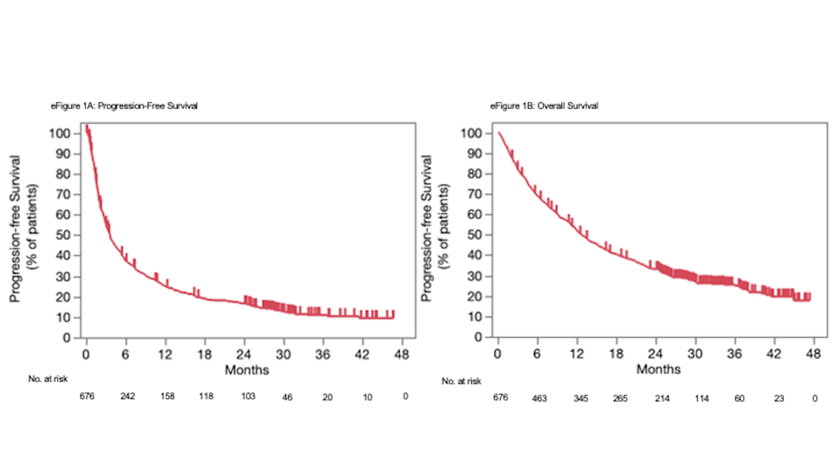
(A) Kaplan-Meier curves of progression-free survival in all patients.
(B) Kaplan-Meier curves of overall survival in all patients.

FIGURE S2 Treatment response in LT and NLT groups
This figure shows the treatment response in the LT and NLT groups. The response rate of the LT group was remarkably higher than that of the NLT group.

Abbreviations: CR, complete response; LT group, patients receiving initial immune checkpoint inhibitor for > 1 year without progression disease; NE, not evaluable; NLT group, patients other than LT group; PD, progressive disease; PR, partial response; SD, stable disease.

FIGURE S3 Progression-free survival in all patients by subgroup analysis
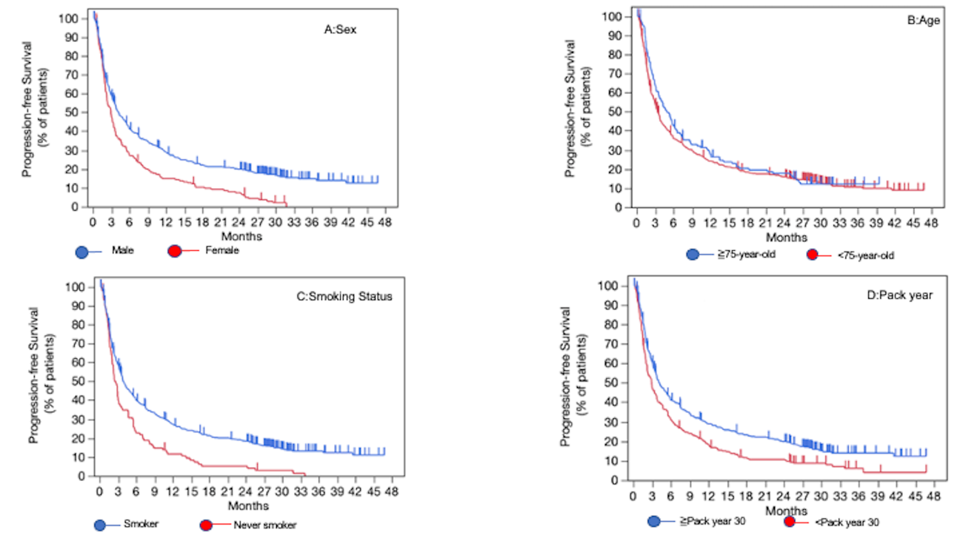
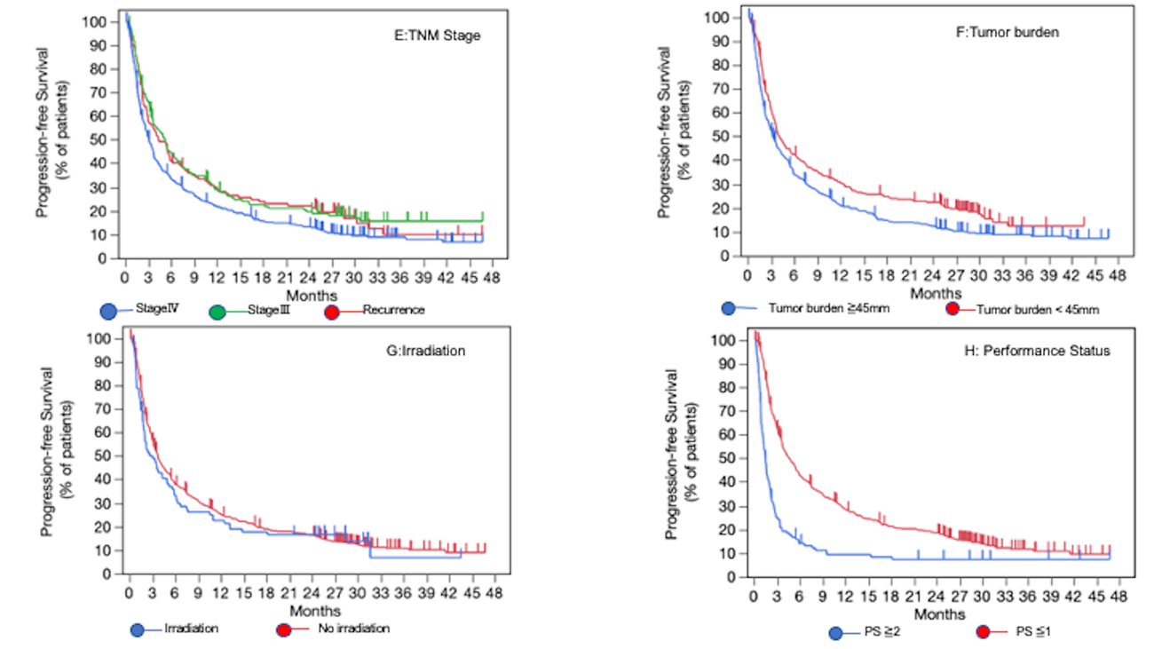
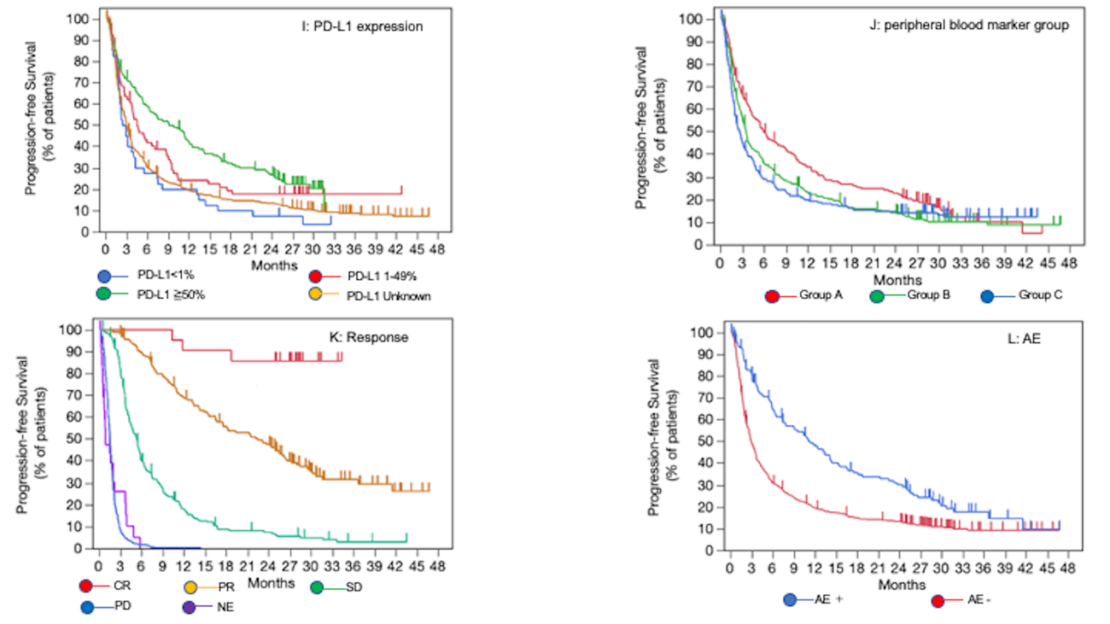

Kaplan–Meier curves of progression-free survival in all patients according to (A) sex, (B) age, (C) smoking status, (D) pack year, (E) TNM stage, (F) tumor burden, (G) irradiation, (H) performance status, (I) PD-L1 expression, (J) peripheral blood marker group, (K) response, (L) AE.
Abbreviations: AE, adverse event; CR, complete response; NE, not evaluable; PD, progressive disease; PR, partial response; PS, performance status; SD, stable disease; WBC, white blood cell.

FIGURE S4 Overall survival in all patients by subgroup analysis
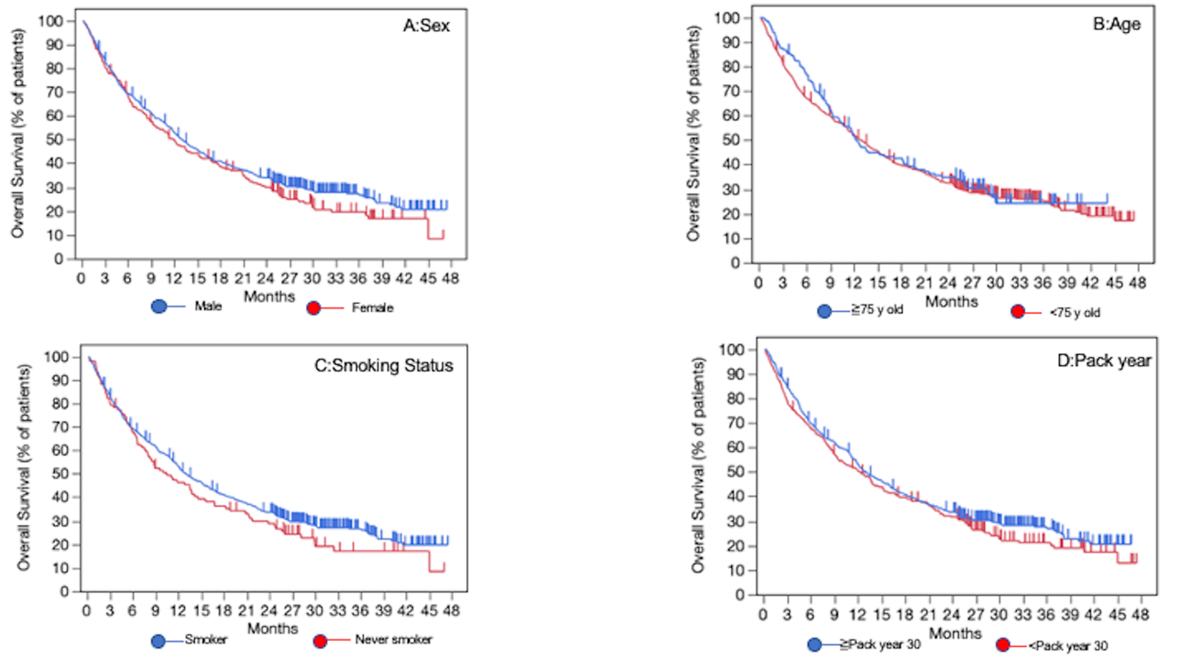
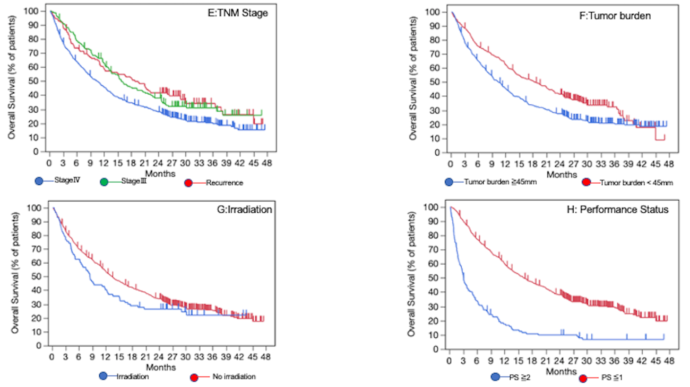
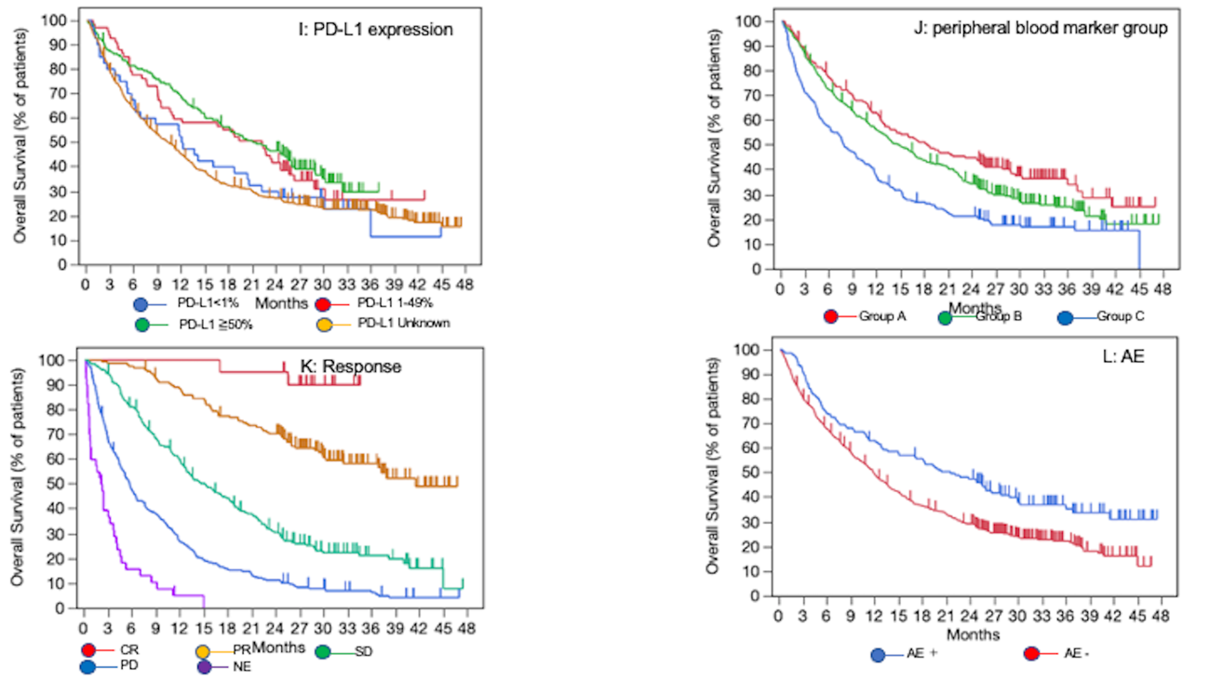
Kaplan–Meier curves of overall survival in all patients according to (A) sex, (B) age, (C) smoking status, (D) pack year, (E) TNM stage, (F) tumor burden, (G) irradiation, (H) performance status, (I) PD-L1 expression, (J) peripheral blood marker group, (K) response, (L) AE.
Abbreviations: AE, adverse event; CR, complete response; NE, not evaluable; PD, progressive disease; PR, partial response; PS, performance status; SD, stable disease; WBC, white blood cell.

FIGURE S5 Progression-free survival in LT group by subgroup analysis
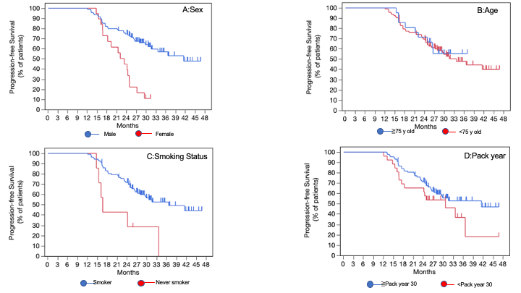
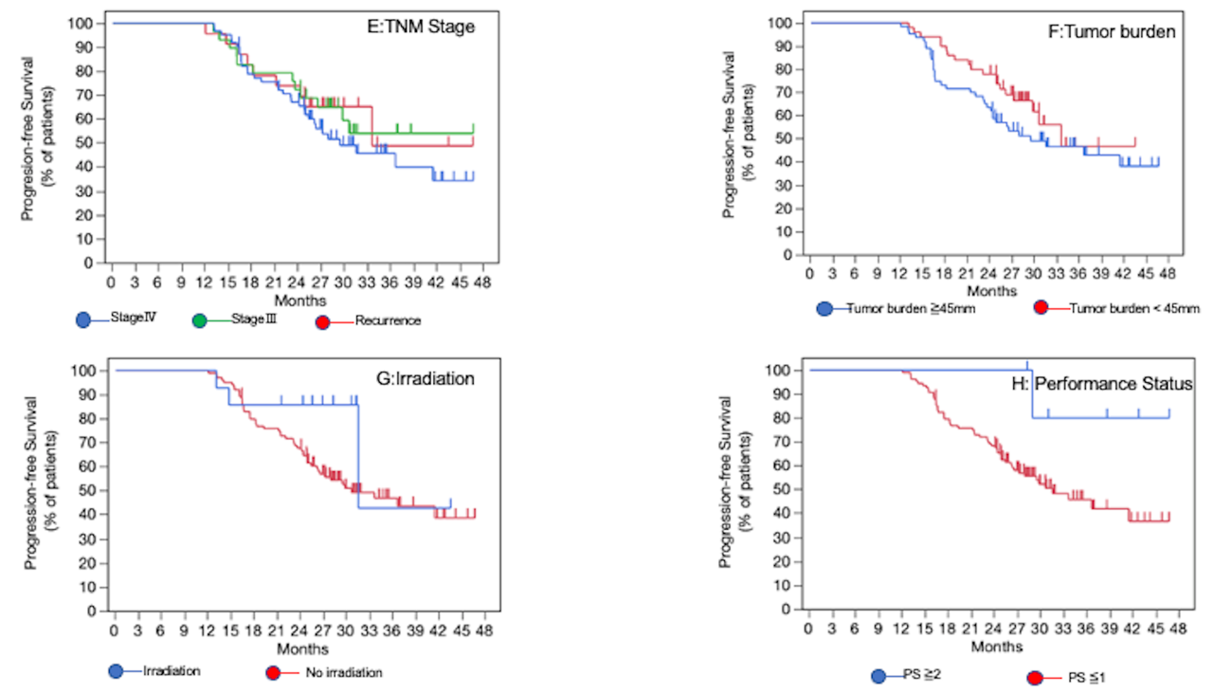
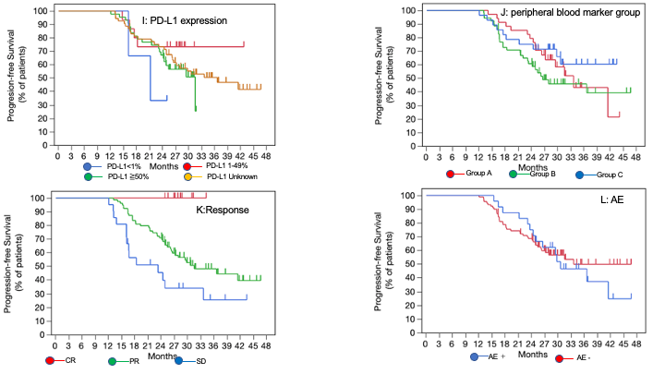

Kaplan–Meier curves of progression-free survival in LT group of patients according to (A) sex, (B) age, (C) smoking status, (D) pack year, (E) TNM stage, (F) tumor burden, (G) irradiation, (H) performance status, (I) PD-L1 expression, (J) peripheral blood marker group, (K) response, (L) AE.
Abbreviations: AE, adverse event; CR, complete response; LT group, patients receiving initial immune checkpoint inhibitor for >1 year without progression disease; NE, not evaluable; PD, progressive disease; PR, partial response; PS, performance status; SD, stable disease; WBC, white blood cell.

FIGURE S6 Overall survival in LT group by subgroup analysis
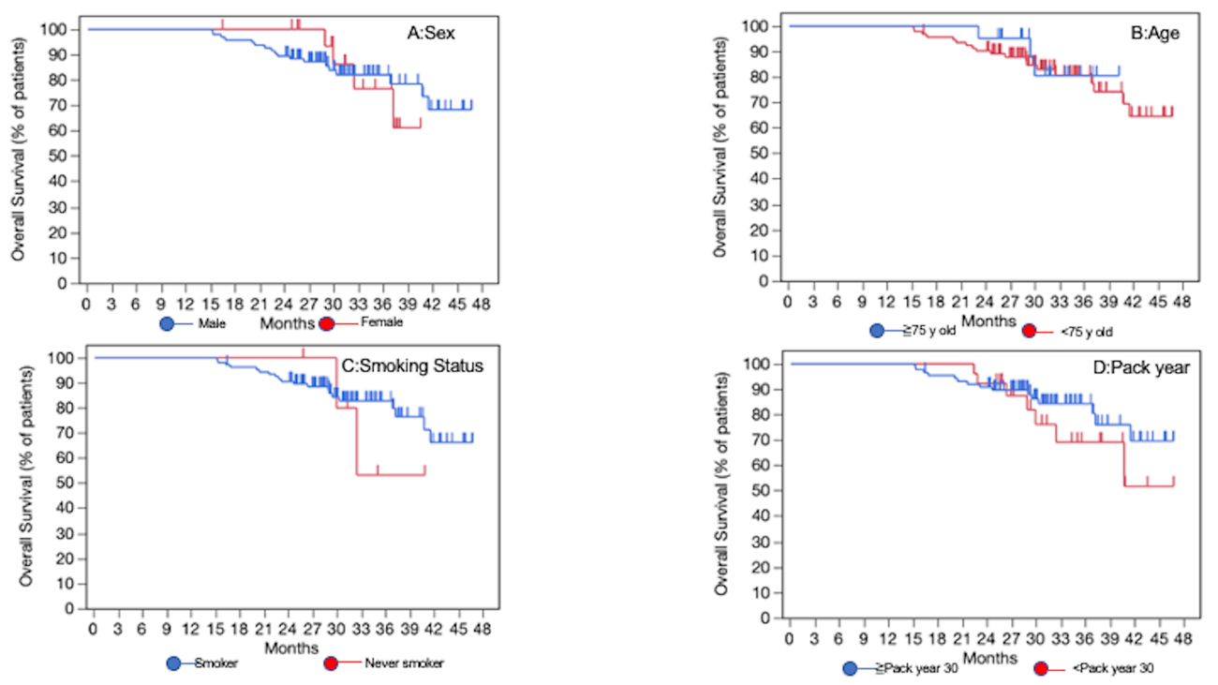
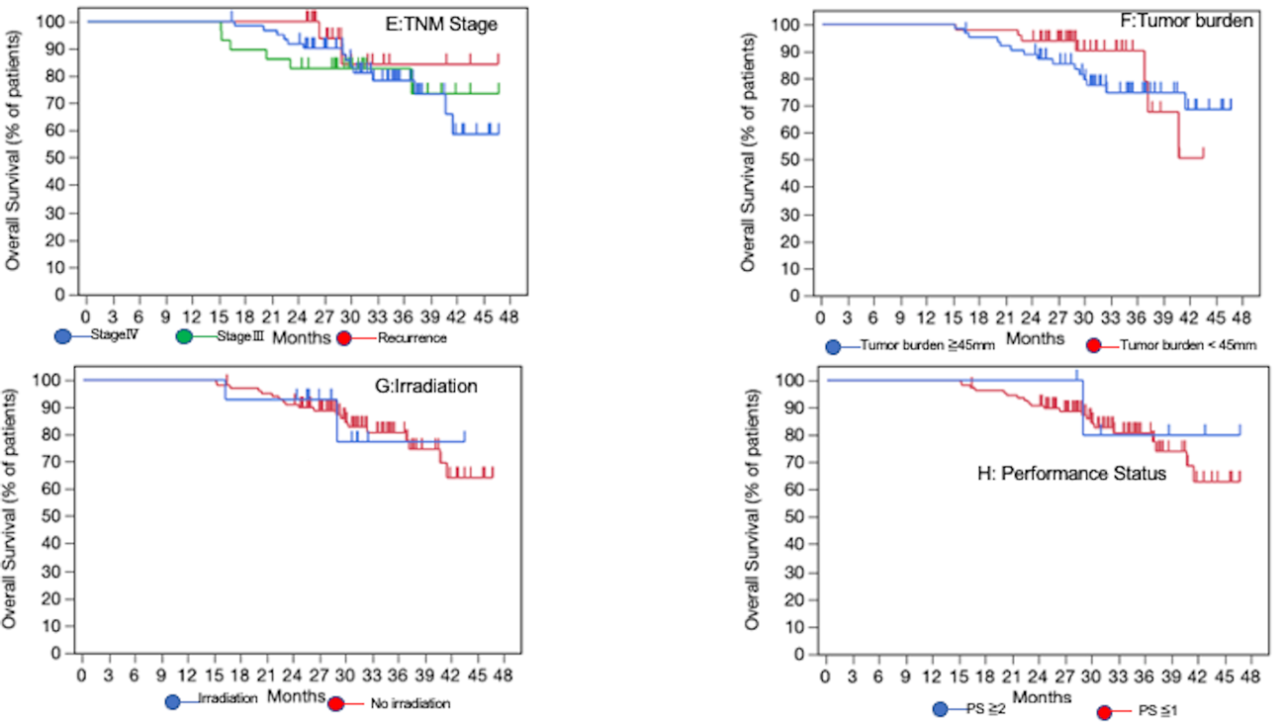
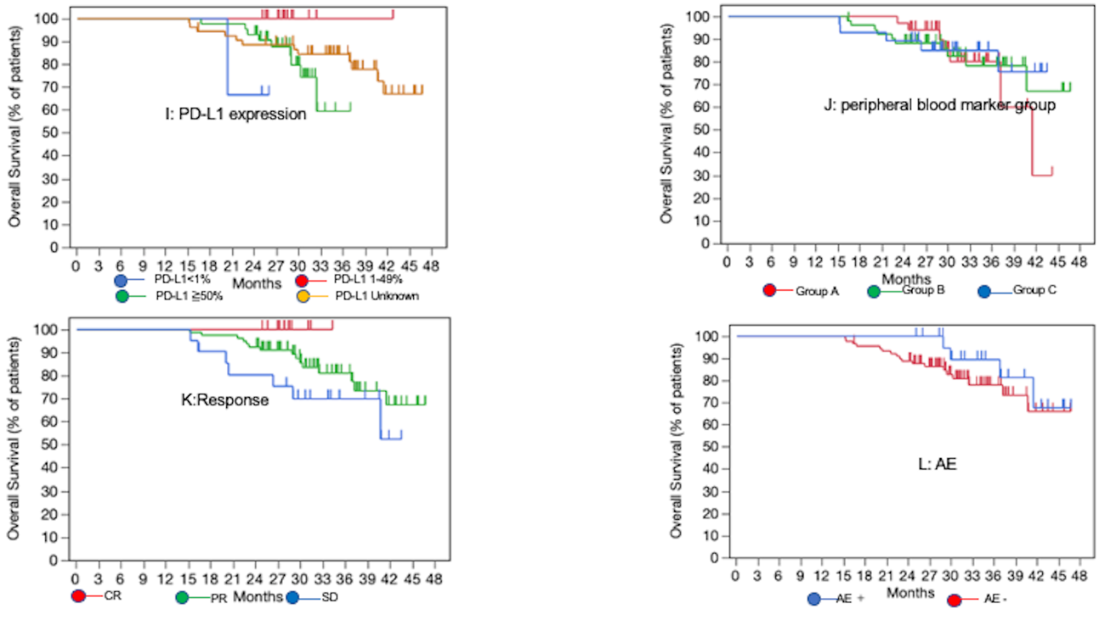
Kaplan–Meier curves of overall survival in LT group of patients according to (A) sex, (B) age, (C) smoking status, (D) pack year, (E) TNM stage, (F) tumor burden, (G) irradiation, (H) performance status, (I) PD-L1 expression, (J) peripheral blood marker group, (K) response, (L) AE.
Abbreviations: AE, adverse event; CR, complete response; LT group, patients receiving initial immune checkpoint inhibitor for >1 year without progression disease; NE, not evaluable; PD, progressive disease; PR, partial response; PS, performance status; SD, stable disease.

FIGURE S7 Progression-free survival in LT group calculated from 1 year / 1.5 years / 2 years after ICI treatment initiation
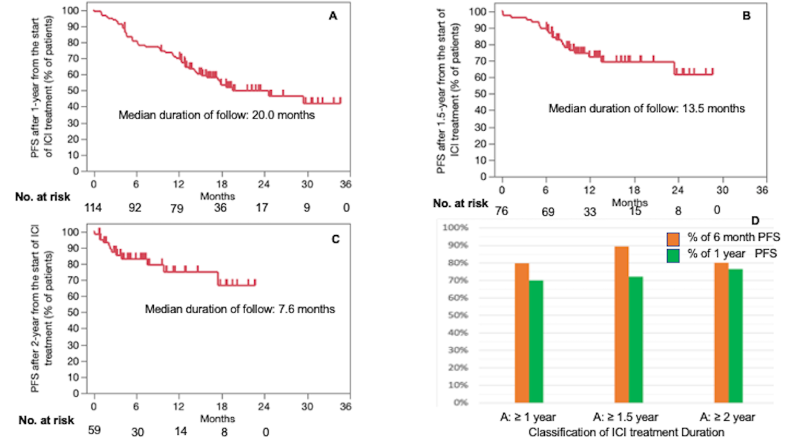
Kaplan-Meier curves of progression-free survival at (A) 1 year / (B) 1.5 years / (C) 2 years after the start of ICI treatment.
(D) The 6-month PFS rate at 1 year / 1.5 years / 2 years after the start of ICI treatment were 79.8%, 89.5%, and 80.2%, respectively. The 1-year PFS rate at 1 year / 1.5 years / 2 years after the start of ICI treatment were 69.9%, 72.2%, and 76.5%, respectively.
Abbreviations: LT group, patients receiving initial immune checkpoint inhibitor for >1 year without progression disease; ICI, immune checkpoint inhibitor; PFS, progression-free survival.

FIGURE S8 Overall survival in all patients who were administered rechallenge treatment
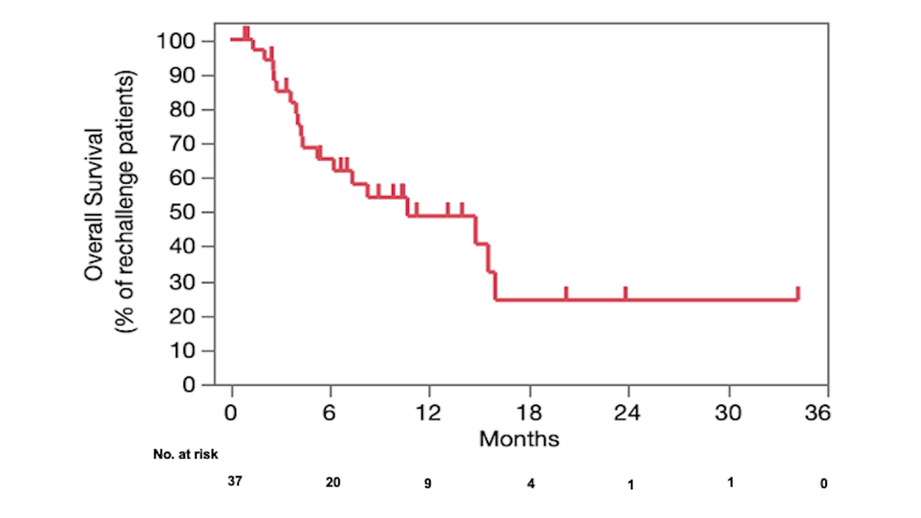
Kaplan–Meier curves of overall survival in all patients from the start of rechallenge treatment.

