Factors influencing lifespan dependency on agricultural crops by brown bears

Tomoki Sakiyama, Junko Morimoto, Jun Matsubayashi, Yasuto Furukawa, Mami Kondo, Hifumi Tsuruga, Tsutomu Mano, and Futoshi Nakamura

Corresponding author
Tomoki Sakiyama
E-mail: wisdom.tree.1994@gmail.com
Tel.: +81-80-6643-0141
Fax: +81-152-26-7575

Supplementary material

Table S1. Mean (±SD) stable isotope ratios [δ13C, δ15N] and concentrations of carbon (C) and nitrogen (N) [%] in the potential dietary resources of brown bears (Ursus arctos) harvested from 2000 to 2012 in Hokkaido, Japan.
Group | n | δ¹³C (‰) | δ¹⁵N (‰) | C (%) | N (%)
C₃ herbs | 72 | -30.6±2.2 | -1.8±1.6 | 41.09±3.78 | 3.47±1.45
C₃ fruits | 35 | -28.6±2.3 | -1.0±1.5 | 41.73±2.71 | 2.85±2.80
Corn | 5 | -10.9±0.1 | 10.7±1.1 | 41.81±0.29 | 1.79±0.15
Ants | 29 | -26.6±0.7 | 3.0±0.9 | 50.15±3.42 | 9.66±1.29
Deer | 4 | -26.8±0.6 | 3.0±0.9 | 45.53±0.47 | 13.99±0.39
Terrestrial animalsª | 33 | -26.7±0.7 | 3.0±0.9 | 49.59±3.55 | 10.18±1.88
ªAnts and deer combined

Table S2. Spearman’s correlation analysis results for the explanatory variables of each buffer size in the generalized linear model analysis.
Sex | Buffer  size  (km) | Age-  Femur Length | Age-  Human Population | Age-  Edge Length | Age-  Corn Field Area | Femur Length-  Human Population | Femur  Length-  Edge Length | Femur Length-  Corn Field  Area | Human Population-  Edge Length | Human Population-  Corn Field Area | Edge Length-  Corn Field  Area
Female | 1.0 | -0.147 | 0.026 | -0.124 | -0.040 | 0.260 | 0.043 | -0.085 | -0.284 | -0.255 | 0.897
Female | 1.5 | -0.147 | 0.000 | -0.123 | -0.034 | 0.269 | 0.036 | -0.091 | -0.351 | -0.284 | 0.892
Female | 2.0 | -0.147 | -0.039 | -0.106 | -0.028 | 0.278 | 0.003 | -0.124 | -0.357 | -0.271 | 0.873
Female | 2.5 | -0.147 | -0.055 | -0.111 | -0.029 | 0.283 | -0.002 | -0.128 | -0.326 | -0.226 | 0.863
Female | 3.0 | -0.147 | -0.056 | -0.105 | -0.034 | 0.271 | -0.008 | -0.135 | -0.318 | -0.208 | 0.870
Female | 3.5 | -0.147 | -0.047 | -0.099 | -0.029 | 0.269 | -0.008 | -0.139 | -0.294 | -0.185 | 0.870
Male | 1.0 | 0.394 | 0.061 | 0.032 | -0.032 | 0.024 | 0.255 | 0.153 | -0.010 | 0.068 | 0.873
Male | 1.5 | 0.394 | 0.075 | 0.038 | -0.026 | 0.070 | 0.254 | 0.166 | 0.055 | 0.084 | 0.872
Male | 2.0 | 0.394 | 0.088 | 0.039 | -0.002 | 0.085 | 0.258 | 0.185 | 0.086 | 0.133 | 0.869
Male | 2.5 | 0.394 | 0.092 | 0.053 | 0.006 | 0.073 | 0.262 | 0.183 | 0.098 | 0.188 | 0.873
Male | 3.0 | 0.394 | 0.088 | 0.060 | 0.007 | 0.077 | 0.261 | 0.187 | 0.104 | 0.181 | 0.873
Male | 3.5 | 0.394 | 0.120 | 0.056 | 0.006 | 0.073 | 0.255 | 0.175 | 0.128 | 0.200 | 0.871
Male | 4.0 | 0.394 | 0.126 | 0.053 | 0.013 | 0.066 | 0.258 | 0.168 | 0.111 | 0.204 | 0.864
Male | 4.5 | 0.394 | 0.146 | 0.049 | 0.020 | 0.073 | 0.252 | 0.169 | 0.077 | 0.179 | 0.862
Male | 5.0 | 0.394 | 0.153 | 0.050 | 0.018 | 0.074 | 0.256 | 0.146 | 0.081 | 0.179 | 0.860

Text S1. Sources of corn field area data
The listed sources were used to derive the municipal area of corn fields in our study area.

Hakodate City (2017) Overview of Hakodate agriculture, forestry and fisheries. https://www.city.hakodate.hokkaido.jp/docs/2014031100781/files/zentai.pdf. Accessed 1 March 2018
Hiyama Subprefecture (2015). Area of dent corn fields in Hiyama subprefecture. http://www.hiyama.pref.hokkaido.lg.jp/ss/num/toukei/25-18dentokon.pdf. Accessed 1 December 2016
Ministry of Agriculture, Forestry and Fisheries Hokkaido Statistics Office (2002) Annual statistics of Hokkaido agriculture, forestry, and fisheries (Municipally sorted statistics) from 2000 to 2001. Ministry of Agriculture, Forestry and Fisheries, Japan
Ministry of Agriculture, Forestry and Fisheries Hokkaido Statistics Office (2003) Annual statistics of Hokkaido agriculture, forestry, and fisheries (Municipally sorted statistics) from 2001 to 2002. Ministry of Agriculture, Forestry and Fisheries, Japan
Ministry of Agriculture, Forestry and Fisheries Hokkaido Statistics Office (2004) Annual statistics of Hokkaido agriculture, forestry, and fisheries (Municipally sorted statistics) from 2002 to 2003. Ministry of Agriculture, Forestry and Fisheries, Japan
Ministry of Agriculture, Forestry and Fisheries Hokkaido Statistics Office (2005) Annual statistics of Hokkaido agriculture, forestry, and fisheries (Municipally sorted statistics) from 2003 to 2004. Ministry of Agriculture, Forestry and Fisheries, Japan
Ministry of Agriculture, Forestry and Fisheries Hokkaido Statistics Office (2006) Annual statistics of Hokkaido agriculture, forestry, and fisheries (Municipally sorted statistics) from 2004 to 2005. Ministry of Agriculture, Forestry and Fisheries, Japan
Ministry of Agriculture, Forestry and Fisheries Hokkaido Statistics Office (2007) Annual statistics of Hokkaido agriculture, forestry, and fisheries (Municipally sorted statistics) from 2005 to 2006. Ministry of Agriculture, Forestry and Fisheries, Japan
Ministry of Agriculture, Forestry and Fisheries Hokkaido Statistics Office (2008) Annual statistics of Hokkaido agriculture, forestry, and fisheries (Municipally sorted statistics) from 2006 to 2007. Ministry of Agriculture, Forestry and Fisheries, Japan
Oshima Subprefecture (2013) Statistics on Oshima agriculture 2013. Oshima Subprefecture, Hokkaido, Japan
Setana Town (2014) Overview of Setana agriculture. http://www.town.setana.lg.jp/uploads/documents/669640.pdf. Accessed 3 April 2019
Yakumo Town (2019) Statistics on industry in Yakumo town 2016. https://www.town.yakumo.lg.jp/uploaded/attachment/5976.pdf. Accessed 3 April 2019

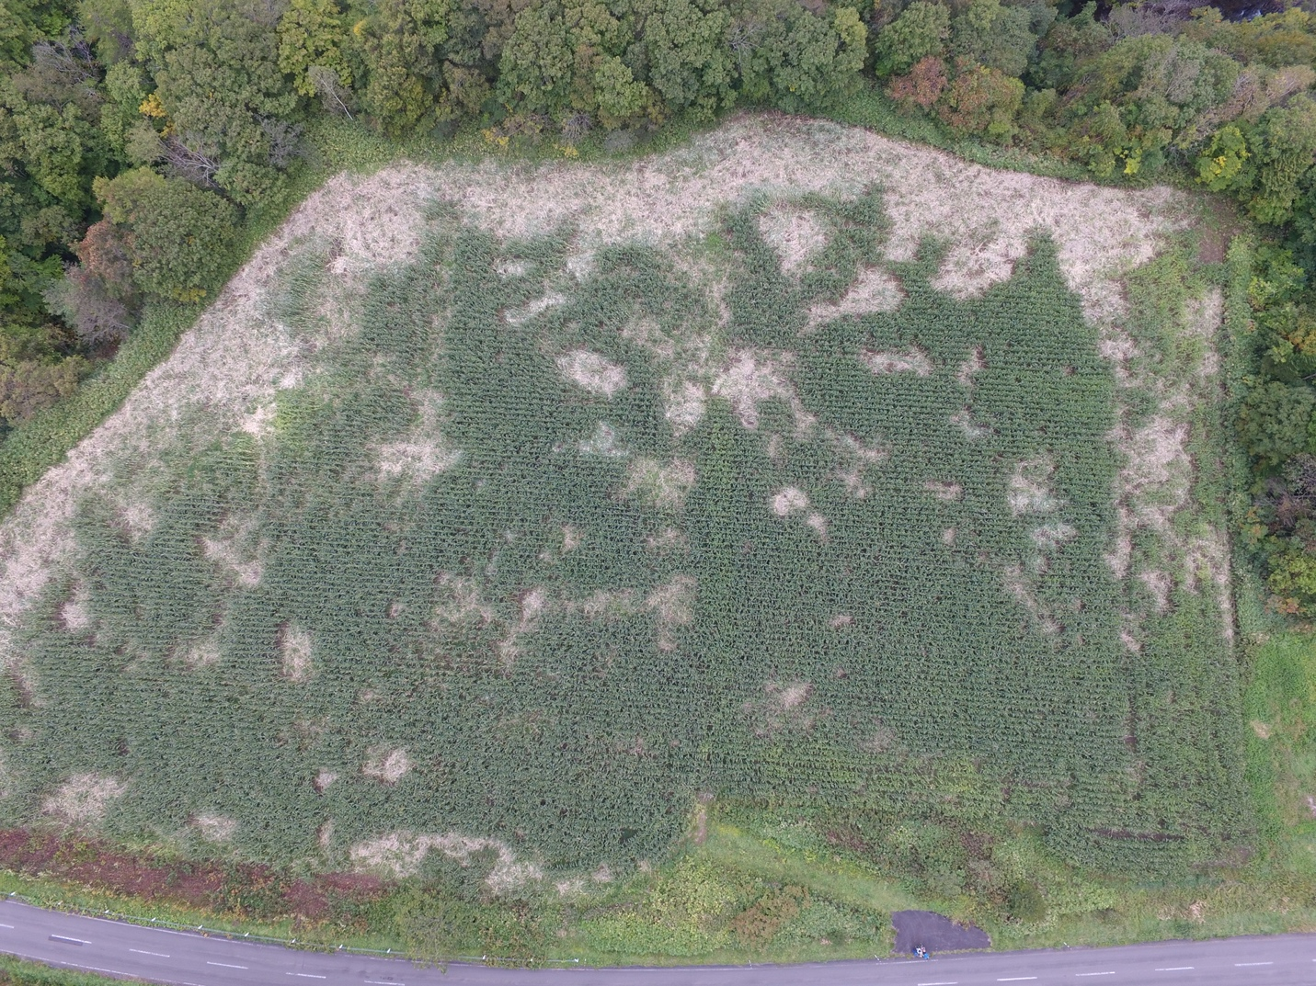
Fig. S1 An aerial photo of a damaged corn field surrounded by a forest in the Oshima Peninsula. Damaged corns (white area) are distributed mostly at the periphery of the field, while some small patches of corn are also present inside the field

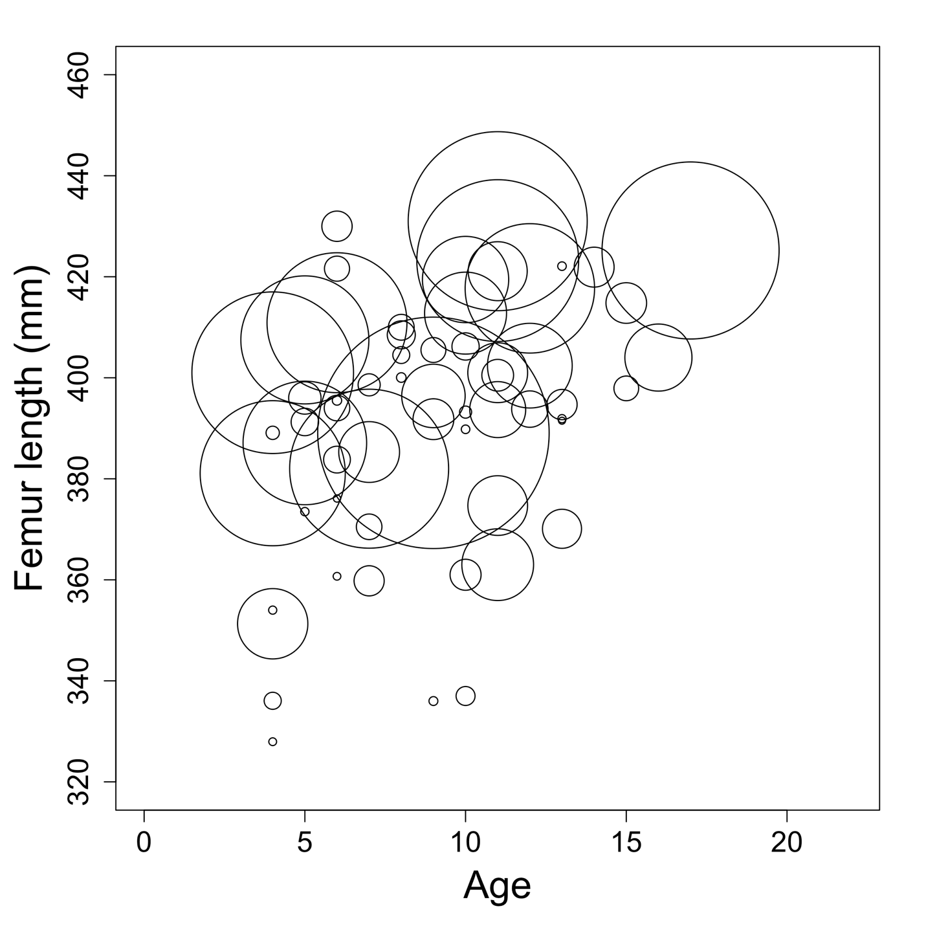
Fig. S2 A bubble chart showing the relationship between age, femur length (e.g., body size), and corn consumption of male brown bears (Ursus arctos) harvested from 2000 to 2012 in Hokkaido, Japan. The diameter of the circles indicates the relative amount of corn consumption by bears

