Journal name: Canadian Journal of Zoology
Article title: Protogynous hermaphroditism in Crustacea: a new example from Tanaidacea
Author(s): Keiichi Kakui and Chizue Hiruta
Corresponding author: Keiichi Kakui. E-mail: kakui@eis.hokudai.ac.jp. Department of Biological Sciences, Faculty of Science, Hokkaido University, Sapporo, Hokkaido, Japan

Supplementary Figure S1. Ventral view of pereonite 6 and pleonite 1 of Nesotanais sp. aff. ryukyuensis. (A) Male with a pair of genital cones (arrowheads). (B) Female without genital cones. Abbreviations: P6, pereonite 6; Pl1, pleonite 1. Scale bar: 0.1 mm.
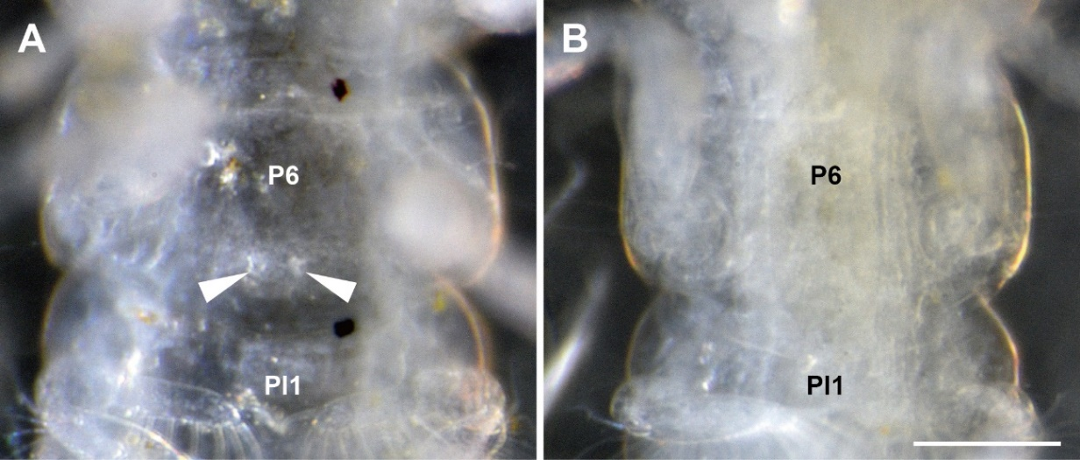

Supplementary Figure S2. Relationship between body length (BL) and carapace length (CL) in Nesotanais sp. aff. ryukyuensis.
