Supporting Information

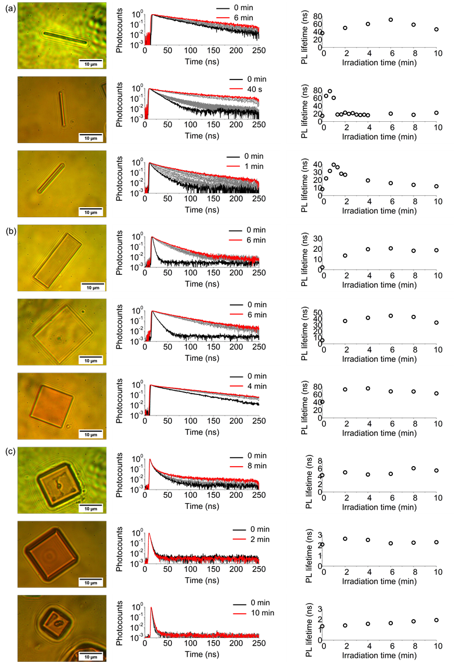
Figure S1. Optical microscope images, the PL decays, and the temporal evolutions of PL lifetime values of (a) a microrod, (b) a microplate, and (c) a microcube.
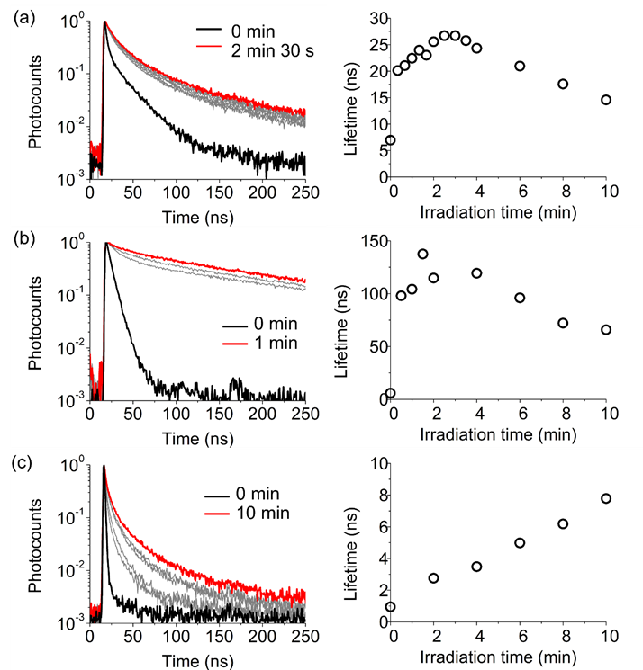
Figure S2. The PL decays and the temporal evolutions of the PL lifetime values of (a) a microrod, (b) a microplate, and (c) a microcube.

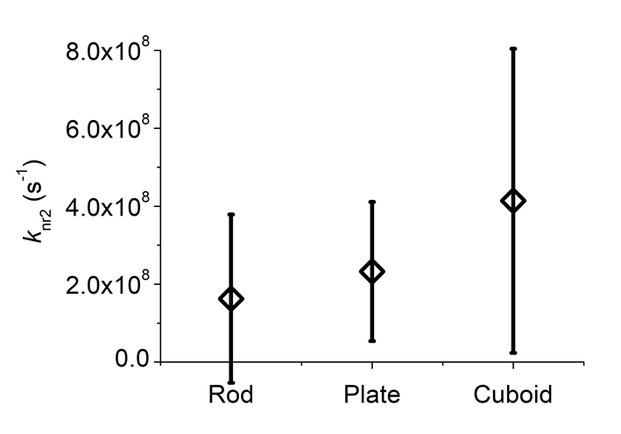
Figure S3. The average ${\text{k}}_{\text{nr}{\text{Br}}_{\text{V}}}$ (s⁻¹) for each shaped MAPbBr₃ microcrystals. The vertical bars give the standard deviation obtained for five different microcrystals shown in Figures 2, 3, and S1.

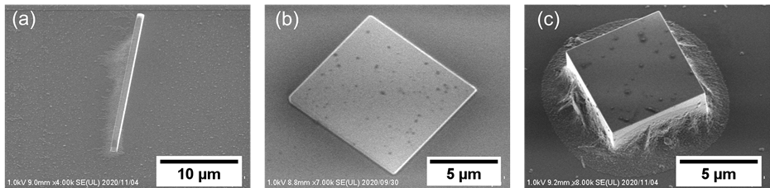
Figure S4. SEM images tilted with 30° of (a) a microrod, (b) a microplate, and (c) a microcube after ps laser irradiation in a MABr solution.

Reference
- a) R. García-Aboal, R. Fenollosa, F. Ramiro-Manzano, I. Rodríguez, F. Meseguer, P. Atienzar, ACS Omega 2018, 3, 5229–5236; b) M. J. Islam, M. Shahjahan, K.-I. Yuyama, V. Biju, ACS Materials Letters 2020, 2, 403–408.

