Supporting Information

Solid-State Electrochemical Switch of Superconductor-Metal-Insulators

Xi Zhang^{a*}, Gowoon Kim^{b}, Qian Yang^{b}, Jiake Wei^{c,d}, Bin Feng^{c}, Yuichi Ikuhara^{c,d} and Hiromichi Ohta^{a*}

ª Research Institute for Electronic Science, Hokkaido University, N20W10, Kita, Sapporo 001-0020, Japan

^{b} Graduate School of Information Science and Technology, Hokkaido University, N14W9, Kita, Sapporo 060-0814, Japan

^{c} Institute of Engineering Innovation, The University of Tokyo, 2-11-16 Yayoi, Bunkyo, Tokyo 113-8656, Japan

^{d} Elements Strategy Initiative for Structural Materials, Kyoto University, Yoshida-honmachi, Sakyo-ku, Kyoto 606-8501, Japan

*Email: zhangxielle@gmail.com, hiromichi.ohta@es.hokudai.ac.jp

Table S1. Oxygen deficiency (δ), electron density (Q), lattice parameter (c), thermopower (S) at room temperature, electrical resistivity (ρ) at room temperature, and superconducting transition temperature (T_{c}) of the YBCO samples.

Sample | δ | Q (cm⁻³) | c (nm) | S (μV K⁻¹) | ρ (Ω cm) | T_{c} (K)
A | 0.28 | 0 | 1.1821 | 20.1 | 8.32 × 10⁻⁴ | 41
B | 0.098 | −2.93 × 10²² | 1.1771 | 0.96 | 4.56 × 10⁻⁴ | 50
C | 0.071 | −1.01 × 10²³ | 1.1764 | −1.39 | 3.58 × 10⁻⁴ | 66
D | 0.069 | −1.32 × 10²³ | 1.1753 | −1.61 | 1.63 × 10⁻⁴ | 87
E | 0.64 | +2.5 × 10²¹ | 1.1856 | 81.5 | 4.29 × 10⁻³
F | 0.72 | +4.0 × 10²¹ | 1.1906 | 110 | 8.42 × 10⁻³
G | 0.86 | +8.9 × 10²¹ | 1.1897 | 218 | 5.99 × 10⁻²
H | 0.87 | +9.4 × 10²¹ | 1.1911 | 241 | 7.69 × 10⁻²
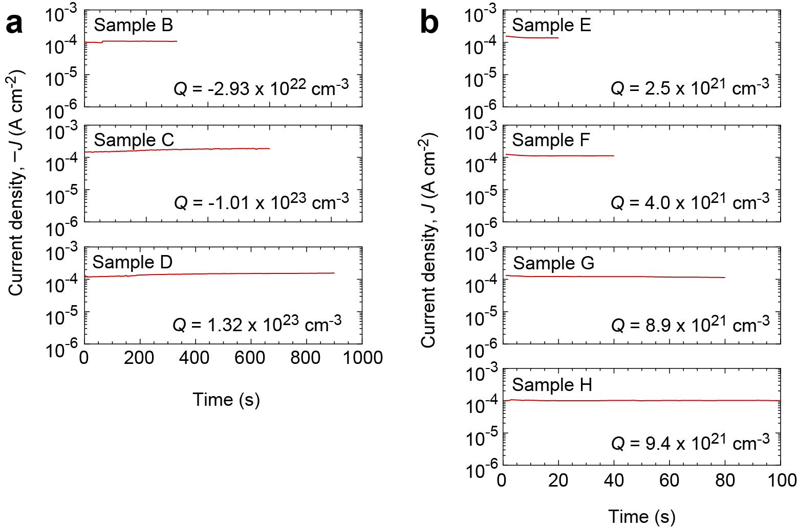
Figure S1. Applied current densities for the electrochemical redox treatment. (a) Oxidation treatment. (b) Reduction treatment.

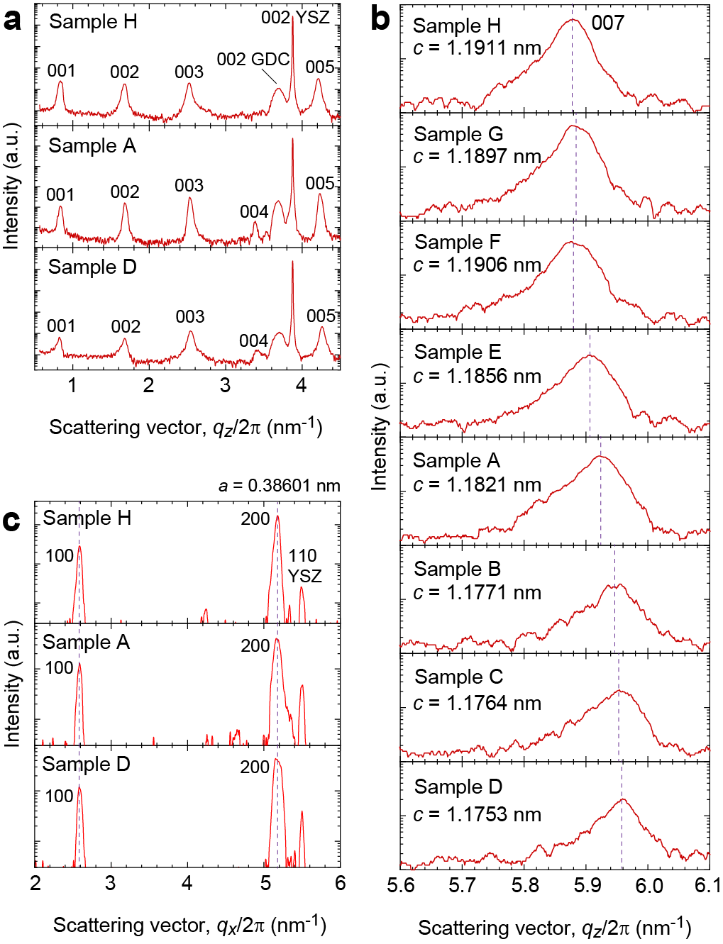

Figure S2. X-ray diffraction patterns of the YBa₂Cu₃O_{7−δ} films with various redox states. (a) Out-of-plane XRD patterns. Intense diffraction peaks of 00l YBa₂Cu₃O_{7−δ} are observed along with 00l GDC/YSZ. (b) Magnified out-of-plane XRD patterns around 007 YBCO. (c) In-plane X-ray Bragg diffraction patterns. Diffraction peak positions of samples A, D, and H are the same. a-axis lattice parameter of the samples is 0.38601 nm. [A: as-grown, B: Q = −2.93 × 10²² cm⁻³, C: Q = −1.01 × 10²³ cm⁻³, D: Q = −1.32 × 10²³ cm⁻³, E: Q = +2.5 × 10²¹ cm⁻³, F: Q = +4.0 × 10²¹ cm⁻³, G: Q = +8.9 × 10²¹ cm⁻³, and H: Q = +9.4 × 10²¹ cm⁻³]

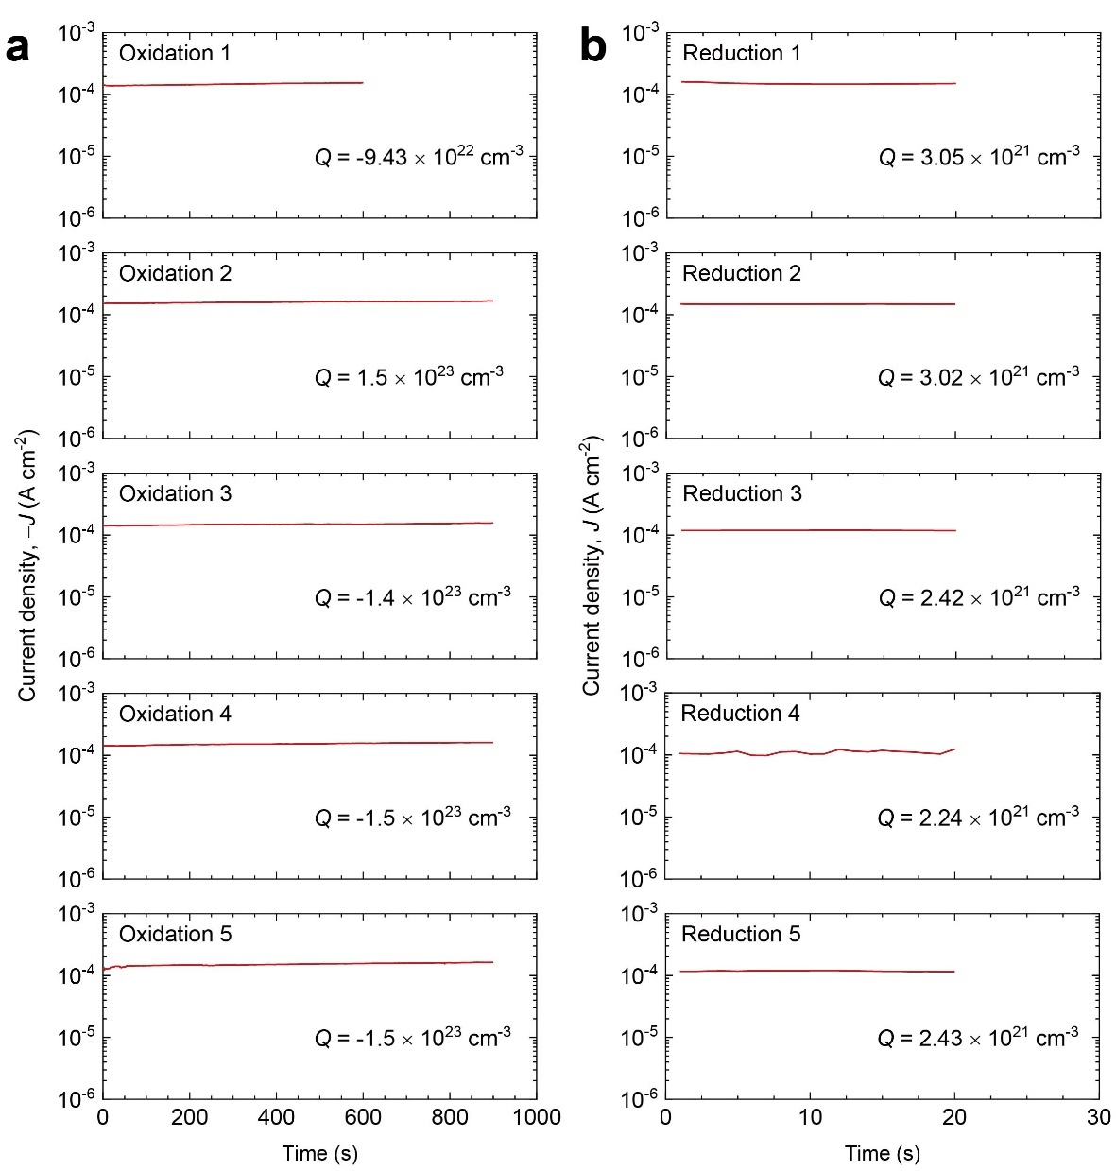

Figure S3. Applied current densities for the electrochemical redox treatment. (a) Oxidation treatment. (b) Reduction treatment. The oxidation and reduction treatment were alternatively applied.

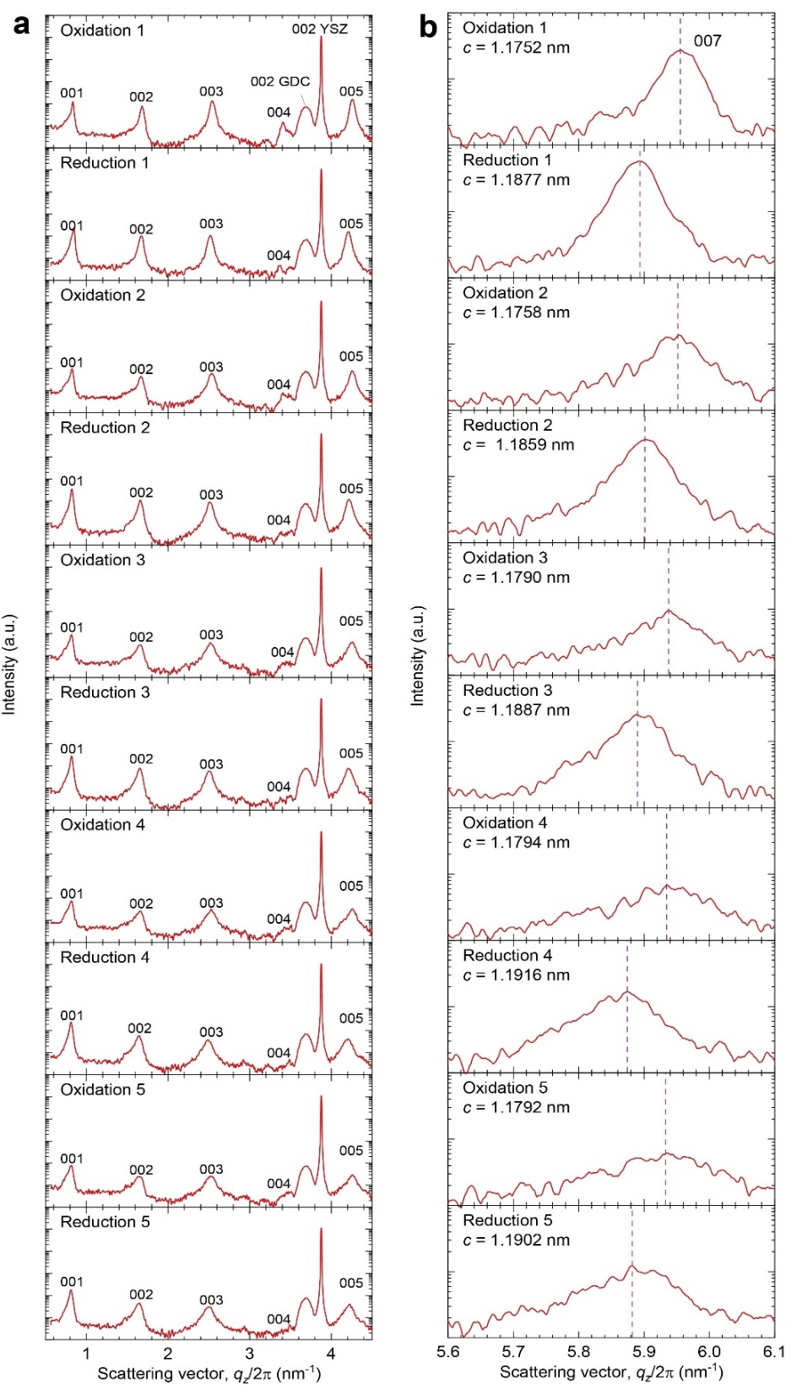

Figure S4. X-ray diffraction patterns of the YBa₂Cu₃O_{7−δ} films after cycling electrochemical oxidation and reduction. (a) Out-of-plane XRD patterns. Intense diffraction peaks of 00l YBa₂Cu₃O_{7−δ} are observed along with 00l GDC/YSZ after 5 oxidation-reduction cycles. (b) Magnified out-of-plane XRD patterns around 007 YBCO. The peak positions show clear revisable shift by cycling electrochemical oxidation and reduction.

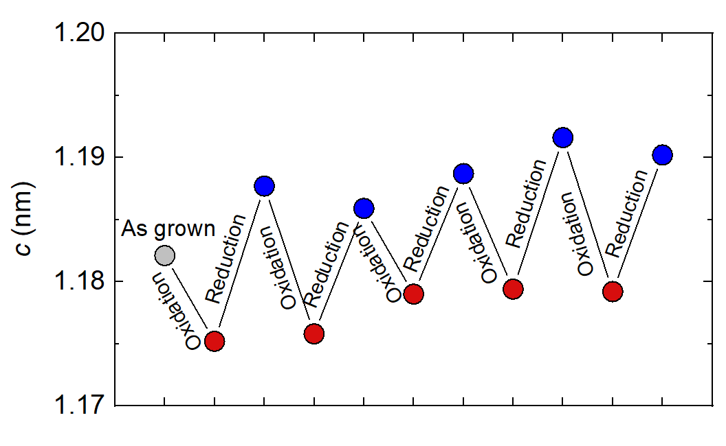

Figure S5. c-axis lattice parameter changes after cycling electrochemical oxidation and reduction.

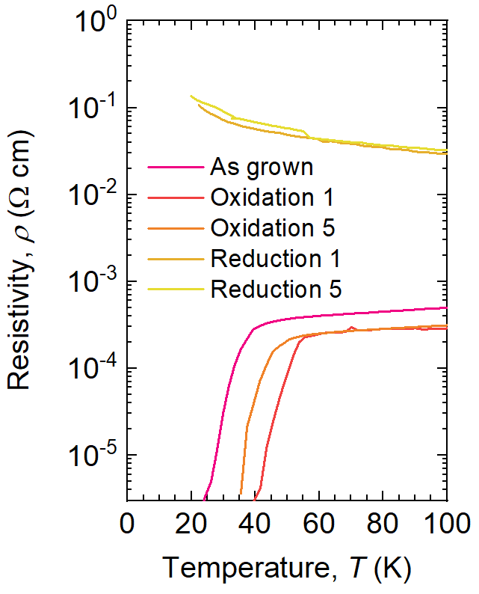

Figure S6. ρ−T curves of the YBa₂Cu₃O_{7−δ} films after different oxidation-reduction cycles. The superconductor-metal-insulator modulation shows good cyclability by repeating the electrochemical redox treatment for 5 times.

