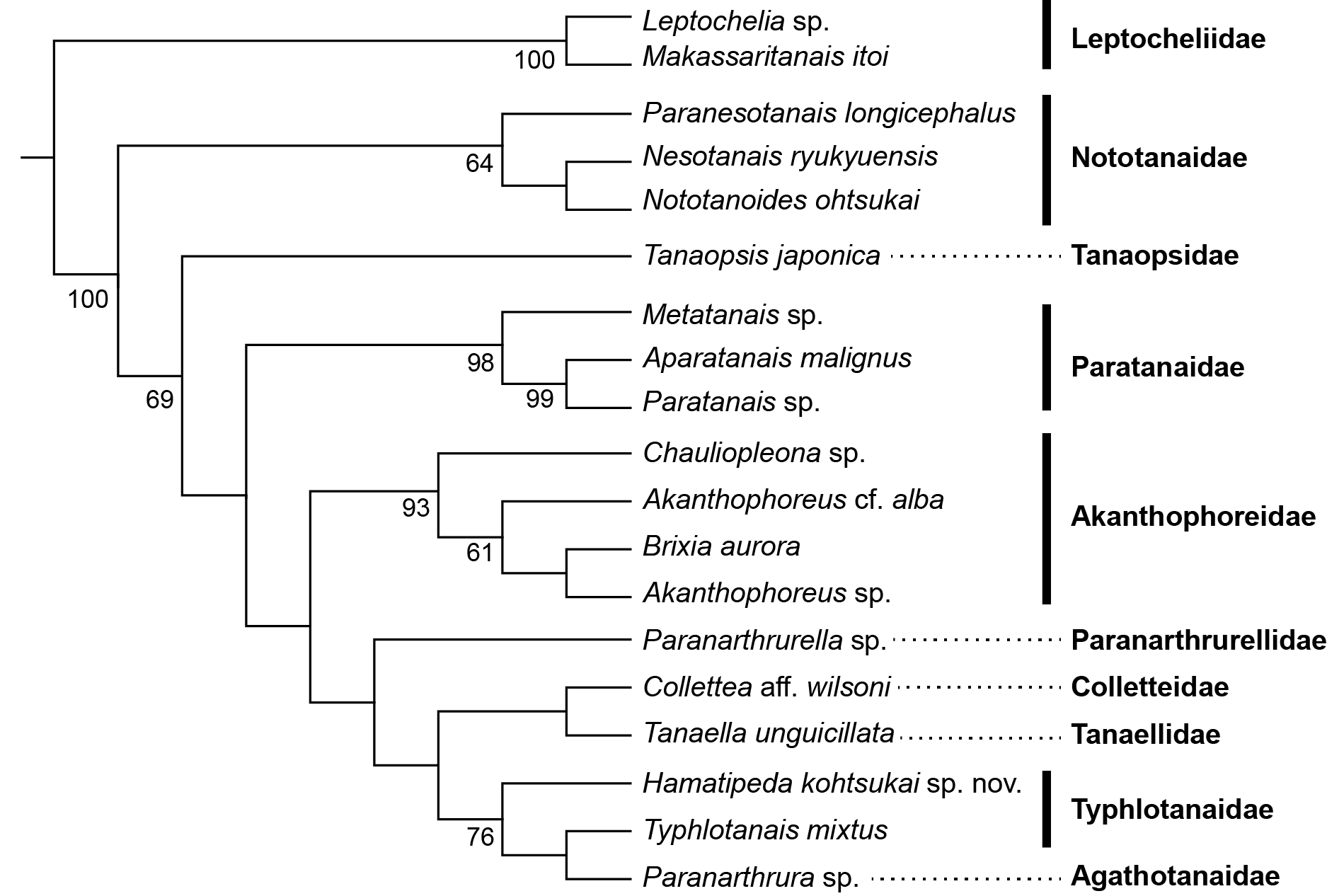

Supplementary Figure S1. Maximum parsimony (MP) tree for 18S sequences from tanaidaceans, including Hamatipeda kohtsukai sp. nov. There were a total of 1427 positions in the final dataset. Nodal support values were obtained by analysis of 1000 bootstrap pseudoreplicates and put near nodes (< 60% not shown). Family names are indicated in bold font. The outgroup taxon (Arctotanais alascensis) is not shown.

