**Photocatalytic Activity of Radial Rutile Titanium(IV) Oxide Microspheres for Aerobic Oxidation of Organics**

Ryota Kojima,[a] Bunsho Ohtani,* [b] Hiroaki Tada*[a]

[a] Graduate School of Science and Engineering, Kindai University, 3-4-1, Kowakae, Higashi-Osaka, Osaka 577-8502, Japan.

[b] Graduate School of Environmental Science, Hokkaido University, Sapporo, Hokkaido 060-0810, Japan, and Institute for Catalysis, Hokkaido University, Sapporo, Hokkaido 001-0021, Japan.

* To whom correspondence should be addressed: TEL: +81-6-6721-2332, FAX: +81-6-6727-2024,

E-mail: [h-tada@apch.kindai.ac.jp](mailto:h-tada@apch.kindai.ac.jp).

**Figure S1.**Absorption spectra of TiO2 particles recovered from aqueous and acetonitrile solutions of 2-naphthol with different concentrations (10 M and 5 mM).

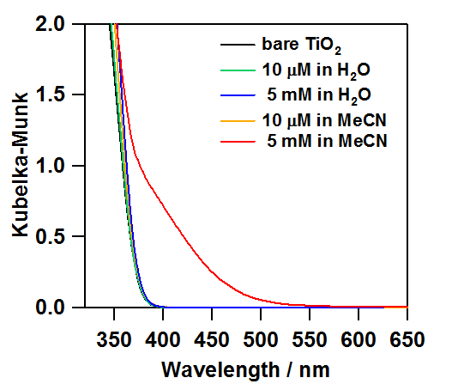

**A)**

**B)**

**Figure S2.**The energy difference between the surface electron traps (SETs) and the CBB in the TiO2-NR HOMC system in the ERDT/CBB pattern (*E*) and the compensated value (*E*c) in the . TiO2-NR HOMC (A) and FeOx/TiO2-NR HOMC (B) systems. The energy of the SETs observed in the ERDT/CBB pattern occurs from the levels 0.1~0.2 eV below the CBB since the DOSs of the VBT and the SETs are small. Then, the energy difference is compensated by *E*c ≈ *E* – 0.15 eV in the TiO2-NR HOMC system. Also, the energy difference can be compensated by *E*c ≈ *E* – 0.55 eV in the FeOx/TiO2-NR HOMC system.

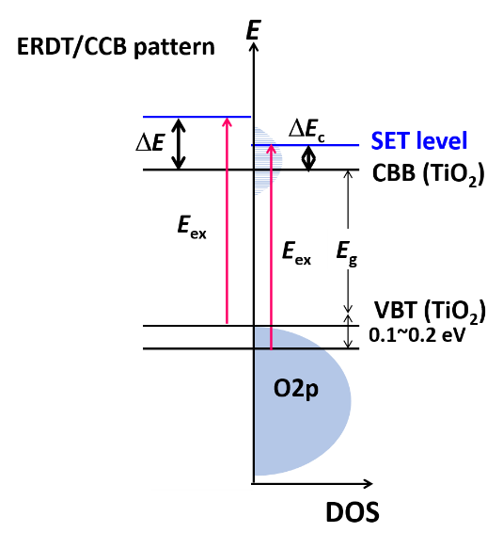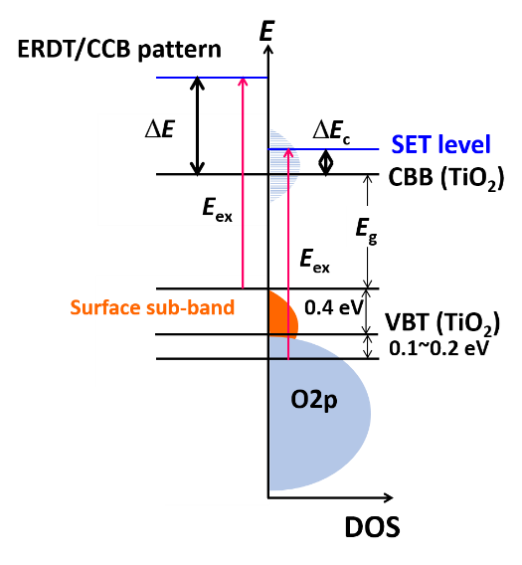

**A)**

**B)**

**Figure S3.**Plots of Fe-loading amount (**) vs. Fe(acac)3 concentration in the chemisorption-calcination ptocess (*C*) (A) and **-1vs. *C*-1 in the FeOx/TiO2-NR HOMC system.

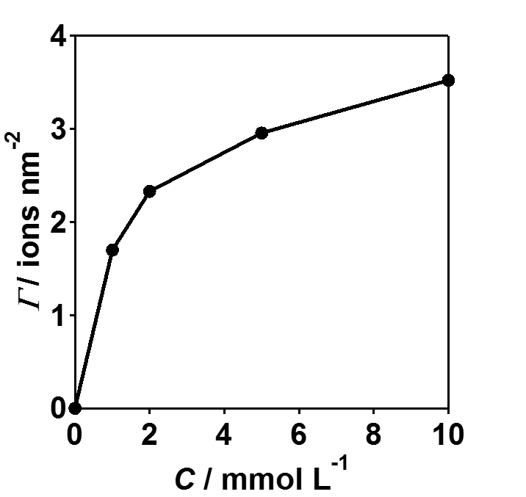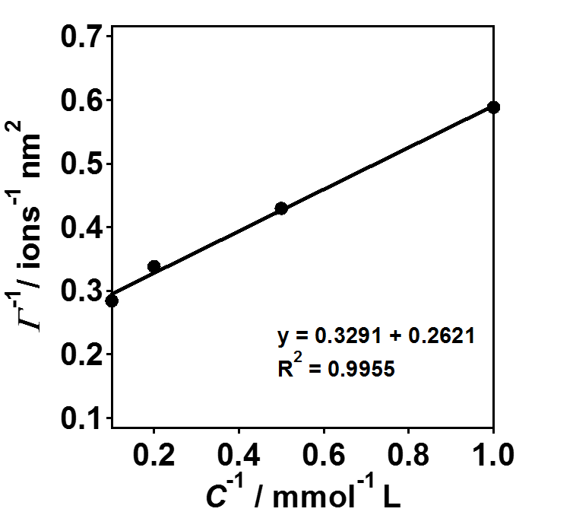

**Figure S4.**Time courses for FeOx(**)/TiO2-NR HOMC-photocatalyzed 2-naphthol degradation under irradiation of visible light (*I* 420~485 nm = 10 mW cm-2).

