Fig.1 (Hasegawa and Nakaoka)

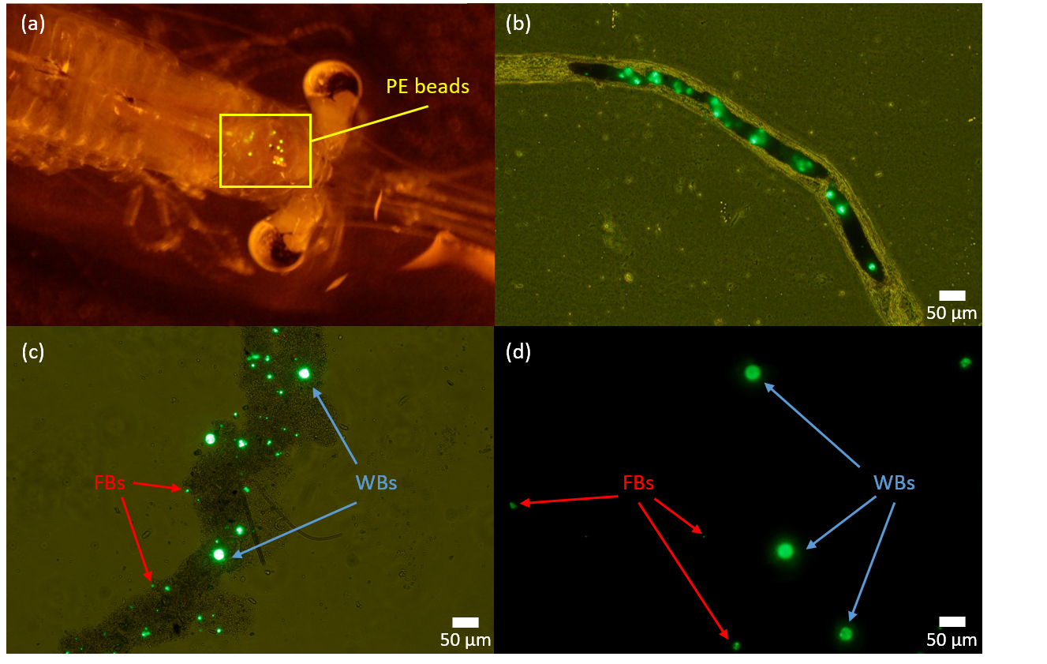

Fig.2 (Hasegawa and Nakaoka)

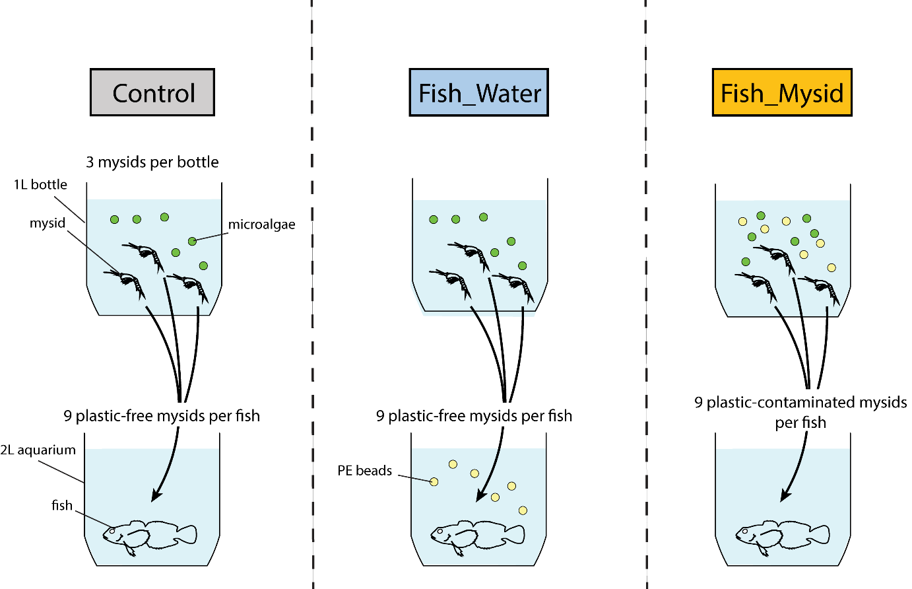

Fig. 3 (Hasegawa and Nakaoka)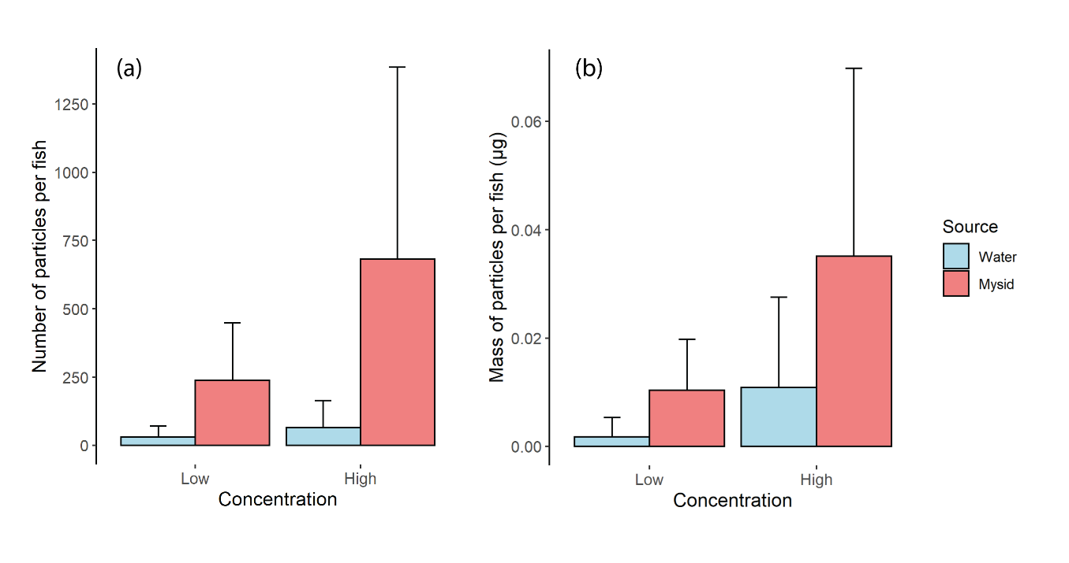

Fig. 4 (Hasegawa and Nakaoka)

